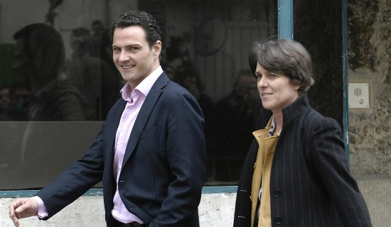
Jérôme Kerviel

Rogue trader, lost €4.9 billion

Largest fraud in banking history at that time

Worked in the compliance department of a French bank

Defeated security at his bank by concealing transactions with other transactions

Arrested in Jan 2008, out and working at a computer consulting firm in April 2008

Links Ch7a, 7b
Understanding Basic Control Types

Risk

The likelihood that a threat will exploit a vulnerability, resulting in a loss

Risk Management

Using controls to reduce risk

Controls

Also called countermeasures or safeguards

Types of Controls

Technical

Uses technology to reduce vulnerabilities

Management

Primarily administrative

Operational

Ensure that day-to-day operations comply with security plan

Functions of Controls

Preventative

Prevent an incident from occurring

Detective

Detect when a vulnerability has been exploited

Corrective

Reverse the impact of an incident after it has occurred

Examples of Technical Controls

Least Privilege

Users have only enough permissions to do their job, but not more

Antivirus software

Intrusion Detection Systems (IDSs)

Monitors a network or host for network-based threats

Firewalls

Restrict network traffic with rules

Examples of Management Controls

Risk Assessments

Quantitative risk assessment

Uses cost and asset values to determine monetary risk

Qualitative analysis

Categorizes and rates risks

“High risk”, “Medium risk”, “Low risk”

Vulnerability Assessments

Examples of Operational Controls

Awareness and Training

Maintain password security

Clean desk policy

Understand phishing and malware

Configuration Management

Record performance baselines

Change management

Contingency Planning

Prepare for outages

Media Protection

Physical media like USB flash drives, hard drives, and backup tapes

Physical and Environmental Protection

Cameras

Door locks

Heating and ventilation systems

Controls Based on Functions

Preventative Controls

Prevent an incident from occurring

Detective Controls

Detect when a vulnerability has been exploited

Cannot predict an incident

Cannot prevent an incident

Corrective

Reverse the impact of an incident after it occurs

Examples of Preventative Controls

Security Guards

Attacker is less likely to attempt social engineering and less likely to succeed

Change Management

All changes most go through a change management process

Prevents ad-hoc configuration errors

Examples: promoting users to Administrator casually; installing a rogue Wi-Fi access point

Account Disablement Policy

When an employee is terminated

System Hardening

Making systems more secure than default configurations

Removing and disabling unneeded services and protocols

Patches and updates

Enabling firewalls

Video Surveillance

Can prevent attack, acts as a deterrent

Examples of Detective Controls

Security Audit

Examines the security posture of an organization

Password audit

User permissions audit

Video Surveillance

Records activity and detects what occurred

Visible cameras can also act as a preventative control, deterring attacks

Examples of Corrective Controls

Active IDS

Detect attacks and modifies the environment to block them

Backups and System Recovery

When data is lost, backups ensure that it can be recovered

System recovery restores damaged systems to operation
Exploring Access Control Models

RBAC, DAC, MAC

Role-Based Access Control (RBAC)

Rule-Based Access Control (RBAC)

Discretionary Access Control (DAC)

Mandatory Access Control (MAC)

Subjects and Objects

Subjects

Users or groups that will access an object

Object

A file, folder, share, printer, or other asset which subjects may want to access

Data Classification

Classification detemines how much protection the data requires

The access control model (RBAC, DAC, or MAC) helps determine how the data is protected

US Gov't uses these classifications

Top Secret

Secret

Confidential

Unclassified

Role-Based Access Control (RBAC)

Commonly used in Windows domains

Users are grouped into Roles

Example: Manager, Technician, Sales, Financial

Rights and Permissions are assigned to Roles

Example: Financial can access the payroll database, but Sales cannot

Rule-Based Access Control (RBAC)

Rules define what is allowed

Examples: firewall rules, Parental Controls, Time-of-Day restrictions

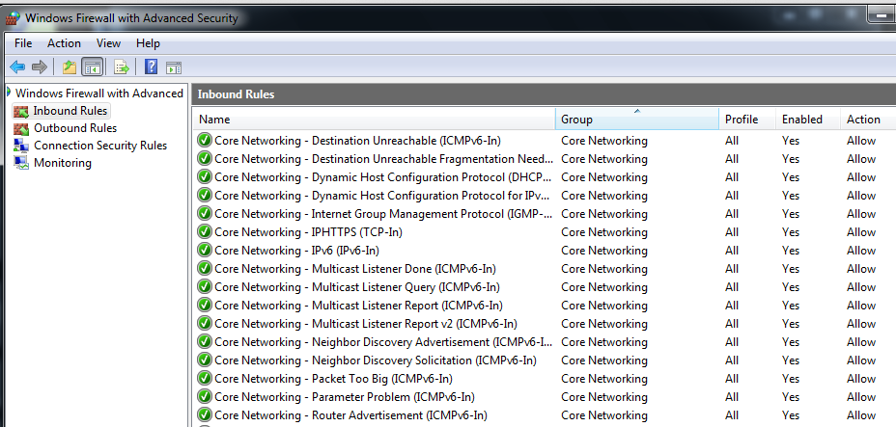
Firewall Rules

Cisco ACLs

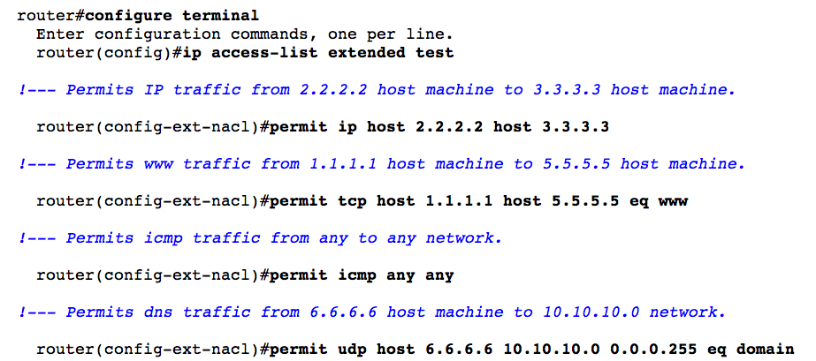
Link Ch 2g

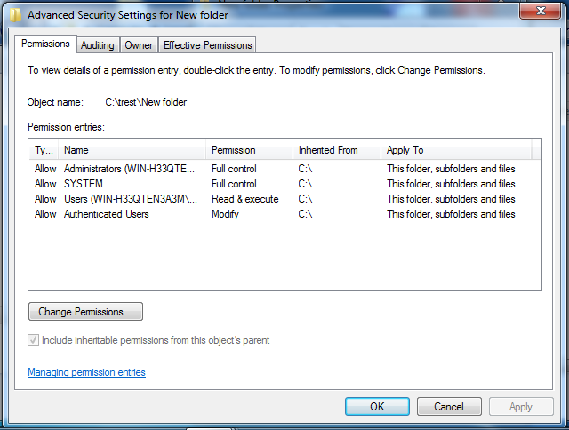
Discretionary Access Control (DAC)

Each object has an owner

The owner assigns access rights at their discretion

Used by Windows computers that are not in a corporate domain

Windows DAC

Owner of a folder can assign

Full Control

Read

Write

etc.

SID (Security Identifier)

Windows identifies users by SID

Unique value

Link Ch 2b
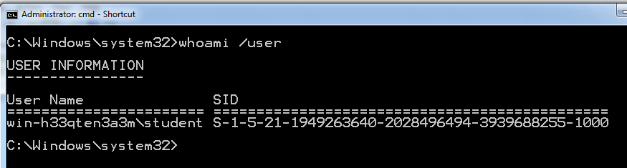

Mandatory Access Control (MAC)\

Most restrictive, used by military

Subjects and objects are classified by a higher authority

Top Secret

Secret

Confidential

Unclassified

Top Secret data must stay on "Top Secret" devices, and only seen by personnel cleared for "Top Secret" access

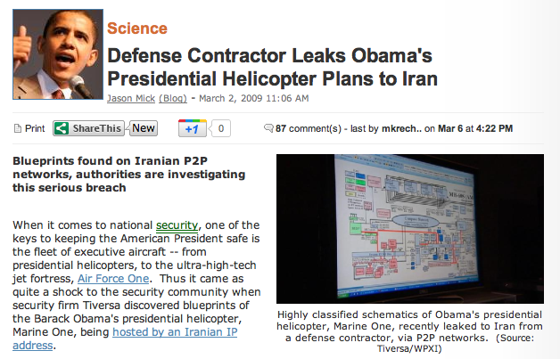

Link Ch 2a

Understanding Physical Security Controls

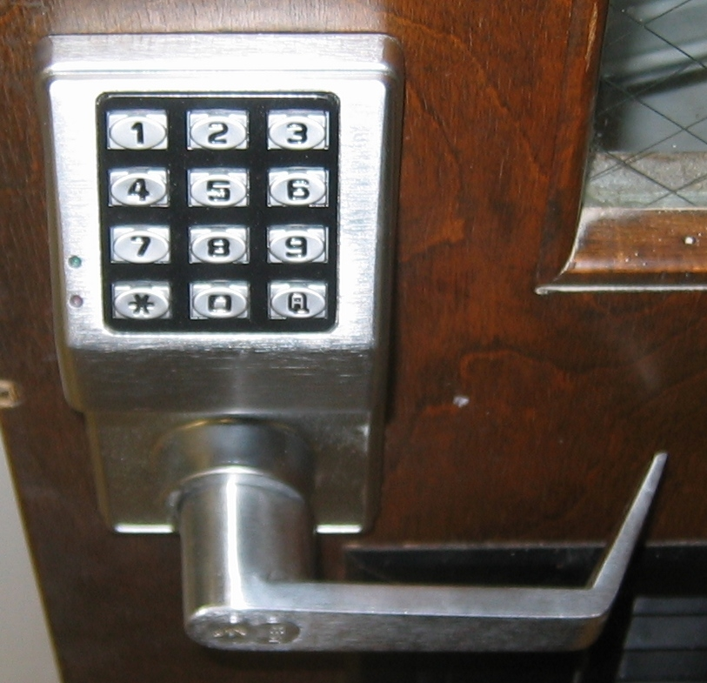
Boundaries

Perimeter

Example: Fence around campus

Building

Secure work areas

Example: Clean room

Server and network devices

Example: Server room

Door Access Systems

Cipher locks

Image from mssparky.com

Proximity Cards

image from beresfordco.com

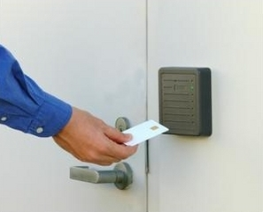
ID Badges

Image from pimall.com

Physical Access List and Logs

Access List

Specifies who is allowed to enter

Enforced by guards

Log

Records who went in and out

Video surveillance is most reliable

Tailgating

Following a person through a secure door

Also called piggybacking

To prevent this, use mantraps, turnstiles, or security guards

Man Trap

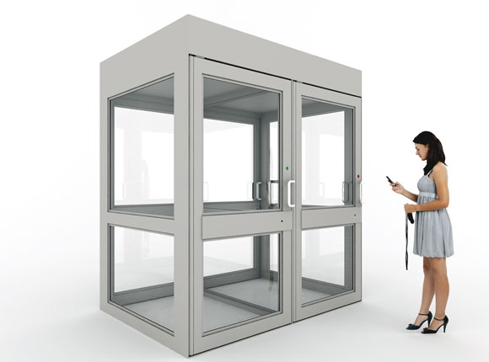
Image from flaglerchat.com

Turnstile

Image from sunshinetek.en.made-in-china.com

Video Surveillance (CCTV)

Reliable proof of a person's location and activity

Only record in public areas

Notify employees of the surveillance

Do not record audio

It's often illegal without consent of all parties

Camera Types

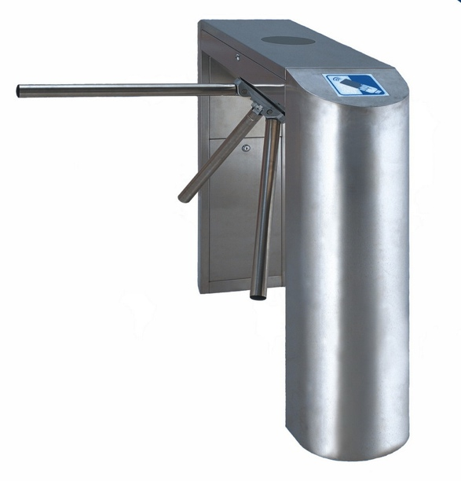
Wireless

Wired

Low-light

Often infrared

Color

Black and white

Hardware Locks

Inexpensive access control

No record of who entered or when

Cable locks for laptops

Locked cabinets or safes
Understanding Logical Access Controls

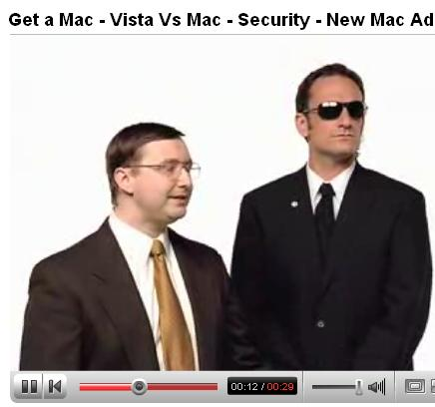
Least Privilege

A technical control that uses access controls

Individuals and processes are granted only the rights and permissions they need

Don't let everyone log on as Administrator

User Account Control: Cruel Mac Video

Link Ch 2c

Access Control Lists

Implicit deny

A user who is not on the list gets no access

Group Policy

Implemented on a Windows domain controller

Security settings affect all computers and users in the domain

Central point of administration

Password Policy

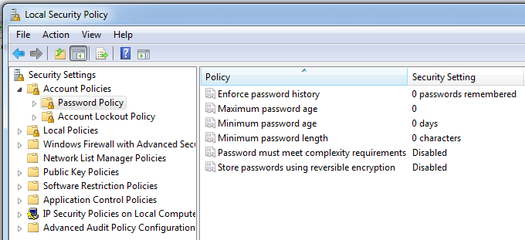
Device Policy

Disable Autorun

Prevent use of USB devices

Detect use of USB devices

IEEE 1667: USB device authentication

Link Ch 2e

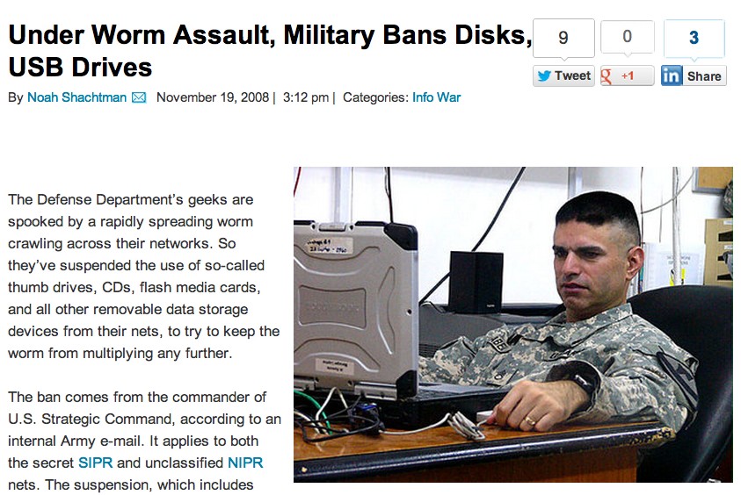
Link Ch 2d

Account Management

Creating, Management, Disabling, or Terminating user accounts

Centralized Account Management

One point of administration

Windows domain controller, using LDAP

Decentralized

Accounts stored on each workstation locally

Windows workgroup

Disabling and Deleting Accounts

Disable inactive accounts

Terminated employees

Often old accounts are left active

Leave of Absence

Disable account temporarily

Time-of-Day Restrictions

Logon hours in Windows 7

Link Ch 2f

Account Expiration and Access Review

Account Expiration

Appropriate for temporary contract employees

Account Access Review

Log and audit times of logon and logoff

Detect password-guessing attacks

Monitor remote access logins

Last modified 8-28-12

