Reviewing Basic Networking Concepts

Basic Connectivity Protocols

TCP (Transmission Control Protocol)

UDP (User Datagram Protocol)

IP (Internet Protocol)

ARP (Address Resolution Protocol)

ICMP (Internet Control Message Protocol)

TCP

Connection-oriented: guaranteed delivery

Three-way handshake

SYN

SYN/ACK

ACK

SYN Flood Attack

Consumes server resources, creating a Denial of Service (DoS)

UDP

Connectionless

No handshake

No guarantee of delivery

Often used for DoS attacks

IP

Delivers packets to specified computer by IP Address

IPv4: 32-bit address

192.168.1.1

IPv6: 128-bit address

fe80:0:0:0:462a:60ff:fef6:278a

ARP

Finds MAC address from IP address

ARP Poisoning

Sends false ARP messages

Redirects traffic on a LAN

Commonly used for Man-In-The-Middle Attacks

ICMP

Connectivity tests

Ping

Pathping

Tracert

Used in DoS attacks

Blocked by default by Windows XP SP2 and later firewalls

Encryption Protocols

SSH (Secure Shell)

SSL (Secure Sockets Layer)

TLS (Transaction Layer Security)

IPSec (Internet Protocol Security)

SSH

Used to encrypt Telnet

Telnet lacks encryption and uses port TCP 23

Secure Copy Protocol (SCP)

Secure File Transfer Protocol (SFTP)

Runs on port TCP 22

SSL

Can be used to encrypt HTTP traffic, as HTTPS

Port TCP 443

Can also secure LDAP as LDAPS

Port TCP 636

SSL is old and has security weaknesses

TLS

Replacement for SSL

Runs on the same ports

HTTPS on TCP 443

LDAPS on TCP 636

IPSec

Native to IPv6 but back-ported to IPv4

Encapsulates and encrypts IP packets

Two components

AH (Authentication Header)

Protocol ID 51 (neither TCP nor UDP)

ESP (Encapsulating Security Payload)

Protocol ID 50

Application Protocols

HTTP (Hypertext Transfer Protocol)

HTTPS (HTTP Secure)

FTP (File Transfer Protocol)

SFTP (Secure FTP)

FTPS (FTP Secure)

TFTP (Trivial File Transfer Protocol)

Application Protocols

Telnet

SNMP (Simple Network Management Protocol)

DNS (Domain Name System)

NetBIOS (Network Basic Input/Output System)

LDAP (Lightweight Directory Access Protocol)

Application Protocols

Kerberos

SQL Server (Structured Query Language)

RDP (Remote Desktop Protocol)

Used by Terminal Services

Also called Remote Desktop Service or Remote Administration

HTTP

Normal Web browser traffic

Port TCP 80

Not encrypted

HTTPS

Encrypts traffic

Guarantees identity of server

Displays padlock in Web browser and HTTPS at start of URL

Uses SSL or TLS, port TCP 443

FTP

Upload or download files

Data in cleartext, including passwords

Active mode

Ports TCP 20 for data and TCP 21 for control

Passive mode

Random port for data and TCP 21 for control

SFTP and FTPS

SFTP

FTP over SSH

Port TCP 22

FTPS

FTP over SSL or TLS

Ports TCP 989 and 990

TFTP

Uses UDP port 69

No authentication at all

Used for IP phone and router firmware updates

Many attacks used it

Telnet

Used to send command lines to remote systems

Uses no encryption, not even for passwords

Port TCP 23


SNMP

Used to monitor and manage network devices like routers, switches, and firewalls

Sends traps – signals notifying management systems of their status

Port UDP 161

SNMPv1 and v2 sent "community strings" (passwords) in cleartext

SNMPv3 encrypts passwords

DNS

Resolves host names like www.ccsf.edu into IP addresses like 147.144.1.212

Ports UDP 53 and TCP 53

Many security problems, which will be improved by switching to DNSSEC

Dan Kaminsky

World-famous DNS expert

Found a serious flaw that enabled him to redirect Internet traffic

Kept it secret till Microsoft and other vendors patched it

Testified before Congress

Link Ch 3a

NetBIOS

Used to resolve Windows computer names like SERVER1 to IP addresses on Local Area Networks

A legacy protocol, replaced by DNS on most modern networks

Still used by Windows

Ports 137-139, both TCP and UDP

LDAP

Used for directories of users and objects on networks, including

Microsoft Active Directory

Novell Netware Directory Services

Port TCP 389 (unencrypted)

Port TCP 636 (LDAPS, encrypted)

Kerberos

Uses tickets for authentication

Used in Windows domains and some Unix environments

Port 88, both TCP and UDP

SQL Server

Manages databases

Often has SSNs, email addresses, account numbers, and other PII (Personally Identifiable Information)

Commonly hacked via SQL Injection

Port TCP 1433 (Also UDP 1434)

RDP

Remotely control a Windows computer

Service is called "Remote Administration", "Terminal Services", or "Remote Desktop"

Port TCP 3389

Also used by Remote Assistance

Email Protocols

SMTP (Simple Mail Transfer Protocol)

Sends mail to other email servers

Port TCP 25

POP3 (Post Office Protocol v3)

Moves incoming email to your local Inbox in clients like Outlook

Port TCP 110

IMAP4 (Internet Message Access Protocol v4)

Moves incoming email to your local Inbox in clients like Outlook, or lets you view them on the server

Port TCP 143

Remote Access Protocols

PPP (Point-to-Point Protocol)

IPSec (Internet Protocol Security)

PPTP (Point-to-Point Tunneling Protocol)

L2TP (Layer 2 Tunneling Protocol)

RADIUS (Remote Authentication Dial-in User Service)

TACACS (Terminal Access Controller Access-Control System)

TACACS+

PPP

Used to create dial-up connections to a server

Commonly used by clients to connect to an ISP

IPSec

Can be used as a remote access tunneling protocol

To encrypt traffic, forming secure connections over the Internet

Uses IKE (Internet Key Exchange) over port UDP 500

PPTP

Old VPN (Virtual Private Network) protocol

Included in Microsoft Windows

Has serious security flaws

Still commonly used

Port TCP 1723

L2TP

Combines Microsoft's PPTP with Cisco's L2F

Often combined with IPSec for encryption

Port UDP 1701

RADIUS

Central authentication for remote access clients

Encrypts passwords only

TACACS / XTACACS

Older network authentication protocols

TACACS is generic

XTACACS is Cisco proprietary

Port UDP 49 for both TACACS and XTACACS

TACACS+

Used by Cisco VPN concentrators

Encrypts entire authentication process

Multiple challenge responses for Authentication, Authorization, and Accounting (AAA)

Port TCP 49

Subnetting

See Binary Games in Projects (Extra Credit)

Ports

0-1023: Well-known ports

1024-49151: Registered ports

Registered by IANA for convenience

Example: SQL Server on 1433

49152-65535: Dynamic and private ports

"Ephemeral" ports for temporary use by any application
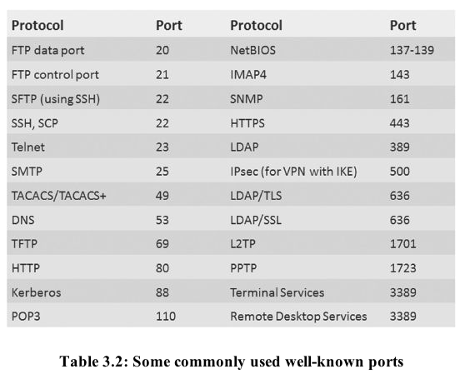

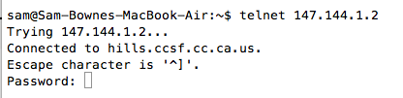
Demo: Telnet to 147.144.1.2

Firewalls

Block ports by protocol and number

For example, allowing TCP 80 but blocking UDP 69

Port Scanners

Find open , closed, or filtered ports

Nmap
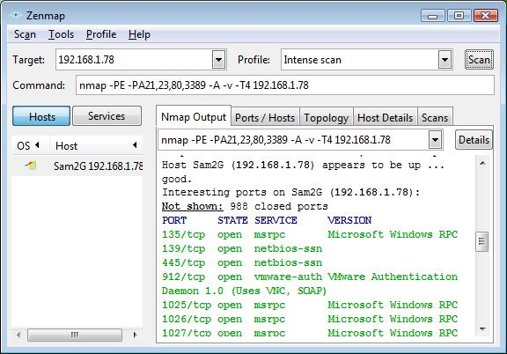

Understanding Basic Network Devices

IP Address Types

Unicast

One sender, one receiver

The most common type

Broadcast

One sender to all devices on a LAN

IP 255.255.255.255 sends to all devices on a LAN

147.144.255.255 sends to all devices in the 147.144.0.0 network

Hub

Common on old 10 Mbps LANs

Zero intelligence

Whatever comes in on a port goes out all other ports

Each user can sniff traffic intended for others

Switch

Replaces hubs in almost all LANs now

Learns which devices are connected to each port

Sends traffic only to the correct port, after learning where the devices are

At first, it acts like a hub while learning

Security Benefits of Switches

Reduces the threat of sniffing attacks

Because devices don't get other devices' traffic

Can be defeated by flooding with random MAC addresses

Switch runs out of RAM for switching table and acts like a hub instead

Can also be defeated by ARP poisoning

Security Benefits of Switches (continued)

Port Security

Only allow a device with the approved MAC address to connect to each port

BUT: MAC addresses can be spoofed

Physical Security of a Switch

Put the switch in a locked wiring closet

Prevents attacker from accessing:

Console port used to manage the switch

Monitor port used to sniff all traffic

STP (Spanning Tree Protocol)

If wires allow traffic to flow in loops, this can lead to a broadcast storm

To prevent this, switches use

STP (Spanning Tree Protocol) or

RSTP (Rapid Spanning Tree Protocol)

Blocks unneeded ports to prevent loops

Included in all switches and on by default

VLAN (Virtual Local Area Network)

At CCSF, the CNIT Dept. computers are in several different rooms and buildings

SCIE 37, CLOU 218, SCIE 214, etc.

But they are all in the same subnet and see one another as on the same LAN

Switches sort traffic by adding a VLAN Tag to each ethernet frame

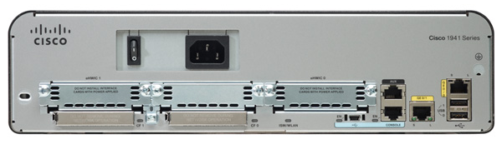
Router

Connect network segments together

For example, a LAN to the Internet

Don't forward broadcasts

Reduce "noise" traffic on segments

Computers can act as routers

But most networks use hardware routers

Image from Cisco

ACLs (Access Control Lists)

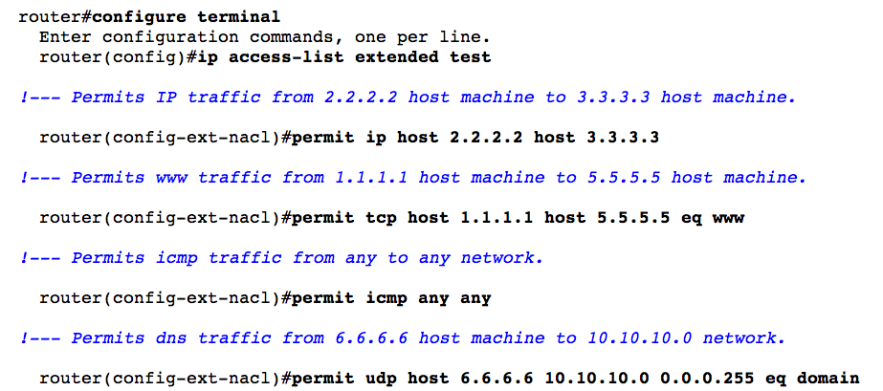
Packet filtering

Traffic that is not allowed is usually discarded

Routers and Firewalls

Routers can filter traffic in simple ways

By protocol, port, or address

Early firewalls filtered the same way

Firewalls are much more advanced now

Home Router

You can also use a router or residential gateway, which typically adds network address translation (NAT) capabilities and security features

Firewall

Filters traffic, both inbound and outbound

Host-based Firewall

Protects a single host from intrusion

Example: Windows Firewall

Network-based Firewall

Protects a whole network

Image from Palo Alto Networks

Firewall Rules

For simple packet-filtering, they are similar to router access lists

Web Application Firewall

Specifically designed to stop SQL Injection and other Web App attacks

Example: modsecurity for Apache

Web Security Gateway and Appliances

Unified security solution

Content inspection—attachments

Content inspection—spam

Content inspection—streaming data

URL filtering

Certificate inspection

Spam Filters

Google’s Postini is very good too
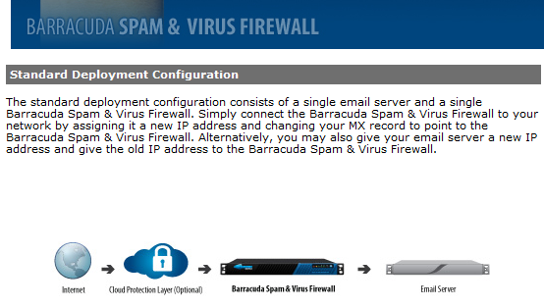

Firewall Logs and Log Analysis

Firewalls log all blocked traffic, all allowed traffic, or both

Splunk (Link Ch 3b)

AlienVault OSSIM (Link Ch 3c)

Load Balancers

Distributes traffic to a cluster of servers

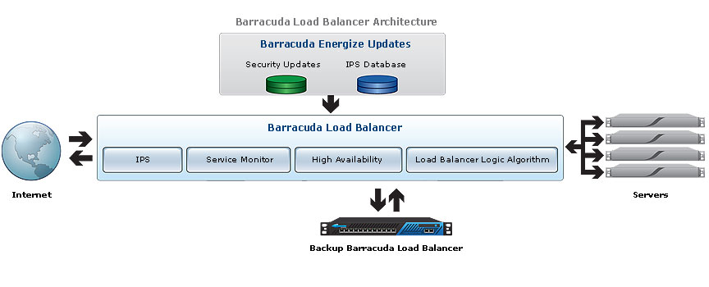
High availability

Exploring the Network Perimeter

DMZ (Demilitarized Zone)

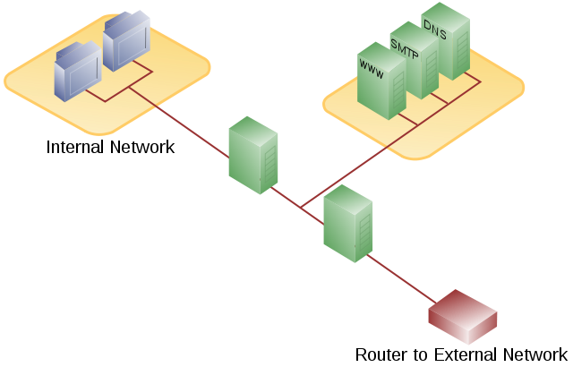
A semi-trusted zone between a private network and the Internet

Provides defense in depth for internal network

Image from Wikipedia

Public and Private IPv4 Addresses

Public IP addresses are used to send and receive Internet traffic

They aren't free, but leased from Internet Service Providers

Private addresses can't be used on the Internet, but are free for use on private networks

RFC 1918 Private Addresses

10.0.0.1 – 10.255.255.254

172.16.0.1 – 172.21.255.254

192.168.0.1 – 192.168.255.254

NAT
(Network Address Translation)
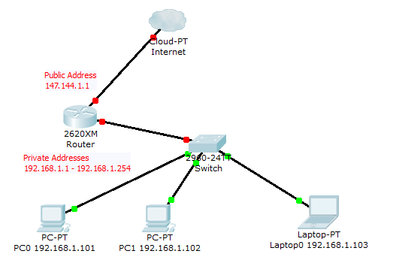

NAT allows many clients to share a single public IP address

Cost savings

Hides local IP addresses

Provides some protection

Users can't run unauthorized servers

NAT breaks some network services

IPSec and many others

Proxy Server

No direct connections from clients to Internet allowed

Proxy fetches content from the Internet and clients look at cached content

Makes Web pages load faster

Can filter content and log visited sites
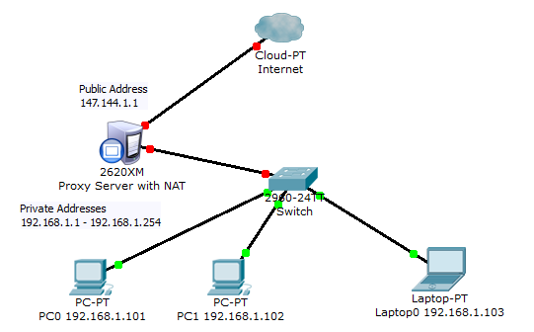

Last modified 9-9-12

