Understanding IDSs and IPSs

IDS v. IPS

IDS detects attacks but does not stop them

Detective technical control

Passive IDS merely logs attacks, and/or sends alerts

Active IDS may send alerts and change environment

IPS stops attacks in progress

Preventive technical control

Similar to Active IDS

HIDS v. NIDS

HIDS (Host-based IDS)

Installed on a server or workstation

NIDS (Network-based IDS)

Installed on a network device, such as a router or switch

Signatures v. Anomalies

Signature-based monitoring recognizes known attack patterns

Also called definition-based

Anomaly-based monitoring detects abnormal behavior based on a baseline

Also valled behavior-based or heuristics-based

Active IDS v. IPS

Both react to an attack in some manner

IPS must be placed in line with the traffic to prevent the attack

HIDS

Additional software on a workstation or server

Can detect attacks on the local system

Can monitor changes to operating system files

Protects only one host

NIDS

Can only see network traffic, not OS files

Unable to decrypt encrypted traffic

Detection Methods

Signature-based

Uses a database of predefined traffic patterns

Database requires frequent updates

Anomaly-based

Needs to measure a performance baseline

Baseline must be updated if network is changed

Data Sources and Trends

IDS collects data from various sources

Firewall logs

System logs

Application logs

May monitor logs in real time

Alarms, Alerts, and Trends

Alarms

Also called Alerts

Indicates that an interesting event was detected

Does not always indicate a real attack

Goal

Set threshold low enough to detect all real attacks, but

High enough to avoid too may false positives

IDS Threshold

Number of events required to cause an alert

Example: 50 incomplete TCP handshakes per minute from the same IP

There are no established rules for thresholds

Must be "tuned" by administrators

Untuned security devices tend to produce many false positives

IDS Responses

Passive (Alerts personnel)

Pop-up window

Central monitor

E-mail

Page or text message

Active

Alerts personnel

Modify ACL on Firewall

Divert attack to a honeypot or other safe environment

Honeypot

Appears to be a server worth hacking into

Has no valuable data

Often used to collect knowledge about attackers

Zero-Day Vulnerability

A vulnerability that is not publicly known

Or a vulnerability for which there is no patch available


Link Ch 4d

Demo at link Ch 4e

Honeynet

A group of virtual servers appearing to be a live network

Counterattacks

Some active IDS systems attack the attacker back

Legal problems

Likely that you are attacking another innocent victim
Securing Wireless Networks

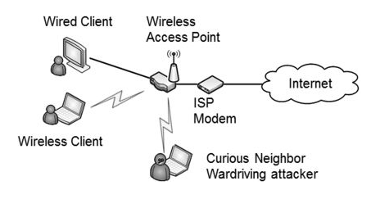
Wireless Footprint

High power makes a large footprint

Easier for users to connect

Easier for attackers to snoop on

Careful antenna placement

Metal in walls

Directional antennas increase range of reception

Security Protocols

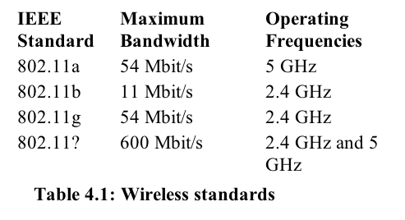
WEP – Broken and unsafe to use

WPA – Much safer, stronger with AES than TKIP

WPA2 – Best security currently available, especially in Enterprise mode with 802.1x or RADIUS server

WEP (Wired Equivalent Privacy)

Mathematically insecure

Can be broken with no knowledge of the key 100% of the time

Attacker needs 50,000 packets or so

WPA (Wi-Fi Protected Access)

Designed to run on hardware designed for WEP with only a software upgrade

Weakest form of WPA uses TKIP (Temporal Key Integrity Protocol) and RC4 encryption

Stronger form of WPA uses AES encryption

WPA-2

Stronger cryptography than WEP or WPA

Uses CCMP mode of AES

Personal and Enterprise Modes

Both WPA and WPA-2 have Personal and Enterprise modes

Personal

Pre-Shared Key must be entered in each device

Same for all users

Personal and Enterprise Modes

Enterprise mode

Each user has individual credentials

Username and password

Extensible protocols like LEAP and PEAP which can use certificates

Credentials stored on an 802.1x server

Attacking WPS (Wi-Fi Protected Setup)

Link Ch 4g


EAP, LEAP, and PEAP

EAP (Extensible Authentication Protocol)

A framework that provides general guidance for authentication

LEAP (Lightweight EAP)

Cisco's attempt to improve WEP

Uses CHAP

Not secure, subject to offline dictionary attack

Cisco recommends using PEAP instead

ASLEAP

Lightweight Extensible Authentication Protocol (LEAP)

A Cisco product

Vulnerable, but Cisco didn’t care

Joshua Wright wrote the ASLEAP hacking tool to crack LEAP, and forced Cisco to develop a better protocol

See link Ch 4f

Reaction to ASLEAP

“Within months, some "helpful" person invested their time into generating a cracker tool. Publicizing the threat was a service to everyone, but I leave it as an exercise for readers to determine what satisfaction is obtained by the authors of tools that turn threat into reality and lay waste to millions of dollars of investments.”

--"Real 802.11 Security", William Arbaugh and Jon Edney, as quoted in link Ch 4f

PEAP (Protected EAP)

Encapsulates EAP conversation in a TLS tunnel

Requires a digital certificate for the server

Requires a Certificate Authority

WTLS and ECC

WTLS (Wireless Transport Layer Security)

Used by many smaller wireless devices

ECC (Ellipt Curve Cryptography)

A more efficient cryptography method than the RSA algorithm used on the Internet

Used on small wireless devices to save power

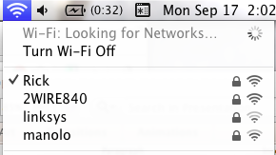
Other Security Concerns

Change default administrator password

MAC filtering

Allows only approved MAC addresses to connect

Easily sniffed & spoofed

Disable SSID (Service Set Identifier) Broadcasts

SSID is the name that identifies your network, such as "Linksys" or "CCSF Wifi"

Only stops sloppy attackers who use NetStumbler

SSID is in every packet sent anyway

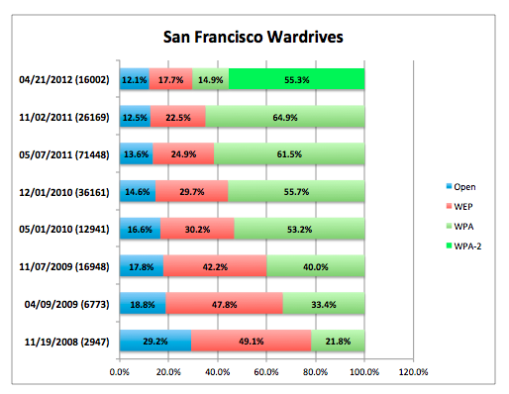
Change Default SSID

Conceals the real model of your router

Makes attackers work harder

CCSF Wardriving

Tue, nov. 13, 6 PM SCIE 200

Wardriving Results

WIGLE.NET

Wardriving

Part of a wireless audit

Finds "Rogue" access points

Unauthorized routers added to network

Finds "Evil Twins"

Access points spoofing the authorized ones to perform MITM attacks

Interference

Attackers can use radio transmissions to interfere with Wi-Fi

Changing channel or power levels may help to resist the attack

Disassociation Frames are the most effective DoS attack

Isolation Mode

Each client is on a separate VLAN, in effect

Isolates clients better

Protects clients from each other

Done at Starbuck's


Ad-Hoc Mode

Infrastructure Mode

The usual situation

A wireless router connects all clients to the Internet

Ad-Hoc Mode

Wlreless clients connect to each other in a peer-to-peer manner

Similar to a crossover cable in wired Ethernet

Bluetooth Wireless

Sh ort-range connections

In 'Discovery Mode", a Bluetooth device broadcasts its MAC address, to allow "pairing"

PINs are often set to 0000


Bluesnarfing and Bluejacking

Bluesnarfing

Access to or theft of data from a Bluetooth connection

Bluejacking

Unauthorized sending of text messages from a Bluetooth device

Smartphone Security

Data encryption

Protects data if phone is lost

Remote wipe

Password protection

Bluesnarfing attack bypasses password protection and data encryption

Location systems via GPS

Exploring Remote Access

Remote Access

Allows users who are travelling to connect to internal network services

Remote Access Service

Through dial-up or VPN (Virtual Private Network)

Components

Access Method

Dial-up or VPN

Authentication

Require secure authentication because users may use insecure lines

Access Control

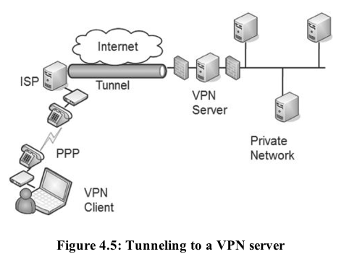
User authorization

Client health

Dial-Up RAS

Client and sever need phone lines and modems

Requires POTS line (Plain Old Telephone Service)

Requires a long-distance phone call

Uses PPP (Point-to-Point Protocol)

VPN

Uses the Internet

Faster and cheaper than Dial-up

Uses tunneling to move LAN packets over the Internet

VPN Concentrator

Used at large companies

Includes

Strong encryption and authentication

Handles many clients

Tunneling Protocols

IPSec (port UDP 500 for IKE)

Problems with NAT

PPTP (port TCP 1723)

Old and vulnerable

L2TP (port UDP 1701)

No encryption, often used with IPSec

SSTP (port TCP 443)

Works through NAT

For more details, see link Ch 4i

IPsec as a Tunneling Protocol

IPsec has two modes

Transport Mode

Only the payload is encrypted

Tunnel Mode

The entire IP packet is encrypted

Uses IKE over UDP port 500 to authenticate clients

Creates Security Associations (SAs) for the VPN

AH and ESP

IPsec can use

AH (Authentication Header) alone

for Authentication and Integrity

no encryption

Protocol 51

or ESP (Encapsulating Security Payload)

to encrypt the data

providing Confidentiality, Integrity, and Authentication

Protocol 50

Link Ch 4j

L2TP and IPsec

L2TP creates a tunnel, but without encryption

No confidentiality

L2TP/IPsec used together provide

Authentication

from Authentication Header

on Protocol 51

Encryption

from Encapsulating Security Payload (ESP)

on Protocol 50

NAT and IPsec

NAT changes the IP addresses of packets

IPsec detects this change as packet damage and discards it

To use IPsec through NAT, use

NAT-T (NAT Traversal) (link Ch 4k), or

Another tunneling protocol such as SSTP

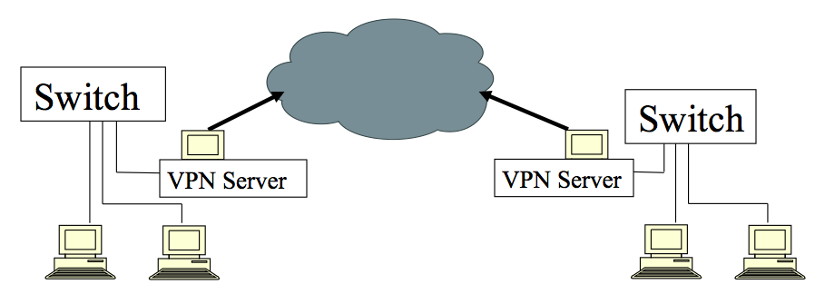
Site-to-Site VPNs

Easier for users; just appears as a normal network connection

RAS Authentication

CHAP (Challenge Handshake Authentication Protocol)

Old, rarely used anymore

MS-CHAPv2

Much more secure than CHAP

Mutual authentication

Can be integrated with other authentication methods such as EAP, PEAP, and more

RAS Authentication

RADIUS (Remote Authentication Dial-In User Service)

Central server for authentication

Encrypts only passwords

TACACS+

Used by Cisco VPN concentrators

Replaces RADIUS

Encrypts entire client-server negotiation process

Uses multiple challenges and responses

Network Access Control

Checks health of client before allowing it to connect to the company LAN

Up-to-date patches and antivirus, firewall on

Health agent runs on client

Authentication

NAC can deny access if clients don't provide valid credentials
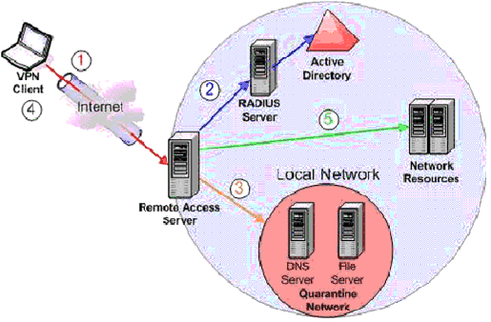

Image from Microsoft

MAC Filtering

A form of network access control

Only approved MAC addresses can connect

Easy for attackers to circumvent on a wireless network

By sniffing and spoofing MAC addresses

Last modified 9-17-12

