Implementing Host Security

Hardening Systems

A host is any device with an IP address; such as servers, workstations, printers, etc.

Hardening is the practice of making the system more secure than a default installation

Disabling unnecessary services

Disabling unneeded applications

Protecting management interfaces and applications

Disabling Unnecessary Services

Provides protection against zero-day attacks

Undisclosed vulnerabilities

Reduces risks from open ports

Ports won’t be open when scanned

Using Baselines

Security baseline

Configuration baseline

Performance baseline

Security Baseline

Starting point for OS

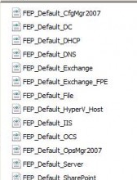
Deployed by

Group policy

Group Policy Objects (GPOs) on Windows domains

Security templates

Imaging

Security Templates

Preconfigured settings for various common computer types

Domain Controller, Email server, Web server, etc.

Security Templates contain

Account polcies

Password and lockout settings

Local policies

User rights

System services

Software restrictions

Restricted groups

Control membership in groups

Link Ch4a

Configuration Baseline

A record of all the settings on a system, including non-security settings and security settings

The security baseline contains only the security settings

Every time a system is changed, the configuration baseline must be updated

Change management

Performance Baselines

Documents the overall performance of a system at a point in time

Useful for reference later when performance changes

Baseline Reporting

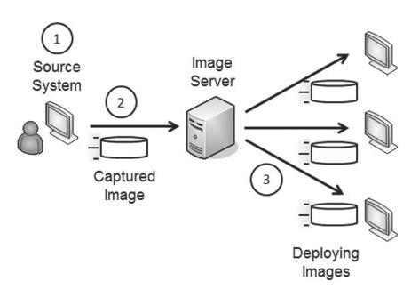
A document that records normal system performance for later reference

Can be used to identify abnormal activitity

Similar to anomaly-based IDS baselines

Understanding Imaging

Capturing and Deploying Images

Prepare a reference computer with everything installed and configured properly

Capture an image of the reference computer

Deploy the image to many computers

Image Deployment Tools

Norton Ghost

Acronis TrueImage

Microsoft Windows Image Backup

Windows Automated Installation Kit

Windows Deployment Services

Many others

Imaging Benefits

Secure starting point

Reduced costs

Maintenance is much simpler

Laptops are often sold with built-in images, to restore factory default settings

Reduces Total Cost of Ownership

Virtualization and Images

Images can be deployed to virtual or physical computers

Physical machines can be converted to virtual machines, and vice versa

US Gov't Configuration Baseline
(USGCB)

First: Standard Desktop Core Configuration (SDCC) in the Air Force

Then: Federal Desktop Core Configuration (FDCC)

Mandated by the Office of Management and Budget (OMB) for all federal agencies

Current version is the USGCB, also mandated by the OMB

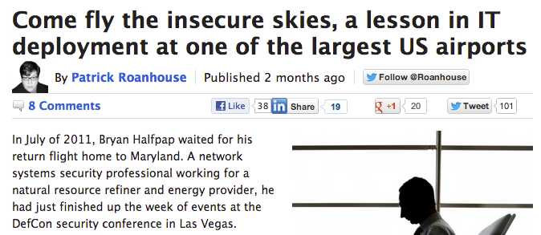
Links Ch 4b, 4c, 4d

Understanding Virtualization

Understanding Virtualization

Reduces costs; makes deploying machines cheaper and faster

VM can run any OS

Windows, Linux, Unix

Even OS X although that violates Apple's license agreement

Host computer needs more resources to host VMs

RAM, Hard disk space, processor speed

Virtualization Technologies

VMware

VMware Workstation

VMware Player (free)

VMware Server (free)

VMware ESXi (Enterprise solution)

Microsoft's Hyper-V

Also Virtual PC

Sun's VirtualBox (free)

Reduced Footprint

Footprint

Amount of physical space and power consumed by an IT system

VMs have smaller footprint

Many VMs can run on a single physical server

Many physical servers are under-utilized

VMs use servers more efficiently

Save power and money

Increased Availability

Virtual servers are easy to copy and convert into clusters

Easy to restore a failed server from a snapshot or image

Isolation

Virtual machines can be isolated from a network, making it easy to

Test risky software

Analyze malware

Perform attacks to test security products

Safe training environments

Virtualization Weakness

VM Escape

An attack that starts in a VM and accesses the host system

VM Sprawl

Non-IT departments at companies now set up VMs

Easy to do with Amazon E2C

But they rarely patch, update, and secure them

Loss of Confidentiality

Each VM may have confidential company data

So there are more copies of the data that could be lot or stolen

Encrypt VMs as well as physical machines

Loss of Availability

A single physical server can host multiple VMs

But the physical server is a single point of failure

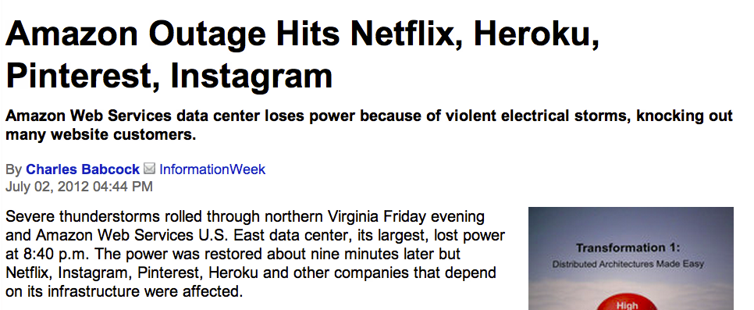
Redundant physical servers are still needed

Link Ch 4e

Implementing Patch Management

Comparing Updates

Patch

Small piece of code to fix a single bug

Hotfix

A patch you apply without rebooting the system

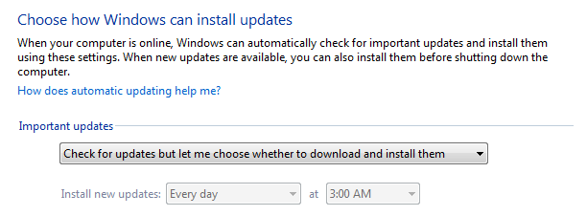
Service pack

A collection of patches and fixes

Useful to apply all patches up to a certain date at once

Deploying Patches

Automatic Updates on workstations

Appropriate for home or very small business networks

Not all machines will always be patched to the same level
Patch management server

Company controls patch distribution

All machines are updated at once

Only approved patches are used (test them first)

Testing Patches

Some patches create problems

All patches must be tested before deployment onto a large company network

Test them in an environment that mirrors the production network

Regression testing

Administrators run a series of known tests on a system

Compare results to tests run before patching

Scheduling Patches

Patch Tuesday

Microsoft issues patches on 2nd Tues of month

Exploit Wednesday

Attackers reverse-engineer the patches and attack systems the next day

This is why Microsoft keeps vulnerabilities secret and doesn't patch them till there are attacks in the wild
Understanding Change Management

Goals of Change Management

Ensure that changes do not cause unintended outages

Provide an accounting structure or method to document all changes

Effect of Change Management

Administrators are discouraged from making ad-hoc changes

Approval is needed before making a change

Simple changes should be approved quickly

Formal change review board is slower but more thorough
Protecting Data

Data loss can cause

Harm to customers

Reputation damage to company

Regulatory fines

Lawsuits

Data Categories

Data at rest

Stored on a hard disk, USB drive, mobile phone, external drive, backups

Data in motion

Travelling over a network

Data Loss Prevention (DLP) detects sensitive data travelling over a network

Encrypt traffic: IPsec, SSH, SFTP, etc.

Data in use

Data in RAM while in use on a workstation

Applications are responsible for protecting data in use

This is why whole-disk encryption is needed to protect data on laptops

Temporary copies of the data are stored in the clear on the hard drive, even when the original data file is encrypted

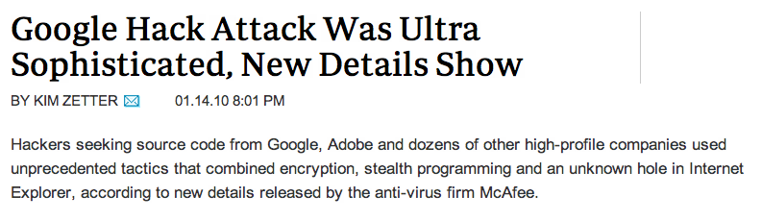
Link Ch 5f

Software-Based Encryption

NTFS permissions don't protect data if the attacker can boot the system from a disk

File and folder-level encryption protect files at rest

But not in use

Applications can encrypt data

Oracle can encrypt sensitive data in a database

Hardware-Based Encryption

Trusted Platform Module (TPM)

Cryptographic co-processor

Used with Microsoft's BitLocker whole-drive encryption

Hardware Security Module (HSM)

Details below

Much quicker to use

Slower to deploy

TPM

TPM is a hardware chip on the motherboard of a laptop

Includes an unique RSA asymmetric-encryption key

Can generate and store other keys

Provides full-disk encryption

Used by BitLocker in Windows 7

HSM

A security device you can add to a system

Manages, generates, and securely stores cryptographic keys

Can be connected to a network, expansion card, or computer port

External device, as opposed to TPM

Usages of HSMs

High-speed SSL sessions

E-commerce sites use SSL accelerators with HSMs

Mission-critical systems

High-speed services in high availability clusters

Certificate Authorities (CAs)

HSMs used to create, store, and manage the Public Key Infrastructure (PKI)

Data Leakage

Data Loss Prevention

Inspects network data

Looks for unauthorized data transmissions

Usually network-based

Scans text of emails and content of attached files

Looks for sensitive data, as defined by an administrator

Such as SSNs, by format ###-##-####

Data classification: Sensitive or Secret

Portable Storage Devices

USB hard drives and flash drives

Very risky: employees can lose the device with company data on it

Encryption is the best defense

TrueCrypt is the free solution

Microsoft's BitLocker To Go is another solution

Protecting Mobile Devices

Encrypt the data

Locate them with GPS

Remote wipe

Lock passcode

MobileMe for iPhone and iPad
Understanding Cloud Computing

Cloud Computing

Accessing computers elsewhere, usually over the Internet

Example: Gmail

Three specific services:

SaaS (Software as a Service)

IaaS (Infrastructure as a Service)

Also known as Hardware as a Service

PaaS (Platform as a Service)

Software as a Service

Gmail

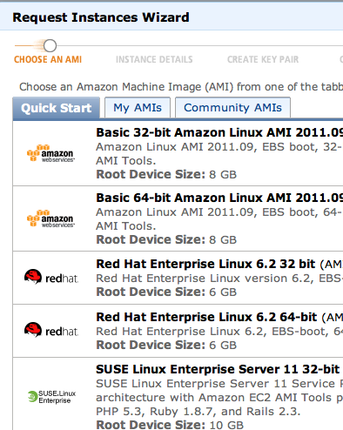
Customer can use any computer, OS, Browser

Service provides all the software required

Google Docs

No need to have Microsoft Office yourself

Security concern: data is now stored in the cloud

Infrastructure as a Service

Outsource equipment requirements

Servers, routers, switches

I use a RapidXen virtual server

Platform as a Service

Provides a computing platform with an easy-to-configure operating system

Amazon E2C

Customers rent virtual machines and configure them as needed

Drawbacks to Cloud Computing

Lose physical control of your data

Cloud service could steal or lose your data

Example: Dropbox failed to enforce passwords briefly in June 2011

Last modified 9-25-12

