Understanding Malware

Malicious Software (Malware)

Installed through devious means

Symptoms:

System runs slower

Unknown processes start

Sends out email by itself

Random reboots

more…

Viruses

Code attaches to a host application

Virus acts and spreads when the host application is run

Payload

Causes damage or delivers a message

May join computer to a botnet

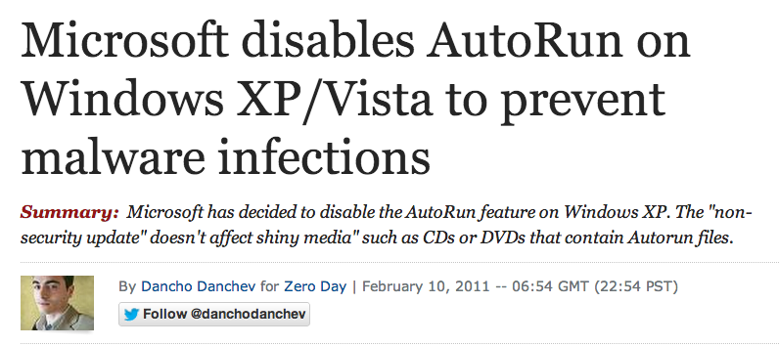
Often delayed, so virus can spread

USB Malware

Can run automatically when the USB device is plugged in

Since Win XP SP3, "Autorun" is off by default in Windows (link Ch 6a)

Virus Characteristics

Replication mechanism

Infects other applications

Activation mechanism

Executes its objective

Objective mechanism

Payload: do damage

Delivery of Viruses

Attached to email

Links in spam go to infected websites

USB drives with viruses

Buckshot Yankee

US Military compromised by USB-borne virus

Led to a ban on USB sticks for a while

Link Ch 6b

Virus Hoaxes

Scary email message

Recommending some unwise action, such as deleting system files

To detect hoaxes:

Antivirus vendor sites

Urban legend sites like snopes.com

Worms

Self-replicating malware

Does not need a host application or user interaction

Consumes network bandwidth

Unlike viruses, worms don't need to be replicated

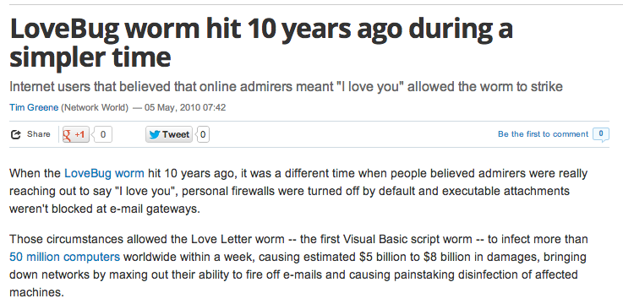
LoveBug Worm

Link Ch 6c

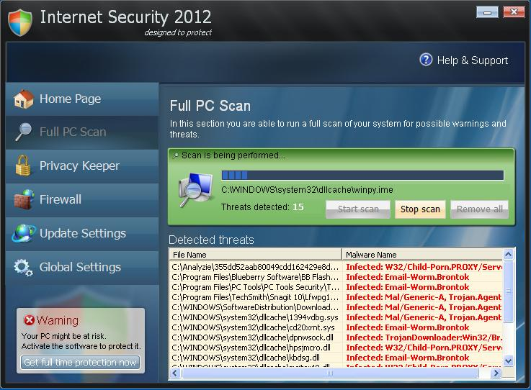

Trojan Horse

Appears to be a good program, but does something nasty instead

Very common in warez (pirated games & apps), keygens, pirated movies, etc.

Rogue antivirus "scareware"

Fake Antivirus

Link Ch 6d

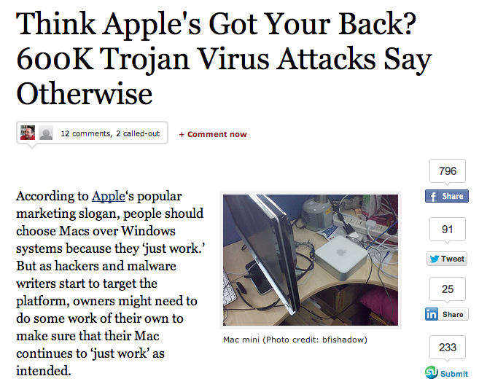

Mac Flashback Trojan

Link Ch 6e

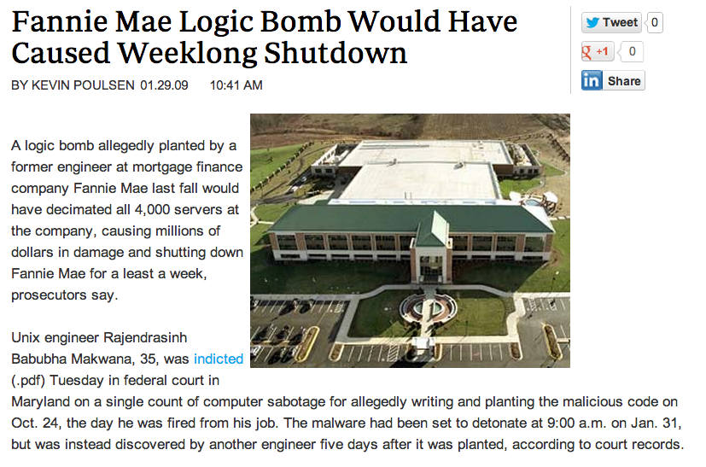
Logic Bombs

Code that waits for some event, like a certain date

Planted by malicious insiders

Then executes payload

May destroy data, etc.

Link Ch 6f

Rootkits

Malware that alters system files

Hides from the user and antivirus

Conceals files, running processes, and network connections

Very difficult to detect and remove

File Integrity Checker

Can detect system file alterations

Records hash values of system files, and detects changes

Included in some HIDS and antivirus

Link Ch 6g
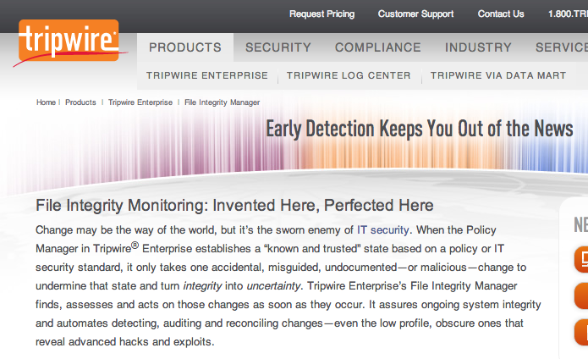

Spam and Spam Filters

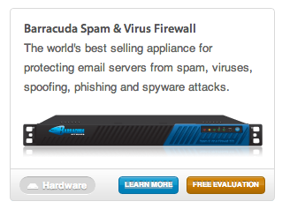
Much spam is malicious

Malicious attachment and links

Spam filters are useful

Network-based spam filters

Link Ch 6h

Spam filters on end-user machines

Spim

Spam over Instant Messaging

Can be reduced by whitelisting in the IM client

Image from wsj.com

Spyware

Reports on user's activity to a remote server

Actions:

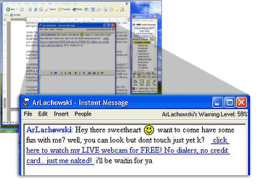
Changing a browser home page

Redirecting browser

Installing browser toolbars

Keylogger to steal passwords

Often included with a Trojan

Link Ch 6i

Adware

Pop-up ads

Annoying, but not malicious

Pop-up blockers in browsers are common

Some software is free, but includes ads

Not illegal

Backdoors

Allow an attacker to access system covertly

Sometimes manufacturers include secret backdoors in devices

Poor security practice

Protection against Malware

Mail servers

Scan email for malicious attachments

All systems

Put antivirus on all workstations and servers

Boundaries or firewalls

Web security gateways block malicious files and sites

Antivirus Software

Detects viruses, Trojans, worms, spyware, rootkits, and adware

But some malware gets past it, especially rootkits

Real-time protection

Checks every file and device accessed

Scheduled and manual scans

Scan the file system

Signature-based Detection

Signature files

Also called data definition files

Contain patterns that match known viruses

Must be updated frequently

When a matching file is detected

It is deleted, or quarantines

Quarantined files can be inspected, but won't do any harm

Heuristic-based Detection

Detects suspicious behavior

Similar to anomaly-based detection in IDS

Runs questionable code in a virtualized environment

Detects "viral activities"

Prone to false positives

Anti-spyware Software

Some overlap with antivirus software

Examples

Ad-Aware

Windows Defender

Spybot—Search and Destroy

Privilege Escalation

Moving from "User" to "Administrator"

Not necessary if user logs in as "Administrator" in Windows XP or earlier versions

User Account Control

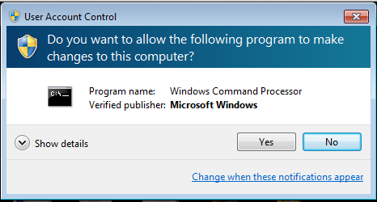
Windows 7's "User Account Control" monitor s privilege escalation attempts and warns the user

Trusted Operating System

Provides multilevel security

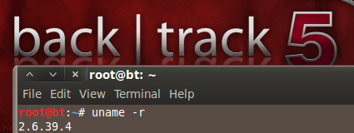
Appropriate for a Mandatory Access Control environment

Security-Enhanced Linux (SELinux)

Created by the NSA

Some features included in Linux kernel v. 2.6

Recognizing Social Engineering Tactics

Social Engineering Methods

Flattery and conning

Assuming a position of authority

Encouraging someone to perform a risky action

Encouraging someone to reveal sensitive information

Impersonating someone authorizes

Tailgating—following others into a secure area

Education and Awareness Training

The single best protection against social engineering

Social Engineering Tactics

Rogueware and Scareware

Tricks users into thinking their system is infected

Phishing

Email looks like real mail from Paypal, mostly

Tricks user into logging in to a fake site

May link to malware

Phishing to Get Money

Nigerian "419" scam

Someone has millions of dollars in Nigeria

Wants to use your bank account to smuggle it to the USA

Lottery scams

"Money Mules"

People who repackage stolen goods and send them to criminals
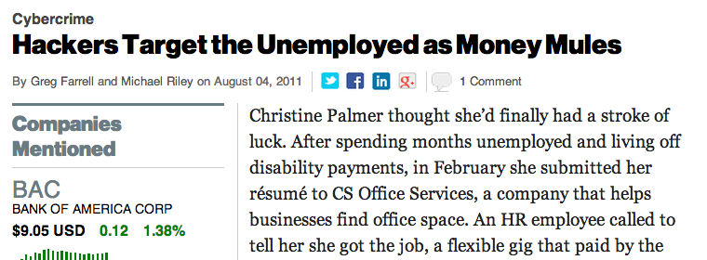

Link Ch 6l

Spear Phishing

Spear phishing

Target a specific set of users with a customized message

One risk caused by database breaches that reveal email addresses

Ex: Email CCSF employees about accreditation and layoffs

Whaling

Targeting high-level executives with phishing attacks

Vishing

Free, untraceable VoIP (Voice over IP) phone calls

Spoof Caller ID

Try to trick target into revealing credit card number, SSN, birthday, etc.

Tailgating

Following another person closely through a door without showing credentials

Also called piggybacking

Can be prevented with mantraps, turnstiles, or security guards

Dumpster Diving

Searching through trash to find useful documents

Company directories

Preapproved credit card applications

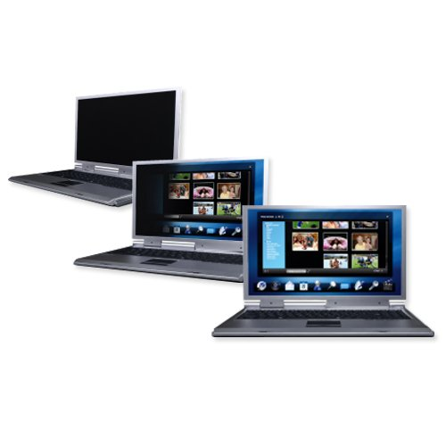
Any Personally Identifiable Information (PII)

Countermeasures

Shredding documents

Burning documents

Impersonation

Wear a uniform

Phone repair technician

Janitor

Etc.

Shoulder Surfing

Looking over a person's shoulder

See passwords typed in

Countermeasure

Privacy screens

Link Ch 6m

Password masking

Passwords appear as dots

Last modified 10-3-12

