Analyzing Attacks

Denial of Service (DoS)

Makes system unavailable to users

D0S is from a single source

DDoS is from many sources

SYN Flood

TCP handshake: SYN, SYN/ACK, ACK

Each SYN sent burdens the server because it has to calculate the SYN/ACK and remember to wait for the ACK

SYN floods are more effective than other packets, such as pings, at DoS

Demo: SYN Flood

Flood Guard Techniques

Defend against SYN floods

Block source IP addresses that send too many SYNs

But attacker can randomize the source IP

Shorten timeout for half-open connection

But you may lose some real users

SYN Cookies

A way to more efficiently process half-open connections

Smurf Attack

Send a PING to a broadcast address, with target's IP in the source field

Target gets many replies for every ping sent

Packet Amplification

Distributed Denial of Service(DDoS)

Many computers attack a target simultaneously

Botnets with thousands of zombies are common

Can be very difficult to stop

"Slashdot effect" can resemble a DDoS, if thousands of real customers visit your page simultaneously

Botnet

Zombie computers are infected with malware

Under control of a bot herder

Command and Control (C&C) server

C&C traffic can be detected in firewall logs

Connections can be seen on a zombie with netstat

IRC (Internet Relay Chat)

An early chat service

Used to control many older botnets

Blocked at many companies now

Botnet Attacks

Download additional malware, such as keyloggers

Launch DDoS attacks

Send spam email

Spoofing

Pretending to be someone else

MAC address spoofing to get onto wireless networks

Smurf attack spoofs source IP

Email sent with spoofed "From" address

XMAS Scan

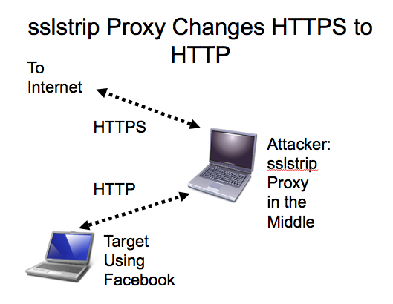
Sends TCP packets with many flags set

Used to identify the server's OS, not to bring it down

Man in the Middle (MITM)

Intercept traffic

"Active eavesdropping"

Can insert malicious code into traffic stream

ARP Poisoning redirects traffic to put the attacker in the middle

Kerberos prevents MITM attacks with mutual authentication and a trusted authentication server (link Ch 7a)

Replay

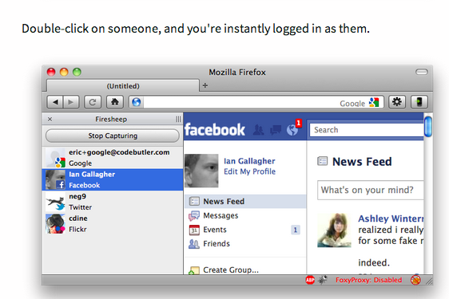
Attacker captures network packets and replays them to impersonate a client

Countermeasures

Kerberos

HTTPS

Secure cookies

Firesheep Replays Cookies

Web Browser Concerns

Malicious add-ons

Cookies

May contain private data

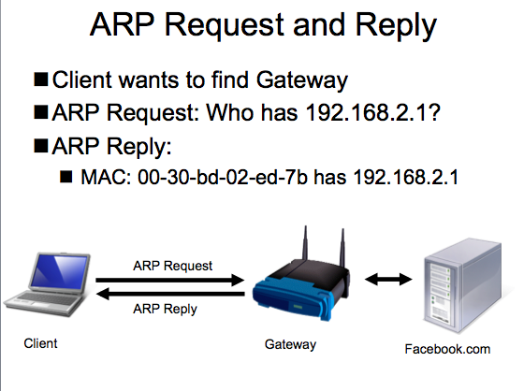
May be used in replay attacks

Session Hijacking

Old version: Inject packets into a TCP session

New version: Replay authentication cookies

Technical name: Cross-Site Request Forgery (CSRF or XSRF)

ARP Request and Reply

Client wants to find Gateway

ARP Request: Who has 192.168.2.1?

ARP Reply:

MAC: 00-30-bd-02-ed-7b has 192.168.2.1

ARP Poisoning

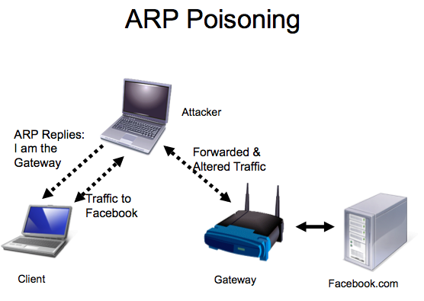
Redirects Traffic at Layer 2

Sends a lot of false ARP packets on the LAN

Can be easily detected

DeCaffienateID by IronGeek

http://k78.sl.pt

ARP Poisoning DoS

Attacker can change MAC address of the gateway to a bogus value

This renders the Internet unavailable

VLAN Segregation

ARP packets are broadcast to the layer 2 subnet only

Broadcasts are not forwarded by routers

They do not cross VLAN boundaries

This limits the range of layer 2 attacks like ARP poisoning

Domain Name Kiting

Domain names are free for 5 days

Criminals register a domain and only use it for a few days before cancelling it

They they "purchase" it again

This way they can use a domain without paying for it

Some domain name registrars now charge immediately to prevent kiting
Securing Applications

Basic Application Hardening Steps

Harden the server itself

Disable unnecessary services

Disable default accounts

Change passwords

Follow vendor guidelines for application

Change default passwords

Disable unnecessary accounts

Eliminate backdoors

Software Development Life Cycle

SDLC models

Waterfall

Spiral

V-Shaped

Rapid Application Model

Software Development Life Cycle Goals

Requirements and design identification

Secure code review

at many stages of development

Testing

Best technique is black-box testing by external experts

"Black box" means they don't know any internal details of the application

Performing Input Validation

Checking data for validity before using it

Never trust anything that came from the user!

Error-handling routines should be friendly and helpful but not disclose too much information

Input Attacks

All these attacks can be prevented with input validation

Buffer overflow

Input too long

SQL injection

Input misinterpreted as code and executed

Cross-site scripting

Input misinterpreted as code and executed

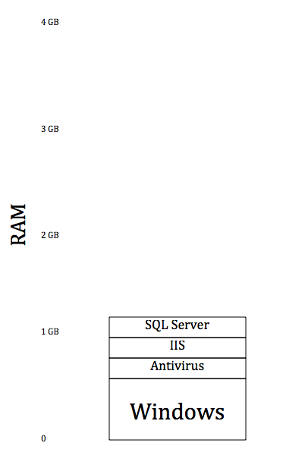
Analyzing Server Attacks

Web Servers

Apache

Most popular Web server

Free, can run on Unix, Linux or Windows

IIS (Internet Information Systems)

Microsoft's Web server

Used by large companies on Windows Servers

nginx

More efficient than Apache, growing in popularity

Buffer Overflows

Application reserves some space for a variable, such as a username of 30 characters

Attacker puts in a longer name, such as 1000 characters

Overwrites memory locations with injected code

Can cause DoS or Remote Execution

NOP Sled

Attacker puts a string of No Operation (NOP) commands before the "egg"

Egg is code that connects back to the attacker for remote control

This makes attacks more likely to succeed, because it's easier to predict where the injected code is

Buffer Overflow Attack

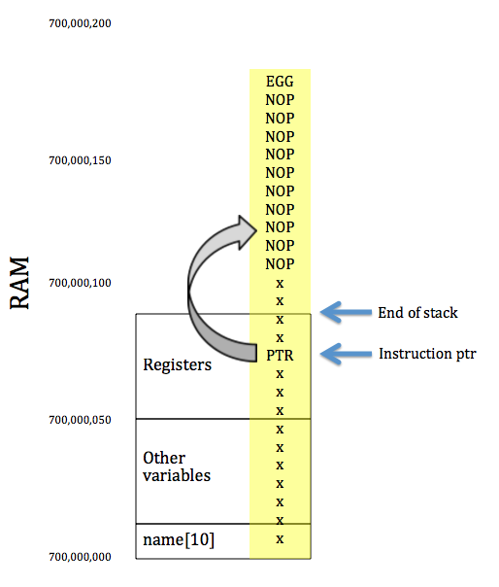

Defenses Against Buffer Overflows
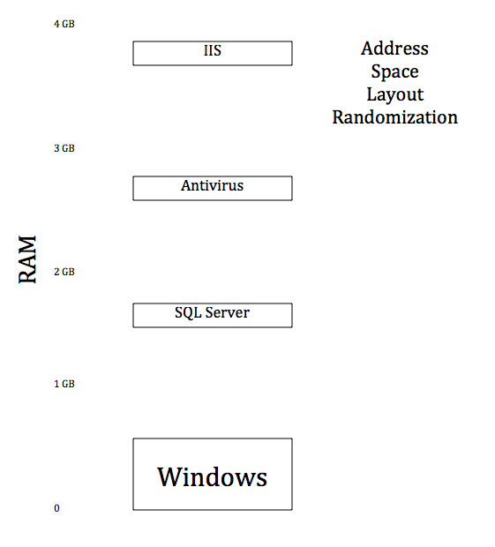

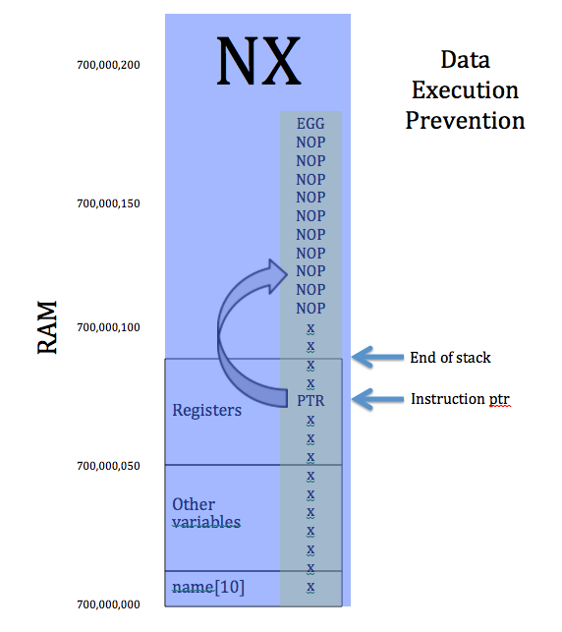

SQL Queries
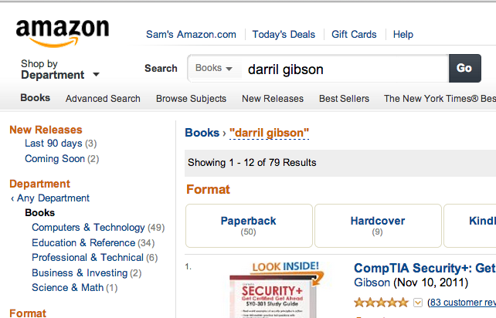

SQL Code

SELECT * From Books where Author = 'Darril Gibson'

* is a wildcard that returns every column in a table

Books is the Table Name

Author is a column name

'Darril Gibson' contains input from the user

SQL Injection

SELECT * From Books where Author = 'darril gibson' OR 'a' = 'a'

Condition is always true

This would dump all the data in the Books table



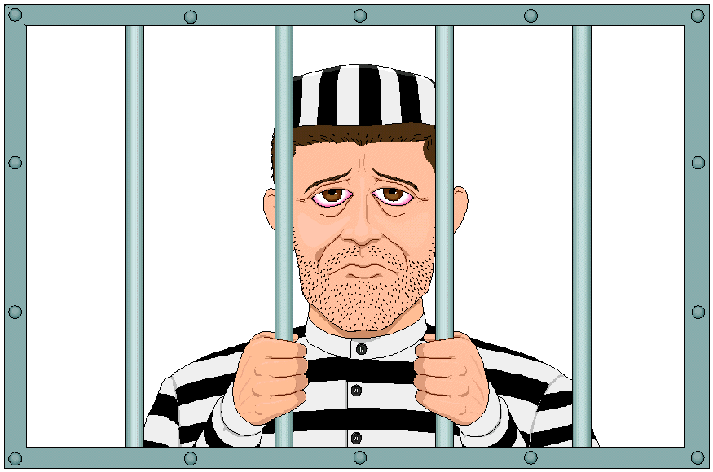
SQL Injection Effects

Expose data

Add or alter data

Delete data

Run shell commands

Gain control of the server

Plant malware on Websites

Be Careful

Don't try SQL injection on real websites

Use safe training tools like WebGoat amd SQLol

Image from http://opinitimoreg.blogspot.com/2012/08/civil-society-does-not-agree-that-ex.html

Protecting Against SQL Injection Attacks

Input Validation

Blacklisting: Remove characters like ' and "

Not very effective

Whitelisting: Allow only "safe" characters

Better but still not the best defenst

Parameterized Queries (also called "Stored Procedures")

Data is treated separately from code

No data can be executed

This is the safest technique

XML Injection

Many databases use XML (eXtensible Markup Language) to input or export data

XML is plaintext, with data tags like HTML

<name>Joe Green</name>

XPath is a query language for XML

XML Injection is similar to SQL Injection
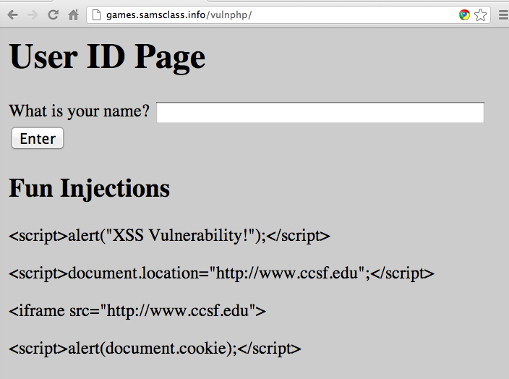

Cross-Site Scripting (XSS)

Cross-Site Scripting

Code from one site runs on another site

Possible Effects

Read cookies from other browser tabs

Take action on other tabs, like making purchases or Facebook posts

Add malware to page

Redirect page

XSS Countermeasures

One common type of XSS embeds the attack in a link and emails it to victims

Not clicking on suspicious links can prevent the attack

Best solution is for the website designer to validate input

Replace < with &lt;, and so on for other symbols

Cross-Site Request Forgery (XSRF)

Attack tricks user into performing a action on a website, when they click a URL like this

http://facebook.com?add_friend=hacker

Can take an action on any site where the user is already logged in

Gmail, Facebook, Twitter, Amazon, etc.

XSRF Countermeasures

Users can avoid clicking on phishy links

Developers can help by making users authenticate before risky actions, or by making sessions expire quickly

Directory Traversal

http://samsclass.info/125/proj11/../../

Is the same as http://samsclass.info/

Because ../goes UP a directory

At vulnerable sites, you can exit the Web page directory and reveal the file system

http://samsclass.info/../../../etc/passwd

Would reveal user names

Command Injection

If an attacker can traverse to executable files, they can be executed from the browser's URL bar

http://samsclass.info/../../../windows/system32/cmd.exe?c+dir+c:\

Displays a directory in the browser

Countermeasure: input validation, use of directory permissions

LDAP Injection

Lightqeight Directory Access Protocol is used in Windows domains

LDAP injection allows an attacker to query and modify information in Active Directory

Fuzzing

Sending random data to a program

If it crashes, that indicates a DoS vulnerability

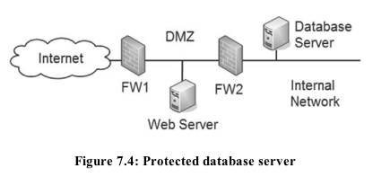
Analyzing the crash may result in a remote code execution vulnerability as well

Database Servers

Internet users can't connect directly to the database server

But SQL injections may still go through, the same way normal SQL queries do

Web Application Firewalls are designed to protect such systems, but they are not very strong

Transitive Access and Client-side Attacks

Database server trusts the Web server and answers its queries

Attacker needs to use the Web server to attack the database server

This is called transitive access

Email Servers

SMTP used to send mail

POP3 and IMAP used to retrieve email to client applications like Outlook

Spam filtering helps remove malicious emails

Open SMTP Relays are servers that attackers can use to send spam

Most SMTP servers require authentication now

DNS Servers

Resolve domain names like www.ccsf.edu to IP addresses like 147.144.1.212

Results are held in a cache for a few minutes on each client

Reverse DNS finds domain names from IP addresses

Sometimes used to block spam, making sure the IP address matches the "From" email address

DNS Attacks

DNS Cache Poisoning

Like ARP poisoning, tricks the target machine into resolving domain names to incorrect IP addresses

Pharming

Changing the hosts file to redirect traffic to a spoofed website

DNS Cache Snooping

Can find out what sites people have been visiting

Last modified 10-7-12

