Designing Redundancy

Redundancy

Duplication of systems to provide availability

Fault Tolerant

Prevents a fault from leading to a failure

Fault

A device stops working

Failure

Users stop receiving service

Examples of Redundant Systems

Disk redundancy: RAID (Redundant Array of Independent Disks)

Server redundancy: Failover cluster

Power redundancy: Add generator or UPS

Site redundancy: Add hot, cold, or warm sites

Single Point of Failure

A single component which can cause a failure

Examples

Disk: a server with a single disk drive instead of a RAID

Server: a standalone server instead of a cluster

Power: Relying only on the power grid without UPS or generator

RAID Types

RAID-0 (Striping)

Increases speed, but provides no fault tolerance

RAID-1 (Mirroring)

Two disks with identical data

Fault tolerant, but disk controller use a single point of failure

RAID-1 with two disk controllers is called disk duplexing

RAID Types

RAID-5

Three or more disks

"Parity" data stored on some of the stripes

If one drive fails, the "Parity" data can be used to recover the data

If two or more drives fail, data is lost

RAID-10

Combines Mirroring (RAID-1) and Striping (RAID-0)

Software vs. Hardware RAID

Hardware RAID

Better performance

Removes load from the operating system

Often "hot swappable" – replace a disk with zero downtime

Software RAID

Implemented in software by the operating system

Rarely used

Server Redundancy

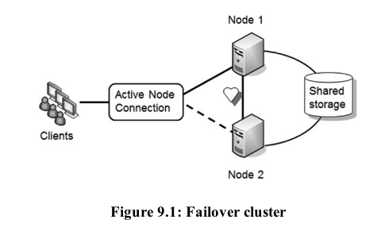
99.999% uptime (five nines) means 5 minutes/year downtime

Failover clusters

Two or more servers

One or more are active

One or more are inactive

When active node fails, inactive nodes take over

Two networks

Heartbeat goes through internal network

Load Balancers

Distributes traffic to a cluster of servers

Scalability and high availability

Load Balancers

Scalability

Allows the cluster to easily expand to handle more clients as the business grows

Round-robin

Sends clients to servers in order, one per server

Load balancer detects when a server fails

Sends clients to the other servers

Power Redundancies

UPS (Uninterruptible Power Supply)

Contains batteries

Provides power for a specified duration if main power fails, often 10-15 min.

Can also protect devices from power surges and spikes

Generators

Provide longer-term power during extended power outages

UPS Purpose

UPS provides a few minutes of power, so the server can:

Shut down cleanly

Wait while generators are started

Wait for commercial power to return

Generators

Diesel generators are common

Takes some time to start up

Power takes some time to stabilize
Protecting Data with Backups

Backups

Extra copies of data

Off-site storage

Allow recovery after a data loss

Usually due to human error

Fault tolerance is NOT the same as backup

Only availability

If you accidentally delete a file, a RAID doesn't save you

Backup Types

Usually on tape or removable hard disks

Full backup

Complete copy of all the data

Differential backup

Backs up data that has changed since the last full backup

Incremental backup

Backs up data that has changed since the last full or incremental backup

Backup Comparison

Full backup

Most expensive: uses the most time and tape

Easiest to restore data

Differential backup

Cheaper and faster

Requires two tapes to restore data

Incremental Backup

Cheapest and fastest

May require several tapes to restore data

Testing Backups

Restore some data

Regular tests are essential

Otherwise backup procedures can fail and remain unnoticed for a long time

Symform

Donate space on your servers to the system

Store your data on other members' servers

It's like a RAID with 96 disks; 32 of them are parity

BUT: I suspect they have a single point of failure at AWS

Protecting Backups

Protect backups at the same level as the original data

Storage

Clear labeling

Physical security

Transfer

Protected from physical theft or loss

Destruction

Wipe or physically destroy media

Backup Policies

Which data to backup

Off-site storage of backups

In case of fire or flood

Label media

Testing

Retention requirements

Execution and frequency of backups

Protection of backups

Disposing of media

Comparing Business Continuity Elements

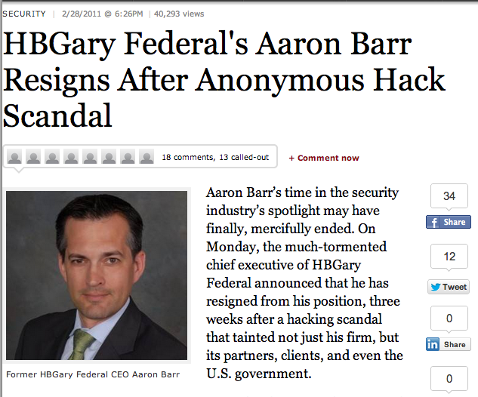
Business Continuity Plan

Ensures that critical business functions will continue even after a disaster

May include temporary measures, like alternate locations

Includes Disaster Recovery Plan

Complete restoration of original location to service

Disasters

Fire

Flood

Power outage

Data loss

Hardware and software failures

War or terrorist attack

Business Continuity Planning Steps

Complete Business Impact Analysis (BIA)

Develop recovery strategies

Develop recovery plans

Test recovery plans

Update plans

Business Impact Analysis

Identify critical functions and services

Recovery Time Objectives

How long till systems are recovered

Recovery Point Objective

How much recent work will need to be repeated

BIA doesn't specify solutions

Issues Addressed by BIA

What assets are included in recovery plans?

What business functions must continue to operate?

Are alternate sites required?

What data should be backed up?

Are backup utilities needed (water, gas, etc.)?

MTBF & MTTR

Mean Time Between Failures

Measures the reliability of a system

Some hard drives claim 300,000 hours MTBF

Mean Time to Restore

Maintenance contract will specify time to repair or restore item

Continuity of Operations Plan (COOP)

Part of a BCP (Business Continuity Plan)

Focuses on restoring critical business functions at an alternate site

Hot site

Cold site

Warm site

Video: AT&T's Disaster Recovery Team

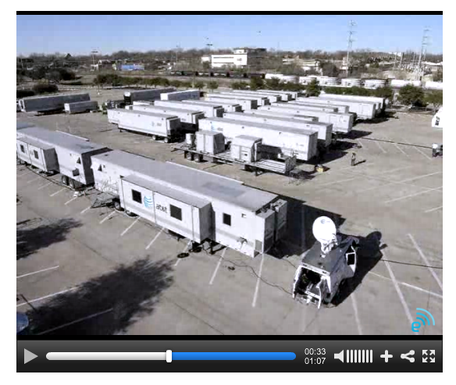
Link Ch 9c

Hot Site

Equipment installed and running already

Copies of backup tapes already there or nearby

Often another company location

Fastest recovery time—typically one hour

Most expensive

Cold Site

Location with power and connectivity

When it is used, company must bring in equipment, software, and data

Cheapest to maintain

Most difficult to test

Slow—takes days to set up

Warm Site

Compromise between hot site and cold site

Example: equipment installed but data is out of date

Mobile and Mirrored Sites

Mobile site

Self-contained transportable site

In a truck or other vehicle

Mirrored site

Identical to primary location

Gets immediate copy of all data

Always up and operational

Provides uninterrupted service in case of failure at primary location

After the Disaster

Return all business functions to the primary site

Move least critical functions first

Disaster Recovery Plan (DRP)

BCP may include several DRPs

Specify plans to recover servers

Recovery steps for different types of disasters, such as hurricanes or tornadoes

Hierarchical list of critical systems

Prioritize systems to restore after an outage

Disaster Recovery Phases

Activation

Implement contingencies

Recovery

Testing recovered systems

Documentation and review

IT Contingency Planning

Focused on recovery for IT (Information Technology) systems only

BCP looks at entire organization

Succession Planning

Non-disaster sense: Identifying people who can fill key leadership positions

Business continuity and disaster preparedness

Defines hierarchical chain of command

Who can make decisions if some personnel, such as the CEO, are unavailable

BCP and DRP Testing

Desktop or tabletop exercise

Participants talk through a scenario

Simulation

Participants go through recovery steps

Does not affect actual systems

Full-blown test

Goes through all the steps

Determines the amount of time required

Elements of Testing

Server restoration

Server redundancy

Alternate sites

Backups
Environmental Controls

Fire Suppression

A fire requires four components

Heat

Oxygen

Fuel

Chain reaction creating the fire

Fire Suppression Methods

Remove the heat

With water or chemical agents

Remove the oxygen

Displacing it with CO2 or another gas

Common for electrical fires, especially server rooms

Remove the fuel (not an option, usually)

Disrupt the chain reaction

Some chemicals work this way

Classes of Fires and Fire Extinguishers

Class A

Ordinary combustibles

Wood, paper, cloth, trash, rubber, plastics

Class B

Flammable liquids

Gasoline, propane, solvents, paint,…

Classes of Fires and Fire Extinguishers

Class C

Electrical equipment

Computers, wiring, motors, etc.

Don't use water on a class C fire because it conducts electricity and may shock personnel

Class D

Combustible metals like magnesium and sodium

Much more difficult to extinguish

Heating, Ventilation, and Air Conditioning (HVAC)

Cooling computers makes them more available

It is traditional to chill server rooms with powerful air conditioners

Employees need to wear sweaters

Google saves power by running servers much hotter

Link Ch 9d
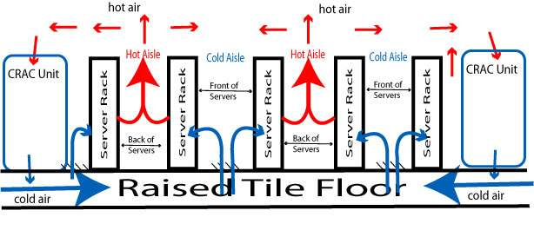

Image from nih.gov

Humidity

High humidity

Condensation on equipment

Water damage to computers

Low humidity

Higher incidence of electrostatic discharge

Recommended humidity: 45% - 55%

Link Ch 9e

HVAC and Fire

HVAC systems often integrated with fire alarms

Controls airflow to help prevent rapid spread of a fire

May turn off HVAC when a fire is detected

Failsafe/secure vs. Failopen

Failsafe, Fail secure, Fail closed

All mean the same thing

System becomes unavailable when it fails

Failopen

System becomes available when it fails

Example: Card reader locks on doors often fail open when power fails

So employees aren't trapped inside

Availability and Failopen

Failopen

If availability is more important than preventing unauthorized use

Fail closed

If loss of availability is acceptable to prevent unauthorized use

Example: a firewall on a system with sensitive data

Shielding

To prevent EMI (Electromagnetic Interference) and RFI (Radio Frequency Interference)

Also prevents unwanted emissions which can leak data

Shielded cables reduce this problem

Fiber-optic cables are immune
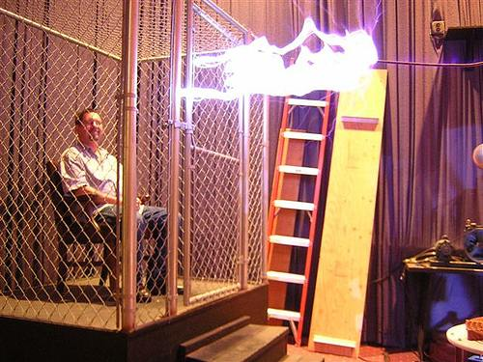

Faraday Cage

image from digitaltrends.com

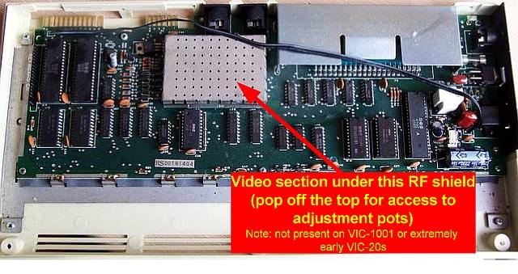

RF Shield

From sleepingelephant.com

TEMPEST

US Gov't program

Measures emanations from devices

A serious security threat

Last modified 10-22-12

