Introducing Cryptography Concepts

Integrity

Assures that data has not been modified

Hash is a number calculated from data

If the data is unchanged, the hash is unchanged

Common hash algorithms

MD5, SHA, HMAC

MD5 is 128 bits

SHA-1 is 256 bits

Concepts

Confidentiality

Ensures that only authorized users can view data

Encryption

Ciphers data to make it unreadable if intercepted

Includes algorithm and key

Symmetric and Asymmetric Encryption

Symmetric encryption

Uses same key to encrypt and decrypt data

Asymmetric encryption

Uses two keys: public and private

Data encrypted with the public key can only be decrypted with the private key

Data encrypted with the private key can only be decrypted with the public key

Concepts

Authentication

Validates an identity

Non-repudiation

Prevents a party from denying an action

Digital signature

Provides authentication, non-repudiation, and integrity

Hash of a message, encrypted with sender's private key

Anyone can verify it with the sender's public key
Providing Integrity with Hashing

MD5

Message Digest 5

128 bits

Commonly used to verify disk files, downloads, etc.

Not very secure—hash collisions can be found fairly easily

Collisions

Two different files with the same hash

SHA

Secure Hash Algorithm (SHA)

SHA-0 (not used)

SHA-1

160 bits long, very common

No collisions found yet, but they are now within reach of well-funded attackers

Should require 2^80 calculations to find a collision, but an attack has been found that requires only 2^52

Link Ch 10b, 10c

SHA-2 and SHA-3

SHA-2

Stronger than SHA-1

Four versions: SHA-224, SHA-256, SHA-384 and SHA-512

SHA-3

Approved in Oct. 2012

Even stronger

Link Ch 10d
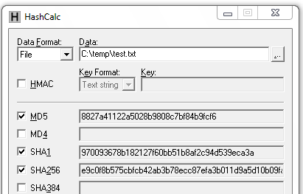

HMAC

Hash-based Message Authentication Code

Hash the message

Then encrypt the hash with a shared secret key

Provides integrity and authenticity

Example: HMAC-MD5

Hashing Files

md5sum

Hashcalc

FileAlyzer

Hashing on PC & Mac

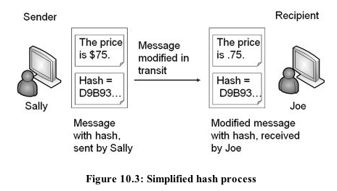
Hashing Provides Integrity

Using HMAC

A MITM attacker could change the "correct" hash value to fool the recipient

The general solutions for such MITM attacks are

A trusted third party

A shared secret

HMAC uses a shared secret key for this reason

RIPEMD Hash Algorithm

RACE Integrity Primitives Evaluation Message Digest

Patent-free, came from open academic community

NSA designed SHA-1 & SHA-2

Original RIPEMD was based on MD4 and has known collisions

RIPEMD-160, 256, and 320 are improved versions

Considered similar to SHA-1 in security, but less used

Link Ch 10g

LANMAN Password Hashes

Used in Microsoft Windows through Windows XP to hash passwords

Very old and weak, easily cracked with rainbow tables

Too insecure to be trusted

Should be disabled in Local Security Policy on Windows XP or earlier systems

Disabling LANMAN Hashes

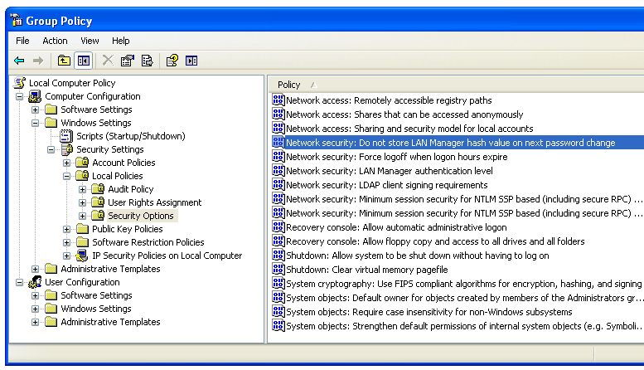
Link Ch 10h

LANMAN Algorithm

Password: Xydke23498Qq

Break into 7-character fields

Change letters to UPPERCASE

XYDKE23 498QQ

Hash each field separately, using DES

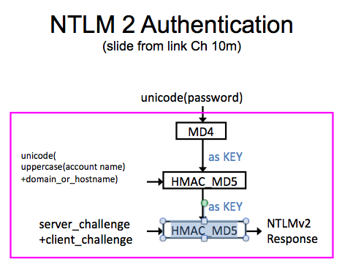
Link Ch 10i

NTLM Password Hashes

Microsoft's replacement for LANMAN

NTLMv1 uses MD4

Considered compromised

Still used for logon passwords

See project 5x in CNIT 124

NTLMv2 uses MD5

More secure, used for network authentication

Links Ch 10j, 10k, 10l

NTLMv2 in Windows XP

NTLM 2 Authentication
(slide from link Ch 10m)

NTLMv2 in Windows Versions

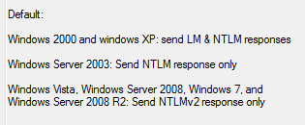
From the Windows 7 Local Security Policy setting's "Explain" tab

Providing Confidentiality with Encryption

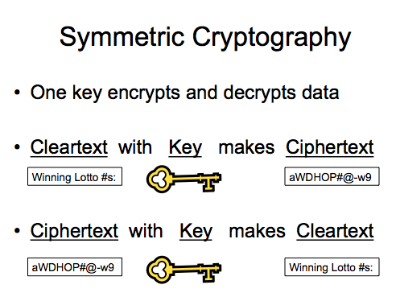
Symmetric and Asymmetric Encryption

Encryption turns plaintext into unreadable ciphertext

Symmetric encryption uses the same key for encryption and decryption

Asymmetric encryption uses two keys

A public key and a private key
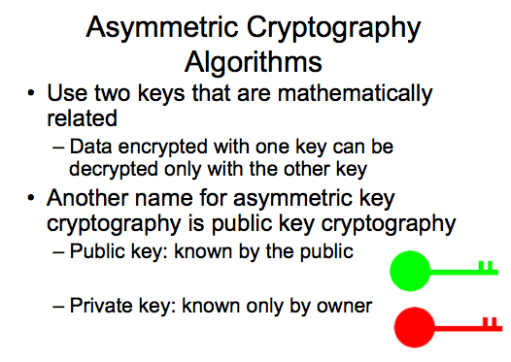

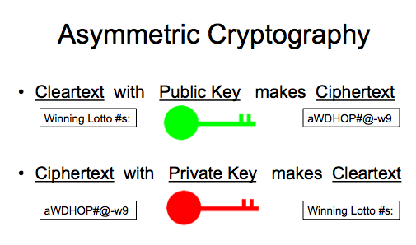
Algorithm and Key

Algorithm

The mathematical steps used for encryption and decryption

Key

A number used to perform encryption and decryption, usually a long random number

Symmetric is Faster

Symmetric encryption is much faster to perform than asymmetric encryption

Symmetric encryption keys are much shorter

128 or 256 bits is enough for excellent security

Asymmetric encryption key length

1024-bit keys are no longer recommended

2048-bit is the minimum acceptable key length
Symmetric Encryption

Block v. Stream Cipher
(both symmetric)

Block cipher

Encrypts groups of bits together

Typically blocks of 64 or 128 bits

AES uses 128-bit blocks, which is safer

Link Ch 10o

Stream cipher

Encrypts each bit individually

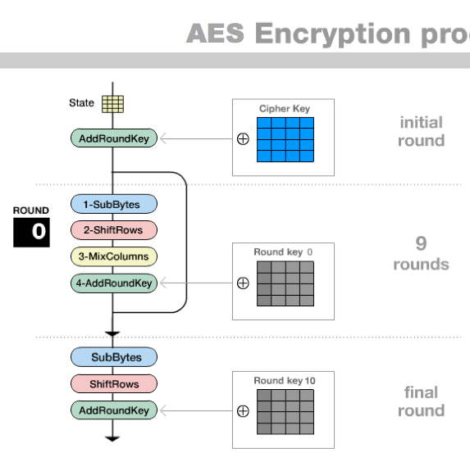
WEP uses RC4 stream cipher

Symmetric Encryption is Like a Door Key

Every person who needs a key gets an identical copy

Same key used to lock the door and open it

AES

Strong symmetric block cipher

NIST recommends it

Different key sizes

AES-128

AES-196

AES-256

All are apparently unbreakable at present

AES Advantages

Fast to compute

Efficient, even on small devices

Strong

Pretty animation at Link Ch 10p

DES (Data Encryption Standard)

Recommended by NIST even though it was not secure

56-bit key length

Subject to brute force attack

Try all 2^56 keys

Data Encryption Standard (DES) (continued)

In 1988, NSA thought the standard was at risk to be broken

In 1997, a DES key was broken in 3 months

In 1998, the EFF built a a computer system that cracked a DES key in 3 days

Link Ch 10q

3DES

Performing DES three times makes it stronger

Using 2 or 3 56-bit keys

Less efficient than AES

Secure enough to use—effective key strength of 112 bits

RC4

Strong symmetric stream cipher

Used in WEP

But it was not the weak point that broke WEP

SSL uses RC4

Therefore, so does HTTPS

One-Time Pad

A printed list of random numbers

Effectively a very long shared-secret key

Each part of the key is used only once

Considered unbreakable

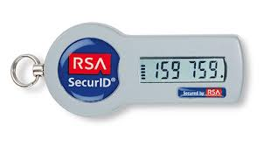
Key must be random

Key must be as long as the message

Key is never re-used

RSA Tokens

These things SHOULD be one-time pads

They aren't—RSA held some sort of master key and got hacked in 2011, compromising their security

Link Ch 10r

Blowfish

Strong symmetric block cipher

Designed by Bruce Schneier
Asymmetric Encryption

Key Pairs

Every user of asymmetric encryption must generate a key pair

Public key

Shared with the world

Private key

Kept secret

The two keys are mathematically related

There is no practical way to find the private key from the public key

Key Use

Data encrypted with the public key must be decrypted with the private key

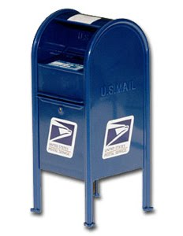
Data encrypted with the private key must be decrypted with the public key

Private keys are kept secret and never shared

Public keys are distributed widely, in certificates or key servers

Symmetric Keys

Asymmetric encryption is strong, but resource intensive

It's too slow to encrypt all traffic

Instead, it's used to share a symmetric key which is then used to encrypt data

Protocols Using Asymmetric Encryption

SSL and TLS (therefore HTTPS)

RSA and Diffie-Hellman

S/MIME and PGP/GPG

Elliptic curve cryptography

ElGamal

Rayburn Box (fiction)

A box to transfer secret documents

Uses two types of physical keys

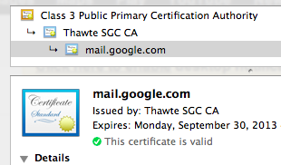
The private key opens the box, and there is only one copy of it

The public key has many copies, and can lock the box but not unlock it

Mailbox

Anyone can put mail in

Only the mail handler with the secret key can take the mail out

Certificates

Certificate is like a digital ID card

It has the name of the owner and a public key

Issued by Certificate Authorities (CAs)
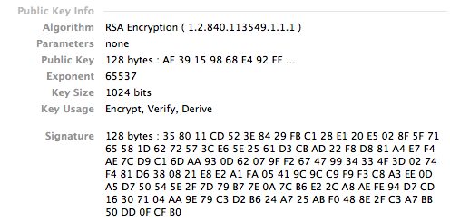

Certificate Uses

Encryption

Authentication

Digital signatures

NIST Recommended Key Sizes

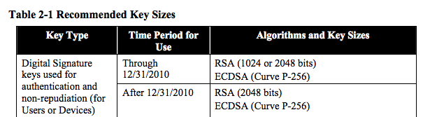
From Dec. 2009 (Link Ch 10s)

RSA

A cryptography system invented by Rivest, Shamir, and Adelman

The standard used on the Internet for HTTPS

Uses prime numbers

Private key is a long prime number

Public key is the product of two long prime numbers

Considered very secure


Diffie-Hellman

Not an encryption system

A key exchange algorithm to share a private key between two parties

Had been a military secret, but it was independently re-invented by civilian mathematicians

The basis for public-key cryptography

Moxie Marlinspike and Whitfield Diffie at Defcon 19

Elliptic Curve Cryptography (ECC)

Uses elliptic curves instead of prime numbers to calculate keys

Faster and more efficient than RSA

Used on small wireless devices

Approved by NIST in 2005

Steganography

The process of hiding data in plain view in pictures, graphics, or text

Example: changing colors slightly to encode individual bits in an image

The image on the left contains the image on the right hidden in it (link Ch 10t)

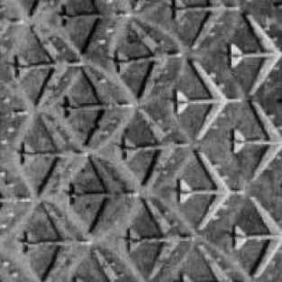

Spam Mimic Link Ch 10u

Steganography

Steganography hides the existence of a message

No one even knows you sent a message at all

This is one type of covert channel

A way to send messages without others even knowing you sent anything

Quantum Cryptography

Send a secret key one photon at a time

A photon can only be measured once

Because measuring it destroys it

So if the key gets to the recipient undamaged, that proves no one else snooped on it

Commercial Quantum Cryptography Devices

$82,000 for a pair of devices

Links Ch 10v, Ch 10w

SSL (Secure Sockets Layer)

Created by Netscape

Used to secure several higher-level protocols

HTTPS

FTPS

SSL uses certificates for authentication, asymmetric cryptography, and symmetric cryptography

TLS (Transport Layer Security)

Created by the IETF to standardize improvements in SSL

Replaces SSL

Protected EAP (PEAP) uses TLS
(PEAP-TLS) to encrypt authentication

TLS requires certificates and CAs

IPsec

Can be used for point-to-point VPNs

L2TP/IPsec is used for one-to-many VPNs

AH (Authentication Header) provides authentication and integrity

ESP (Encapsulating Security Payload) provides confidentiality, integrity, and authentication

AH uses protocol ID 51 and ESP uses protocol ID 50

SSH (Secure Shell)

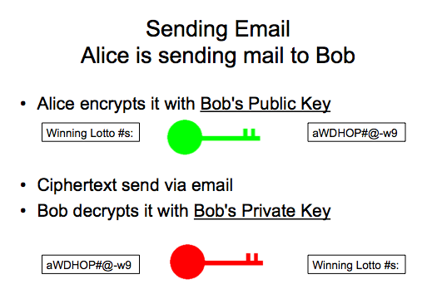
SSH encrypts Telnet traffic

SCP (Secure Copy)

Copies files over SSH

SFTP

Secures FTP

SSH uses port 22

HTTPS

Sends HTTP traffic over SSL ot TLS

Uses port 443

Bob decrypts it with Bob's Private Key

HTTPS Websites

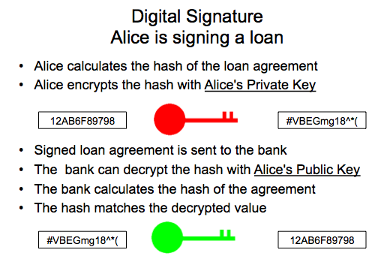
When you connect, the server sends your browser a certificate containing its public key

Your browser creates a public-private key pair, and sends the public key to the server

Asymetric encryption is used to transmit a session key which is used for symmetric encryption of the session

Signing Email with Digital Signatures

Digital signatures provide

Authentication

Only holder of the private key could create the signature

Non-repudiation

The sender cannot later deny sending the message

Integrity

The hash value ensures that the message has not been altered

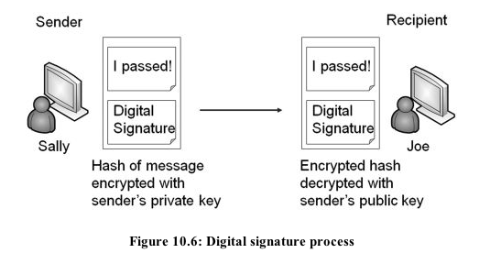
Process at Email Sender

Sender's email application:

Hashes the message

Uses sender's private key to encrypt the hash

Sends these items to the recipient

Unencrypted message

Encrypted hash

Process at Email Receiver

Receiver's email application:

Retrieves the sender's public key, from a certificate or keyserver

Decrypts the encrypted hash with the sender's public key

Hashes the message

Compares the decrypted hash to the calculated hash

If they match, the message has authentication, non-repudiation, and integrity

Encrypted Email

You can also encrypt the body of the message

If you need confidentiality

This can be done with asymmetric or symmetric encryption

S/MIME

Secure/Multipurpose Internet Mail Extensions (S/MIME)

A popular standard used to sign and encrypt email

Uses RSA for asymmetric encryption

And AES for symmetric encryption

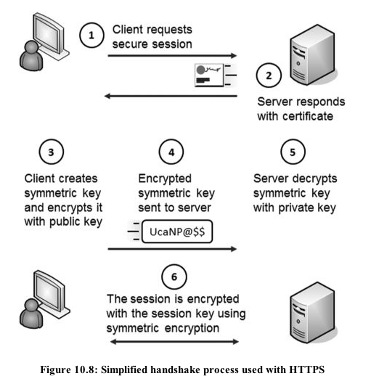
Requires CAs and a PKI (Public Key Infrastructure) to distribute and manage certificates

PGP/GPG

Pretty Good Privacy (PGP)

A commercial encryption system developed by Phil Zimmerman

GNU Privacy Guard (GPG)

Free open-source replacement for PGP

Uses RSA asymmetric encryption and symmetric encryption

Usually with CAs

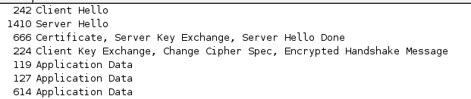

Capturing SSL Handshake with Wireshark

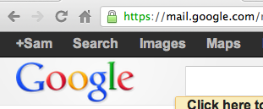
How to Recognize Secure Sites

Padlock icon (not always present)

https:// at start of URL (not always visible)

Exploring PKI Components

Public Key Infrastructure (PKI)

Technologies for digital certificates

Create

Manage

Store

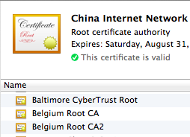
Distribute

Revoke

With PKI, two people or entities can communicate securely without knowing one another previously

Certificate Authority (CA)

Public CAs are trusted by browsers

They issue digital certificates, which act as online ID cards

CAs must be trusted, or the system will fail

Trusted Root Certification Authorities

Link Ch 10x
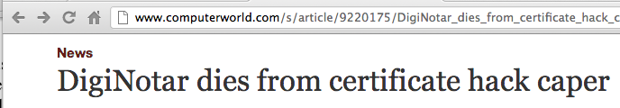

Link Ch 10x1

Trust Models

Hierarchical

Most common trust model

Public CA creates the root CA

Large CAs also create Child CAs

Trust chain

Root CA issues certificates to Intermediate CAs

Intermediate CAs issue certificates to Child CAs

Child CAs issue certificates to end users

Chain of Trust

PGP and GPG can use a "Chain of Trust"

You sign public keys of your friends

This avoids the cost of Certificate Authorities (CAs)

An old traditional system

Not used for e-commerce

Chain of Trust Problem

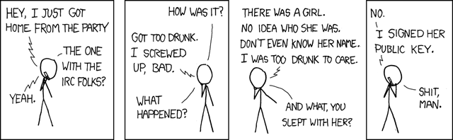
Do you really trust a friend of a friend?

How about a friend of a friend of a friend?

http://xkcd.com/364

Self-signed Certificates

You can create a CA and use self-signed certificates

It saves money, but no one will trust your CA

Except your own employees, with your CA added to the "Trusted Root CA" list

Unacceptable for e-commerce

Registration

Purchase a certificate from a CA

Register it with your website

In large organizations, these tasks are separated

Registration Authority (RA)

Certificate Authority (CA)

Revoking Certificates

Reasons

Key compromise

CA conpromise

Change of affiliation

Superseded

Cease of operation

Certificate hold

Certificate Revocation List

Published by each CA

Validating Certificates

Clients check with CA each time they get a certificate

The CA is the Trusted Third Party

Check to see that certificate is not revoked

Two ways

CRL

OSCP (Online Certificate Status Protocol)

Google's New System

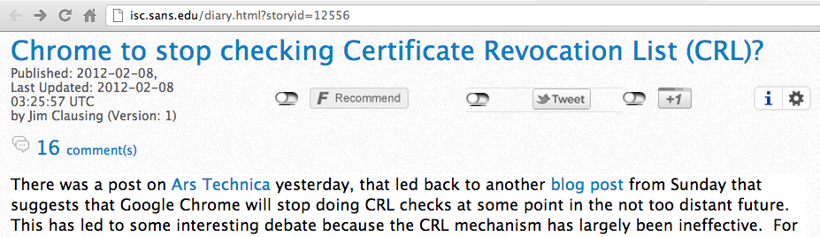
Link Ch 10y

Key Escrow

Placing a copy of a private key in a safe environment

Prevents data loss from a lost private key

Recovery Agent

A designated person who can recover or restore cryptographic keys

Microsoft BitLocker supports a recovery agent with a second key that works

Last modified 11-6-12

