Exploring Security Policies

Security Policies

Written documents

Created as an early step to mitigate risks

Brief, high-level statements that identify goals

Guidelines and Procedures are created later to support the policies

They provide details

Security controls enforce the requirements of a security policy

Guidelines, Procedures, and Controls

Guidelines and Procedures are created later to support the policies

They provide details

Security controls enforce the requirements of a security policy

Such as firewalls that block BitTorrent

Common Security Policy Elements

Clean desk policy

Account management policies

Change management policy

Portable device policies

Personnel policies

Data policies

Clean Desk Policy

Keep desks organized and free of papers

Prevents data theft or inadvertent disclosure of information

Also presents a positive, professional image

Items Left on a Desk

Keys

Cell phones

Access cards

Sensitive papers

Logged-in computer

Printouts left in printer

Passwords on sticky notes

File cabinets left open or unlocked

Personal items such as mail with PII

Account Management Policies

User privilege policy

Least privilege: users have only the rights and permissions needed to do their jobs

In Discretionary Access Control systems, like Windows workgroups, users own their files

Role-Based Access Control is better at companies, such as Windows domains

User Rights and Permissions Review

An audit to ensure

Policy is being followed

Users don't have more privileges than they need

Inactive accounts are disabled or deleted

Require Administrators to Use Two Accounts

One account for regular work, with limited privileges

Elevated account only for administrative work

This protects against the "Pass the Hash" and other privilege escalation attacks (Link Ch 11a)

Or the simpler problem of an administrator accidentally leaving a workstation logged in

Account Disablement Policy

Disable accounts

For ex-employees

Employees on leave of absence

Often part of the normal exit process, such as during the exit interview

Employees who leave without normal process may be overlooked

Account expiration may limit exposure

Change Management Policy

Ensures that changes in IT systems don't cause unintended outages

Provides an accounting structure to document changes

Includes patch management

Change Management Process

Change request

Review of request

Approval

Technician implements change

Every step is documented

Plan for reversal of change if necessary

Portable Device Policies

USB devices

Can carry malware in

Can carry confidential data out

Often prohibited

MP3 players, iPads, phones can all be used the same way

Phones can be used as bugs, recording audio and video

Some companies prohibit mobile phones in high-security areas

Personnel Policies

Acceptable use

Mandatory vacations

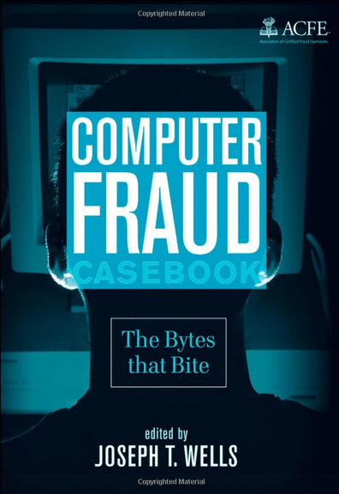
Separation of duties

Job rotation

Acceptable Use

Defines proper system usage

Includes definitions and examples of unacceptable use

Personal shopping on company computers

Web browsing

Users must agree to the policy

Sometimes a written document they sign

Sometimes a logon banner or email

Mandatory Vacations

Help detects fraud or embezzlement

Often used for financial workers

Good for administrators too

Good examples in the Computer Fraud Casebook

Link Ch 11b

Separation of Duties

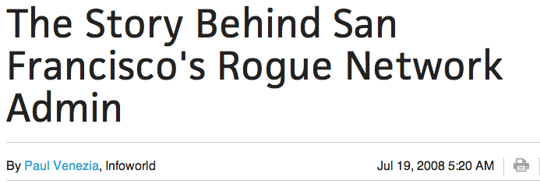
Prevents any one person from completing all the steps of a critical or sensitive process

Prevents fraud, theft, and errors

Accounting is designed this way
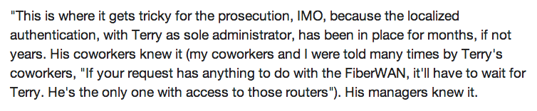

IT systems need this protection too

The "all-powerful administrator" violates this principle

Link Ch 11c

Job Rotation

Employees rotate through different jobs

They learn the processes and procedures for each job

Helps expose dangerous shortcuts or fraudulent activity

No one person can retain control of any process or data

Security Awareness and Training

Minimizes risk posed by users

Helps reinforce user compliance with policies

Risks of USB drives

Awareness and training plan needs support from senior management

Refresher training required periodically

Training Topics

Security policy contents

Acceptable use and user responsibilities

Protection of PII

Data labeling, handling, and disposal

Laws, best practices, and standards

Threat awareness

Risky user habits like sharing passwords and tailgating

Social networks and file-sharing

Data Policies

Companies must protect private data

Research & Development

Customer databases

Proprietary information on products

Data Policies

Types of Data Policies

Information classification

Data labeling and handling

Storage and retention

PII (Personally Identifiable Information)

Privacy policy for websites

Social networking

P2P

Information Classification

Identify, classify, and label data

Gov't

Top Secret, Secret, Confidential, Unclassified

Companies

Proprietary, Private, Classified, Public

Data Labeling and Handling

Label media such as backup tapes

File labels

Properties, headers, footers, watermarks

Prevents accidental disclosure of confidential data during talks, etc.

Backups need labeling and careful handling

eDisclaimers

A missing e-disclaimer nearly cost Google billions of dollars

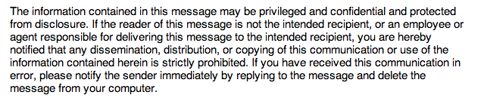
Example disclaimer from link Ch 11d

Storage and Retention

Examples

Users must store all data on servers instead of workstations

Email will be retained for only one year

Laws may require longer retention

PII (Personally Identifiable Information)

Two or more of

Full name

Birthday or birth place

Medical or health information

Address

Biometric data

SSN, Driver's License #, or any other ID #

One item is not enough to count as PII

Passwords don't count as PII

PII Data Breach

Many real data breaches each year

Two recent events that were NOT PII data breaches

LinkedIn's loss of thousands of password hashes

CCSF's bogus "virus" scandal (even if the viruses had been real)

Protecting PII

If a company collects PII data, it must be protected

California and many other states require notification of customers when a PII breach occurs

Many breaches come from employees' sloppy handling of PII

USB sticks

Backup tapes

Files on public servers

Privacy Policy for Websites

States how a website collects data

Also how the data is used, and whom it is shared with

California law requires a conspicuously posted privacy policy

On websites that collect information about CA residents

Even if the website is hosted outside CA

Social Networking

Facebook, Twitter, etc.

Users post personal information, including answers to security questions, such as birthday, home town, etc.

Information can also be used in scams

Employers search social networking sites when hiring

P2P

Peer-to-peer or file-sharing

Used to share pirated MP3s, videos, and software

Napster, MegaUpload, Bittorrent, Pirate Bay, etc.

Can be blocked by content-aware firewalls

Also called Layer 7 Firewalls

P2P Risks

Copyright infringement

Bandwidth consumption

Data leakage

President's helicopter plans found in Iran in 2009, shared accidentally on P2P

A schoolgirl found pornography on her computer that she didn't put there

P2P stores files for others on your system

Decommissioning Systems

Old computers retain data

Sanitizing a hard drive

Bit-level overwrite with pattern of 1s and 0s

Degauss disk or tape with a powerful magnet

Physical destruction of disk (safest)

Copiers often contain hard drives

SSDs cause new data remanence disks
Incident Response

Security Incident

Attacks

Malware Infection

Security policy violation

Unauthorized access to data

Inappropriate usage of sytems

Incident Response

Containment

Prevent problem from getting worse

Forensic examination

To identify root cause

Recovery

Review security controls to reflect lessons learned

Incident Response Team

Senior management

With enough authority to get things done

Network administrator/engineer

Security expert

Able to preform forensic analysis

Communications expert

Public relations

First responders

Basic Forensic Procedures

Collect and preserve evidence

Forensic software suites

EnCase

FTK

ProDiscover

Order of Volatility

RAM

Running processes

Network connections

Application remnants

Hard disk

Logs stored on remote systems

Archived data

Capture Images

Image is a snapshot of a hard disk, or of RAM

Ghost images are used to deploy operating systems, but they don't include unused parts of the disk

Forensic images include every usable bit on the disk

Write-Blocker

Ensures that a disk is not modified during collection of data

All analysis uses copies of the data, not the original disk

MD5 or SHA-1 hash is stored with image, to verify that copies are exact

Original disk must be preserved to bring to court as evidence

Network Traffic and Logs

IP address or MAC address used to identify system

MAC address is better, but neither are perfect

Logs record events that happened during an incident

Chain of Custody

A document that identifies people who controlled and handled the evidence

Avoid gaps—or evidence may be worthless in court

Lock evidence in a safe or evidence locker

Record every time anyone accessed it

Video Surveillance

Video records are very common

Excellent source of evidence

Record Time Offset

Times are very important, to identify who was using the computer

Perps modify time settings to mislead investigators

Screenshots

Screen images of desktop display

You use them to turn in homework

One way to collect data from a cell phone is to just photograph the screen while paging through the messages

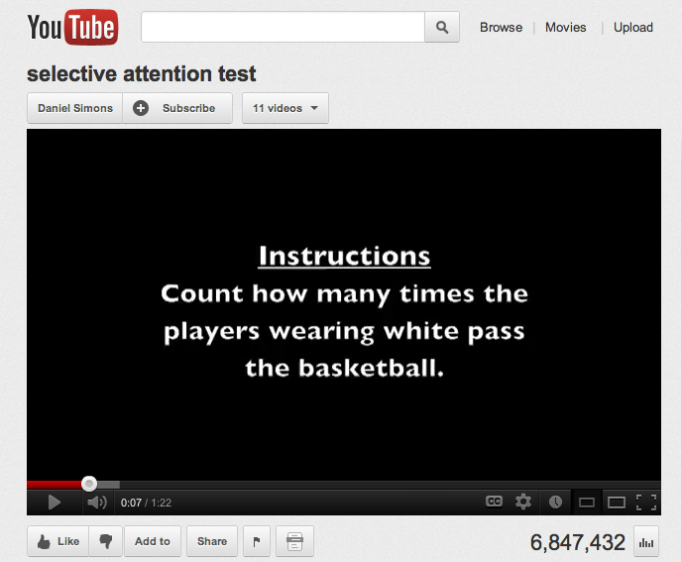
Witnesses

Eyewitness testimony is very influential in court

Despite studies that show how unreliable it is

Link Ch 11e

Track Hours and Expense

Investigations can take many hours and cost a lot of money

Include costs in quantitative risk assessment

Last modified 11-26-12

