What You Need for This Project
- A computer running Windows Vista, with Internet access.
- You need administrator privileges on the computer.

Choosing an Operating System
- Boot a machine to Vista (NOT Windows 7). Log in as Student with no password.

Installing the Microsoft Baseline Security Analyzer
- Open Internet Explorer (Firefox often fails when downloading things from Microsoft).
- Go to http://www.microsoft.com/technet/security/tools/mbsahome.mspx
- Near the top of the page, click the "MBSA 2.1" link.
- Click the latest version – at the time I wrote this, it was MBSA 2.1.
- At the next screen, click Download now.
- On the next screen, in the "Download Now" section, click "Microsoft Baseline Security Analyzer 2.1 (available in English, French, German, and Japanese)".
- A page opens titled "Microsoft Baseline Security Analyzer 2.1 (for IT Professionals)". Scroll down to "Files in This Download" section, as shown below on this page.
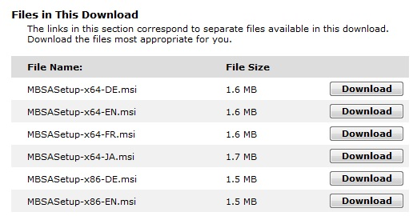

- In the "MBSASetup-x86-EN.msi" line, click the Download button. This is the correct version for a 32-bit computer using English.
- In the "File Download – Security Warning" box, click Run.
- In the "Internet Explorer – Security Warning" box, click Run.
- A "Microsoft Baseline Security Analyzer Setup" box appears. Click Next. Agree to the agreement, and click through the installer accepting all the default options. If a "User Account Control" box pops up, click Yes or Continue.
- When the "MBSA Setup" box pops up, saying "Microsoft Baseline Security Analyzer Setup has completed successfully", click OK.
Scanning Your Computer with MBSA
- At the lower left of your keyboard, press the Windows Logo key (). In the Search box, type Microsoft. Look at the top of the Start menu, and use the arrow keys as needed to highlight "Microsoft Baseline Security Analyzer 2.1" Press the Enter key.
- Click Start, "Microsoft Baseline Security Analyzer 2.1". If a "User Account Control" box pops up, click Yes or Allow.
- In the "Microsoft Baseline Security Analyzer" window, click Scan a computer.
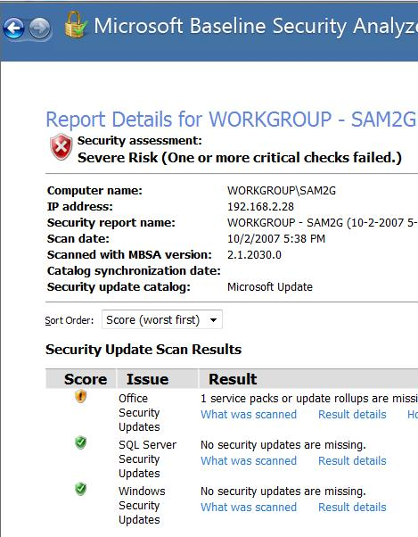
- In the Pick a computer to scan screen, notice that you can scan more than one computer with this tool, and that you can scan for many different problems. We will use the default selection to scan the local computer, and to scan for all the vulnerabilities. The only items not checked by default are "Configure computers for Microsoft Update and scanning prerequisites" and "Advanced Update Services Options" which we won't use.
- On the lower right, click the "Start Scan" button. Wait until the scan completes.
Saving the Screen Image
- When you see the View Security Report header, the scan is complete. Make sure the Windows Security Updates line is visible, as shown to the right on this page. Press Alt+PrtScn to copy this window to the clipboard.
- On the Start menu, click Run. Enter the command mspaint and press the Enter key. Paint opens.
- Press Ctrl+V on the keyboard to paste the image into the Paint window. Save the document in the Shared Documents folder with the filename Your Name Proj 6. Select a Save as type of JPEG. Close Paint.
Reading the Security Report
- Read the Security Report and answer the questions in the box below.
A: In the Administrative Vulnerabilities section, what did it say about your File System?
_________________________________________________________________________
B: What was the result of the Password Expiration test?
_________________________________________________________________________

Turning in your Project
- Email the JPEG image to me as an attachment to an e-mail message. Answer the questions in the box in the body of the e-mail message. Send the message to: cnit.120@gmail.com or cnit.120@gmail.com with a subject line of "Proj 6 From Your Name", replacing Your Name with your own first and last name. Send a Cc to yourself.

Last modified 1-30-09

