What You Need for This Project
Warning! "Ethical Hacking and Network Defense" students will capturing passwords in room S214. Don't do online shopping, personal e-mailing, or any other private computer work in that lab. Make up a new password just for that lab. Nothing you do in that lab is private!
- A trusted computer running any version of Windows, with Internet access.
- You need administrator privileges on the computer.

Choosing an Operating System
- Start a machine. Each machine in S214 has many operating systems, and you can use any of them. For this project, I recommend that you use Vista or Windows 7 Beta. Log in as Student with no password.

Opening CNN.com in Internet Explorer
- Click Start, "All Programs", "Internet Explorer". Go to cnn.com
- The CNN Web page opens, showing one or more advertisements.

Verifying that Firefox is Installed
- Click Start, "All Programs", and look for "Mozilla Firefox". If it's not there, you will need to open Internet Explorer, go to getfirefox.com, download and install the latest version. Avoid using Internet Explorer! That is the single most important security habit you can form.

Opening CNN.com in Firefox
- Open Firefox. Go to cnn.com
- The CNN Web page opens, showing one or more advertisements.

Installing NoScript
- In the Firefox window, click Tools, Add-ons.
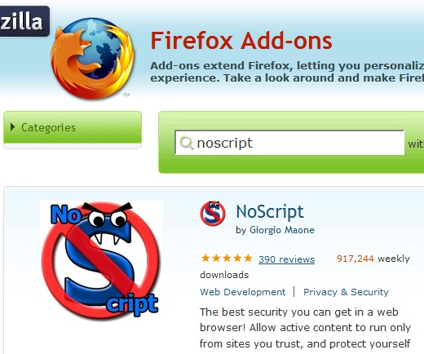
- In the Add-ons box, click the "Get Add-ons" tab. Click the blue "Browse All Add-ons" link.
- The "Firefox Add-ons" Web page opens. Type noscript into the search box and press the Enter key.
- NoScript should be found, as shown to the right on this page. Click the green "Add to Firefox" button.
- In the "Software Installation" box, click the "Install Now" button.
- Close all Firefox windows.

Opening CNN.com in Firefox with NoScript
- Open Firefox. Go to cnn.com
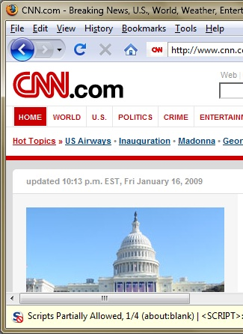
- The CNN Web page opens. Some of the advertisements may now show empty boxes. A message appears at the bottom of the window saying "Scripts Partially Allowed" as shown to the right on this page..

Saving a Screen Image
- You have now completed Project 1. The only thing that remains is to turn it in.
- Notice the hand symbol above on this page. In my projects, that indicates an image you need to capture and email in.
- To do that, you need to make a JPEG image of the screen and email it to me, as explained below. Note the hand symbol just below this text: that indicates screen images that you must capture and turn in.
- Press the PrintScrn key in the upper-right portion of the keyboard. That will copy the whole desktop to the clipboard.
- Click Start. Type PAINT and click Paint. Click in the untitled - Paint window and press Ctrl+V. The image appears in the Paint window.
- In the untitled - Paint window, click File, Save. Save the document in the My Pictures folder (or any other place you wish, such as a floppy disk) with the filename Your Name Proj 1.
- Email the image to me as an attachment to an e-mail message. Send it to: cnit.120@gmail.com with a subject line of "Proj 1 From Your Name", replacing Your Name with your own first and last name. Send a Cc to yourself.

Allowing the Scripts
- To see the page in its original form, you can tell NoScript to allow the scripts.

Conclusion
Using Internet Explorer to browse the Web is very dangerous. Machines get rapidly infected with malicious software that way. Firefox is a much safer browser, and Firefox with NoScript is even safer. For the best security, use Firefox with NoScript and avoid Internet Explorer as much as possible.

Last Modified: 8-16-12

