What You Need
- A computer running Windows XP or any later version of Windows, with at least 512 MB of RAM and several GB of storage available. Each virtual machine is 2-4 GB, or even larger if you install a lot of software on the virtual machine
- A broadband Internet connection so you can download large files
- The instructions below assume you are using Vista or Windows 7 in S214

Getting the VMware Player Installer
- Start a computer and boot to Vista or Windows 7. Log in as Student with no password. If that doesn't work, try P@ssw0rd
- Click Start, Computer. Double-click the VMs drive to open it. Open the Install folder. Look for the VMware-player-2.5.1-126130.exe file, or possibly an earlier version. If it's not there, or you are working at home, follow these steps to download it:
  - Open Firefox and go to vmware.com. On the upper left of the page, click Products, "Desktop Products". In the center of the page, click "VMware Player". Follow the instructions on the screen to download the latest version, for Windows. Save the file on the VMs drive, in the Install folder.

Installing VMware Player
- Double-click the VMware-player-2.5.1-126130.exe file and install VMware player with the default options. You can now use virtual machines, but you cannot create them with the player. To create virtual machines, see the next section.

VMmanager
- VMmanager allows you to create VMware virtual machines, and the modify existing ones. It is a completely different product than Microsoft’s VM Manager – don’t confuse the two!
- Open a browser and go to vmmanager.sourceforge.net. Click Download. Click Download.
- The next screen shows three packages, as shown below on this page. The package we want is vmmanager—the one in the middle. In the middle row, click the Download button.
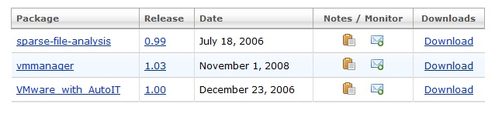

- The next screen again shows a choice of three files. The one we want is in the middle again. Click the vmmanager1.03-setup.exe link. Save the file on the VMs drive, in the Install folder.
- Double-click the downloaded file to start the installer. Agree to the agreement and install the software with the default selections.

Creating a New Virtual Machine with VMmanager
- First, create a folder for your VMs to live in. Click Start, Computer. Double-click the VMs drive to open it. Right-click an empty portion of the window and click New, Folder. Name the folder with your own name, so you can easily find your own virtual machines.
- Double-click the folder with your name on it to open it. Right-click an empty portion of the window and click New, Folder. Name the folder Ubuntu.
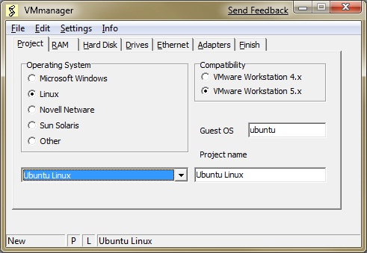
- Click Start. In the Search box, type vmmanager
- When Vmmanager appears at the top of the list, press the Enter key on the keyboard.
- In the VMmanager window, click the New button.
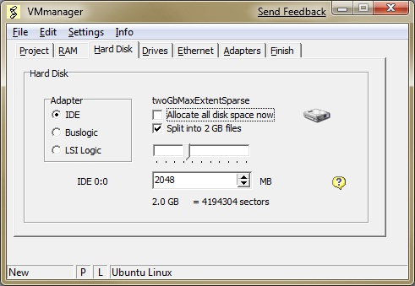
- In the VMmanager window, on the Project tab, select an Operating System of Linux. In the crop-down list box at the bottom, select "Ubuntu Linux", as shown to the right on this page.
- In the VMmanager window, click the Hard Disk tab. Do these three things adjustments on this screen:
  - Clear the "Allocate all disk space now" check box.
  - Make sure the "Split into 2 GB files" box is checked
  - In the lower right field, enter 8000
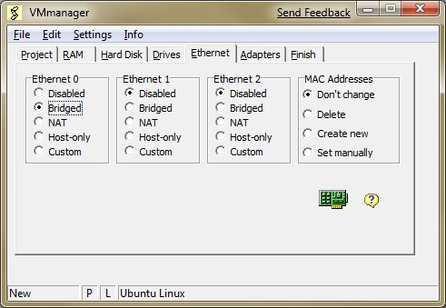
- In the VMmanager window, click the Ethernet tab. By default, there is no networking enabled, which is very rude. In the Ethernet 0 section, click Bridged. That will share your host operating system's physical NIC with the virtual machine, so the VM appears on your network with its own IP address in the same subnet.
- In the VMmanager window, click the Finish tab. Click the OK button. In the Save As box, navigate to the VMs drive and open the folder with your name on it. Click the Ubuntu folder, and click Open. Click Save. In the VM Manager box, click OK.

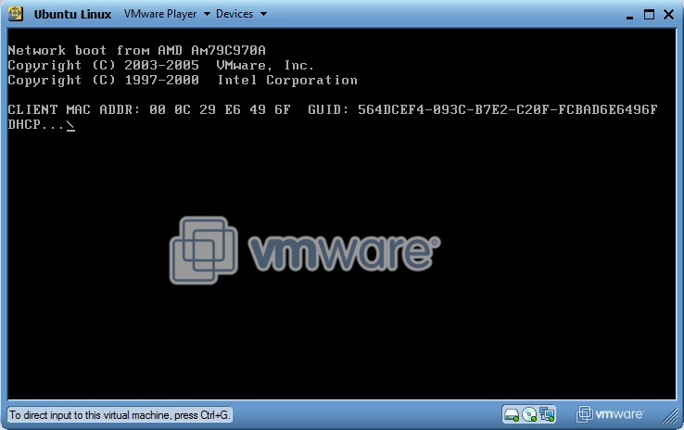
Starting the New Virtual Machine
- Click Start. In the Search box, type vmware
- When "VMware Player" appears at the top of the list, press the Enter key on the keyboard.
- If you see an Agreement, agree to it.
- In the "VMware Player" box, click Open.
- In the "Open Virtual Machine" box, navigate to the VMs drive. Open the folder with your name on it, and the Ubuntu folder. Click the "Ubuntu Linux.vmx" file and click the Open button.
- The virtual machine starts up, but ends with a dark screen, as shown to the right on this page. This is normal, because the virtual machine doesn't have any operating system installed yet.
Saving the Screen Image
- Press Ctrl+Alt to release the mouse from the virtual machine.
- Click on the host Windows desktop taskbar. Press the PrntScn key to copy whole screen to the clipboard.
- On the host Windows desktop, open Paint and paste in the image. Save it as a JPEG, with the filename Your Name Proj 3.
Turning in your Project
- Email the JPEG image to me as an attachment. Send the message to cnit.120@gmail.com with a subject line of Proj 3 From Your Name. Send a Cc to yourself.
Last Modified: 1-22-09

