Starting the Virtual Machine with No Operating System
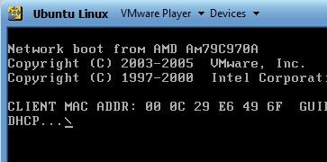
- You should have your virtual machine running with no operating system, as shown to the right on this page. If you don't, launch VMware player and open your virtual machine, as you did at the end of the previous project.
- Insert an Ubuntu installation CD into your machine.
- Press Ctrl+Alt to release the mouse from the virtual machine.
- In the title bar of the VMware Player window, click "VMware Player", Troubleshoot, Reset. Your virtual machine should restart and boot from the CD. If it does not, call your instructor over to help—you may need to adjust the BIOS and that's a bit clumsy with virtual machines.

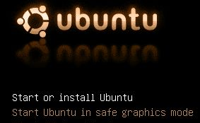
Starting Linux from the CD Image
- The virtual machine should boot from the CD image, and show you the ubuntu starting screen shown to the right on this page.
- Press the Enter key to "Start or Install Ubuntu".

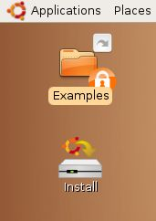
- Ubuntu starts, and show a brown desktop with an Install icon on it, as shown to the right on this page.
- At this point, Ubuntu is running from the CD. This “Live CD” mode is intended to let people try Linux on a Windows machine without changing the hard disk. The problem with it is that you cannot install software, save files, or customize it. Besides, we are using VMware, which protects the Windows host system anyway—we don’t need the Live CD feature. So we will install Ubuntu onto the virtual hard disk.

Installing Ubuntu Linux on the Virtual Hard Disk
- Double-click the Install icon.
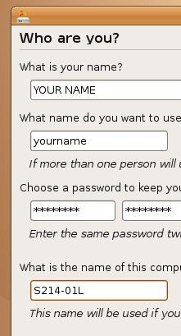
- In the first Linux install screen, labeled "Step 1 of 7" in the lower left corner, accept the default selection of English and click the Forward button.
- In"Step 2 of 7", click on the map to select Los Angeles for a time zone, and click the Forward button.
- In"Step 3 of 7", accept the default keyboard layout selection of "U.S. English" and click the Forward button.
- Step 4 of 7 is preparing the disk space. Accept the default selections of "Guided – use entire disk" and "IDE1 master (hda)" and click the Forward button.
- In"Step 5 of 7", "Migrating User Settings", don't change anything and click the Forward button.
- Step 6 of 7 is the Who are you? Screen. Type in your name and a logon name of your choice. Enter a password you can remember – I recommend P@ssw0rd. Name your computer after the station number on the front panel, adding an L (for Linux) to the end, as shown to the right on this page. Click the Forward button.
- Step 7 of 7 is the "Ready to install" screen. Click the Install button.
- Wait while Linux installs – it will take about 30 minutes. When you see an Installation Complete box, click Restart now.

Removing the Virtual CD
- Ubuntu shuts down, leaving a black screen with small blue letters at the bottom saying "please remove the disc". Remove the CD.

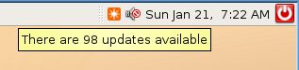
Concerning Updates
- At the upper right of the screen, you will see a clock with some icons near it. The leftmost icon is an orange square with a white star on it. Point to that icon and you should see that updates are available – 98 updates, when I did it, as shown to the right on this page.
- Just like Windows, Ubuntu has vulnerabilities and a constant stream of updates. But the updates are not as important, because Linux is a lot more secure in the first place. Also, in my experience, Ubuntu updates are much more likely to break a working machine than Windows updates. So my recommendation is to not bother updating during this class unless there is a specific new feature you want.
Opening Firefox
- On the upper left of the Ubuntu desktop, click the red Firefox icon, as shown to the right on this page.
Firefox
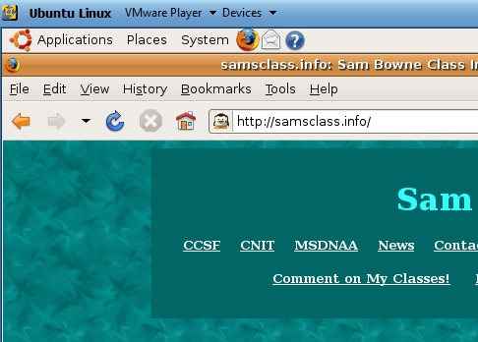
- Open a Web page, such as samsclass.info

Saving the Screen Image
- Click on the host Windows desktop taskbar. Press the PrntScn key to copy whole screen to the clipboard.
- On the host Windows desktop, open Paint and paste in the image. Save it as a JPEG, with the filename Your Name Proj 4.

Shutting Down the Ubuntu Machine
- When your Ubuntu machine restarts, click System, Quit. Click the "Shut Down" button.
Turning in your Project
- Email the JPEG image to me as an attachment. Send the message to cnit.120@gmail.com with a subject line of Proj 4 From Your Name. Send a Cc to yourself.

Last modified 1-22-09

