What You Need for This Project
- A computer running Windows Vista or Windows 7, with Internet access.
- You need administrator privileges on the computer.

Choosing an Operating System
- Boot a machine to Vista or Windows 7. Log in as Student with no password.

Installing the Windows Vista Security Guide
- Open Internet Explorer (Firefox often fails when downloading things from Microsoft).
- In the upper right portion of your browser window, in the "Live Search" box, type this text, and then press the Enter key:
Windows Vista Security Guide
- Find the item shown in the figure below on this page and click it.
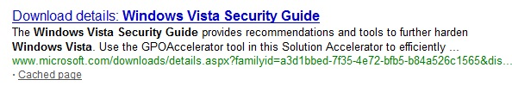

- On the next page, scroll down to find the Download links, as shown below on this page. Click the download link in the "Windows Vista Security Guide.msi" line.
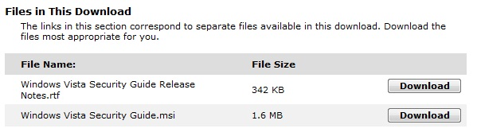

- In the "File Download – Security Warning" box, click Run.
- In the "Internet Explorer – Security Warning" box, click Run.
- A "Windows Vista Security Guide Setup" box appears. Click Next. Agree to the agreement, and click through the installer accepting all the default options.

Examining the Security Templates
- At the lower left of your keyboard, press the Windows Logo key (). In the Search box, type MMC and then press Shift+Ctrl+Enter. This is the Microsoft Management Console, used for many advanced Windows configuration tasks.
- If a "User Account Control" box pops up, click Yes or Continue.
- In the "Console 1 – [Console Root]" box, click File, "Add/Remove Snap-in".
- In the "Add or Remove Snap-ins" box, in the left pane, scroll down and double-click "Security Templates". Click OK.
- In the left pane, right-click "Security Templates" and click Open.
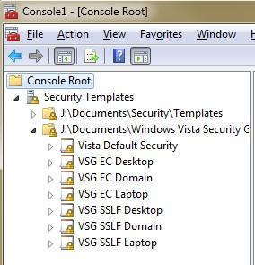
- In the left pane, right-click "Security Templates" again, but this time click "New Template Search Path".
- In the "Browse for Folder" box, your logon name is highlighted, probably Student. Expand the folder with your logon name.
- If you are using Vista, expand Documents. If you are using Windows 7, expand "My Documents".
- Expand "Windows Vista Security Guide". In the "GPOAccelerator Tool" section, click "Security Templates". Click OK.
- In the "Console 1 – [Console Root]" box, in the left pane, expand "Security Templates". Expand the second folder with the longer name, and you will see the Security Templates, named "Vista Default Security", "VSG EC Desktop", etc., as shown to the right on this page.

Examining the "Vista Default Security" Template
- In the "Console 1 – [Console Root]" box, in the left pane, expand "Vista Default Security". Expand "Account Policies". Click "Account Lockout Policy" to highlight it. In the right pane, you can see that "Account Lockout Threshold" is set to "0 invalid logon attempts", as shown below on this page.
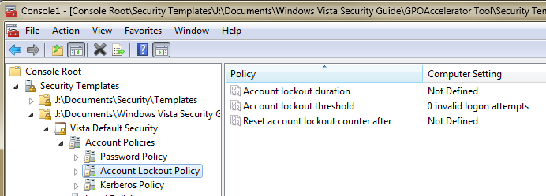

- This setting means that Vista will let a user try over and over again to log in, no matter how many times the user enters an incorrect password. That is not a very secure option, because it makes it possible for a brute-force password guessing program to try thousands of passwords.

Examining the "VSG SSLF Domain" Template
- The "VSG SSLF Domain" policy is the Vista Security Guide for "Specialized Security – Limited Functionality", intended for companies that are so concerned about security that a significant loss of functionality is acceptable.
- In the "Console 1 – [Console Root]" box, in the left pane, expand "VSG SSLF Domain". Expand "Account Policies". Click "Account Lockout Policy" to highlight it. In the right pane, you can see that "Account Lockout Threshold" is set to "10 invalid logon attempts", as shown below on this page. This means that a person who forgets his or her password and guesses wrong ten times will be locked out of their account for 15 minutes.
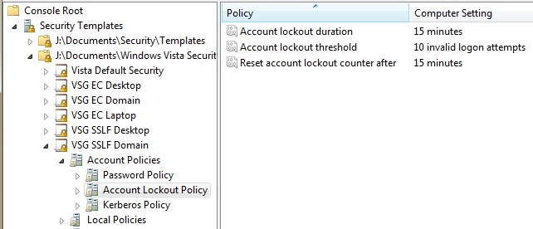

Comparing Your Machine to the "VSG SSLF Domain" Template
- Close the "Console 1 – [Console Root]" box. Do not save changes.
- At the lower left of your keyboard, press the Windows Logo key (). In the Search box, type MMC and then press Shift+Ctrl+Enter. This is the Microsoft Management Console, used for many advanced Windows configuration tasks.
- If a "User Account Control" box pops up, click Yes or Continue.
- In the "Console 1 – [Console Root]" box, click File, "Add/Remove Snap-in".
- In the "Add or Remove Snap-ins" box, in the left pane, scroll down and double-click "Security Configuration and Analysis". Click OK.
- In the left pane, right-click "Security Configuration and Analysis" and click "Open Database…".
- In the "Open Database" box, type in a File Name of Compare and click Open.

- In the "Import Template" box, browse to C:\Users\Student\Documents\Windows Vista Security Guide\GPOAccelerator Tool\Security Templates. Double-click "VSG SSLF Domain".
- In the left pane, right-click "Security Configuration and Analysis" and click "Analyze Computer Now".
- In the "Perform Analysis" box, click OK. A box pops up showing the progress of the analysis. It finishes after only a few seconds.
- In the left pane, expand "Security Configuration and Analysis".
- Expand "Account Policies". Click "Account Lockout Policy" to highlight it. In the right pane, you see that the "Database Setting" for the Account lockout threshold is 10 invalid logon attempts, but your "Computer Setting" is 0 invalid logon attempts. The analysis shows that your computer is less secure than it should be to match the "VSG SSLF Domain" recommendations.

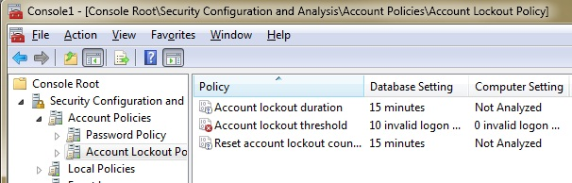

Saving a Screen Image
- Make sure the "Console 1 – [Console Root]" box page is open, showing the "Account lockout threshold" values as shown in the figure above on this page.
- Press the PrintScrn key in the upper-right portion of the keyboard. That will copy the whole desktop to the clipboard.
- Click Start, Programs, Accessories, Paint. In the untitled - Paint window, select Edit, Paste from the menu bar. The desktop appears in the Paint window (only a corner of it will be visible).
- In the untitled - Paint window, click File, Save. Save the document in the My Pictures folder (or any other place you wish, such as a floppy disk) with the filename Your Name Proj 5. Select a Save as type of JPEG.
- Email the JPEG image to me as an attachment to an e-mail message. Send it to: cnit.120@gmail.com with a subject line of "Proj 5 From Your Name", replacing Your Name with your own first and last name. Send a Cc to yourself.

Last Modified: 1-30-09

