What You Need for This Project
Warning! "Ethical Hacking and Network Defense" students will capturing passwords in room S214. Don't do online shopping, personal e-mailing, or any other private computer work in that lab. Make up a new password just for that lab. Nothing you do in that lab is private!
- A trusted computer running any version of Windows, with Internet access.
- You need administrator privileges on the computer.
- You need a Gmail account (or other Webmail) to use. You should already have made a temporary one you can use in the lab.

Choosing an Operating System
- Start a machine. Each machine in S214 has many operating systems, and you can use any of them. For this project, I recommend that you use Vista or Windows 7 Beta. Log in as Student with no password.

Installing the KeePass Password Manager
- Open Firefox. Go to keepass.com
- On the bottom of the page, click "Keepass Download Latest Stable Release (Windows Installer EXE)".
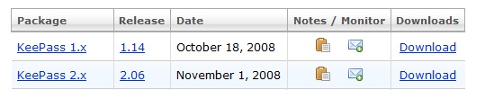
- On the next page, in the "KeePass 1.x" line, click the Download link, as shown below on this page. The 2.x is a beta version, not yet ready for real use.

- On the next page, click the "KeePass-1.14-Setup.exe" link. Save the file on your desktop.
- Minimize all windows. On your desktop, double-click the KeePass-1.14-Setup.exe file. Click through all the security warnings and install the software with the default options.

Entering a Master Password
- On the lower left of your keyboard, press the Windows Logo key (). In the Search box, type keep
- When "KeePass" appears at the top of the list, use the up-arrow and down-arrow keys as necessary to highlight it and press the Enter key on the keyboard.
- In the "KeePass Password Safe" window, click File, New.
- In the "Master Password" field, enter a password you plan to use to keep your other passwords safe. WRITE IT DOWN SO YOU DON'T FORGET IT. Click OK.
- In the "Repeat Master Password" box, enter the password again and click OK.

Putting a Gmail Password into KeePass
- In the left pane of the "KeePass Password Safe" box, click eMail.
- Point to an empty portion of the right pane, right-click, and click "Add entry…".
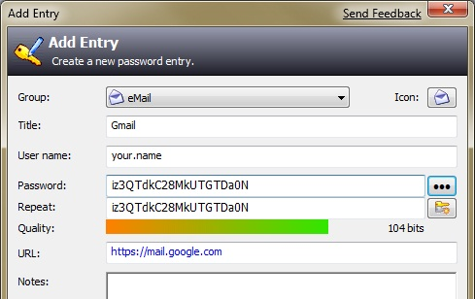
- Enter a Title of Gmail. In the "User name" field, type your Gmail account name.
- The Password box contains a lot of dots. To see the randomly-generated password, click the button showing three dots—as you can see, the passwords are very long and complex, as shown to the right on this page.
- In the "URL" field, type https://mail.google.com
- Click OK.

Saving the Password Database
- In the "KeePass Password Safe" box, click File, Save.
- Change the default filename of "Database.kdb" to your own name. Save the file in your Documents folder.

Updating your Gmail Password to the Secure One
- In the bottom portion of the "KeePass Password Safe" box, click https://mail.google.com.
- Log in to the Gmail account you use in the lab, as usual. Do NOT use your normal email account in Science 214! If you don't have another account to use, just create a new Gmail account.
- Once you are logged into Gmail, click the Settings link. Click the Accounts tab. Click "Google Account Settings". On the next page, click "Change password"
- In the "Change password" screen, enter your current password in the top field.

- In the "KeePass Password Safe" box, right-click the Gmail entry, and click "Copy Password to Clipboard", as shown below on this page.
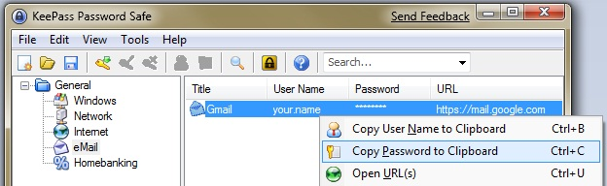

- In the Google "Change password" screen, right-click in the "New password" field and click Paste. Also right-click the "Confirm new password" field and click Paste. Click Save.

Examining the Password Database
- On the lower left of your keyboard, press the Windows Logo key (). In the Search box, type note
- When "Notepad" appears at the top of the list, use the up-arrow and down-arrow keys as necessary to highlight it and press the Enter key on the keyboard.
- In the Notepad box, click File, Open. Navigate to the Documents folder.
- In the lower right of the "Open" box, set the file type to "All files (*.*)".
- Open your KeePass database. It should be named with your own name.
- In the Notepad window, click Format, "Word Wrap". You should see a screen full of random characters, as shown below on this page. This file contains your password, encrypted in a very secure manner.
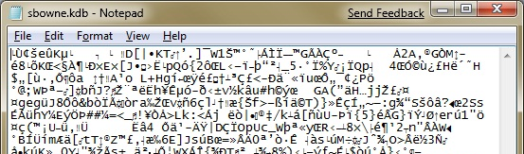

Saving a Screen Image
- Make sure the Notepad window shows the contents of your password database, as shown above on this page.
- Press the PrintScrn key in the upper-right portion of the keyboard. That will copy the whole desktop to the clipboard.
- Click Start, Programs, Accessories, Paint. In the untitled - Paint window, select Edit, Paste from the menu bar. The desktop appears in the Paint window (only a corner of it will be visible).
- In the untitled - Paint window, click File, Save. Save the document in the My Pictures folder (or any other place you wish, such as a floppy disk) with the filename Your Name Proj 7. Select a Save as type of JPEG.
- Email the JPEG image to me as an attachment to an e-mail message. Send it to: cnit.120@gmail.com with a subject line of "Proj 7 From Your Name", replacing Your Name with your own first and last name. Send a Cc to yourself.

Saving the Password Database
- You will need to keep your password database available. I recommend that you email it to your normal email as a file attachment, and/or copy it to a USB memory stick. Don't lose it, or you will be locked out of all your accounts!

Last Modified: 2-4-09

