√What You Will Need
- A computer with Vista or Windows 7 (or Windows XP, if you are working at home and have Administrator privileges). The instructions assume you are using Windows 7.

Downloading and Installing FileAlyzer
- Open Firefox and go to forums.spybot.info/downloads.php
- Scroll down to "Analysis Tools". Click the "FileAlyzer" link. On the next page, in the Download column, click the latest version--it was "filealyz-2.0.5.57.exe" when I did it, as shown below on this page. Notice the MD5 and SHA-1 hash values on the right side of this page—you will use those later.

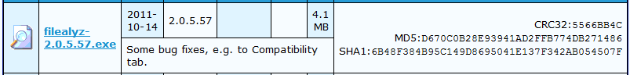
- In the "Opening filealyz-2.0.5.57.exe" box, click "Save file". Save the file on your desktop.
- On your desktop, double-click filealyz-2.0.5.57.exe. Click through all the warning boxes and install the software with the default options.

Verifying the MD5 and SHA-1 Hashes
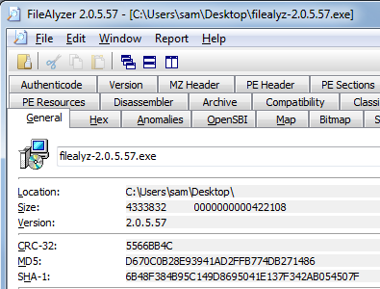
- On your desktop, right-click filealyz-2.0.5.57.exe. In the context menu, click "Analyze file with FileAlyzer 2". In the "Open File – Security Warning" box, click Run.
- FileAlyzer opens, showing the properties of the file. Notice that this page shows the MD5 and SHA-1 hashes of the file, which match the values posted on the Web page shown above on this page.
- Click through the other tabs and investigate the file—this is a very powerful tool. Notice all the different hashes on the Hashes tab. You can even see the machine language code inside this file with the Disassembler tab.
- Close the FileAlyzer window.
Making a Copy of the File
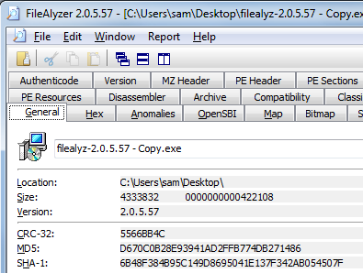
- On your desktop, point to the filealyz-2.0.5.57.exe icon. Press down the right mouse button and hold it down. Move the mouse an inch to the right and release the button. In the context menu, click "Copy Here".
- A new file appears named "filealyz-2.0.5.57- Copy.exe".
- Right-click "filealyz-2.0.5.57- Copy.exe ". In the context menu, click "Analyze file with FileAlyzer 2". In the "Open File – Security Warning" box, click Run.
- Examine the MD5 hash value. It should still be the same. Changing the file name does not alter the hash value.

Capturing the Screen Image
- Press the PrntScn key to copy whole screen to the clipboard. Open Paint and paste in the image. Save it as a JPEG, with the filename Your Name Proj 7a.

Downloading and Installing HxD
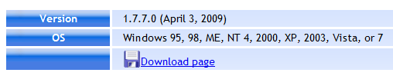
- Open Firefox and go to http://mh-nexus.de/en/hxd/
- Scroll down and click the "Download page" link, as shown to the right on this page.
- On the next page, find an English version, as shown below on this page. Click any of the links on the right side to download the program
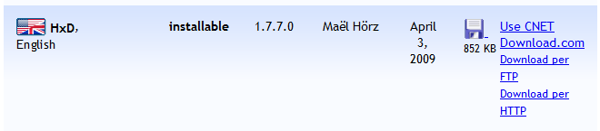

- Download and install HxD. Accept all the default installation options.

Modifying the File
- If HxD is not already open, click Start. In the Search box, type HxD and then press the Enter key.
In the HxD window, click File, Open. Navigate to your desktop and open the "filealyz-2.0.5.57- Copy.exe" file. HxD displays the file in hexadecimal form on the left side, and in ASCII text on the right side, as shown below.
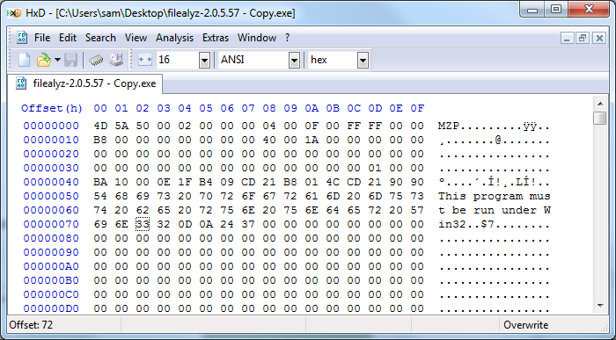

- On the right side of the HxD window, find the text saying "This program must be run under Win32". Click on the numeral 3 and type 64
- The black 32 changes to a red 64 as shown below on this page.
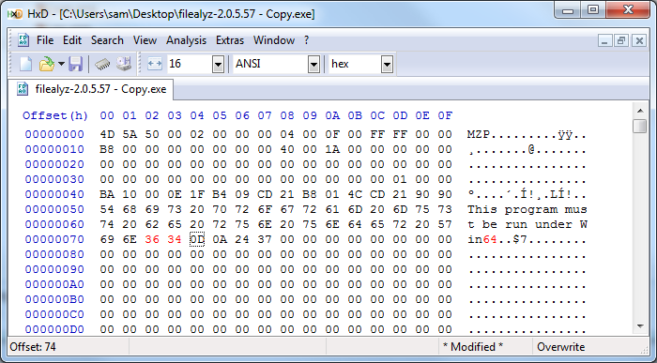

- In the HxD window, click File, Save. Close HxD.

- On your desktop, right-click "filealyz-2.0.5.57 - Copy.exe ". In the context menu, click "Analyze file with FileAlyzer 2". In the "Open File – Security Warning" box, click Run.
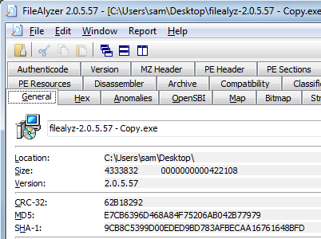
- Examine the MD5 hash value. It is completely different. That's the whole point of hashing—any change in the file can be detected by examining the hash.

Capturing the Screen Image
- Press the PrntScn key to copy whole screen to the clipboard. Open Paint and paste in the image. Save it as a JPEG, with the filename Your Name Proj 7b.
Examining a Digital Signature
- The process you just went through was a lot of work—looking up the MD5 hash, calculating it, and comparing it to the original. With digital signatures, that's all done for you automatically.
- On your desktop, right-click "filealyz-2.0.5.57 - Copy.exe ". In the context menu, click "Properties".
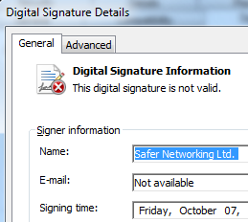
- In the "filealyz-2.0.5.57 - Copy.exe Properties" box, click the "Digital Signatures" tab.
- In the "Signature list" section, click "Safer Networking". Click the Details button.
- This box says "This digital signature is not valid". That's because the file has been modified.
Capturing the Screen Image
- Press the PrntScn key to copy whole screen to the clipboard. Open Paint and paste in the image. Save it as a JPEG, with the filename Your Name Proj 7c.
Turning in your Project
- Email the JPEG images to me as attachments to a single email message. Send the message to cnit.120@gmail.com with a subject line of Proj 7 From Your Name. Send a Cc to yourself.

Last modified 8-30-12

