What You Need for This Project

LEGAL WARNING!
Use only machines you own, or machines you have permission to hack into. Hacking into machines without permission is a crime! Don’t do it! If you do illegal things, you may be arrested and go to jail, and I will be unable to save you. These instructions are intended to train computer security professionals, not to help criminals.
- A computer running any version of Windows, with Internet access. You need administrator privileges.
Installing the Wireshark Packet Sniffer
- Open a Web browser and go to WireShark.org
- Download and install the latest version of Wireshark. The installer will also install WinPCap.
Starting a Packet Capture
- Click Start, All Programs, Wireshark, Wireshark.
- From the Wireshark menu bar, click Capture, Interfaces.
- In the "Wireshark: Capture Interfaces" box, find the Interface with an IP address starting with 192.168.1. In the example as shown below on this page, it's the top one. This interface should show some packets passing through it, because it's connected to the network. Click the Start button in that interface’s line.
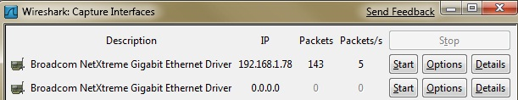

- You should see packets being captured and scrolling by, as shown below on this page. Every packet sent from or to your machine is shown here. But it shows a lot more information than you usually want to know.

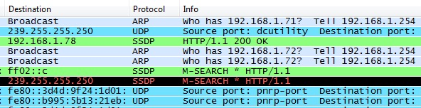

Sending a Test Password to Wikipedia
- Open Firefox and go to wikipedia.com
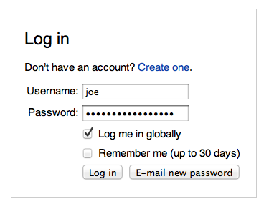
- Click English
- On the top right of the screen, click "Log In".
- Enter a Username of joe and a Password of topsecretpassword as shown to the right on this page.
- Do NOT put in your real user name and password! As you will see, this Web page is not secure. After this lab, you might not want to use it anymore!
- Click the "Log In" button. If you see a message asking whether to remember the password, click "Not Now".
- In the Wireshark window, box, click Capture, Stop.
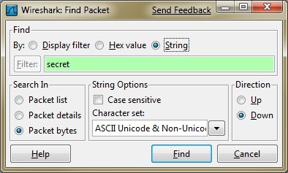
Observing the Password in Wireshark
- In the Wireshark window, box, click Edit, "Find Packet".
- In the "Wireshark: Find Packet" box, click the String button. Enter a search string of secret, as shown to the right on this page. Click Find.

- Wireshark finds the text. It highlights a packet with an Protocol of HTTP and Info of "POST /w/index.php", as shown below on this page.
- In the center pane of the Wireshark window, expand the item labeled "Line-based text data" and you should see your password right in that line, as indicated in the figure below. The password can also be seen at the lower right, in the byte-by-byte raw packet data.
Password
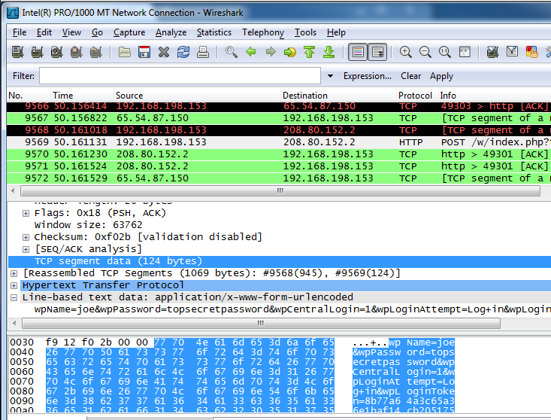

Saving the Screen Image
- Make sure the captured password is visible in the Wireshark window.
- Press the PrintScrn key in the upper-right portion of the keyboard.
- Click Start and type in Paint. Click Paint.
- Press Ctrl+V on the keyboard to paste the image into the Paint window. Save the document with the filename Your Name Proj 3. Close Paint.
Starting Another Packet Capture
- From the Wireshark menu bar, click Capture, Start.
- A bob pops up asking "Save capture file before starting a new capture?" Click "Continue without saving".
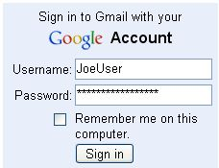
Using a Secure Password Transmission
- In Firefox, go to gmail.com. Log in with the fake name JoeUser and password topsecretpassword, as shown to the right on this page.
- In the Wireshark window, box, click Capture, Stop.
Observing the Password in Wireshark
- In the Wireshark window, box, click Edit, "Find Packet".
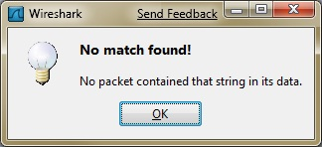
- In the "Wireshark: Find Packet" box, click the String button. Enter a search string of secret. Click Find.
- A box pos up saying "No match found!", as shown to the right on this page. The password cannot be found because Gmail encrypts it before transmitting it.
Turning in your Project
- Email the JPEG image to me as an attachment to cnit.120@gmail.com with a subject line of Proj 8 From Your Name. Send a Cc to yourself.

Last modified 7-31-11

