What You Will Need
- A USB drive containing the Ophcrack installer and tables
- A computer with Vista or Windows 7 (any version

Installing Ophcrack
- Copy these two files from the USB drive to your desktop: ophcrack-win32-installer-3.1.0.exe and tables_vista_free.zip.
- On your desktop, double-click the ophcrack-win32-installer-3.1.0.exe file. If a "User Account Control" box appears, approve the installation.
- In the "Welcome to the ophcrack 3.10 Setup wizard" box, click Next.
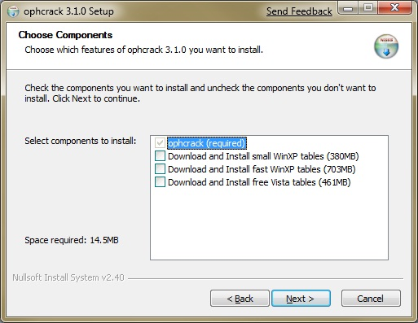
- In the "Choose Components" screen, uncheck all the tables, as shown to the right on this page. Then click Next.
- In the "Choose Install Location" box, click Next.
- In the "Installation Complete" box, click Next.
- In the "Completing the ophcrack 3.10 Setup wizard" box, click Finish.

Unzipping the Tables
- On your desktop, right-click the tables_vista_free.zip file, and click "Extract all…". In the "Select a destination and extract files" box, click Extract. a "User Account Control" box appears, approve the installation.

Running Ophcrack
- Click Start, ophcrack.
- On the ophcrack toolbar, click the Tables button. In the "Table Selection" box, click "Vista free". Click the Install button.
- In the "Browse For Folder" box, navigate to your desktop and click the "tables_vista_free" folder. Click OK.
- In the "Table Selection" box, click OK. Click the Install button.

Creating a Password Hash to Crack
- Open Firefox and go to objectif-securite.ch/en/products.php.
- Scroll to the bottom of the page and type in a password of 12345 and then click the "submit password" button.
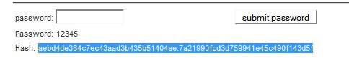
- The hash appears below the password on the screen. Drag the mouse through the hash with the left button down to highlight it, right-click it, and click Copy.

Loading the Password Hash into Ophcrack
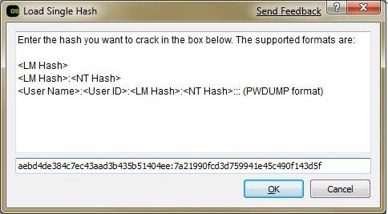
- In the Ophcrack window, click Load, "Single hash".
- At the bottom of the "Load Single Hash" box, in the empty text field, right-click and click Paste. Your window should now look like the image to the right on this page. Click OK.
- In the Ophcrack window, click the Crack button. It should find the password in a few seconds, in the "NT Pwd" column to the right of the window, as shown below on this page.
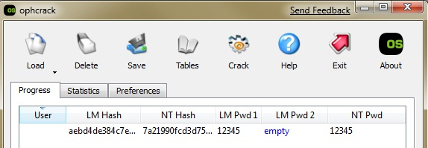
Cracking a Six-Letter Password
- Repeat the process with a stronger password—make up one with six characters, mixing lowercase letters and numbers, such as frog14. It should find the password within a few minutes. On my machine it took 51 seconds.
Capturing the Screen Image
- Make sure the "NT Pwd" shows at least one cracked password, as shown below on this page. )The image below shows an attempt to crack a seven-letter password which failed after almost 2 hours, I don't recommend trying that.)
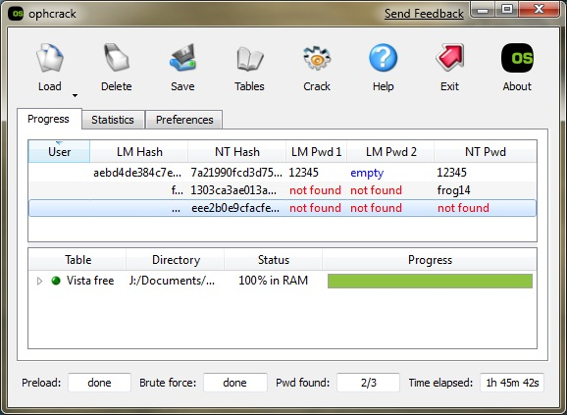

- Press the PrntScn key to copy whole screen to the clipboard. Open Paint and paste in the image. Save it as a JPEG, with the filename Your Name Proj 11.
Turning in your Project
- Email the JPEG image to me as an attachment. Send the message to cnit.120@gmail.com with a subject line of Proj 11 From Your Name. Send a Cc to yourself.

Last modified 3-7-09

