What You Will Need
- A computer with Vista or Windows 7 (or Windows XP, if you are working at home and have Administrator privileges)

Downloading and Installing Nessus
- Open Firefox and go to nessus.org
- In the center left of the page, click Download.
- In the "Select a product to download" drop-down list box, select "Nessus 3.2.1.1 for Windows". Click the Download button.
- At the bottom of the next page, click "I accept".
- On the next page, click "Click Here to Download Nessus Directly".
- On the next page, click the blue Nessus-3.2.11.exe link.
- Save the file on your desktop.
- On your desktop, right-click the Nessus-3.2.11.exe icon and click "Run as Administrator".
- Install the software with the default options.
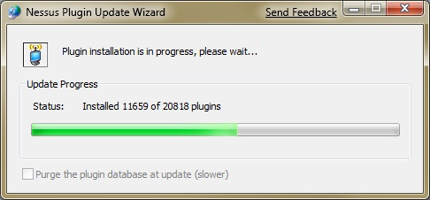
- A Question box opens asking if you have a product registration code. Click No.
- The "Nessus Plugin Update Wizard" shown to the right on this page will take a long time to complete—perhaps half an hour or more.
Running the Nessus Server
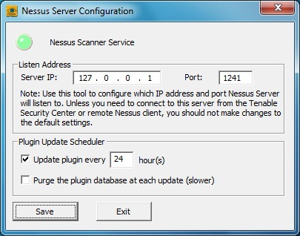
- Point to Start, "All Programs", "Tenable Network Security", Nessus, "Nessus Server Configuration". Right-click and click "Run as Administrator". In the "User Account Control" box, allow the privilege escalation.
- In the "Nessus Server Configuration" box, accept the default settings, as shown to the right on this page. Click Save.
- In the "Service Restart" box, click Yes.
Running the Nessus Client
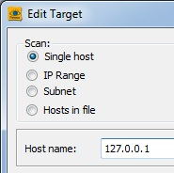
- Click Start, "All Programs", "Tenable Network Security", Nessus, "Nessus Client". A "Tenable Nessus 3" window opens.
- In the lower left of the "Tenable Nessus 3" window, click the + button.
- In the "Edit Target" box, in the "Host name" field, enter 127.0.0.1, as shown to the right on this page. This is the loopback address, so you will be scanning your own machine. Click the Save button.
- In the lower left of the "Tenable Nessus 3" window, click the Connect… button.
- In the "Connection Manager" box, click localhost and click the Connect button.
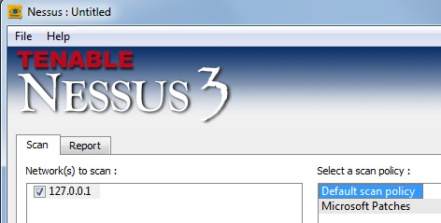
- In the "New Certificate" box, click Yes.
- In the "Tenable Nessus 3" window, in the right pane, click "Default scan policy", as shown to the right on this page. Click the "Scan Now" button.
- You should see a report after a few minutes. Click 127.0.0.1 to show a summary of the results, as shown on the next page of these instructions.

Capturing the Screen Image
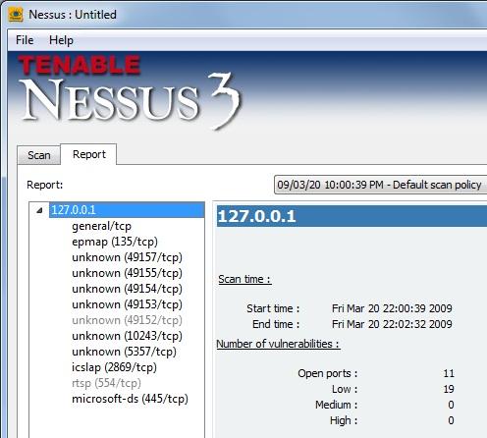
- Make sure the "Nessus: Untitled" window shows the number of open ports,as shown to the right on this page.

- Press the PrntScn key to copy whole screen to the clipboard. Open Paint and paste in the image. Save it as a JPEG, with the filename Your Name Proj 12.
Reading the Vulnerability Report
- Click through the open ports one by one and read the results. In your own words, explain a test that was run, and the results.
Turning in your Project
- Email the JPEG image to me as an attachment. Put your description of a test and its results in the body of the email message. Send the message to cnit.120@gmail.com with a subject line of Proj 12 From Your Name. Send a Cc to yourself.

Last modified 3-20-09

