What You Will Need
- A computer with Vista or Windows 7 (or Windows XP, if you are working at home and have Administrator privileges). The instructions assume you are using Windows 7.

Downloading and Running DecaffeinatID
- Open Firefox and go to samsclass.info
- Click the "CNIT 120" link. On the next page, click "Links". Scroll down and click " Ch 10b: DecaffeinatID".
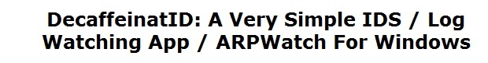

- On the next page, scroll down and find the download link to get the latest version—0.09 Beta when I wrote this.
- Download the decaffeinatid0.09.zip file and save it on your desktop.
- On your desktop, right-click the decaffeinatid0.09.zip file and click "Extract All…". In the "Extract Compressed (Zipped) Folders", click the Extract button.
- A window opens showing a folder named decaffeinatid0.09. Double-click that folder to open it.
- Right-click the DecaffeinatID.exe file and click "Run as Administrator".
- Approve the security warnings.
- In the lower right corner of the desktop, click the little upward-pointing triangle to reveal the hidden icons.
- Find the yellow-and-blue DecaffienatID icon, as shown below on this page, and right-click it. Point to Monitor to see what it is monitoring.
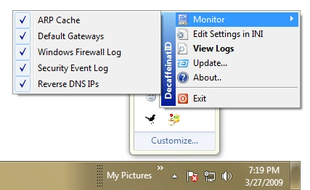

Creating a New User
- Click Start. Type in USER. Find "User Accounts" near the top of the menu and click it.
- In the "Control Panel ► User Accounts and Family Safety ► User Accounts" box, click "Manage another account".
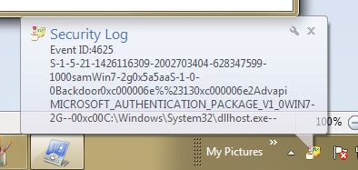
- In the next window, click "Create a new account".
- In the next window, enter an account name of "Backdoor" and click "Create Account".
- A "Security Log" box should pop up, as shown to the right on this page. This is a warning to you that someone just created a new user account.
Viewing the Log
- In the lower right corner of the desktop, click the little upward-pointing triangle to reveal the hidden icons.
- Right-click the yellow-and-blue DecaffienatID icon, and click "View Logs".
- The idslog should appear, as shown below on this page. You should see an "Event ID 4625"item with "Backdoor" appearing in it, as highlighted in the image below. This is the record of the new account creation.
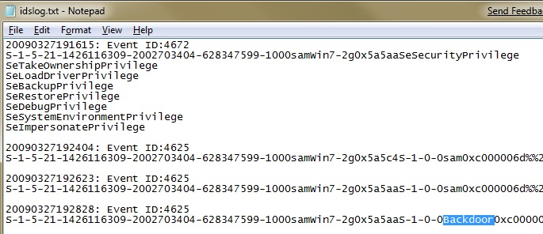

Capturing the Screen Image
- Press the PrntScn key to copy whole screen to the clipboard. Open Paint and paste in the image. Save it as a JPEG, with the filename Your Name Proj 13.
Turning in your Project
- Email the JPEG image to me as an attachment. Put your description of a test and its results in the body of the email message. Send the message to cnit.120@gmail.com with a subject line of Proj 13 From Your Name. Send a Cc to yourself.
Last modified 3-27-09

