What You Will Need
- A computer with Vista or Windows 7 (or Windows XP, if you are working at home and have Administrator privileges). The instructions assume you are using Windows 7.

Downloading and Running FileAlyzer
- Open Firefox and go to forums.spybot.info/downloads.php
- Scroll down to "Analysis Tools". Click the "FileAlyzer" link. On the next page, in the Download column, click "filealyz-2.0.0.10.exe", as shown below on this page. (If a later version is available, use that instead.) Notice the MD5 and SHA-1 hash values on the right side of this page—you will use those later.

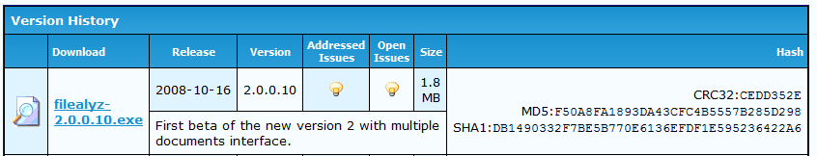
- In the "Opening filealyz-2.0.0.10.exe" box, click "Save file". Save the file on your desktop.
- On your desktop, double-click filealyz-2.0.0.10.exe. Click through all the warning boxes and install the software with the default options.

Verifying the MD5 and SHA-1 Hashes
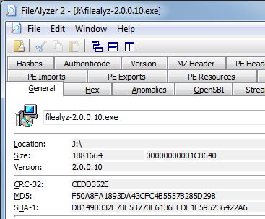
- On your desktop, right-click filealyz-2.0.0.10.exe. In the context menu, click "Analyze file with FileAlyzer 2". In the "Open File – Security Warning" box, click Run.
- FileAlyzer opens, showing the properties of the file. Notice that this page shows the MD5 and SHA-1 hashes of the file, which match the values posted on the Web page shown above on this page.
- Click through the other tabs and investigate the file—this is a very powerful tool. Notice all the different hashes on the Hashes tab. You can even see the machine language code inside this file with the Disassembler tab.
- Close the FileAlyzer window.
Making a Copy of the File
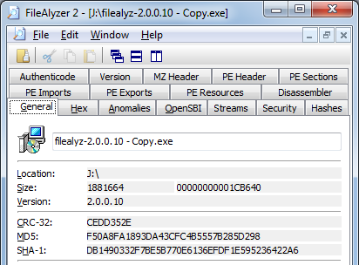
- On your desktop, point to the filealyz-2.0.0.10.exe icon. Press down the right mouse button and hold it down. Move the mouse an inch to the right and release the button. In the context menu, click "Copy Here".
- A new file appears named "filealyz-2.0.0.10 - Copy.exe".
- Right-click "filealyz-2.0.0.10 - Copy.exe ". In the context menu, click "Analyze file with FileAlyzer 2". In the "Open File – Security Warning" box, click Run.
- Examine the MD5 hash value. It should still be the same. Changing the file name does not alter the hash value.

Capturing the Screen Image
- Press the PrntScn key to copy whole screen to the clipboard. Open Paint and paste in the image. Save it as a JPEG, with the filename Your Name Proj 14a.
Modifying the File
- Click Start. In the Search box, type CMD and then press the Enter key. A Command Prompt window opens.
- In the Command Prompt window, type this command and then press the Enter key:
cd Desktop
This changes the current directory to your Desktop.
- In the Command Prompt window, type this command and then press the Enter key:
echo "x" >> "filealyz-2.0.0.10 - Copy.exe"
Tip: Just type the first three letters of the filename and press the Tab key—the filename will auto-complete. This adds the letter "x" to the end of the file, changing it.

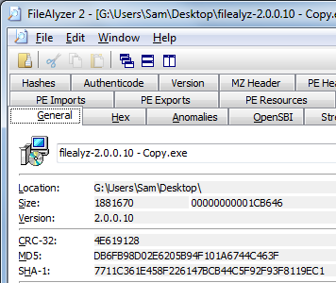
- Right-click "filealyz-2.0.0.10 - Copy.exe ". In the context menu, click "Analyze file with FileAlyzer 2". In the "Open File – Security Warning" box, click Run.
- Examine the MD5 hash value. It is completely different. That's the whole point of hashing—any change in the file can be detected by examining the hash.

Capturing the Screen Image
- Press the PrntScn key to copy whole screen to the clipboard. Open Paint and paste in the image. Save it as a JPEG, with the filename Your Name Proj 14b.
Examining a Digital Signature
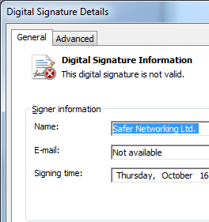
- The process you just went through was a lot of work—looking up the MD5 hash, calculating it, and comparing it to the original. With digital signatures, that's all done for you automatically.
- On your desktop, right-click "filealyz-2.0.0.10 - Copy.exe ". In the context menu, click "Properties".
- In the "filealyz-2.0.0.10 - Copy.exe Properties" box, click the "Digital Signatures" tab.
- This box says "This digital signature is not valid". That's because the file has been modified.
Capturing the Screen Image
- Press the PrntScn key to copy whole screen to the clipboard. Open Paint and paste in the image. Save it as a JPEG, with the filename Your Name Proj 14c.
Turning in your Project
- Email the JPEG images to me as attachments to a single email message. Put your description of a test and its results in the body of the email message. Send the message to cnit.120@gmail.com with a subject line of Proj 14 From Your Name. Send a Cc to yourself.

Last modified 4-17-09

