What You Will Need
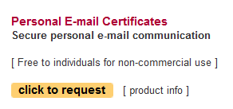
- A computer with Windows 7 (I think Vista or Windows XP will work too). The instructions assume you are using Windows 7.

Getting a Thawte Personal Digital Certificate
- Open Firefox and go to thawte.com
- On the top left of the page, click the "Buy SSL Certificates" button.
- On the next page, scroll down to the "Personal E-mail Certificates" section and click the "click to request" button.
- A "Terms and Conditions" box pops up. Scroll to the bottom of it and click next.
- Fill in your name and birth information. Use your real name and accurate information. Then click next.

Username: _______________________

Password: _______________________
- Enter your email address on the next page and click next. Write your email address in the box to the right on this page.
- On the "Personal Preferences" page, click next.
- On the next page enter a password twice. Write your password in the box above on this page. Click next.
- On the next page, fill in five Password Questions and click next.
- On the next page, click next.
- On the next page, fill in five Password Questions and click next.
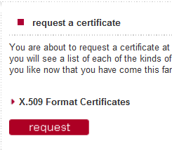
- Check your email. You should get a message with a Subject of "Thawte Mail Ping". Open that message and click the link inside it.
- Copy the "Probe" and "Ping" values from the email to the Thawte page and click next.
- You should see a message saying "Thawte Username Successfully Created!". Click next.
- A box pops up asking for a username and password. Enter them as you wrote them in the box above on this page.
- On the next page, in the "X.509 Format Certificates" section, click request.
- A box pops up titled "certificates available for request". Accept the default selection of "Mozilla Firefox/Thunderbird, Netscape Communicator/Messenger" and click request.
- In the "Certificate Bearers Name" window, click next.
- In the "configure email addresses for certificate" window, check the box next to your email address and click next.
- In the "configure extranet capabilities for certificate" window, click next.
- In the "configure X.509v3 certificate extensions" window, click accept.
- In the "generate certificate public key" window, accept the default selection of "High Grade" and click next.
- Wait until the key generation process completes. It only took a few seconds when I did it.
- In the "confirm certificate request" window, click finish.
- In the "personal certificate requested" window, click the red here link.
- The other Firefox window should now show your certificate with status issued, as shown below on this page.
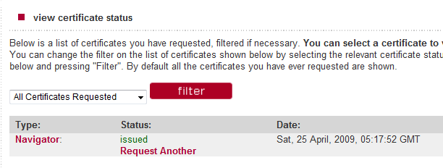

Download your Certificate
- Click the red Navigator link.
- In the next page, click the fetch button.
- A file downloads named mycert.spc. Save the file on your desktop.

Import your Certificate
- On your desktop, double-click the mycert.spc file.
- In the left pane of the certmgr window, expand the folder. Click the "Certificates" folder.
- In the right pane, double-click "Thawte Freemail Member", as shown below on this page.
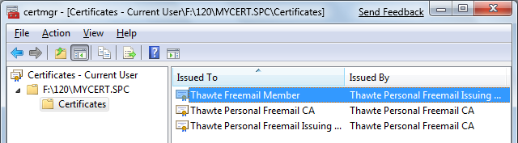

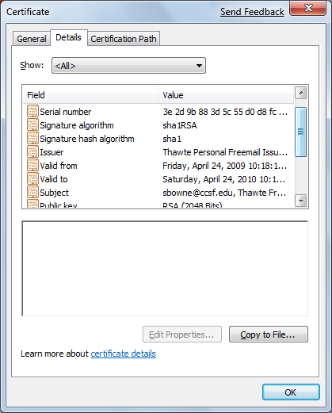
- In the "Certificate" box, click the "Install Certificate" button. Click Next three times.
- In the "Certificate" box, click the Details tab. Scroll down until your email address is visible, as shown to the right on this page.

Capturing the Screen Image
- Press the PrntScn key to copy whole screen to the clipboard. Open Paint and paste in the image. Save it as a JPEG, with the filename Your Name Proj 15.
Turning in your Project
- Email the JPEG image to me as an attachment to an email message. Send the message to cnit.120@gmail.com with a subject line of Proj 15 From Your Name. Send a Cc to yourself.

Last modified 4-29-09

