What You Will Need
- A computer with Vista or Windows 7 (or Windows XP, if you are working at home and have Administrator privileges). The instructions assume you are using Windows 7.

Creating a Big File With Secrets
- Open Notepad. Type in this line:
This is my secret information. I want to be sure nobody sees it.
- Click in the Notepad window.
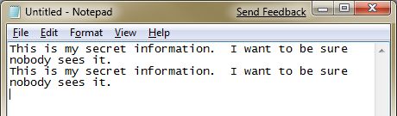
- Press Ctrl+A. Press Ctrl+C. Press Ctrl+V. Press Ctrl+V again. You should now see two copies of the line, as shown to the right on this page.
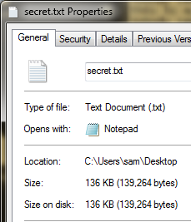
- Repeat the four-step process ten times: Ctrl+A, Cttrl+C, Ctrl+V, Ctrl+V. That will make the file 1024 times as large.
- Save the file on your desktop with the name secret.
- On your desktop, right-click the secret file and click Properties. The Size should be large, something like 136 KB, as shown to the right on this page.
- Close the Properties box.

Cleaning the File
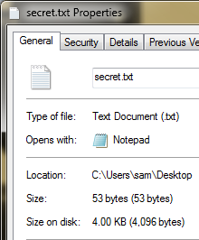
- Press Ctrl+A. Press the Delete key. The file is now empty.
- Type in this line:
This is innocent text. There's nothing secret here.
- Save the file on your desktop without changing its name.
- On your desktop, right-click the secret file and click Properties. The Size should be really small now, something like 53 bytes, as shown to the right on this page.
- Close the Properties box. Close Notepad.

Downloading and Installing Directory Snoop
- Open Firefox and go to http://www.briggsoft.com/dsnoop.htm
- Click the blue "Download" button. Save the file on your desktop. On your desktop, double-click the installer file and install the software with the default options.

Using Directory Snoop
- On your desktop, double-click the DS-NTFS icon If a "User Account Control" box pops up, allow the application to launch.
- In the "Directory Snoop" window, at the top, click the C: button. Wait while the file table is read in.
- In the middle pane, navigate to C:\Users\Student\Desktop (note: if your logon name is not Student, use that name instead of Student).
- Click the + sign next to Desktop. Scroll down and click the Secret.txt file. Your screen should now look like the example below.
- Notice the large pane in the lower center, showing every byte in the cluster containing the Secret.txt file. As you can see, the file contains the innocent line of text, and then a lot of zeroes. At first glance, you might think your secrets were erased.
- Notice the "Drive Clusters" list on the right side of the window. The clusters after the one you are currently viewing show in red font, and are labeled <none>.
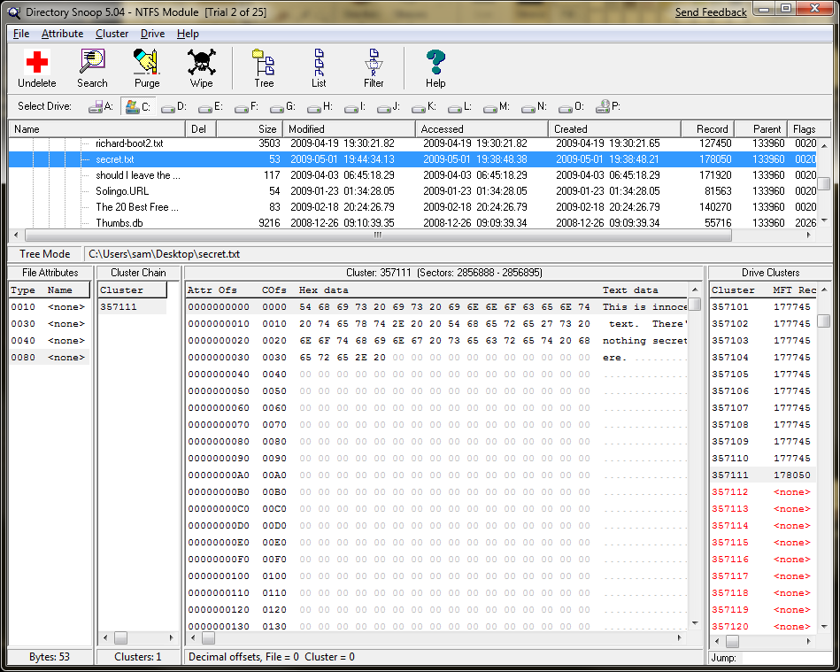

Recovering Erased Data with Directory Snoop
- In the "Drive Clusters" list, click one of the clusters labeled <none>. The secret text appears in the lower center portion of the window. The clusters were not erased by making the file smaller!
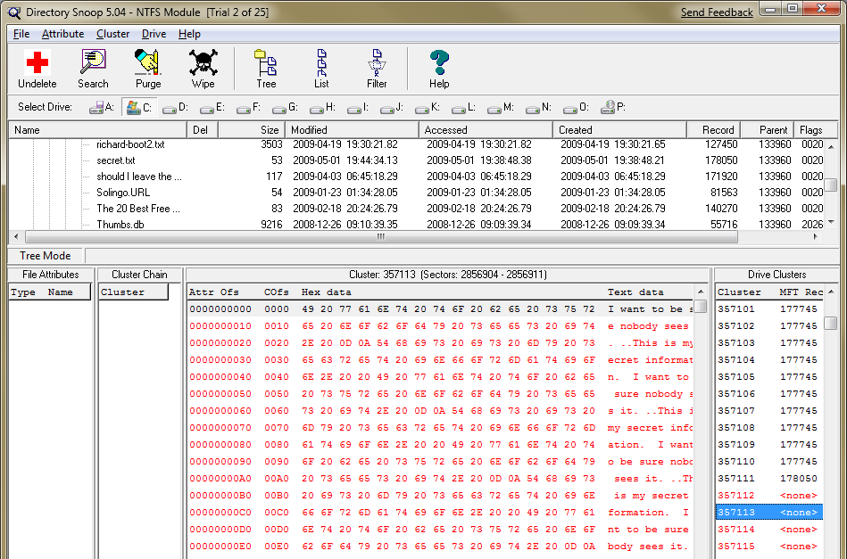
Capturing the Screen Image
- Press the PrntScn key to copy whole screen to the clipboard. Open Paint and paste in the image. Save it as a JPEG, with the filename Your Name Proj 16.
Turning in your Project
- Email the JPEG image to me as an attachment. Send the message to cnit.120@gmail.com with a subject line of Proj 16 From Your Name. Send a Cc to yourself.
Last modified 7-9-10

