What You Will Need
- A computer Windows 7 (or Windows XP, or Vista)
- The computer must have Microsoft Word on it.
- Administrator privileges
- The instructions assume you are using Windows 7

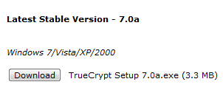
Downloading and Installing TrueCrypt
- Open Firefox and go to truecrypt.org
- On the upper left, click Downloads.
- In the "Latest Stable Version" section, under the 'Windows 7/Vista/XP/2000" line, click the Download button. Save the file on your desktop.
- On your desktop, double-click the installer file and install the software with the default options.

Creating an Encrypted Volume
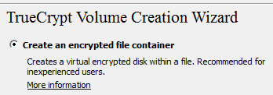
- Click Start, TrueCrypt.
- In the TrueCrypt window, click the "Create Volume" button.
- In the "TrueCrypt Volume Creation Wizard" box, accept the default selection of "Create an encrypted file container", as shown to the right on this page. Click Next.
- In the "Volume Type" box, accept the default selection of "Standard TrueCrypt volume". Click Next.
- In the "Volume Location" box, click the "Select File..." button. Navigate to your desktop and type in a File Name of YourNameEncrypted, replacing YourName with your own name. Click Save. Click Next.
- In the "Encryption Options" box, accept the default choices and click Next.
- In the "Volume Size" box, enter a size of 10 MB. Click Next.
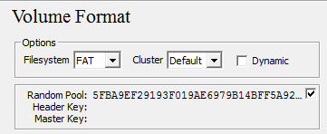
- In the "Volume Password" box, enter a password of your choice in both boxes. Click Next. If a WARNING box pops up saying your password is too short, click Yes.
- In the "Volume Format" box, move the mouse randomly for a few seconds to create random values, as shown to the right on this page. Click Format. Click OK.
- In the "Volume Created" box,. click Exit.

Assigning a Drive Letter to the Encrypted Volume
- In the TrueCrypt window, in the top pane, click a drive letter, such as M:. In the lower portion of the window, click the "Select File…" button. Navigate to your desktop and double-click the YourNameEncrypted file.
- In the lower portion of the TrueCrypt window, click the Mount button.
- A box pops up asking for your password. Enter it and then click OK.
- You should see your file mounted as a drive in the upper portion of the TrueCrypt window, as shown below on this page.
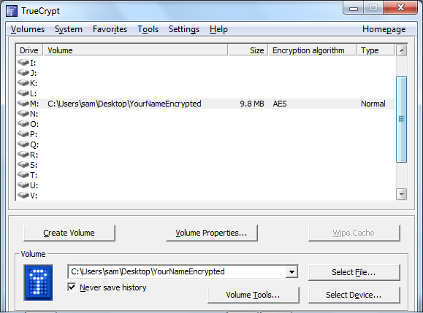

Capturing the Screen Image
- Make sure the path to your encrypted file appears next to a drive letter in the upper portion of the TrueCrypt window. Press the PrntScn key to copy whole screen to the clipboard. Open Paint and paste in the image. Save it as a JPEG, with the filename Your Name Proj 17a.
Saving Data in the Encrypted Volume
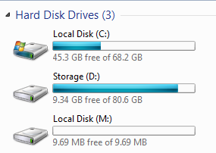
- Click Start, Computer. You should see a Local Disk with the drive letter you chose, as shown to the right on this page--this is the encrypted volume
- Double-click the encrypted volume to open it.
- In the "Local Disk: (M:)" window, right-click an empty portion and click New, :"Text Document".
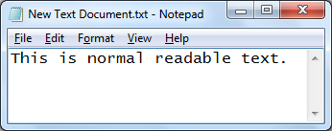
- Double-click the new document to open it in Notepad. Type in a readable sentence, as shown to the right on this page. Save the file. Close Notepad.
Viewing the Raw Encrypted Volume
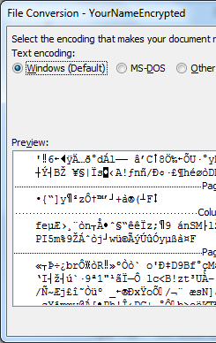
- The encrypted volume works just like a regular volume once it has been mounted through TrueCrypt. But if someone without the password attempts to open it, it will be unreadable, as you will see.
- In the TrueCrypt window, click your mounted volume in the upper pane and click the Dismount button.
- Minimize all windows. Right-click the YourNameEncrypted file and click Open. In the "Open With…" box, double-click Microsoft Word.
- A "File Conversion" box opens, showing a Preview of the file in the lower section. As you can see, he file is unreadable nonsense.
Capturing the Screen Image
- Make sure the window shows the scrambled, unreadable text in the file,
- Press the PrntScn key to copy whole screen to the clipboard. Open Paint and paste in the image. Save it as a JPEG, with the filename Your Name Proj 17b.
Turning in your Project
- Email the JPEG image to me as an attachment. Send the message to cnit.120@gmail.com with a subject line of Proj 17 From Your Name. Send a Cc to yourself.
Last modified 10-27-10

