Warning! Unexpected port scans are rude, and possibly even illegal! Port scans can set off intrusion detection systems and get us all into trouble. Don’t scan other people’s servers, just scan machines you have permission to scan. The only machines you should scan in this project are machines in S214, or on your own network at home.

What You Need
- A Scanner Machine running Windows 7 or Vista with Nmap installed. You should have prepared that machine in Project 9: Port Scans and Windows Firewall.
- An Ubuntu virtual machine. You should have prepared that machine in Project 4: Installing Ubuntu Linux.

Start Your Ubuntu 8.04 Virtual Machine
- Click Start. In the Search box, type vmware
- When "VMware Player" appears at the top of the list, press the Enter key on the keyboard.
- If you see an Agreement, agree to it.
- In the "VMware Player" box, click Open.
- In the "Open Virtual Machine" box, navigate to the VMs drive. Open the folder with your name on it, and the Ubuntu folder. Click the "Ubuntu Linux.vmx" file and click the Open button.
- When your machine starts up, log in as with the name and password you chose in the previous project. If you have forgotten your password, there are several techniques to bypass the password at this link:
http://www.ubuntu-unleashed.com/search/label/Ubuntu%20Password%20Recovery

Ensuring that You Have an Internet Connection
- From the menu bar in the upper left corner of the Ubuntu desktop, click Applications, Accessories, Terminal.
- In the Terminal window, after the $ prompt, enter this command, then press the Enter key:
ping ubuntu.com
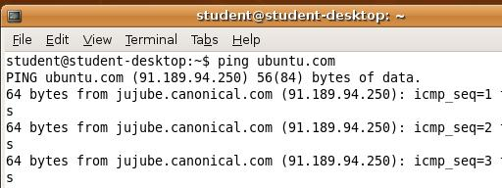
- You should see lines starting "64 bytes from…", as shown to the right on this page. Press Ctrl+C to stop the pinging.
- If you don't see any replies, your virtual machine is not connected to the Internet. You need to be connected to the Internet to proceed with this project. Try the sudo dhclient command to get a new IP address. If that doesn't work, ask your instructor for assistance.
Installing SSH on the Ubuntu Machine
- SSH is a secure way to connect remotely to your Ubuntu machine. We'll install it, just so there's something to see in the port scans.
- On your Ubuntu machine, in the Terminal window, type this command, and then press the Enter key:
sudo apt-get install ssh
Enter your password of P@ssw0rd if you are prompted to. When you are asked "Do you want to continue [Y/n]?", type Y and press the Enter key.

Finding the IP Address of Your Ubuntu Machine
- In the Ubuntu virtual machine, in the Terminal window, after the $ prompt, enter this command, then press the Enter key:

Ubuntu IP: ____________________
ifconfig
- Write your IP address in the box above on this page. It should start with 192.168.1.

Port Scanning Your Ubuntu Machine
- On the Scanner Machine's desktop, double-click "Nmap – Zenmap GUI".
- In the Zenmap window, in the Target: box, type the "Ubuntu IP" you wrote in the box above on this page. Click the Scan button.
- Nmap results appear in the lower pane. Scroll down to the main chart showing "PORT STATE SERVICE VERSION" in blue letters with green results under it. Port 22/tcp should be open, for the ssh service, as shown below on this page. There may be other ports open also.
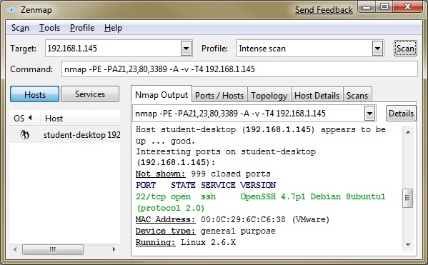

Saving a Screen Image
- On the Scanner Machine, make sure the Zenmap window is visible, showing at least one open port.
- Press the PrintScrn key to copy the whole desktop to the clipboard.
- Press the Windows logo key on the lower left of the keyboard (). Type PAINT into the search box.
- "Paint" should appear in the Programs list. If it's not already highlighted, press the down-arrow as needed to highlight it. Then press the Enter key.
- In the untitled - Paint window, select Edit, Paste from the menu bar. The desktop appears in the Paint window, with only a corner of it visible.
- In the untitled - Paint window, click File, Save. Save the image with the filename Your Name Proj 1xa. Select a "Save as type" of JPEG.
Configuring the iptables Firewall to Allow Established Traffic
- On the Ubuntu machine, in the Terminal window, type this command, and then press the Enter key:
sudo iptables -A INPUT -m state --state ESTABLISHED,RELATED -j ACCEPT
This rule will allow the machine to act as a client, like the Windows firewall—traffic initiated by the machine will be allowed. Of course, this won't make any immediate difference because right now all traffic is allowed anyway.
Configuring the iptables Firewall to Block All Other Traffic
- On the Ubuntu machine, in the Terminal window, type this command, and then press the Enter key:
sudo iptables -A INPUT -j DROP
This rule will cause all traffic to be dropped, except the traffic that was allowed by the previous rule.
- In the Terminal window, type this command, and then press the Enter key:
sudo iptables -L
You should see two rules, one beginning with ACCEPT, followed by one beginning with DROP, as shown below on this page.
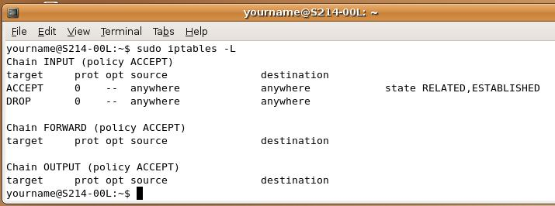

Checking Network Connectivity from the Ubuntu Machine
- On the Ubuntu machine, in the Terminal window, type this command, and then press the Enter key:
firefox
- Firefox opens. View a couple of Web pages. It should work, because those connections are established by the Ubuntu machine, and therefore allowed by the iptables firewall.

Port Scanning Your Ubuntu Machine
- On the Scanner Machine's desktop, double-click "Nmap – Zenmap GUI".
- In the Zenmap window, in the Target: box, verify that the "Ubuntu IP" is entered correctly. Click the Scan button.
- Nmap results appear in the lower pane. Scroll down and find this message "All 1000 scanned ports … are filtered", as shown below on this page.
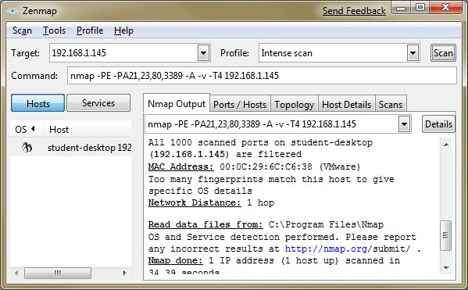

Saving a Screen Image
- On the Scanner Machine, make sure the Zenmap window is visible, showing the message "All 1000 scanned ports … are filtered".
- Press the PrintScrn key to copy the whole desktop to the clipboard.
- Press the Windows logo key on the lower left of the keyboard (). Type PAINT into the search box.
- "Paint" should appear in the Programs list. If it's not already highlighted, press the down-arrow as needed to highlight it. Then press the Enter key.
- In the untitled - Paint window, select Edit, Paste from the menu bar. The desktop appears in the Paint window, with only a corner of it visible.
- In the untitled - Paint window, click File, Save. Save the image with the filename Your Name Proj 1xb. Select a "Save as type" of JPEG.

Turning in Your Project
- Email the JPEG images to me as attachments to a single email message. Send it to: cnit.120@gmail.com with a subject line of Proj 1x From Your Names, replacing Your Names with the complete names of both partners. Send a Cc to yourself.

Last Modified: 7-9-10

