What You Need for This Project
- A trusted computer running Ubuntu Linux 6.10. This can be either a real or virtual machine.
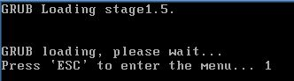
Starting Ubuntu in Recovery Mode
- Start Ubuntu Linux as usual, from the hard disk. When you see a " GRUB Loading" message, as shown to the right on this page, click in the virtual machine and press the ESC key. You have to be fast—you have only a few seconds to do it.
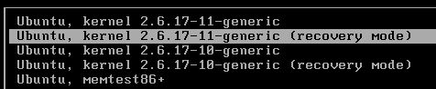
- In the next screen, you have a selection of kernel options, as shown to the right on this page. Select one of the ones labeled (recovery mode).
- This mode is analogous to Window's Safe Mode. If your Ubuntu linux has no password on the root account (which is the default situation), you can start in recovery mode without a password, and run as root, with full administrative privileges.
Using whoami to determine your user name
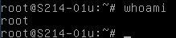
- When Ubuntu starts up, you see text only, no graphics, as shown to the right on this page. This is recovery mode. Enter this command, then press the Enter key:
whoami
The response tells you your user name: it is root.
Editing the passwd File to Create a New User Named drevil
- In the terminal window, enter this command, then press the Enter key:
cd /etc
This command changes the current working directory to /etc. This is where two essential system files are found: passwd and shadow.
- In the terminal window, enter this command, then press the Enter key:
cp passwd passwd.bak
This command copies the passwd file to a backup, so you can undo the changes you are about to make if something goes wrong. Form a strict habit of creating these backup files! You are messing with essential system files, and you will be unhappy if you wreck a system and have no way back. Ubuntu does not have anything like Windows XP's System Restore – if you wreck it, you have to figure out what you did and fix it yourself.

- In the terminal window, enter this command, then press the Enter key:
pico passwd
Scroll to the bottom of the file and type this line in exactly, as shown to the right on this page:
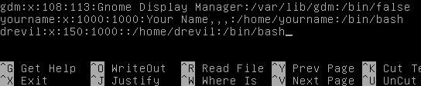
drevil:x:150:1000::/home/drevil:/bin/bash

- Hold down the Ctrl key and press the O key to save your file. A message appears saying File Name to Write: passwd. Press the Enter key.
- Hold down the Ctrl key and press the X key to exit from pico. You should see a # prompt again.
- The passwd file has this format:
Each line in this file contains information about one account. Each line has 7 colon-delimited fields (this means 7 entries separated by colons): login name, the letter "x", the numerical user ID, the numerical primary group ID for the user, a comment field (for example, the full name of the user), the user's $HOME directory, the name of the shell (meaning the program that is run at login). (From http://linux.about.com/od/linux101/l/blnewbie3_2_3.htm)
- So the line you just added created a new user named drevil But we have not created a password for this account yet.
Examining the shadow File
- In the terminal window, enter this command, then press the Enter key:
cp shadow shadow.bak
This command copies the shadow file to a backup.
- In the terminal window, enter this command, then press the Enter key:
pico shadow
The file should open in pico. Use the arrow keys to move the cursor to the bottom of the file. You should see your account names with a hashed password, looking like random characters, as shown below on this page:
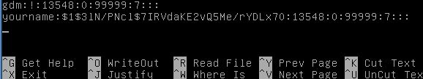

- This file contains the passwords for each account that has a password, in a hashed form (scrambled with a one-way function, usually MD5). Now we have a little problem: we want to give drevil a password, but there is no way to calculate the hashed password. Ubuntu is smarter than Windows XP and does not use predictable hashes. But we can still get the hash by setting the password for the root account.
- Hold down the Ctrl key and press the X key to exit from pico. You should see a # prompt again.
Changing the root Password
- In the terminal window, enter this command, then press the Enter key:
passwd
- When you see the Enter new UNIX password: prompt, type in a new password you like, such as password and press the Enter key. You won't see anything on the screen when you type—just type it anyway.
- At the Retype new UNIX password: prompt, type in a the same password and press the Enter key. . You should see password updated successfully.
Editing the shadow File to Create a Password for drevil
- In the terminal window, enter this command, then press the Enter key:
pico shadow
The file should open in pico, as shown below on this page.
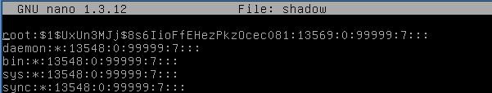

- The first line now contains a long hashed password for the root account. All you need to do is to copy this line and paste it at the bottom, as shown below.
- If necessary, use the arrow keys to place the cursor in the line starting with root. Hold down the Ctrl key an d press K to cut the line. Then hold down the Ctrl key and press U to uncut (paste) the line back.
- Use the arrow keys to move to the bottom of the file. Hold down the Ctrl key and press U to uncut (paste) another copy of the same line.
- Finally, change the name root in the last line to drevil
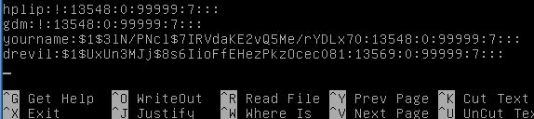

- Your file should contain the same hashed password for the root and drevil accounts, as shown in the figure on the previous this page. Your hashes will be different from mine, even if you use the same password ("password"), because they are "salted" – we will discuss this later.
Saving the Screen Image
- Make sure the pico window is visible, showing the drevil line with the hashed password. Click outside the virtual machine window to make the host Windows XP operating system receive your keystrokes. Then press the PrtScn button to capture the screen image.
- On the host Windows XP desktop, click Start, Run. Enter the command mspaint and press the Enter key. Paint opens.
- Press Ctrl+V on the keyboard to paste the image into the Paint window. Click File, Save. Save the document with the filename Your Name Proj 2xa. Select a Save as type of JPEG.
Saving the Modified shadow File
- Click in the pico window to make it active again. Hold down the Ctrl key and press the O key to save your file. A message appears saying File Name to Write: shadow. Press the Enter key.
- Hold down the Ctrl key and press the X key to exit from pico. You should see a # prompt again.
Creating the Home Directory /home/drevil
- In the terminal window, enter this command, then press the Enter key:
cd /home
This command changes the working directory to /home
- In the terminal window, enter this command, then press the Enter key:
mkdir drevil
This command makes a working directory named drevil
- In the terminal window, enter this command, then press the Enter key:
chown drevil drevil
This command changes the owner of the drevil directory to the user drevil.
Adding drevil to the admin Group
- In the terminal window, enter this command, then press the Enter key:
addgroup drevil admin
This command adds drevil to the admin group, so drevil can use the sudo command to do administrative tasks.
Restarting the Ubuntu Machine
- Press Ctrl+Alt+Ins to restart Ubuntu. Don't enter recovery mode – just let it start normally.
Logging in as drevil
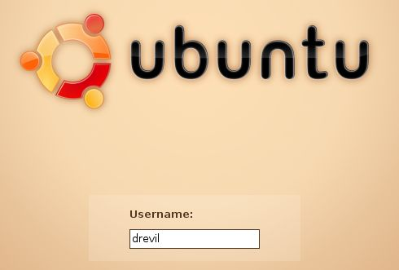
- You should see a login screen, as shown to the right on this page. Type in the user name drevil and press the Enter key.
- In the next screen, enter the password you used, such as password and press the Enter key.
Running whoami
- From the menu bar, click Applications, Accessories, Terminal.
- In the terminal window, enter this command, then press the Enter key:
whoami
Saving the Screen Image
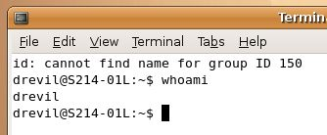
- Make sure the Terminal window identifying you as drevil is visible. Then click outside the virtual machine window to make the host Windows XP operating system receive your keystrokes. Then press the PrtScn button to capture the screen image.
- On the host Windows XP desktop, click Start, Run. Enter the command mspaint and press the Enter key. Paint opens.
- Press Ctrl+V on the keyboard to paste the image into the Paint window. Click File, Save. Save the document with the filename Your Name Proj 2xb. Select a Save as type of JPEG.
Turning in your Project
- Email the JPEG images to me as email attachments to a single message. Send the message to cnit.120@gmail.com with a subject line of Proj 2x From Your Name. Send a Cc to yourself.
Last modified 7-9-10

