What You Will Need
- A computer Windows 7 (or Windows XP, or Vista)
- Administrator privileges
- The instructions assume you are using Windows 7

Downloading and Installing the Gnu Privacy Guard
- The Gnu Privacy Guard is a software package that generates keys and encrypts data.
- Open a Web browser and go to ftp://ftp.gnupg.org/gcrypt/binary
- Scroll down and find the latest Windows version--when I wrote this, it was gupg-w32cli=1.4.9.exe, as shown below on this page.
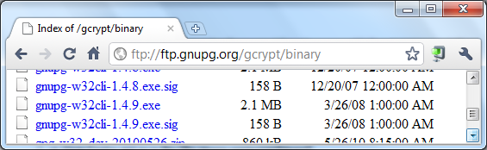

- Download the EXE file. Save the file on your desktop.
- On your desktop, double-click the installer file and install the software with the default options.

Creating a Gmail Account
- You could use an existing email account for this project, but I recommend that you create a new one if you are working in S214 to prevent other students stealing your password. Go to gmail.com and click the "Create an account" button.
- Fill out the form to create an account.

Enabling IMAP
- IMAP is Internet Message Access Protocol, and we will use it to connect Thunderbird to Gmail.
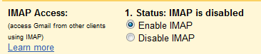
- You should now be logged in to Gmail. On the upper right, click Settings.
- On the Settings page, click "Forwarding and POP/IMAP". In the "IMAP Access" section, click "Enable IMAP", as shown to the right on this page. Click "Save Changes".

Downloading and Installing Thunderbird
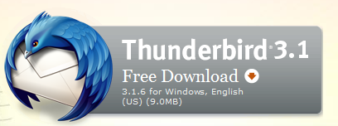
- Thunderbird is an email client.
- Open a Web browser and go to getthunderbird.com
- Click the "Free Download" button, as shown to the right on this page. Download the software and install it with the default options.

Configuring Thunderbird
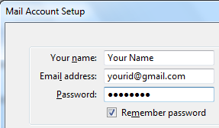
- After installation, Thunderbird launches automatically.
- In the "Import Settings and Mail Folders" box, check the "Don't import anything" box and click Next.
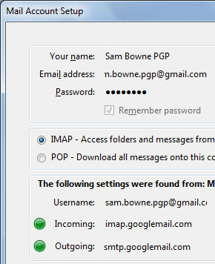
- In the "Mail Account Setup" box, enter you’re the requested information and click Continue. Note:if you are using a real email account on a public computer, don't check the "Remember password" box.
- Thunderbird should automatically configure your email account, so both the Incoming and Outgoing mail servers show green dots, as shown to the right on this page. If that doesn't work, check your user name and password.
- When both dots are green, click the "Create Account" button.
- In the "System Integration" box, click OK.

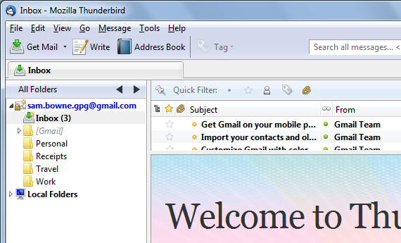
- You should now see your inbox in Thunderbird, as shown to the right on this page.

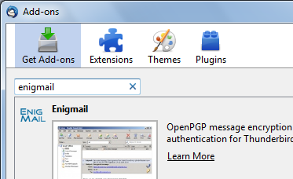
Installing Enigmail
- Enigmail is a Thunderbird add-on that allows you to use Gnu PG to encrypt your email.
- At the top of the Thunderbird window, click Tools, Add-ons.
- In the Add-ons box, type enigmail into the search box and press Enter. Enigmail is found, as shown to the right on this page. Click the "Add to Thuinderbird…" button.
- Click the "Install Now" button. Wait while the software downloads and installs.
- When you see the "Install Complete" message, click the "Restart Thunderbird" button.

Using the Enigmail Key Generation Wizard
- At the top of the Thunderbird window, click OpenPGP, "Key Management"
- In the "Welcome to the OpenPGP Setup Wizard" box, click Next.
- In the Signing box, click Next.
- In the Encryption box, click Next.
- In the Preferences box, click Next.
- In the "Create Key" box, type a passphrase of your choice into both boxes and click Next.
- In the Summary box, click Next.

- A "Key Creation" box appears. You need to use your computer for something else for a while to create randomness. When the key management process is done, you will see an "OpenPGP Confirm" box, as shown below on this page.
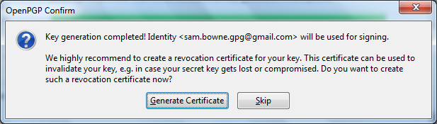

- Click Skip. Click Finish.

Publishing Your Public Key
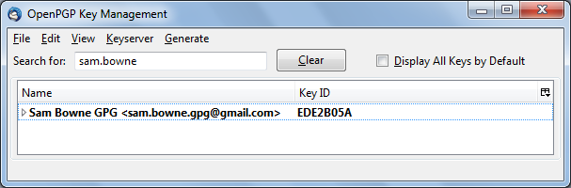
- No one can send you encrypted email unless you put your public key on a server where people can find it.
- In the "OpenPGP Key Management" window, type your email address into the search box. Your key should appear in the lower pane, with a Key ID, as shown below on this page.

- Right-click your key ID and click "Upload public keys to keyserver".
- In the "Select Keyserver" box, click OK.

Importing Sam's Public Key
- In the "OpenPGP Key Management" window, click Keyserver, "Search for Keys".
- In the "Select Keyserver" box, type sam.bowne.pgp@gmail.com and click OK.
- A "Found Keys" box pops up. Check sam.bowne.pgp@gmail.com and click OK.
- In the "OpenPGP Alert" box, click OK.
- Your "OpenPGP Key Management" box should now show two keys: one for you, and one for Sam. Close the "OpenPGP Key Management" box.

Sending an Encrypted Email
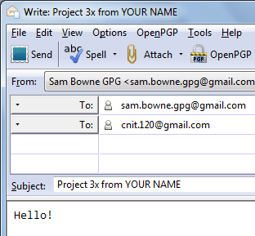
- In Thunderbird, click the Write button.
- Compose an email to these two recipients, as shown to the right on this page:
- sam.bowne.pgp@gmail.com
- cnit.120@gmail.com
- Enter a Subject of "Project 3x from YOUR NAME", replacing YOUR NAME with your own name.
- Put some text in the body of the message, such as "Hello!".
- On the menu bar, click OpenPGP, "Encrypt Message".
- Click Send.
- In the "OpenPGP Key Selection" box, click OK.
- In the "OpenPGP Confirm" box, click Continue.
- You're done--we will grade the project based on that email.

Last modified 11-10-10

