Objectives

Define computer forensics

Describe how to prepare for computer investigations and explain the difference between law enforcement agency and corporate investigations

Explain the importance of maintaining professional conduct
Understanding Computer Forensics

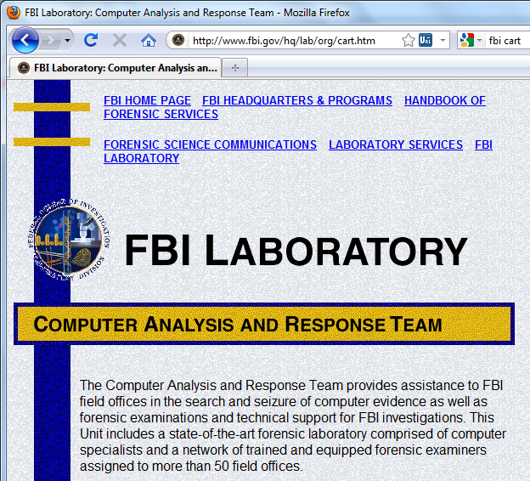
Computer forensics

Involves obtaining and analyzing digital information

As evidence in civil, criminal, or administrative cases

FBI Computer Analysis and Response Team (CART)

Formed in 1984 to handle the increasing number of cases involving digital evidence

Fourth Amendment to the U.S. Constitution

Protects everyone’s rights to be secure in their person, residence, and property

From search and seizure

Search warrants are needed

Computer Forensics Versus Other Related Disciplines

Computer forensics

Investigates data that can be retrieved from a computer’s hard disk or other storage media

Network forensics

Yields information about how a perpetrator or an attacker gained access to a network

Data recovery

Recovering information that was deleted by mistake

Or lost during a power surge or server crash

Typically you know what you’re looking for

Computer forensics

Task of recovering data that users have hidden or deleted and using it as evidence

Evidence can be inculpatory (“incriminating”) or exculpatory

Disaster recovery

Uses computer forensics techniques to retrieve information their clients have lost

Investigators often work as a team to make computers and networks secure in an organization

Enterprise network environment

Large corporate computing systems that might include disparate or formerly independent systems

Vulnerability assessment and risk management group

Tests and verifies the integrity of standalone workstations and network servers

Professionals in this group have skills in network intrusion detection and incident response

Litigation

Legal process of proving guilt or innocence in court

Computer investigations group

Manages investigations and conducts forensic analysis of systems suspected of containing evidence related to an incident or a crime
History of Computer Forensics

A Brief History of Computer Forensics

By the 1970s, electronic crimes were increasing, especially in the financial sector

Most law enforcement officers didn’t know enough about computers to ask the right questions

Or to preserve evidence for trial

1980s

PCs gained popularity and different OSs emerged

Disk Operating System (DOS) was available

Forensics tools were simple, and most were generated by government agencies

Mid-1980s

Xtree Gold appeared on the market

Recognized file types and retrieved lost or deleted files

Norton DiskEdit soon followed

And became the best tool for finding deleted file

1987

Apple produced the Mac SE

A Macintosh with an external EasyDrive hard disk with 60 MB of storage

Early 1990s

Tools for computer forensics were available

International Association of Computer Investigative Specialists (IACIS)

Training on software for forensics investigations

IRS created search-warrant programs

ExpertWitness for the Macintosh

First commercial GUI software for computer forensics

Created by ASR Data

Early 1990s (continued)

ExpertWitness for the Macintosh

Recovers deleted files and fragments of deleted files

Large hard disks posed problems for investigators

Now

iLook

Maintained by the IRS, limited to law enforcement

EnCase

Available for public or private use

AccessData Forensic Toolkit (FTK)

Available for public or private use


Computer Forensics Tools

Most Important Commercial Forensic Software Today

EnCase

link Ch 1a on my Web page

Go to Samsclass.info, then click CNIT 121

FTK

Link Ch 1b

Free demo version (we will use it in this class)

Open Source Forensic Tools

Linux-based

Knoppix Live CDs

Helix

Ubuntu


Backtrack

Not commonly used as the main tool, but for special purposes
Laws and Resources

Understanding Case Law

Technology is evolving at an exponential pace

Existing laws and statutes can’t keep up change

Case law used when statutes or regulations don’t exist

Case law allows legal counsel to use previous cases similar to the current one

Because the laws don’t yet exist

Each case is evaluated on its own merit and issues

Developing Computer Forensics Resources

You must know more than one computing platform

Such as DOS, Windows 9x, Linux, Macintosh, and current Windows platforms

Join as many computer user groups as you can

Computer Technology Investigators Network (CTIN)

Meets monthly to discuss problems that law enforcement and corporations face

High Technology Crime Investigation Association (HTCIA)

Exchanges information about techniques related to computer investigations and security

User groups can be helpful

Build a network of computer forensics experts and other professionals

And keep in touch through e-mail

Outside experts can provide detailed information you need to retrieve digital evidence
Public and Private Investigations

Preparing for Computer Investigations

Computer investigations and forensics falls into two distinct categories

Public investigations

Private or corporate investigations

Public investigations

Involve government agencies responsible for criminal investigations and prosecution

Organizations must observe legal guidelines

Law of search and seizure

Protects rights of all people, including suspects

Private or corporate investigations

Deal with private companies, non-law-enforcement government agencies, and lawyers

Aren’t governed directly by criminal law or Fourth Amendment issues

Governed by internal policies that define expected employee behavior and conduct in the workplace

Private corporate investigations also involve litigation disputes

Investigations are usually conducted in civil cases
Law Enforcement Agency Investigations

Understanding Law Enforcement Agency Investigations

In a criminal case, a suspect is tried for a criminal offense

Such as burglary, murder, or molestation

Computers and networks are sometimes only tools that can be used to commit crimes

Many states have added specific language to criminal codes to define crimes involving computers, such as theft of computer data

Following the legal process

Legal processes depend on local custom, legislative standards, and rules of evidence

Criminal case follows three stages

The complaint, the investigation, and the prosecution
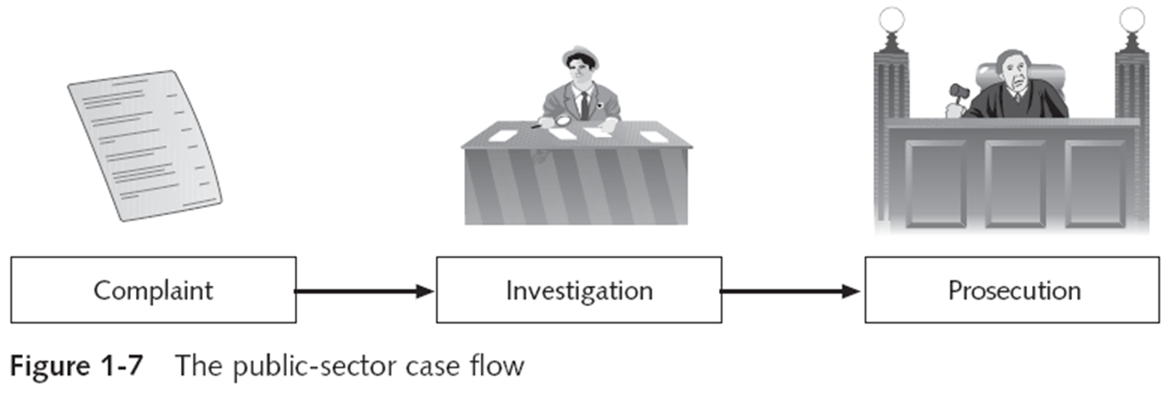

A criminal case begins when someone finds evidence of an illegal act

Complainant makes an allegation, an accusation or supposition of fact

A police officer interviews the complainant and writes a report about the crime

Police blotter provides a record of clues to crimes that have been committed previously

Investigators delegate, collect, and process the information related to the complaint

After you build a case, the information is turned over to the prosecutor

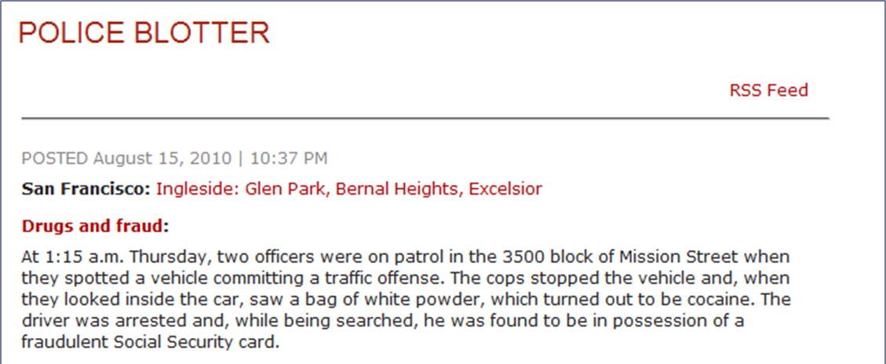

Affidavit

Sworn statement of support of facts about or evidence of a crime

Submitted to a judge to request a search warrant

Have the affidavit notarized under sworn oath

Judge must approve and sign a search warrant

Before you can use it to collect evidence

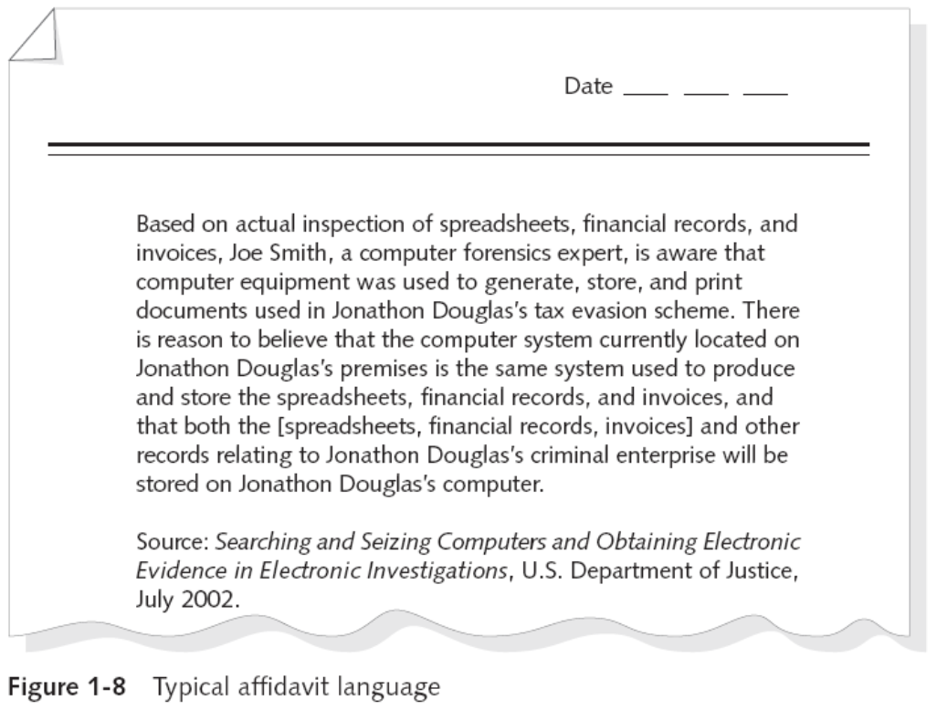

Corporate Investigations

Understanding Corporate Investigations

Private or corporate investigations

Involve private companies and lawyers who address company policy violations and litigation disputes

Corporate computer crimes can involve:

E-mail harassment

Falsification of data

Gender and age discrimination

Embezzlement

Sabotage

Industrial espionage

Establishing company policies

One way to avoid litigation is to publish and maintain policies that employees find easy to read and follow

Published company policies provide a line of authority

For a business to conduct internal investigations

Well-defined policies

Give computer investigators and forensic examiners the authority to conduct an investigation

Displaying Warning Banners

Another way to avoid litigation

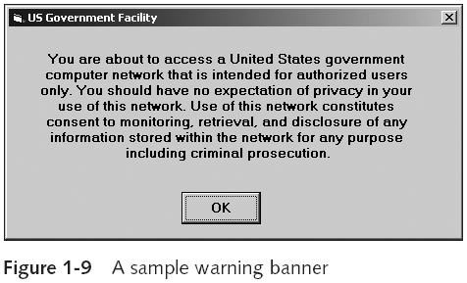
Warning banner

Usually appears when a computer starts or connects to the company intranet, network, or virtual private network

Informs end users that the organization reserves the right to inspect computer systems and network traffic at will

Establishes the right to conduct an investigation

Removes expectation of privacy

As a corporate computer investigator

Make sure company displays well-defined warning banner

Designating an authorized requester

Authorized requester has the power to conduct investigations

Policy should be defined by executive management

Groups that should have direct authority to request computer investigations

Corporate Security Investigations

Corporate Ethics Office

Corporate Equal Employment Opportunity Office

Internal Auditing

The general counsel or Legal Department

Conducting security investigations

Types of situations

Abuse or misuse of corporate assets

E-mail abuse

Internet abuse

Be sure to distinguish between a company’s abuse problems and potential criminal problems

Corporations often follow the silver-platter doctrine

What happens when a civilian or corporate investigative agent delivers evidence to a law enforcement officer

Distinguishing personal and company property

Many company policies distinguish between personal and company computer property

One area that’s difficult to distinguish involves PDAs, cell phones, and personal notebook computers

The safe policy is to not allow any personally owned devices to be connected to company-owned resources

Limiting the possibility of commingling personal and company data

Professional Conduct

Maintaining Professional Conduct

Professional conduct

Determines your credibility

Includes ethics, morals, and standards of behavior

Maintaining objectivity means you must form and sustain unbiased opinions of your cases

Maintain an investigation’s credibility by keeping the case confidential

In the corporate environment, confidentiality is critical

In rare instances, your corporate case might become a criminal case as serious as murder

Maintaining Professional Conduct (continued)

Enhance your professional conduct by continuing your training

Record your fact-finding methods in a journal

Attend workshops, conferences, and vendor courses

Membership in professional organizations adds to your credentials

Achieve a high public and private standing and maintain honesty and integrity

