Objectives

Describe certification requirements for computer forensics labs

List physical requirements for a computer forensics lab

Explain the criteria for selecting a basic forensic workstation

Describe components used to build a business case for developing a forensics lab
Understanding Forensics Lab Certification Requirements

Understanding Forensics Lab Certification Requirements

Computer forensics lab

Where you conduct your investigation

Store evidence

House your equipment, hardware, and software

American Society of Crime Laboratory Directors (ASCLD) offers guidelines for:

Managing a lab

Acquiring an official certification

Auditing lab functions and procedures

Identifying Duties of the Lab Manager and Staff

Lab manager duties:

Set up processes for managing cases

Promote group consensus in decision making

Maintain fiscal responsibility for lab needs

Enforce ethical standards among lab staff members

Plan updates for the lab

Establish and promote quality-assurance processes

Set reasonable production schedules

Estimate how many cases an investigator can handle

Estimate when to expect preliminary and final results

Create and monitor lab policies for staff

Provide a safe and secure workplace for staff and evidence

Staff member duties:

Knowledge and training:

Hardware and software

OS and file types

Deductive reasoning

Technical training

Investigative skills

Deductive reasoning

Work is reviewed regularly by the lab manager

Check the ASCLD Web site for online manual and information (but it's not free, as far as I can tell)

Lab Budget Planning

Break costs down into daily, quarterly, and annual expenses

Use past investigation expenses to extrapolate expected future costs

Expenses for a lab include:

Hardware

Software

Facility space

Trained personnel

Estimate the number of computer cases your lab expects to examine

Identify types of computers you’re likely to examine

Take into account changes in technology

Use statistics to determine what kind of computer crimes are more likely to occur

Use this information to plan ahead your lab requirements and costs

Check statistics from the Uniform Crime Report

For federal reports, see www.fbi.gov/ucr/ucr.htm

Identify crimes committed with specialized software

When setting up a lab for a private company, check:

Hardware and software inventory

Problems reported last year

Future developments in computing technology

Time management is a major issue when choosing software and hardware to purchase

Acquiring Certification and Training

Update your skills through appropriate training

International Association of Computer Investigative Specialists (IACIS)

Created by police officers who wanted to formalize credentials in computing investigations

Only open to law enforcement officers or full-time civilian employees of law enforcement agencies

Certified Electronic Evidence Collection Specialist (CEECS)

Certified Forensic Computer Examiners (CFCEs)

High-Tech Crime Network (HTCN)

Certified Computer Crime Investigator, Basic and Advanced Level

Basic requires 3 years of experience and 10 cases

Certified Computer Forensic Technician, Basic and Advanced Level

Certifications that are available without police experience

EnCase Certified Examiner (EnCE) Certification

Link Ch 3d

AccessData Certified Examiner (ACE) Certification

Link Ch 3e

Other Training and Certifications

High Technology Crime Investigation Association (HTCIA)

Other training and certifications

SysAdmin, Audit, Network, Security (SANS) Institute

Computer Technology Investigators Network (CTIN)

NewTechnologies, Inc. (NTI)

Southeast Cybercrime Institute at Kennesaw State University

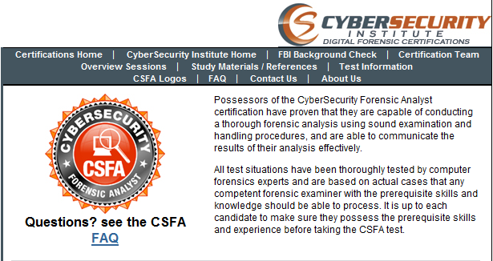
Federal Law Enforcement Training Center (FLETC)

National White Collar Crime Center (NW3C)

CyberSecurity Forensic Analyst (CSFA)

Steve Hailey's company in Washington State

70% of grade based on practical exam

Three days to complete a case

Link Ch 3f

Recommended Certifications

First get ACE Certification

Then get CSFA

We expect a local opportunity to get the CSFA within the next few months

Doug Spindler from PacITPros is working on it

pacitpros.org

Meetings on the first Tuesday each month

Extra credit for attending
Determining the Physical Requirements for a Computer Forensics Lab

Determining the Physical Requirements for a Computer Forensics Lab

Most of your investigation is conducted in a lab

Lab should be secure so evidence is not lost, corrupted, or destroyed

Provide a safe and secure physical environment

Keep inventory control of your assets

Know when to order more supplies

Identifying Lab Security Needs

Secure facility

Should preserve integrity of evidence data

Minimum requirements

Small room with true floor-to-ceiling walls

Door access with a locking mechanism

Secure container

Visitor’s log

People working together should have same access level

Brief your staff about security policy

Conducting High-Risk Investigations

High-risk investigations (national security or murder) demand more security to prevent computer eavesdropping

TEMPEST facilities

Electromagnetic Radiation (EMR) proofed

http://nsi.org/Library/Govt/Nispom.html

TEMPEST facilities are very expensive

You can use low-emanation workstations instead

Using Evidence Containers

Known as evidence lockers

Must be secure so that no unauthorized person can easily access your evidence

Recommendations for securing storage containers:

Locate them in a restricted area

Limited number of authorized people to access the container

Maintain records on who is authorized to access each container

Containers should remain locked when not in use

If a combination locking system is used:

Provide the same level of security for the combination as for the container’s contents

Destroy any previous combinations after setting up a new combination

Allow only authorized personnel to change lock combinations

Change the combination every six months or when required

If you’re using a keyed padlock:

Appoint a key custodian

Stamp sequential numbers on each duplicate key

Maintain a registry listing which key is assigned to which authorized person

Conduct a monthly audit

Take an inventory of all keys

Place keys in a lockable container

Maintain the same level of security for keys as for evidence containers

Change locks and keys annually

Don't use a master key for several locks

Container should be made of steel with an internal cabinet or external padlock

If possible, acquire a media safe

Protects evidence from fire damage

When possible, build an evidence storage room in your lab

Keep an evidence log

Update it every time an evidence container is opened and closed

Overseeing Facility Maintenance

Immediately repair physical damages

Escort cleaning crews as they work

Minimize the risk of static electricity

Antistatic pads

Clean floor and carpets

Maintain two separate trash containers

Materials unrelated to an investigation

Sensitive materials

When possible, hire specialized companies for disposing sensitive materials

Considering Physical Security Needs

Create a security policy

Enforce your policy

Sign-in log for visitors

Anyone that is not assigned to the lab is a visitor

Escort all visitors all the time

Use visible or audible indicators that a visitor is inside your premises

Visitor badge

Install an intrusion alarm system

Hire a guard force for your lab

Auditing a Computer Forensics Lab

Auditing ensures proper enforcing of policies

Audits should include inspecting:

Ceiling, floor, roof, and exterior walls of the lab

Doors and doors locks

Visitor logs

Evidence container logs

At the end of every workday, secure any evidence that’s not being processed in a forensic workstation

Determining Floor Plans for Computer Forensics Labs
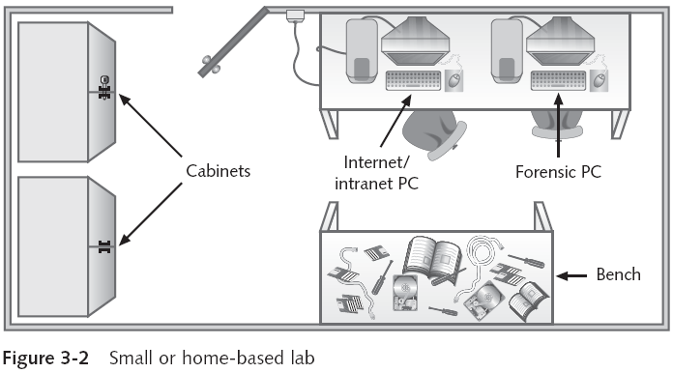

Selecting a Basic Forensic Workstation

Selecting a Basic Forensic Workstation

Depends on budget and needs

Use less powerful workstations for mundane tasks

Use multipurpose workstations for high-end analysis tasks

Selecting Workstations for Police Labs

Police labs have the most diverse needs for computing investigation tools

Special-interest groups (SIG) are helpful to investigate old systems, like CP/M, Commodore 64, etc.

General rule

One computer investigator for every 250,000 people in a region

One multipurpose forensic workstation and one general-purpose workstation

Selecting Workstations for Private and Corporate Labs

Requirements are easy to determine, because you can specialize

Identify the environment you deal with

Hardware platform

Operating system

Gather tools to work on the specified environment

Stocking Hardware Peripherals

Any lab should have in stock:

IDE cables

Ribbon cables for floppy disks

SCSI cards, preferably ultra-wide

Graphics cards, both PCI and AGP types

Power cords

Hard disk drives

At least two 2.5-inch Notebook IDE hard drives to standard IDE/ATA or SATA adapter

Computer hand tools

Maintaining Operating Systems and Software Inventories

Maintain licensed copies of software like:

Microsoft Office 2007, XP, 2003, 2000, 97, and 95

Quicken

Programming languages

Specialized viewers

Corel Office Suite

StarOffice/OpenOffice

Peachtree accounting applications

Using a Disaster Recovery Plan

Keep regular backups, using Ghost or other utilities

Win 7 has Windows Image Backup

Store backups off-site but securely

Be able to restore your workstation and investigation files to their original condition

Recover from catastrophic situations, virus contamination, and reconfigurations

Configuration management

Keep track of software updates to your workstation

Planning for Equipment Upgrades

Risk management

Involves determining how much risk is acceptable for any process or operation

Identify equipment your lab depends on so it can be periodically replaced

Identify equipment you can replace when it fails

Computing components last 18 to 36 months under normal conditions

Schedule upgrades at least every 18 months

Preferably every 12 months

Using Laptop Forensic Workstations

Create a lightweight, mobile forensic workstation using a laptop PC

FireWire port

USB 2.0 port

PCMCIA SATA hard disk

Laptops are still limited as forensic workstations

But improving
Building a Business Case for Developing a Forensics Lab

Building a Business Case for Developing a Forensics Lab

Can be a problem because of budget problems

Business case

Plan you can use to sell your services to management or clients

Demonstrate how the lab will help your organization to save money and increase profits

Compare cost of an investigation with cost of a lawsuit

Protect intellectual property, trade secrets, and future business plans

Preparing a Business Case for a Computer Forensics Lab

When preparing your case, follow these steps:

Justification

Budget development

Facility cost

Computer hardware requirements

Software requirements

Miscellaneous costs

Errors and Omissions Insurance!

Approval and acquisition

Implementation

Steps:

Acceptance testing

Correction for acceptance

Production

Last modified 8-30-10

