Objectives

Explain the rules for digital evidence

Describe how to collect evidence at private-sector incident scenes

Explain guidelines for processing law enforcement crime scenes

List the steps in preparing for an evidence search

Describe how to secure a computer incident or crime scene

Explain guidelines for seizing digital evidence at the scene

List procedures for storing digital evidence

Explain how to obtain a digital hash

Review a case to identify requirements and plan your investigation
Identifying Digital Evidence

Digital evidence

Can be any information stored or transmitted in digital form

U.S. courts accept digital evidence as physical evidence

Digital data is a tangible object

Some require that all digital evidence be printed out to be presented in court

General tasks investigators perform when working with digital evidence:

Identify digital information or artifacts that can be used as evidence

Collect, preserve, and document evidence

Analyze, identify, and organize evidence

Rebuild evidence or repeat a situation to verify that the results can be reproduced reliably

Collecting computers and processing a criminal or incident scene must be done systematically

Understanding Rules of Evidence

Consistent practices help verify your work and enhance your credibility

Comply with your state’s rules of evidence or with the Federal Rules of Evidence

Evidence admitted in a criminal case can be used in a civil suit, and vice versa

Keep current on the latest rulings and directives on collecting, processing, storing, and admitting digital evidence

Data you discover from a forensic examination falls under your state’s rules of evidence

Or the Federal Rules of Evidence

Digital evidence is unlike other physical evidence because it can be changed more easily

The only way to detect these changes is to compare the original data with a duplicate

Most federal courts have interpreted computer records as hearsay evidence

Hearsay is secondhand or indirect evidence

Business-record exception

Allows “records of regularly conducted activity,” such as business memos, reports, records, or data compilations

Generally, computer records are considered admissible if they qualify as a business record

Computer records are usually divided into:

Computer-generated records

Computer-stored records

Computer records must be shown to be authentic and trustworthy

To be admitted into court

Computer-generated records are considered authentic

If the program that created the output is functioning correctly

Collecting evidence according to the proper steps of evidence control helps ensure that the computer evidence is authentic

When attorneys challenge digital evidence

Often they raise the issue of whether computer-generated records were altered

Or damaged after they were created

One test to prove that computer-stored records are authentic is to demonstrate that a specific person created the records

The author of a Microsoft Word document can be identified by using file metadata

Demo: Metadata in FTK

Save a Word document

In FTK:

Click No, OK, OK through the demo warning boxes

Go directly to working with program

File, Add Evidence

Enter your name, Next, Next

Click "Add Evidence" button

Click "Individual File", Continue

Navigate to Word document,double-click it

OK, Next, Continue

FTK Demo

In "File Category", click the Documents button

Select the document in the lower pane

"View files in native format" shows the text typed into the Word document

"View files in filtered text format" shows the metadata, such as the registered owner of the program

The process of establishing digital evidence’s trustworthiness originated with written documents and the best evidence rule

Best evidence rule states:

To prove the content of a written document, recording, or photograph, ordinarily the original writing, recording, or photograph is required

Federal Rules of Evidence

Allow a duplicate instead of originals when it is "produced by the same impression as the original … by mechanical or electronic re- recording … or by other equivalent techniques which accurately reproduce the original."

As long as bit-stream copies of data are created and maintained properly

The copies can be admitted in court, although they aren’t considered best evidence

When a Copy is All You Have

If the hard drive crashes after you make the copy

If removing the original computers is not possible, because it would cause harm to a business or its owner, who might be an innocent bystander

Steve Jackson Games was harmed in this manner when the Secret Service seized all computers because BBS users placed evidence of a crime on them

The company sued and won (link Ch 5a)
Collecting Evidence in Private-Sector Incident Scenes

Collecting Evidence in Private-Sector Incident Scenes

Private-sector organizations include:

Businesses and government agencies that aren’t involved in law enforcement

Agencies must comply with state public disclosure and federal Freedom of Information Act (FOIA) laws

And make certain documents available as public records

FOIA allows citizens to request copies of public documents created by federal agencies

A special category of private-sector businesses includes ISPs and other communication companies

ISPs can investigate computer abuse committed by their employees, but not by customers

Except for activities that are deemed to create an emergency situation

Investigating and controlling computer incident scenes in the corporate environment

Much easier than in the criminal environment

Incident scene is often a workplace

Typically, businesses have inventory databases of computer hardware and software

Help identify the computer forensics tools needed to analyze a policy violation

And the best way to conduct the analysis

Corporate policy statement about misuse of computing assets

Allows corporate investigators to conduct covert surveillance with little or no cause

And access company systems without a warrant

Companies should display a warning banner or publish a policy, or both

Stating that they reserve the right to inspect computing assets at will

Corporate investigators should know under what circumstances they can examine an employee’s computer

Every organization must have a well-defined process describing when an investigation can be initiated

If a corporate investigator finds that an employee is committing or has committed a crime

Employer can file a criminal complaint with the police

Employers are usually interested in enforcing company policy

Not seeking out and prosecuting employees

Corporate investigators are, therefore, primarily concerned with protecting company assets

If you discover evidence of a crime during a company policy investigation

Determine whether the incident meets the elements of criminal law

Inform management of the incident

Stop your investigation to make sure you don’t violate Fourth Amendment restrictions on obtaining evidence

Work with the corporate attorney to write an affidavit confirming your findings

Becoming an Agent of Law Enforcement

If law enforcement officers ask you to find more information, you are at legal risk

Don’t do any further investigation until you receive a subpoena or court order
Processing Law Enforcement Crime Scenes

Processing Law Enforcement Crime Scenes

You must be familiar with criminal rules of search and seizure

You should also understand how a search warrant works and what to do when you process one

Law enforcement officer may search for and seize criminal evidence only with probable cause

Facts or circumstances that lead a reasonable person to believe a crime has been committed or is about to be committed

With probable cause, a police officer can obtain a search warrant from a judge

That authorizes a search and seizure of specific evidence related to the criminal complaint

The Fourth Amendment states that only warrants “particularly describing the place to be searched, and the persons or things to be seized” can be issued

Understanding Concepts and Terms Used in Warrants

Innocent information

Unrelated information

Often included with the evidence you’re trying to recover

Judges often issue a limiting phrase to the warrant

Allows the police to separate innocent information from evidence

Plain view doctrine

Objects falling in plain view of an officer who has the right to be in position to have that view

Are subject to seizure without a warrant and may be introduced in evidence

“Knock and announce”

With few exceptions, warrants require that officers knock and announce their identity

When executing a warrant
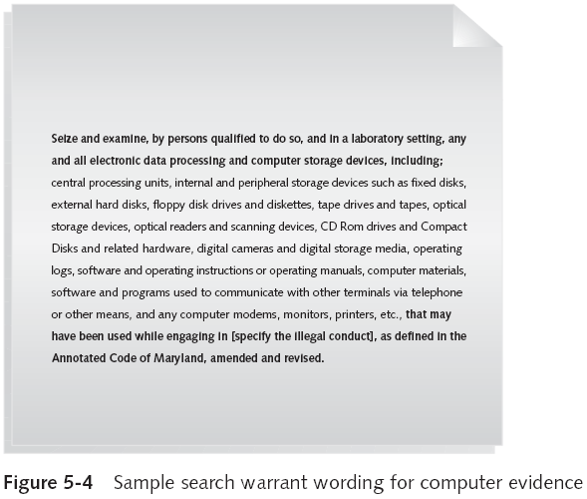
Preparing for a Search

Preparing for a computer search and seizure

Probably the most important step in computing investigations

To perform these tasks

You might need to get answers from the victim and an informant

Who could be a police detective assigned to the case, a law enforcement witness, or a manager or coworker of the person of interest to the investigation

Identifying the Nature of the Case

When you’re assigned a computing investigation case

Start by identifying the nature of the case

Including whether it involves the private or public sector

The nature of the case dictates how you proceed

And what types of assets or resources you need to use in the investigation

Identifying the Type of Computing System

For law enforcement

This step might be difficult because the crime scene isn’t controlled

If you can identify the computing system

Estimate the size of the drive on the suspect’s computer

And how many computers to process at the scene

Determine which OSs and hardware are involved

Determining Whether You Can Seize a Computer

The type of case and location of the evidence

Determine whether you can remove computers

Law enforcement investigators need a warrant to remove computers from a crime scene

And transport them to a lab

If removing the computers will irreparably harm a business

The computers should not be taken offsite

An additional complication is files stored offsite that are accessed remotely

If you aren’t allowed to take the computers to your lab

Determine the resources you need to acquire digital evidence and which tools can speed data acquisition

Obtaining a Detailed Description of the Location

Get as much information as you can

Identify potential hazards

Interact with your HAZMAT team

HAZMAT guidelines

A HAZMAT technician may need to acquire the image, following your instructions

You may need to put the target drive in a special HAZMAT bag

HAZMAT technician can decontaminate the bag

Check for high temperatures

Determining Who Is in Charge

Corporate computing investigations

Require only one person to respond

Law enforcement agencies

Handle large-scale investigations

Designate lead investigators

Using Additional Technical Expertise

Look for specialists

OSs

RAID servers

Databases

Finding the right person can be a challenge

Educate specialists in investigative techniques

Prevent evidence damage

Determining the Tools You Need

Prepare tools using incident and crime scene information

Initial-response field kit

Lightweight

Easy to transport

Extensive-response field kit

Includes all tools you can afford

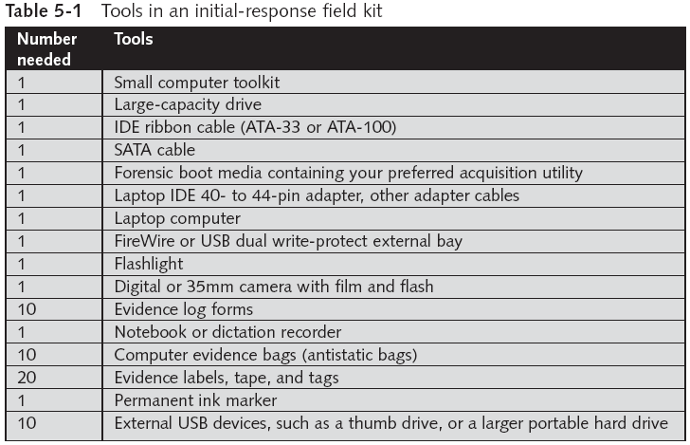

Preparing the Investigation Team

Review facts, plans, and objectives with the investigation team you have assembled

Goals of scene processing

Collect evidence

Secure evidence

Slow response can cause digital evidence to be lost

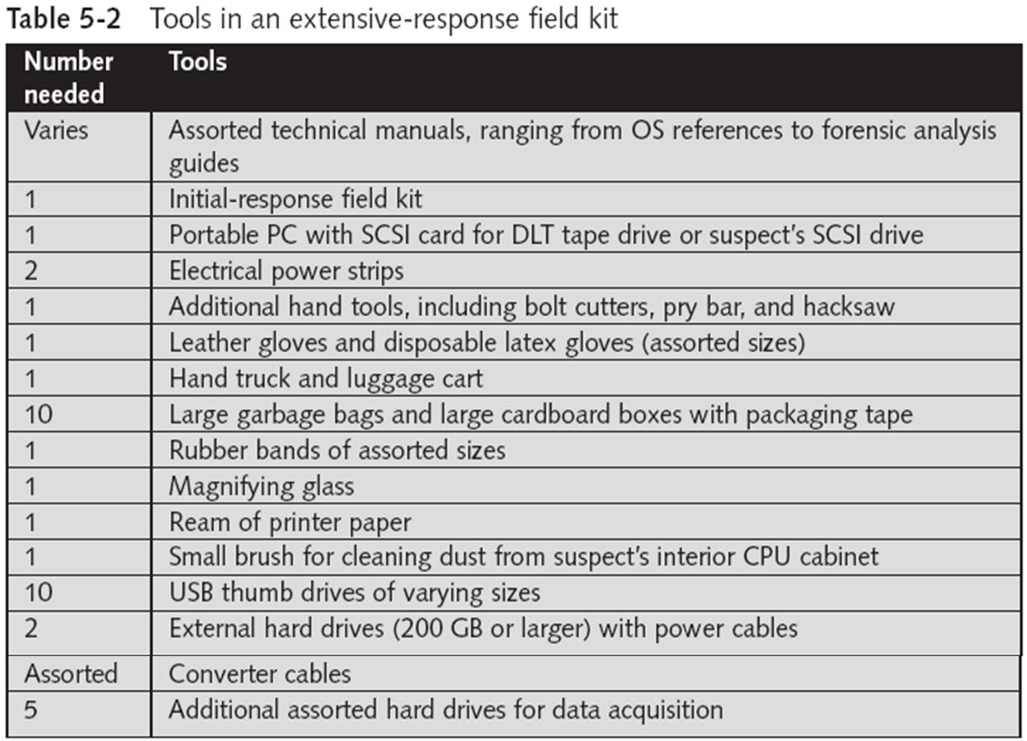

Securing a Computer Incident or Crime Scene

Securing a Computer Incident or Crime Scene

Goals

Preserve the evidence

Keep information confidential

Define a secure perimeter

Use yellow barrier tape

Legal authority: keep unnecessary people out but don’t obstruct justice or fail to comply with police officers

Professional curiosity can destroy evidence

Involves police officers and other professionals who aren’t part of the crime scene processing team

Seizing Digital Evidence at the Scene

Seizing Digital Evidence at the Scene

Law enforcement can seize evidence

With a proper warrant

Corporate investigators rarely can seize evidence

When seizing computer evidence in criminal investigations

Follow U.S. DoJ standards for seizing digital data

Civil investigations follow same rules

Require less documentation though

Consult with your attorney for extra guidelines

Preparing to Acquire Digital Evidence

The evidence you acquire at the scene depends on the nature of the case

And the alleged crime or violation

Ask your supervisor or senior forensics examiner in your organization the following questions:

Do you need to take the entire computer and all peripherals and media in the immediate area?

How are you going to protect the computer and media while transporting them to your lab?

Is the computer powered on when you arrive?

Is the suspect you’re investigating in the immediate area of the computer?

Is it possible the suspect damaged or destroyed the computer, peripherals, or media?

Will you have to separate the suspect from the computer?

Processing an Incident or Crime Scene

Guidelines

Keep a journal to document your activities

Secure the scene

Be professional and courteous with onlookers

Remove people who are not part of the investigation

Take video and still recordings of the area around the computer

Pay attention to details

Sketch the incident or crime scene

Check computers as soon as possible

Handling a Running Computer

Old rule: pull the plug

Don’t cut electrical power to a running system unless it’s an older Windows 9x or MS-DOS system

Perform a live acquisition if possible

When shutting down Win XP or later, or Linux/Unix, perform a normal shutdown, to preserve log files

Save data from current applications as safely as possible

Record all active windows or shell sessions

Photograph the screen

Handling a Running Computer

Make notes of everything you do when copying data from a live suspect computer

Save open files to an external hard drive or a network share

If that is not possible, save them with new names

Close applications and shut down the computer

Bag and tag the evidence, following these steps:

Assign one person to collect and log all evidence

Tag all evidence you collect with the current date and time, serial numbers or unique features, make and model, and the name of the person who collected it

Maintain two separate logs of collected evidence

Maintain constant control of the collected evidence and the crime or incident scene

Look for information related to the investigation

Passwords, passphrases, PINs, bank accounts

Look at papers, in drawers, in trash cans

Collect documentation and media related to the investigation

Hardware, software, backup media, documentation, manuals

Processing Data Centers with RAID Systems

Sparse acquisition

Technique for extracting evidence from large systems

Extracts only data related to evidence for your case from allocated files

And minimizes how much data you need to analyze

Drawback of this technique

It doesn’t recover data in free or slack space

Using a Technical Advisor

Technical advisor

Can help you list the tools you need to process the incident or crime scene

Person guiding you about where to locate data and helping you extract log records

Or other evidence from large RAID servers

Can help create the search warrant by itemizing what you need for the warrant

Technical Advisor Responsibilities

Know aspects of the seized system

Direct investigator handling sensitive material

Help secure the scene

Help document the planning strategy for search and seizure

Conduct ad hoc trainings

Document activities

Help conduct the search and seizure

Documenting Evidence in the Lab

Record your activities and findings as you work

Maintain a journal to record the steps you take as you process evidence

Goal is to be able to reproduce the same results

When you or another investigator repeat the steps you took to collect evidence

A journal serves as a reference that documents the methods you used to process digital evidence

Processing and Handling Digital Evidence

Maintain the integrity of digital evidence in the lab

As you do when collecting it in the field

Steps to create image files:

Copy all image files to a large drive

Start your forensics tool to analyze the evidence

Run an MD5 or SHA-1 hashing algorithm on the image files to get a digital hash

Secure the original media in an evidence locker

Storing Digital Evidence

Storing Digital Evidence

The media you use to store digital evidence usually depends on how long you need to keep it

CD-Rs or DVDs

The ideal media

Capacity: up to 17 GB

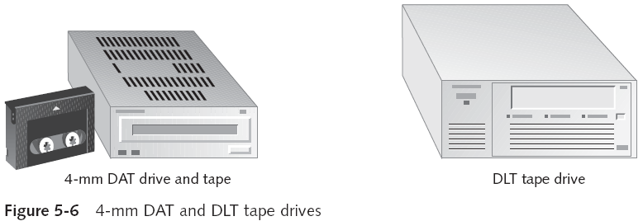
Lifespan: 2 to 5 years

Magnetic tapes

Capacity: 40 to 72 GB

Lifespan: 30 years

Costs: drive: $400 to $800; tape: $40

Evidence Retention and Media Storage Needs

To help maintain the chain of custody for digital evidence

Restrict access to lab and evidence storage area

Lab should have a sign-in roster for all visitors

Maintain logs for a period based on legal requirements

You might need to retain evidence indefinitely

Check with your local prosecuting attorney’s office or state laws to make sure you’re in compliance

You cannot retain child pornography evidence, however

Documenting Evidence

Create or use an evidence custody form

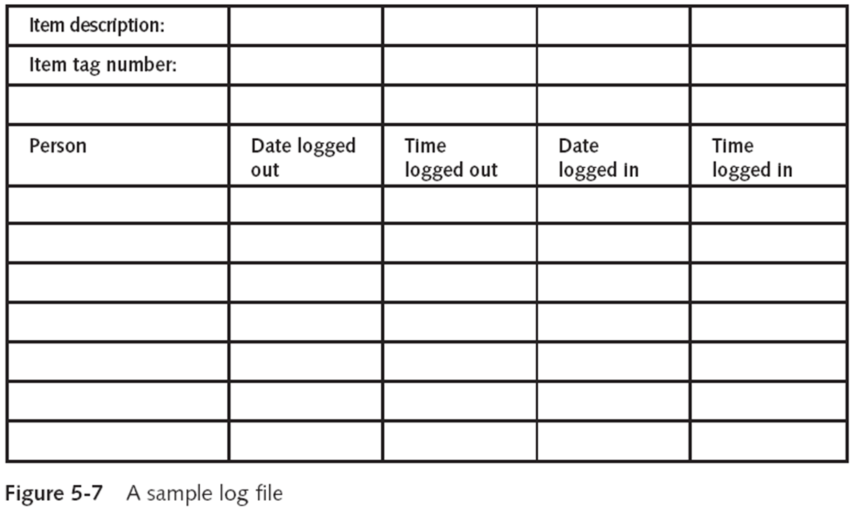
An evidence custody form serves the following functions:

Identifies the evidence

Identifies who has handled the evidence

Lists dates and times the evidence was handled

You can add more information to your form

Such as a section listing MD5 and SHA-1 hash values

Include any detailed information you might need to reference

Evidence bags also include labels or evidence forms you can use to document your evidence
Obtaining a Digital Hash

Obtaining a Digital Hash

Cyclic Redundancy Check (CRC)

Mathematical algorithm that determines whether a file’s contents have changed

Most recent version is CRC-32

Not considered a forensic hashing algorithm

Message Digest 5 (MD5)

Mathematical formula that translates a file into a hexadecimal code value, or a hash value

If a bit or byte in the file changes, it alters the digital hash

Three rules for forensic hashes:

You can’t predict the hash value of a file or device

No two hash values can be the same

If anything changes in the file or device, the hash value must change

Secure Hash Algorithm version 1 (SHA-1)

A newer hashing algorithm

Developed by the National Institute of Standards and Technology (NIST)

In both MD5 and SHA-1, collisions have occurred

Most computer forensics hashing needs can be satisfied with a nonkeyed hash set

A unique hash number generated by a software tool, such as the Linux md5sum command

Keyed hash set

Created by an encryption utility’s secret key

You can use the MD5 function in FTK Imager to obtain the digital signature of a file

Or an entire drive

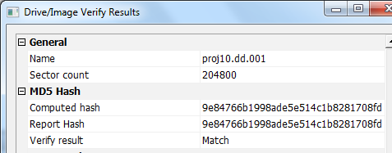
Example Hash from FTK Imager

Reviewing a Case

Reviewing a Case

General tasks you perform in any computer forensics case:

Identify the case requirements

Plan your investigation

Conduct the investigation

Complete the case report

Critique the case

Sample Civil Investigation

Most cases in the corporate environment are considered low-level investigations

Or noncriminal cases

Common activities and practices

Recover specific evidence

Suspect’s Outlook e-mail folder (PST file)

Covert surveillance

Its use must be well defined in the company policy

Risk of civil or criminal liability

Sniffing tools for data transmissions

Covert Surveillance Tools

Spector

WinWhatWhere

EnCase Enterprise Edition

Sample Criminal Investigation

Computer crimes examples

Fraud

Check fraud

Homicides

Need a warrant to start seizing evidence

Limit searching area

Reviewing Background Information for a Case

Company called Superior Bicycles

Specializes in creating new and inventive modes of human-driven transportation

Two employees, Chris Murphy and Nau Tjeriko, have been missing for several days

A USB thumb drive has been recovered from Chris’s office with evidence that he had been conducting a side business using company computers

Identifying the Case Requirements

Identify requirements such as:

Nature of the case

Suspect’s name

Suspect’s activity

Suspect’s hardware and software specifications

Planning Your Investigation

List what you can assume or know

Several incidents may or may not be related

Suspect’s computer can contain information about the case

If someone else has used suspect’s computer

Make an image of suspect’s computer disk drive

Analyze forensics copy

Conducting the Investigation: Acquiring Evidence with AccessData FTK

Functions

Extract the image from a bit-stream image file

Analyze the image

Last modified 9-20-10

