Objectives

Explain the purpose and structure of file systems

Describe Microsoft file structures

Explain the structure of New Technology File System (NTFS) disks

List some options for decrypting drives encrypted with whole disk encryption

Explain how the Windows Registry works

Describe Microsoft startup tasks

Describe MS-DOS startup tasks

Explain the purpose of a virtual machine
Understanding File Systems

Understanding File Systems

File system

Gives OS a road map to data on a disk

Type of file system an OS uses determines how data is stored on the disk

A file system is usually directly related to an OS

When you need to access a suspect’s computer to acquire or inspect data

You should be familiar with the computer’s platform

Understanding the Boot Sequence

Complementary Metal Oxide Semiconductor (CMOS)

Computer stores system configuration and date and time information in the CMOS

When power to the system is off

Basic Input/Output System (BIOS)

Contains programs that perform input and output at the hardware level

Bootstrap process

Contained in ROM, tells the computer how to proceed

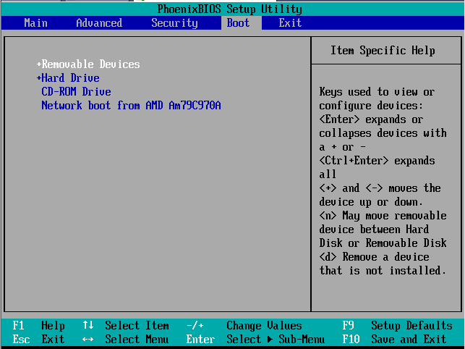
Displays the key or keys you press to open the CMOS setup screen

Could be Delete, F2, F10, Ctrl+Alt+Insert, Ctrl+A, Ctrl+S, Ctrl+F1, or something else

CMOS should be modified to boot from a forensic floppy disk or CD

Understanding Disk Drives

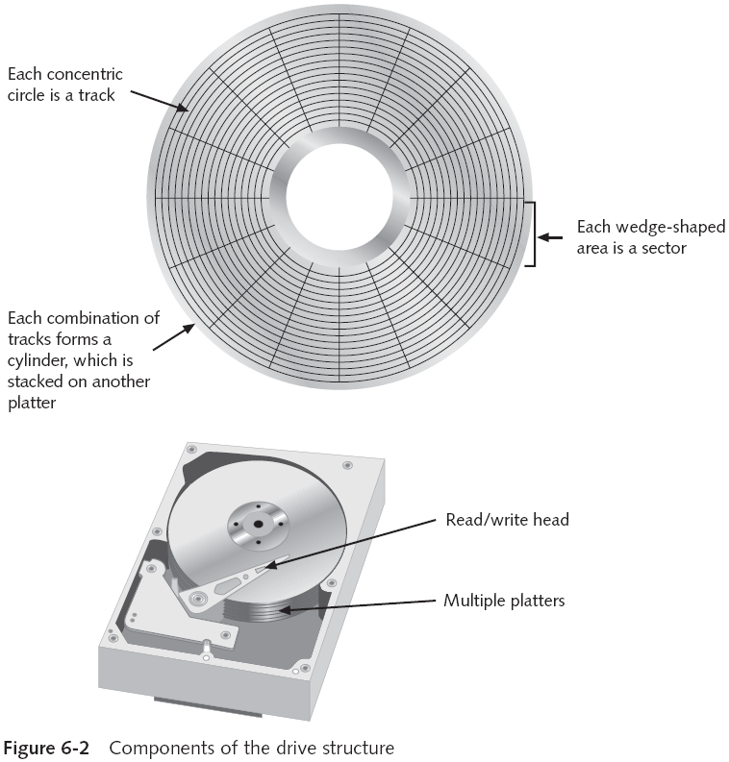
Disk drives are made up of one or more platters coated with magnetic material

Disk drive components

Geometry

Head

Tracks

Cylinders

Sectors

Holds 512 bytes, you cannot read or write anything less than a sector

Properties handled at the drive’s hardware or firmware level

Zoned bit recording (ZBR)

Track density

Areal density

Head and cylinder skew

No Need for Multi-Path Erasure

On older disks, the space between tracks was wider, which allowed heads to wander

This made it possible for specialists to retrieve data from previous writes to a platter, even after erasure

Using an electron microscope

On any IDE or SATA or later hard drive, this is impossible

A single pass of zeroes erases all data on a disk so it cannot be recovered by any currently known technique

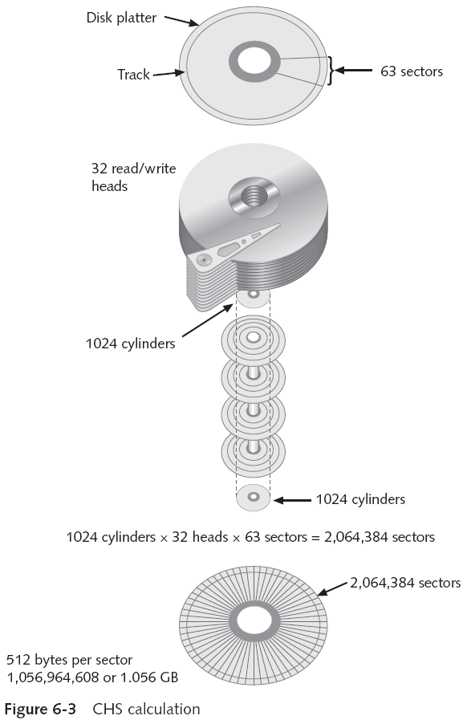
Exploring Microsoft File Structures

Exploring Microsoft File Structures

In Microsoft file structures, sectors are grouped to form clusters

Storage allocation units of one or more sectors

Clusters are typically 512, 1024, 2048, 4096, or more bytes each

Combining sectors minimizes the overhead of writing or reading files to a disk

Clusters are numbered sequentially starting at 2

First sector of all disks contains a system area, the boot record, and a file structure database

OS assigns these cluster numbers, called logical addresses

Sector numbers are called physical addresses

Clusters and their addresses are specific to a logical disk drive, which is a disk partition

Disk Partitions

A partition is a logical drive

FAT16 does not recognize disks larger than 2 GB

Note error on page 202 of textbook

It's 2 GB, not 2 MB

Large disks have to be partitioned

Hidden partitions or voids

Large unused gaps between partitions on a disk

Partition gap

Unused space between partitions

Disk editor utility can alter information in partition table

To hide a partition

Can examine a partition’s physical level with a disk editor:

HxD, Norton DiskEdit, WinHex, or Hex Workshop

Analyze the key hexadecimal codes the OS uses to identify and maintain the file system

Demo: VM with Three Partitions

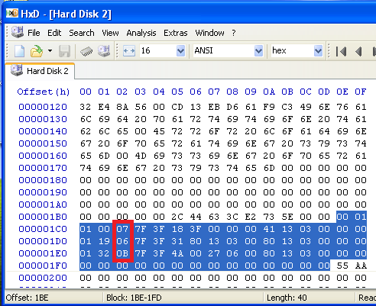
Partition Types

NTFS: 07

FAT: 06

FAT32: 0B

Viewing the Partition Table HxD

Start HxD, Extras, Open Disk, choose Physical Disk

Partition Table starts at 0x1BE

Partition Type field is at offset 0x04 in each record

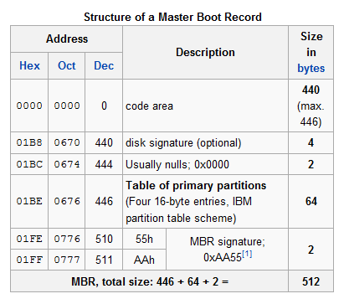

Master Boot Record Structure

From Wikipedia

Link Ch 6a

Partition Table Structure

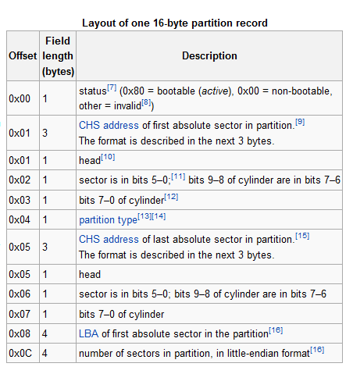
From Wikipedia

Link Ch 6a

Partition Mark at Start of Volume

Start HxD, Extras, Open Disk
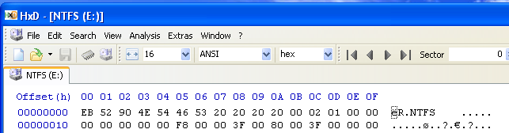

NTFS

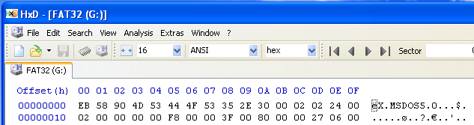

FAT32

BMP File in HxD

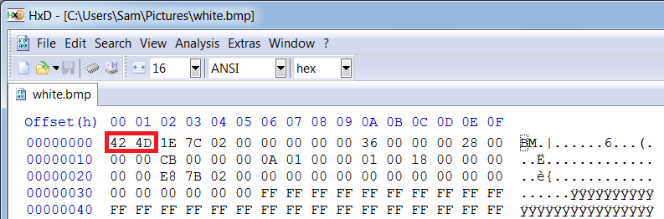
Start HxD, File, Open

BM at start indicates a BMP file

Word Doc File in HxD

Start HxD, File, Open

Word 2003 Format uses these 7 bytes

.docx format is actually a Zip archive

See links Ch 6b, 6c

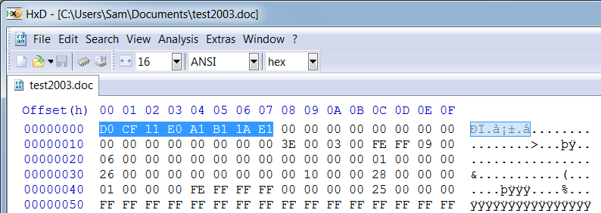

Master Boot Record

On Windows and DOS computer systems

Boot disk contains a file called the Master Boot Record (MBR)

MBR stores information about partitions on a disk and their locations, size, and other important items

Several software products can modify the MBR, such as PartitionMagic’s Boot Magic

Examining FAT Disks

File Allocation Table (FAT)

File structure database that Microsoft originally designed for floppy disks

Used before Windows NT and 2000

FAT database is typically written to a disk’s outermost track and contains:

Filenames, directory names, date and time stamps, the starting cluster number, and file attributes

FAT Versions

FAT12—for floppy disks, max size 16 MB

FAT16—allows hard disk sizes up to 2 GB

FAT32— allows hard disk sizes up to 2 TB

FATX—For Xbox media

The date stamps start at the year 2000, unlike the other FAT formats that start at 1980

VFAT (Virtual File Allocation Table)

Allows long file names on Windows (MS-DOS had 8.3 limitation)

Cluster sizes vary according to the hard disk size and file system

This table is for FAT-16

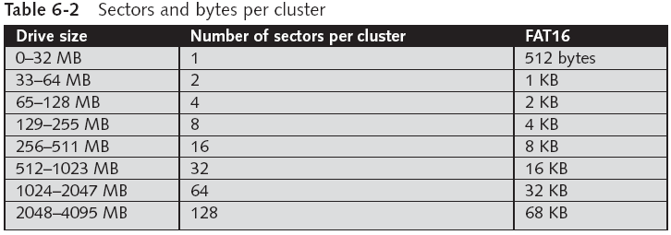

Microsoft OSs allocate disk space for files by clusters

Results in drive slack

Unused space in a cluster between the end of an active file and the end of the cluster

Drive slack includes:

RAM slack and file slack

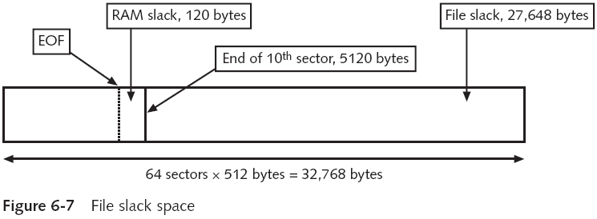

An unintentional side effect of FAT16 having large clusters was that it reduced fragmentation

As cluster size increased

When you run out of room for an allocated cluster

OS allocates another cluster for your file, which creates more slack space on the disk

As files grow and require more disk space, assigned clusters are chained together

The chain can be broken or fragmented

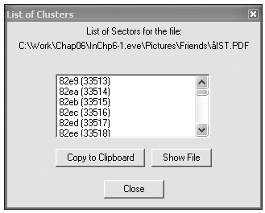
ProDiscover Showing Cluster Chain

When the OS stores data in a FAT file system, it assigns a starting cluster position to a file

Data for the file is written to the first sector of the first assigned cluster

When this first assigned cluster is filled and runs out of room

FAT assigns the next available cluster to the file

If the next available cluster isn’t contiguous to the current cluster

File becomes fragmented

Deleting FAT Files

In Microsoft OSs, when a file is deleted

Directory entry is marked as a deleted file

With the HEX E5 (σ) character replacing the first letter of the filename

FAT chain for that file is set to 0

Data in the file remains on the disk drive

Area of the disk where the deleted file resides becomes unallocated disk space

Available to receive new data from newly created files or other files needing more space

Examining NTFS Disks

New Technology File System (NTFS)

Introduced with Windows NT

Recommended file system for Windows 200 Pro, XP, and later versions through Windows 7 at least

Improvements over FAT file systems

NTFS provides more information about a file

NTFS gives more control over files and folders

NTFS was Microsoft’s move toward a journaling file system

In NTFS, everything written to the disk is considered a file

On an NTFS disk

First data set is the Partition Boot Sector

Next is Master File Table (MFT)

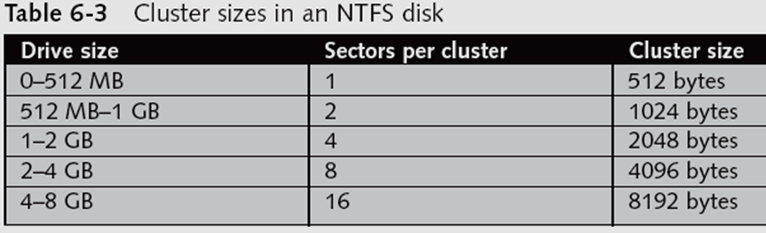
NTFS results in much less file slack space

Clusters are smaller for smaller disk drives

NTFS also uses Unicode

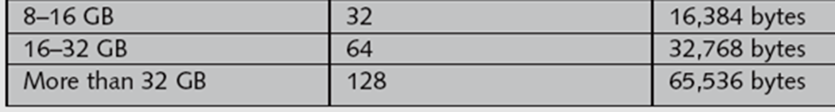
An international data format

NTFS File System

MFT contains information about all files on the disk

Including the system files the OS uses

In the MFT, the first 15 records are reserved for system files

Records in the MFT are called metadata

MFT and File Attributes

In the NTFS MFT

All files and folders are stored in separate records of 1024 bytes each

Each record contains file or folder information

This information is divided into record fields containing metadata

A record field is referred to as an attribute ID

File or folder information is typically stored in one of two ways in an MFT record:

Resident and nonresident

Files larger than 512 bytes are stored outside the MFT

MFT record provides cluster addresses where the file is stored on the drive’s partition

Referred to as data runs

Each MFT record starts with a header identifying it as a resident or nonresident attribute

Resident File in a MFT Record
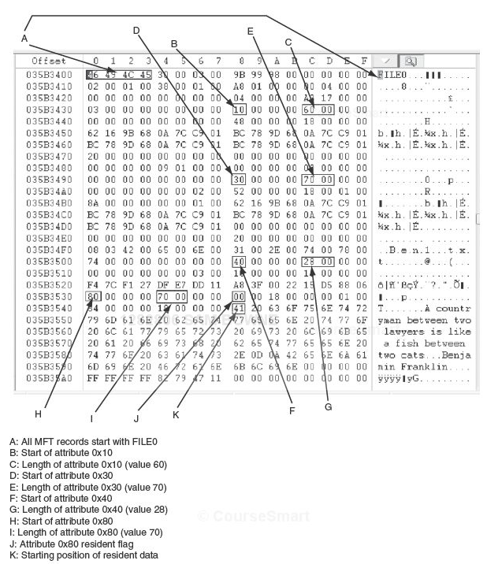

Nonresident File's MFT Record

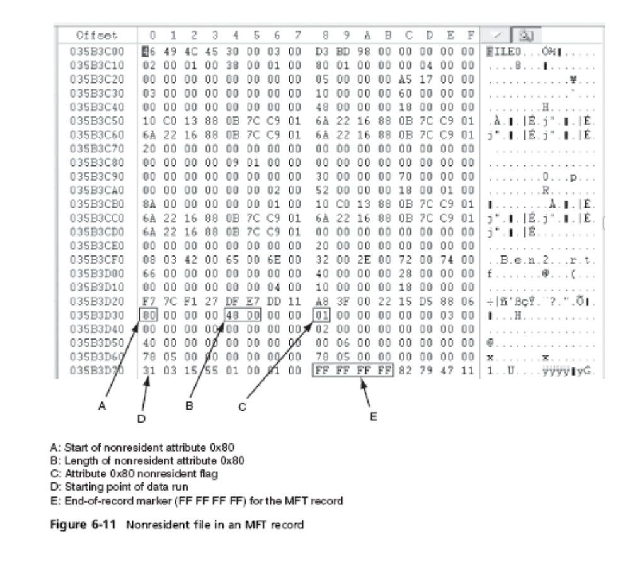

Skip Pages 216-223

When a disk is created as an NTFS file structure

OS assigns logical clusters to the entire disk partition

These assigned clusters are called logical cluster numbers (LCNs)

Become the addresses that allow the MFT to link to nonresident files on the disk’s partition

NTFS Data Streams

Data streams

Ways data can be appended to existing files

Can obscure valuable evidentiary data, intentionally or by coincidence

In NTFS, a data stream becomes an additional file attribute

Allows the file to be associated with different applications

You can only tell whether a file has a data stream attached by examining that file’s MFT entry

Alternate Data Streams Demonstration

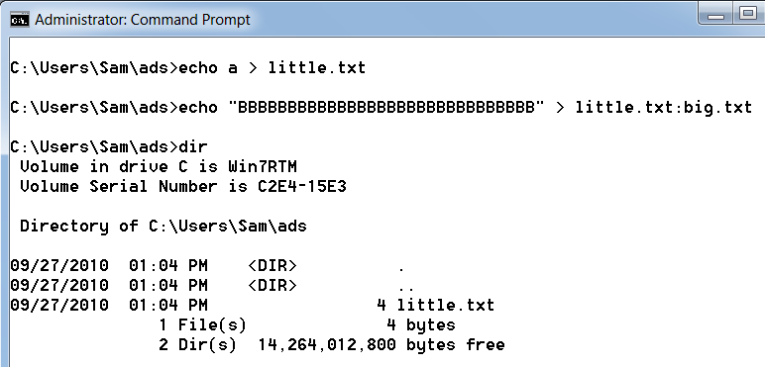
NTFS Compressed Files

NTFS provides compression similar to FAT DriveSpace 3

Under NTFS, files, folders, or entire volumes can be compressed

Most computer forensics tools can uncompress and analyze compressed Windows data

NTFS Encrypting File System (EFS)

Encrypting File System (EFS)

Introduced with Windows 2000

Implements a public key and private key method of encrypting files, folders, or disk volumes

When EFS is used in Windows 2000

A recovery certificate is generated and sent to the local Windows administrator account

Users can apply EFS to files stored on their local workstations or a remote server

Error in Textbook

Page 225

Only Windows 2000 used the Administrator account as the default EFS Recovery Agent

Windows XP and later versions have no EFS recovery agent by default

Links Ch 6e, 6f

Deleting NTFS Files

When a file is deleted in Windows XP, 2000, or NT

The OS renames it and moves it to the Recycle Bin

Can use the Del (delete) MS-DOS command

Eliminates the file from the MFT listing in the same way FAT does
Understanding Whole Disk Encryption

Understanding Whole Disk Encryption

In recent years, there has been more concern about loss of

Personal identity information (PII) and trade secrets caused by computer theft

Of particular concern is the theft of laptop computers and other handheld devices

To help prevent loss of information, software vendors now provide whole disk encryption

Current whole disk encryption tools offer the following features:

Preboot authentication

Full or partial disk encryption with secure hibernation

Advanced encryption algorithms

Key management function

A Trusted Platform Module (TPM) microchip to generate encryption keys and authenticate logins

Whole disk encryption tools encrypt each sector of a drive separately

Many of these tools encrypt the drive’s boot sector

To prevent any efforts to bypass the secured drive’s partition

To examine an encrypted drive, decrypt it first

Run a vendor-specific program to decrypt the drive

Examining Microsoft BitLocker

Available only with Vista/Win 7 Enterprise and Ultimate editions

Hardware and software requirements

A computer capable of running Windows Vista/7

The TPM microchip, version 1.2 or newer

A computer BIOS compliant with Trusted Computing Group (TCG)

Two NTFS partitions; a 1.5 GB or 100 MB partition use just for BitLocker, and the partition containing Windows

The BIOS configured so that the hard drive boots first before checking other bootable peripherals

Examining Third-Party Disk Encryption Tools

Some available third-party WDE utilities:

PGP Whole Disk Encryption

Voltage SecureDisk

Utimaco SafeGuard Easy

Jetico BestCrypt Volume Encryption

SoftWinter Sentry 2020 for Windows XP

Some available open-source encryption tools:

TrueCrypt

CrossCrypt

FreeOTFE
Understanding the Windows Registry

Understanding the Windows Registry

Registry

A database that stores hardware and software configuration information, network connections, user preferences, and setup information

For investigative purposes, the Registry can contain valuable evidence

To view the Registry, you can use:

Regedit (Registry Editor) program for Windows 9x systems

Regedt32 for Windows 2000 and XP

Exploring the Organization of the Windows Registry

Registry terminology:

Registry

Registry Editor

HKEY

Key

Subkey

Branch

Value

Default value

Hives
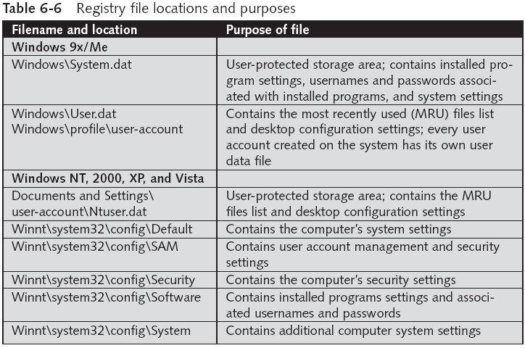
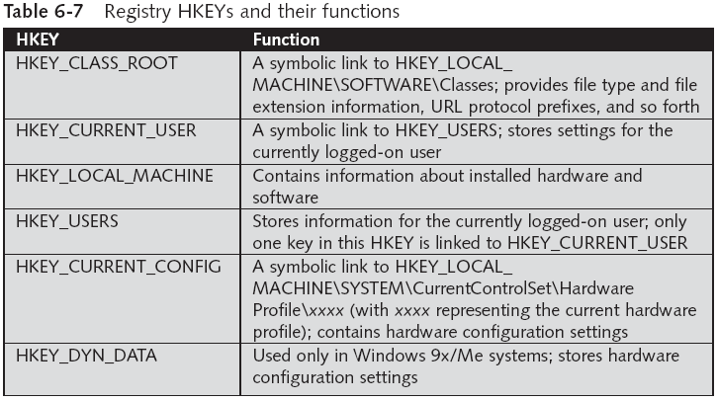

Understanding Microsoft Startup Tasks

Understanding Microsoft Startup Tasks

Learn what files are accessed when Windows starts

This information helps you determine when a suspect’s computer was last accessed

Important with computers that might have been used after an incident was reported

Startup in Windows NT and Later

All Windows NT computers perform the following steps when the computer is turned on:

Power-on self test (POST)

Initial startup

Boot loader

Hardware detection and configuration

Kernel loading

User logon

Startup Process for Windows Vista

Uses the new Extensible Firmware Interface ( EFI) as well as the older BIOS sys-tem.

NT Loader (NTLDR) has been replaced by three boot utilities

Bootmgr.exe—displays list of operating systems

Winload.exe—loads kernel, HAL, and drivers

Winresume.exe—restarts Vista after hibernation

See link Ch 6g

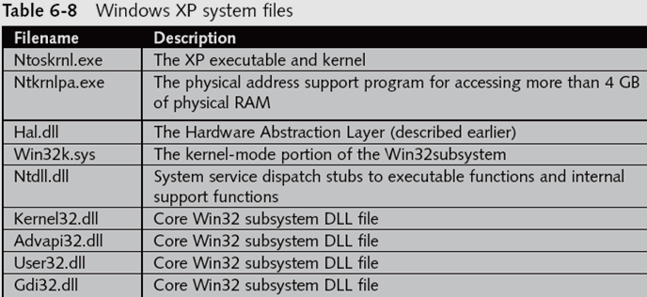
Startup Files for Windows XP

NT Loader (NTLDR)

Boot.ini

BootSect.dos

NTDetect.com

NTBootdd.sys

Ntoskrnl.exe

Hal.dll

Pagefile.sys

Device drivers

Windows XP System Files

Contamination Concerns with Windows XP

When you start a Windows XP NTFS workstation, several files are accessed immediately

The last access date and time stamp for the files change to the current date and time

Destroys any potential evidence

That shows when a Windows XP workstation was last used

Startup in Windows 9x/Me

System files in Windows 9x/Me containing valuable information can be altered easily during startup

Windows 9x and Windows Me have similar boot processes

With Windows Me you can’t boot to a true MS-DOS mode

Windows 9x OSs have two modes:

DOS protected-mode interface (DPMI)

Protected-mode GUI

The system files used by Windows 9x have their origin in MS-DOS 6.22

Io.sys communicates between a computer’s BIOS, the hardware, and the OS kernel

If F8 is pressed during startup, Io.sys loads the Windows Startup menu

Msdos.sys is a hidden text file containing startup options for Windows 9x

Command.com provides a command prompt when booting to MS-DOS mode (DPMI)
Understanding MS-DOS Startup Tasks

Understanding MS-DOS Startup Tasks

Two files are used to configure MS-DOS at startup:

Config.sys

A text file containing commands that typically run only at system startup to enhance the computer’s DOS configuration

Autoexec.bat

A batch file containing customized settings for MS-DOS that runs automatically

Io.sys is the first file loaded after the ROM bootstrap loader finds the disk drive

Msdos.sys is the second program to load into RAM immediately after Io.sys

It looks for the Config.sys file to configure device drivers and other settings

Msdos.sys then loads Command.com

As the loading of Command.com nears completion, Msdos.sys looks for and loads Autoexec.bat

Other Disk Operating Systems

Control Program for Microprocessors (CP/M)

First nonspecific microcomputer OS

Created by Digital Research in 1970

8-inch floppy drives; no support for hard drives

Digital Research Disk Operating System (DR-DOS)

Developed in 1988 to compete with MS-DOS

Used FAT12 and FAT16 and had a richer command environment

Personal Computer Disk Operating System (PC-DOS)

Created by Microsoft under contract for IBM

PC-DOS works much like MS-DOS
Understanding Virtual Machines

Understanding Virtual Machines

Virtual machine

Allows you to create a representation of another computer on an existing physical computer

A virtual machine is just a few files on your hard drive

Must allocate space to it

A virtual machine recognizes components of the physical machine it’s loaded on

Virtual OS is limited by the physical machine’s OS

In computer forensics

Virtual machines make it possible to restore a suspect drive on your virtual machine

And run nonstandard software the suspect might have loaded

From a network forensics standpoint, you need to be aware of some potential issues, such as:

A virtual machine used to attack another system or network

Creating a Virtual Machine

Two popular applications for creating virtual machines

VMware and Microsoft Virtual PC

Using Virtual PC

You must download and install Virtual PC first

You need an ISO image of an OS

Because no OSs are provided with Virtual PC

Virtual PC creates two files for each virtual machine:

A .vhd file, which is the actual virtual hard disk

A .vmc file, which keeps track of configurations you make to that disk

See what type of physical machine your virtual machine thinks it’s running

Open the Virtual PC Console, and click Settings

Last modified 9-27-10

