Objectives

Explain how to evaluate needs for computer forensics tools

Describe available computer forensics software tools

List some considerations for computer forensics hardware tools

Describe methods for validating and testing computer forensics tools
Evaluating Computer Forensics Tool Needs

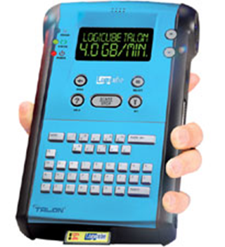
Evaluating Computer Forensics Tool Needs

Look for versatility, flexibility, and robustness

OS

File system(s)

Script capabilities

Automated features

Vendor’s reputation for support

Keep in mind what application files you will be analyzing

Types of Computer Forensics Tools

Hardware forensic tools

Range from single-purpose components to complete computer systems and servers

Software forensic tools
Logicube Talon (link Ch 7a)

Types

Command-line applications

GUI applications

Commonly used to copy data from a suspect’s disk drive to an image file

Tasks Performed by Computer Forensics Tools

Five major categories:

Acquisition

Validation and discrimination

Extraction

Reconstruction

Reporting

Acquisition

Making a copy of the original drive

Acquisition subfunctions:

Physical data copy

Logical data copy

Data acquisition format

Command-line acquisition

GUI acquisition

Remote acquisition

Verification

Two types of data-copying methods are used in software acquisitions:

Physical copying of the entire drive

Logical copying of a disk partition

The formats for disk acquisitions vary

From raw data to vendor-specific proprietary compressed data

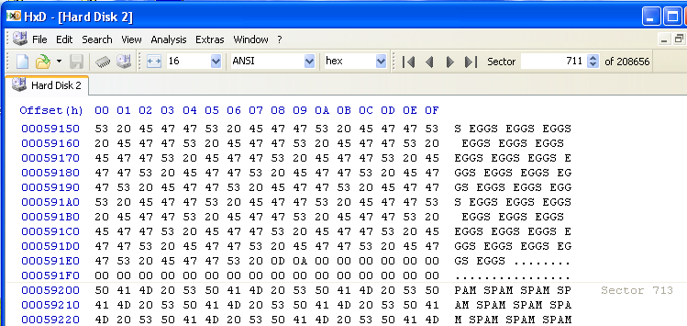
You can view the contents of a raw image file with any hexadecimal editor

Creating smaller segmented files is a typical feature in vendor acquisition tools

All computer forensics acquisition tools have a method for verification of the data-copying process

That compares the original drive with the image

Validation and discrimination

Validation

Ensuring the integrity of data being copied

Discrimination of data

Involves sorting and searching through all investigation data

Subfunctions

Hashing

CRC-32, MD5, Secure Hash Algorithms

Filtering

Known system files can be ignored

Based on hash value sets

Analyzing file headers

Discriminate files based on their types

National Software Reference Library (NSRL) has compiled a list of known file hashes

For a variety of OSs, applications, and images

Many computer forensics programs include a list of common header values

With this information, you can see whether a file extension is incorrect for the file type

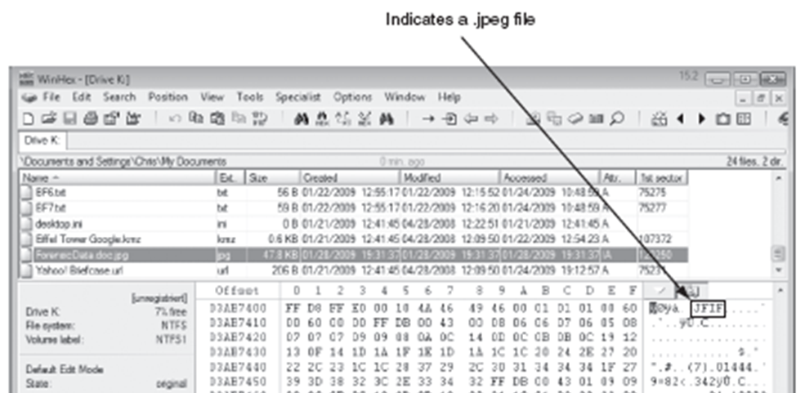
Most forensics tools can identify header values

Extraction

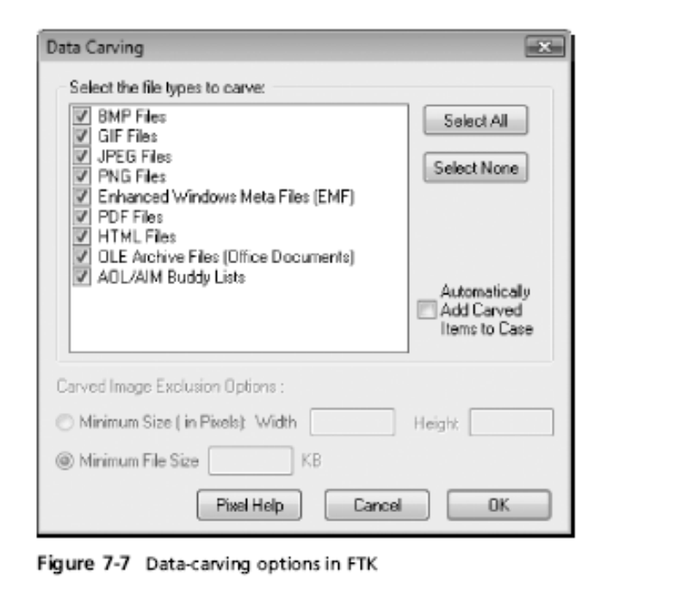
Recovery task in a computing investigation

Most demanding of all tasks to master

Recovering data is the first step in analyzing an investigation’s data

Subfunctions

Data viewing

Keyword searching

Decompressing

Carving (reconstructing file fragments)

Decrypting

Bookmarking

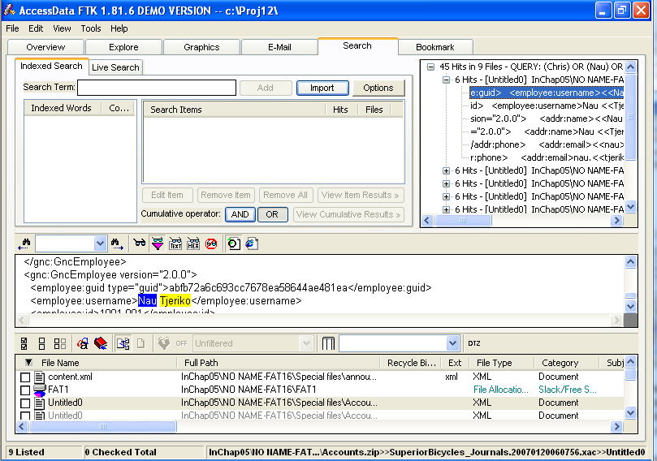
Keyword search speeds up analysis for investigators

From an investigation perspective, encrypted files and systems are a problem

Many password recovery tools have a feature for generating potential password lists

For a password dictionary attack

If a password dictionary attack fails, you can run a brute-force attack

Reconstruction

Re-create a suspect drive to show what happened during a crime or an incident

Subfunctions

Disk-to-disk copy

Image-to-disk copy

Partition-to-partition copy

Image-to-partition copy

This is easiest if a matching blank hard disk is available, same make and model

Some tools that perform an image-to-disk copy:

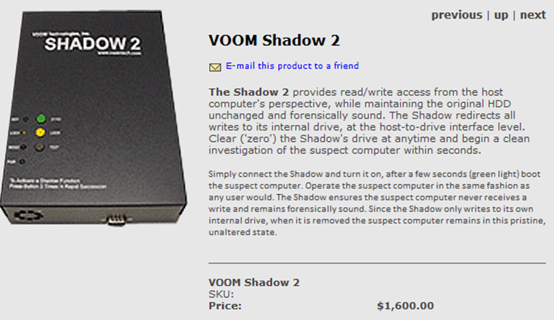
SafeBack

SnapBack

EnCase

FTK Imager

ProDiscover

VOOM Shadow 2

For write-blocked courtroom demos using real original drive, use Voom Shadow 2 (link Ch 7b)

Reporting

To complete a forensics disk analysis and examination, you need to create a report

Subfunctions

Log reports

Report generator

Use this information when producing a final report for your investigation

Other Considerations for Tools

Considerations

Flexibility

Reliability

Expandability

Keep a library with older version of your tools

Create a software library containing older versions of forensics utilities, OSs, and other programs
Computer Forensics Software Tools

Computer Forensics Software Tools

The following sections explore some options for command-line and GUI tools in both Windows and UNIX/Linux

Command-line Forensic Tools

The first tools that analyzed and extracted data from floppy disks and hard disks were MS-DOS tools for IBM PC file systems

Norton DiskEdit

One of the first MS-DOS tools used for computer investigations

Advantage

Command-line tools require few system resources

Designed to run in minimal configurations

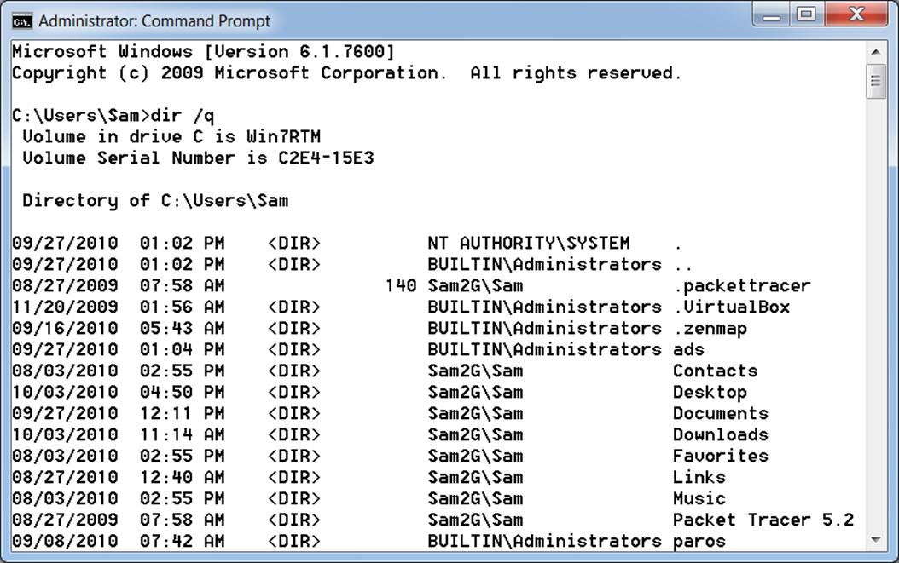
DIR /Q

Shows file owner

UNIX/Linux Forensic Tools

*nix platforms have long been the primary command-line OSs

SMART

Designed to be installed on numerous Linux versions

Can analyze a variety of file systems with SMART

Many plug-in utilities are included with SMART

Another useful option in SMART is its hex viewer

Link Ch 7d

Helix

One of the easiest suites to begin with

You can load it on a live Windows system

Loads as a bootable Linux OS from a cold boot

Autopsy and SleuthKit

Sleuth Kit is a Linux forensics tool

Autopsy is the GUI/browser interface used to access Sleuth Kit’s tools

Knoppix-STD

Knoppix Security Tools Distribution (STD)

A collection of tools for configuring security measures, including computer and network forensics

Knoppix-STD is forensically sound

Doesn’t allow you to alter or damage the system you’re analyzing

Knoppix-STD is a Linux bootable CD

BackTrack

BackTrack 4 has a Forensics Mode

But it’s not the default boot mode, so you need to be careful

Raptor

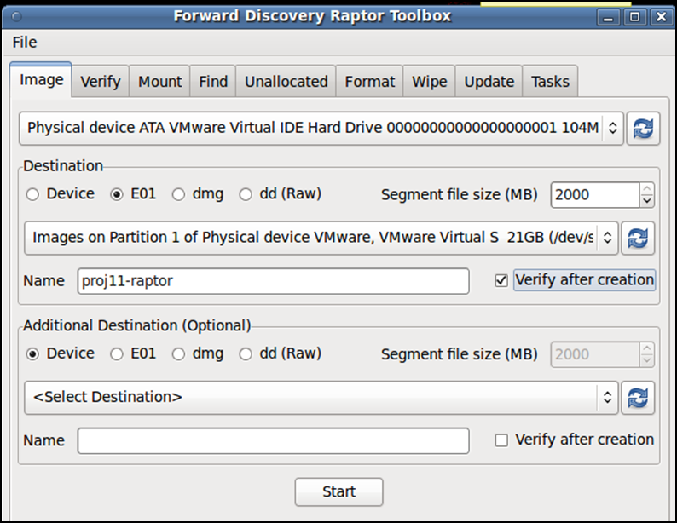
Forensic LiveCD (link Ch 7e)

Other GUI Forensic Tools

Simplify computer forensics investigations

Help training beginning investigators

Most of them come into suites of tools

Advantages

Ease of use

Multitasking

No need for learning older OSs

Disadvantages

Excessive resource requirements

Produce inconsistent results

Create tool dependencies
Computer Forensics Hardware Tools

Computer Forensics Hardware Tools

Technology changes rapidly

Hardware eventually fails

Schedule equipment replacements

When planning your budget consider:

Failures

Consultant and vendor fees

Anticipate equipment replacement

Forensic Workstations

Carefully consider what you need

Categories

Stationary

Portable

Lightweight

Balance what you need and what your system can handle

Police agency labs

Need many options

Use several PC configurations

Private corporation labs

Handle only system types used in the organization

Keep a hardware library in addition to your software library

Building your Own Forensic Workstation

Not as difficult as it sounds

Advantages

Customized to your needs

Save money

Disadvantages

Hard to find support for problems

Can become expensive if careless

Also need to identify what you intend to analyze

Purchasing a Forensic Workstation

You can buy one from a vendor as an alternative

Examples

F.R.E.D.

F.I.R.E. IDE

Having vendor support can save you time and frustration when you have problems

Can mix and match components to get the capabilities you need for your forensic workstation

Using a Write-Blocker

Write-blocker

Prevents data writes to a hard disk

Software-enabled blockers

Software write-blockers are OS dependent

Example: PDBlock from Digital Intelligence

DOS only, not Windows (link Ch 6f)

Hardware options

Ideal for GUI forensic tools

Act as a bridge between the suspect drive and the forensic workstation

Can navigate to the blocked drive with any application

Discards the written data

For the OS the data copy is successful

Connecting technologies

FireWire

USB 2.0

SCSI controllers

Recommendations for a Forensic Workstation

Determine where data acquisitions will take place

Data acquisition techniques

USB 2.0

FireWire

Expansion devices requirements

Power supply with battery backup

Extra power and data cables

External FireWire and USB 2.0 ports

Assortment of drive adapter bridges

Ergonomic considerations

Keyboard and mouse

A good video card with at least a 17-inch monitor

High-end video card and monitor

If you have a limited budget, one option for outfitting your lab is to use high-end game PCs

Validating and Testing Forensic Software

Validating and Testing Forensic Software

Make sure the evidence you recover and analyze can be admitted in court

Test and validate your software to prevent damaging the evidence

Using National Institute of Standards and Technology (NIST) Tools

Computer Forensics Tool Testing (CFTT) program

Manages research on computer forensics tools

NIST has created criteria for testing computer forensics tools based on:

Standard testing methods

ISO 17025 criteria for testing items that have no current standards

ISO 5725

Your lab must meet the following criteria

Establish categories for computer forensics tools

Identify computer forensics category requirements

Develop test assertions

Identify test cases

Establish a test method

Report test results

Also evaluates drive-imaging tools

See link Ch 7g

National Software Reference Library (NSRL) project

Collects all known hash values for commercial software applications and OS files

Uses SHA-1 to generate a known set of digital signatures called the Reference Data Set (RDS)

Helps filtering known information

Can use RDS to locate and identify known bad files

Using Validation Protocols

Always verify your results

Use at least two tools

Retrieving and examination

Verification

Understand how tools work

One way to compare results and verify a new tool is by using a disk editor

Such as Hex Workshop or WinHex

But it won't work with encrypted or compressed files

Disk editors

Do not have a flashy interface

Reliable tools

Can access raw data

Computer Forensics Examination Protocol

Perform the investigation with a GUI tool

Usually FTK or EnCase

Verify your results with a disk editor

If a file is recovered, compare hash values obtained with both tools

Computer Forensics Tool Upgrade Protocol

Test

New releases

OS patches and upgrades

If you find a problem, report it to forensics tool vendor

Do not use the forensics tool until the problem has been fixed

Use a test hard disk for validation purposes

Check the Web for new editions, updates, patches, and validation tests for your tools

Last modified 10-4-10 11:40 am

