Objectives

Explain Macintosh file structures and the boot process

Explain UNIX and Linux disk structures and boot processes

Describe other disk structures
Understanding the Macintosh File Structure and Boot Process

Understanding the Macintosh File Structure and Boot Process

Mac OS X version 10.5 - Leopard

Darwin core

BSD UNIX application layer

This section focuses on Mac OS 9

OS X still uses the HFS+ system, according to links Ch 8j and 8k

Understanding the Macintosh File Structure and Boot Process

Mac OS 9 & earlier used:

Hierarchical File System (HFS)

Files stored in nested directories (folders)

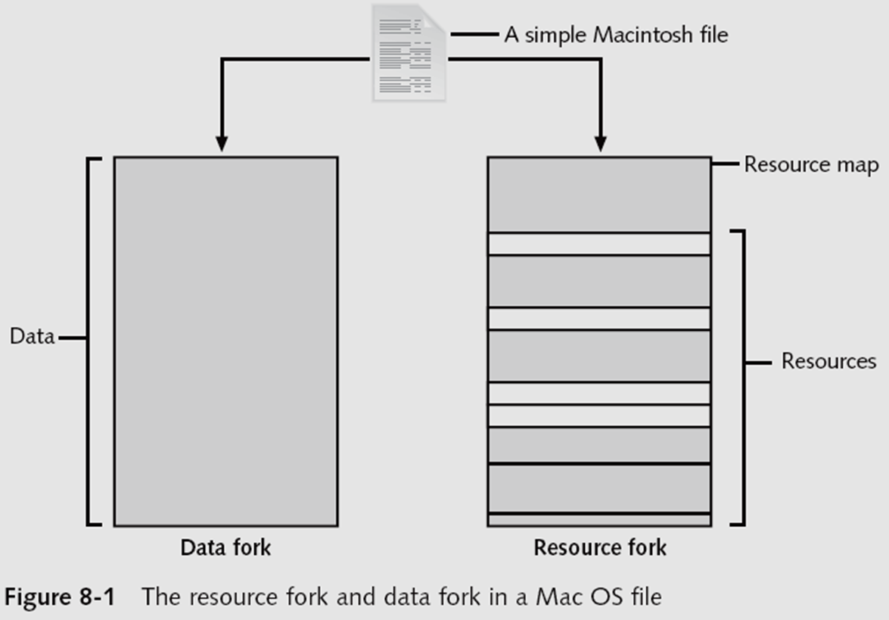
Extended Format File System (HFS+)

Introduced with Mac OS 8.1

Supports smaller file sizes on larger volumes, resulting in more efficient disk use

File Manager utility

Reading, writing, and storing data to physical media

Finder

Keeps track of files and maintain users’ desktops

In older Mac OSs, a file consists of two parts:

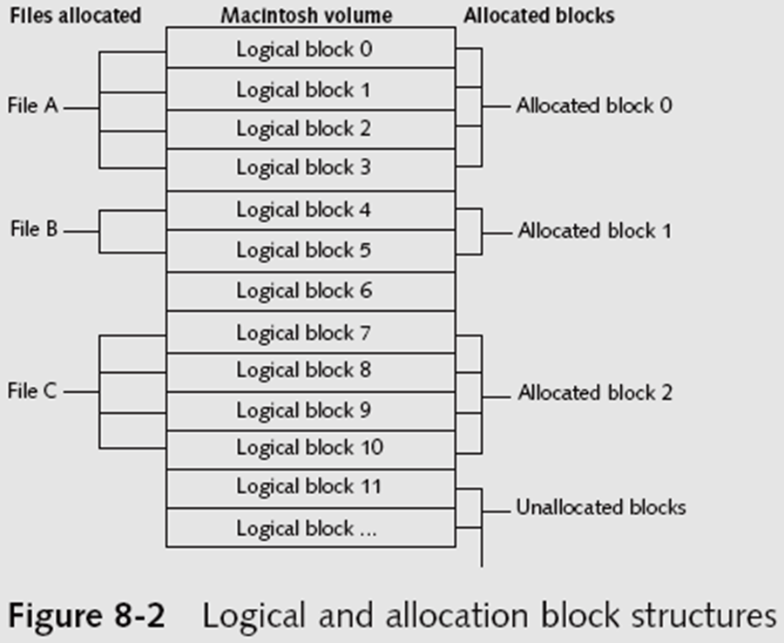
Data fork and resource fork

Stores file metadata and application information

Understanding Macintosh OS 9 Volumes

A volume is any storage medium used to store files

Can be all or part of a hard disk

On a floppy disk is always the entire disk

Allocation and logical blocks

Logical blocks cannot exceed 512 bytes

Allocation blocks are a set of consecutive logical blocks

Two EOF descriptors

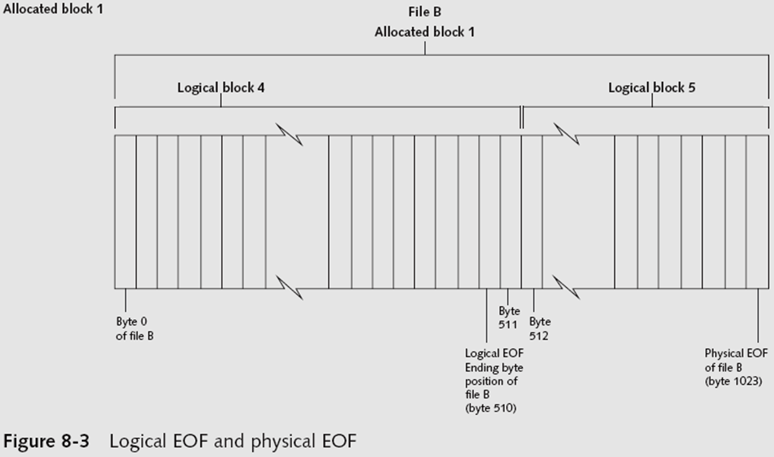
Logical EOF

Actual size of the file

Physical EOF

The number of allocation blocks for that file

Clumps

Groups of contiguous allocation blocks

Reduce fragmentation

Exploring Macintosh Boot Tasks

Use Open Firmware instead of BIOS

Processor- and system-independent firmware

Controls microprocessor after hardware initialization

The boot process for OS 9 is as follows:

1. Power on the computer

2. Hardware self-test and Open Firmware run

3. Macintosh OS starts

4. The startup disk is located

5. System files are opened

6. System extensions are loaded

7. OS 9 Finder starts

Tables 8-1 and 8-2 are an overview of how HFS and HFS+ system files handle data

Details at links Ch 8a, 8b

Older Macintosh OSs use

First two logical blocks as boot blocks

Master Directory Block (MDB) or Volume Information Block (VIB)

Stores all information about a volume

Volume Control Block (VCB)

Stores information from the MDB when OS mounts

Extents overflow file

Stores any file information not in the MDB or a VCB

Catalog

Listing of all files and directories on the volume

Maintains relationships between files and directories

Volume Bitmap

Tracks used and unused blocks on a volume

Mac OS 9 uses the B*-tree file system for File Manager

Actual file data is stored on the leaf nodes

B*-tree also uses header, index, and map nodes

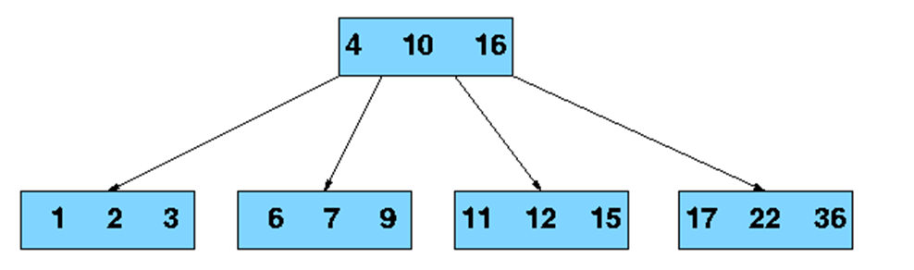
B-Tree

A way of storing records so they can be found rapidly

Each node can only hold a few records, if more are added the node splits and the tree grows taller

Link Ch 8c

Using Macintosh Forensic Software

Tools and vendors

BlackBag Technologies

SubRosaSoft MacForensicsLab

Guidance EnCase

X-Ways Forensics

ProDiscover Forensic Edition

Sleuth Kit and Autopsy

Macintosh Acquisition Methods

Make an image of the drive

Static acquisition of the suspect drive is preferable to a live acquisition

Removing the drive from a Macintosh Mini’s CPU case is difficult

Attempting to do so without Apple factory training could damage the computer

Use a Macintosh-compatible forensic boot CD (or FireWire boot drive) to make an image on an external USB or FireWire drive

BlackBag Technologies sells acquisition products specifically designed for OS 9 and earlier

As well as OS X

MacQuisition is a forensic boot CD that makes an image of a Macintosh drive

After making an acquisition, examine the image of the file system

The tool you use depends on the image file format

BlackBag Technologies Macintosh Forensic Software and SubRosaSoft MacForensicsLab

Can disable/enable Disk Arbitration—which mounts drives

Being able to turn off the mount function in OS X

Allows you to connect a suspect drive to a Macintosh without a write-blocking device

See link Ch 8d

Examining OS 9 Data Structures with BlackBag

Activities in this section assume you have a Macintosh running OS X

All data acquisitions (image files) must be configured as Disk Images

With the correct filename and extensions

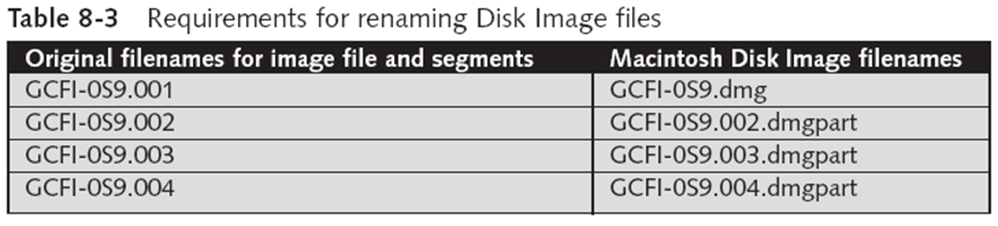
To keep the correct order of each segment

Numbers need to be inserted between the filename and the extension

Load images as a virtual disk image double-clicking the files in Finder

OS X loads and displays an icon of the virtual mounted disk with the name “untitled” on the desktop

You can rename it with your case name

Start BlackBag from Finder

BlackBag includes several utilities for conducting a full analysis of evidence, including

PDISKInfo, PMAPInfo, DirectoryScan, FileSearch, MacCarver, and FileSpy

Activity 1:

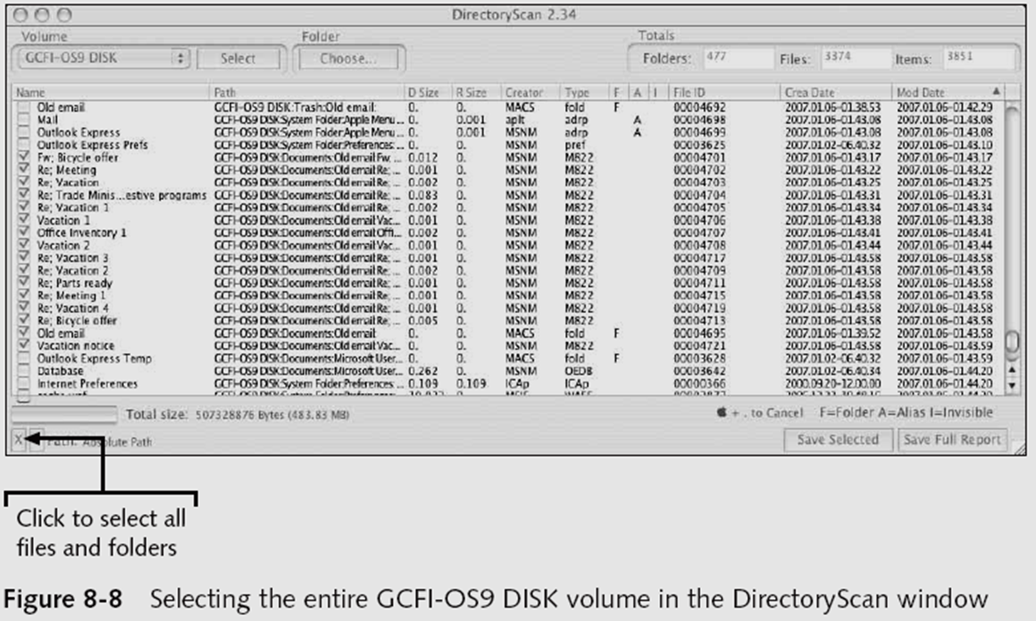
Use the BlackBag DirectoryScan utility, which lists all folders and files, visible and hidden, in the image loaded as a .dmg file

Examining UNIX and Linux Disk Structures and Boot Processes

UNIX flavors

System V variants, Sun Solaris, IBM AIX, and HP-UX

BSD, FreeBSD, OpenBSD, and NetBSD

Linux distributions

Red Hat, Fedora, Ubuntu, and Debian

Most consistent UNIX-like OSs

Linux kernel is regulated under the GNU General Public License (GPL) agreement

BSD license is similar to the GPL

But makes no requirements for derivative works

Some useful Linux commands to find information about your Linux system

uname –a

ls –l

ls –ul filename

netstat -s

Linux file systems

Second Extended File System (Ext2fs)

Ext3fs, journaling version of Ext2fs

Employs inodes

Contain information about each file or directory

Pointer to other inodes or blocks

Keep internal link count

Deleted inodes have count value 0

UNIX and Linux Overview

Everything is a file

Including disks, monitors, NIC, RAM

Files are objects with properties and methods

UNIX consists of four components

Boot block

Superblock

inode block

Data block

Boot block

Block is a disk allocation unit of at least 512 bytes

Contains the bootstrap code

UNIX/Linux computer has only one boot block, located on the main hard disk

Superblock

Indicates disk geometry, available space, location of the first inode, and free inode list

Manages the file system

Multiple copies of the superblock are kept

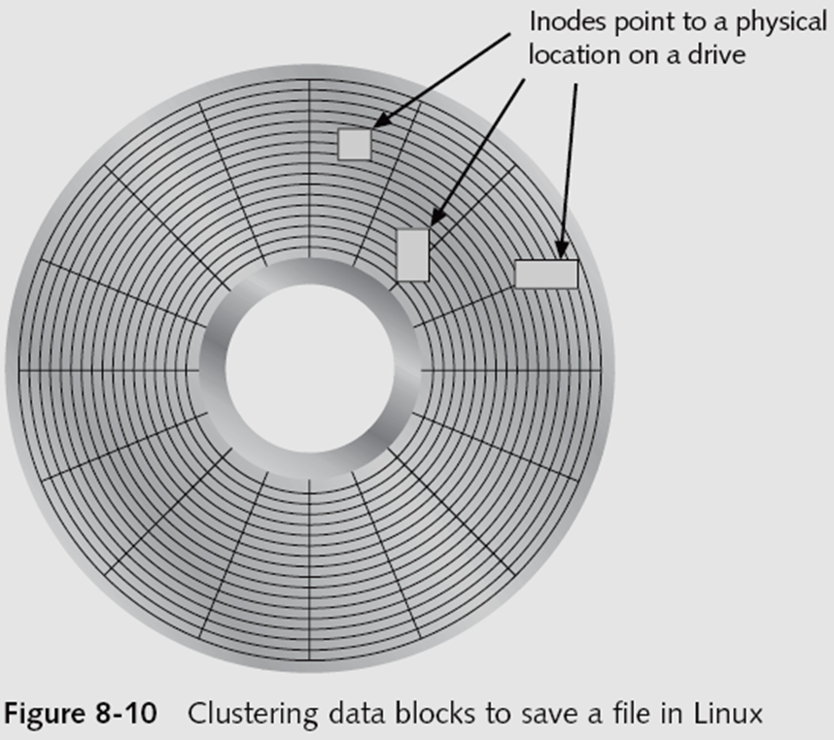
inode blocks

First data after the superblock

An inode is assigned to every file allocation unit

Data blocks

Where directories and files are stored

This location is linked directly to inodes

Each sector contains 512 bytes

Each data block contains 1024-4096 bytes

Analogous to a cluster on a FAT or NTFS volume

Bad block inode

Keeps track of disk’s bad sectors

Commands: badblocks, mke2fs, and e2fsck

Linux ls command displays information about files and directories

lowercase LS

For details, use the ls -l command

lowercase LS –L

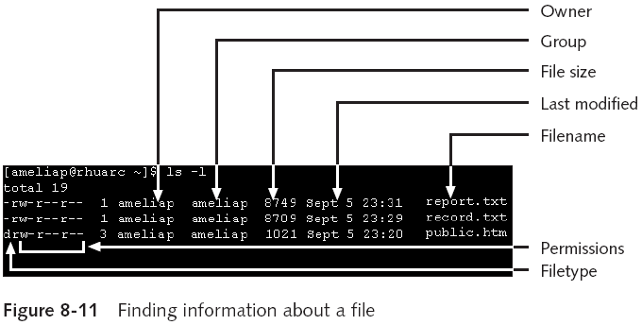

Continuation inode

Provides information about a file or directory

Mode and file type, the quantity of links in the file or directory, the file or directory status flag

Sticky bit

Used in some old Unix versions to make programs load faster by keeping parts of the program in RAM

Used in modern Unix systems to prevent users from deleting files owned by others

Link Ch 8h

Understanding Inodes

Link data stored in data blocks (usually 1024 bytes)

Ext2fs and Ext3fs are improvements over Ext

Data recovery easier on Ext3fs than on Ext2fs

First inode has 13 pointers

Pointers 1 to 10 are direct pointers to data storage blocks

Pointer 11 is an indirect pointer

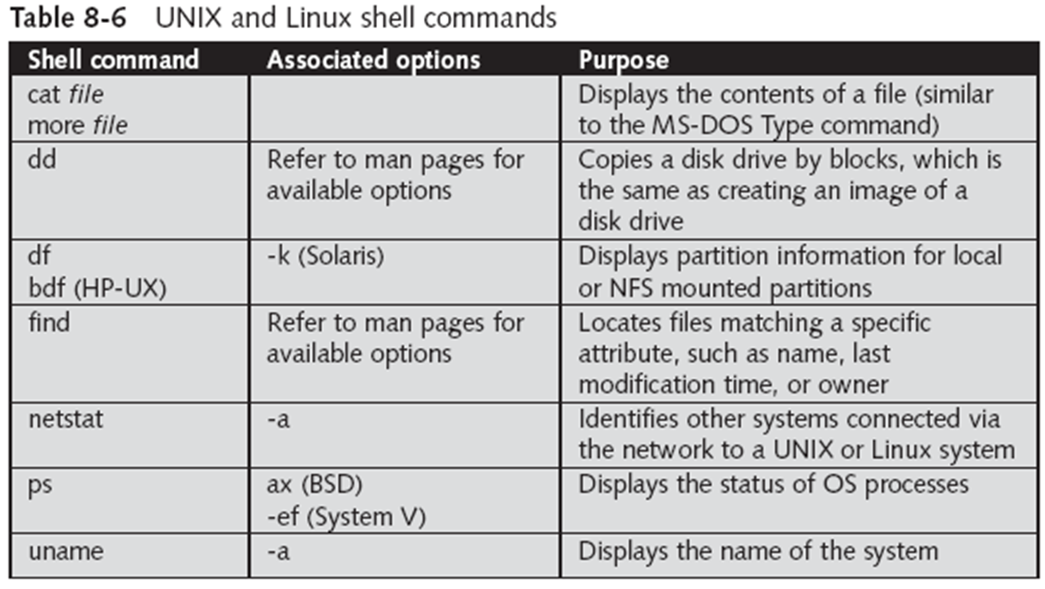
Pointer 12 is a double-indirect pointer

Pointer 13 is a triple-indirect pointer

Pointers 11-13 are needed for large files

Understanding UNIX and Linux Boot Processes

Instruction code in firmware is loaded into RAM

This is called memory-resident code because it is stored in ROM

Instruction code then:

Checks the hardware

Load the boot program

Boot program

Loads kernel

Transfers control to kernel

Kernel’s first task is to identify all devices

Kernel

Boots system on single-user mode

Runs startup scripts

Changes to multiuser mode, then user logs on

Identifies root directory, swap, and dump files

Sets hostname and time zone

Runs consistency checks on the file system and mounts partitions

Starts services and sets up the NIC

Establishes user and system accounting and quotas

Understanding Linux Loader and GRUB

Linux Loader (LILO)

Old boot manager

Can start two or more OSs

Uses configuration file /etc/lilo.conf

Grand Unified Boot Loader (GRUB)

More powerful than LILO

As LILO, it resides on MBR

Command line or menu driven

Understanding UNIX and Linux Drives and Partition Schemes

Labeled as path starting at root (/) directory

Primary master disk (/dev/hda)

First partition is /dev/hda1

Second partition is /dev/hda2

Primary slave or secondary master or slave (/dev/hdb, /dev/hdc, or /dev/hdd)

First partition is /dev/hdb2

SCSI controllers

/dev/sda with first partition /dev/sda1

Linux treats SATA, USB, and FireWire devices the same way as SCSI devices

Examining UNIX and Linux Disk Structures

Most commercial computer forensics tools can analyze UNIX UFS and UFS2

And Linux Ext2, Ext3, ReiserFS, and Reiser4 file systems

Freeware tools include Sleuth Kit and its Web browser interface, Autopsy Browser

Foremost

A freeware carving tool that can read many image file formats

Configuration file: foremost.conf

Tarball

A data file containing one or more files or whole directories and their contents

Installing Sleuth Kit and Autopsy

Requires downloading and installing the most recent updates of these tools

Download the most current source code from www.sleuthkit.org

To run Sleuth Kit and Autopsy Browser, you need to have root privileges

Examining a case with Sleuth Kit and Autopsy

Use Sleuth Kit and Autopsy Browser to analyze a Linux Ext2 and Ext3 file system

Use the File Activity Time Lines function

Identifies what files were active at a specific time
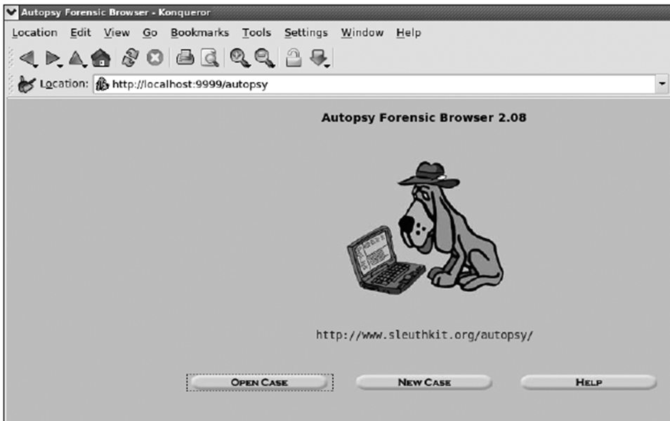

Understanding Other Disk Structures

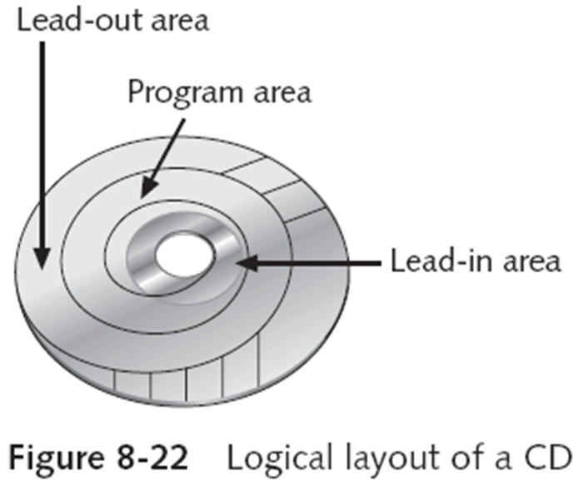
Understanding Other Disk Structures

CDs and DVDs

SCSI disks

IDE/EIDE disks

SATA drives

Examining CD Data Structures

Laser burns flat areas (lands)

Lower areas are called pits

Transitions

From lands to pits have binary value 1 (on)

No transition has binary value 0 (off)

International Organization of Standards (ISO)

ISO 9660 for CD, CD-R and CD-RW

ISO 13346 for DVDs

99 tracks available in the lead-in area, for the table of contents

Program area also has 99 tracks available for data

Frame is the unit storage

Contains 24 17-bits symbols

Frames are combined into blocks

Blocks are combined into sectors

2352 bytes for CD-DA (music CDs)

2048 bytes for CD (data CDs)

Constant Linear Velocity (< 12X)

Constant Angular Velocity (>= 12X)

DVD disk file structures use a Universal Disk Format (UDF)

Called Micro-UDF (M-UDF)

For backward compatibility, some DVDs have integrated ISO 9660

To allow compatibility with current OSs

Examining SCSI Disks

Small Computer System Interface (SCSI)

Provides a common bus communication device

During investigation

Check if the device is internal or external

Check if card, cables, adapters, terminators, and drivers are available

Advance SCSI Programming Interface (ASPI)

Provides several software drivers for communication between the OS and SCSI component

Might need to adjust settings

Port numbers and terminators

Newer SCSI devices typically use an integrated self-terminator

One problem with older SCSI drives is identifying which jumper group terminates and assigns a port number

Examining IDE/EIDE and SATA Devices

Most forensic disk examinations involve EIDE and SATA drives

ATA drives from ATA-33 to ATA-133

Standard 40-pin ribbon or shielded cable

40-pin/80-wire cable for ATA-66, 100, and 133

CMOS identifies proper disk settings using:

Logical block addressing (LBA)

Enhanced CHS configurations

Can be a problem during an investigation

Solutions

Use disk imaging tools

Use an old PC

Cards and adapters

ISA SCSI card

A-Card IDE adapter

SCSI-to-IDE adapter

EISA FireWire card

FireWire-to-EIDE adapter

Examining the IDE host protected area

ATAPI-5 AT introduced in 1998 reserved and protected areas on IDE devices

Protected Area Run Time Interface Extension Service (PARTIES)

Data stored by diagnostic and restore programs

Tools

X-Ways Replica

HPA is also referred to as a BIOS Engineering Extension Record (BEER) data structure

Exploring hidden partitions

Suspects try to conceal evidence by hiding disk partitions

Norton Disk Edit can change the disk partition table

Leaving no indication that the deactivated partition exists in Windows Explorer

Use imaging tools that can access unpartitioned areas of a drive

Last modified 10-18-10

