Objectives

Determine what data to analyze in a computer forensics investigation

Explain tools used to validate data

Explain common data-hiding techniques

Describe methods of performing a remote acquisition
Determining What Data to Collect and Analyze

Determining What Data to Collect and Analyze

Examining and analyzing digital evidence depends on:

Nature of the case

Amount of data to process

Search warrants and court orders

Company policies

Scope creep

Investigation expands beyond the original description

Right of full discovery of digital evidence

Approaching Computer Forensics Cases

Some basic principles apply to almost all computer forensics cases

The approach you take depends largely on the specific type of case you’re investigating

Basic steps for all computer forensics investigations

For target drives, use only recently wiped media that have been reformatted

And inspected for computer viruses

Inventory the hardware on the suspect’s computer and note the condition of the computer when seized

Remove the original drive from the computer

Check date and time values in the system’s CMOS

Record how you acquired data from the suspect drive

Process the data methodically and logically

List all folders and files on the image or drive

If possible, examine the contents of all data files in all folders

Starting at the root directory of the volume partition

For all password-protected files that might be related to the investigation

Make your best effort to recover file contents

Identify the function of every executable (binary or .exe) file that doesn’t match known hash values

Maintain control of all evidence and findings, and document everything as you progress through your examination

Refining and Modifying the Investigation Plan

Considerations

Determine the scope of the investigation

Determine what the case requires

Whether you should collect all information

What to do in case of scope creep

The key is to start with a plan but remain flexible in the face of new evidence

Using AccessData Forensic Toolkit to Analyze Data

Supported file systems: FAT12/16/32, NTFS, Ext2fs, and Ext3fs

FTK can analyze data from several sources, including image files from other vendors

FTK produces a case log file

Searching for keywords

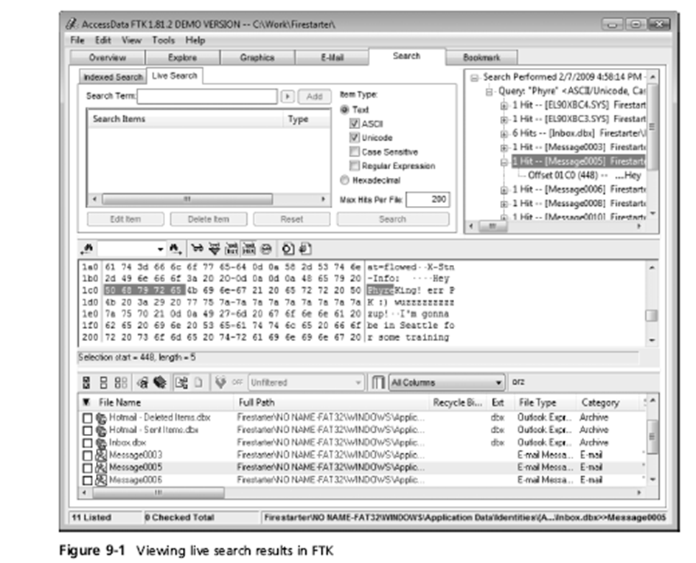
Indexed search

Live search

Supports options and advanced searching techniques, such as stemming

Analyzes compressed files

You can generate reports

Using bookmarks
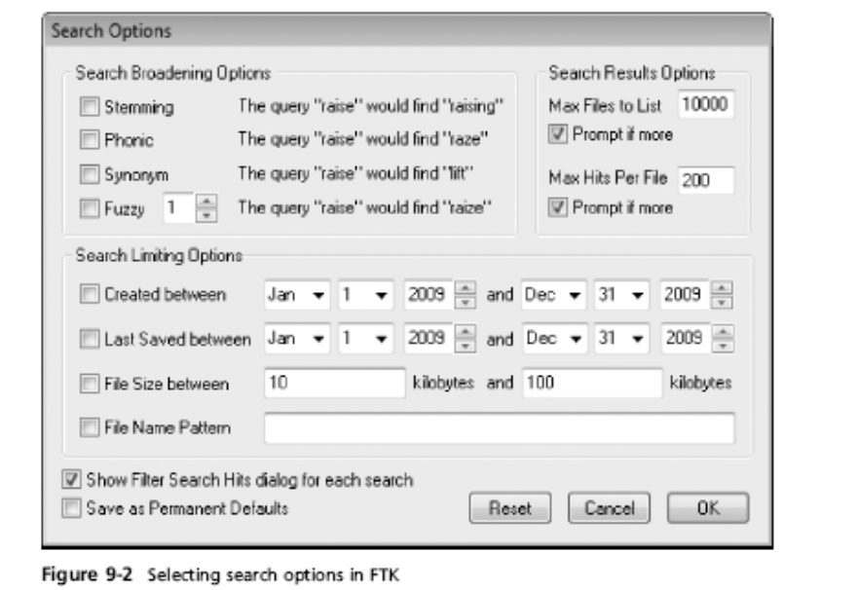

Validating Forensic Data

Validating Forensic Data

One of the most critical aspects of computer forensics

Ensuring the integrity of data you collect is essential for presenting evidence in court

Most computer forensic tools provide automated hashing of image files

Computer forensics tools have some limitations in performing hashing

Learning how to use advanced hexadecimal editors is necessary to ensure data integrity

Validating with Hexadecimal Editors

Advanced hexadecimal editors offer many features not available in computer forensics tools

Such as hashing specific files or sectors

Hex Workshop provides several hashing algorithms

Such as MD5 and SHA-1

See Figures 9-4 through 9-6

Hex Workshop also generates the hash value of selected data sets in a file or sector

Using hash values to discriminate data

AccessData has a separate database, the Known File Filter (KFF)

Filters known program files from view, such as MSWord.exe, and identifies known illegal files, such as child pornography

KFF compares known file hash values to files on your evidence drive or image files

Periodically, AccessData updates these known file hash values and posts an updated KFF

Validating with Computer Forensics Programs

Commercial computer forensics programs have built-in validation features

ProDiscover’s .eve files contain metadata that includes the hash value

Validation is done automatically

Raw format image files (.dd extension) don’t contain metadata

So you must validate raw format image files manually to ensure the integrity of data

In AccessData FTK Imager

When you select the Expert Witness (.e01) or the SMART (.s01) format

Additional options for validating the acquisition are displayed

Validation report lists MD5 and SHA-1 hash values
Addressing Data-hiding Techniques

Addressing Data-hiding Techniques

File manipulation

Filenames and extensions

Hidden property

Disk manipulation

Hidden partitions

Bad clusters

Encryption

Bit shifting

Steganography

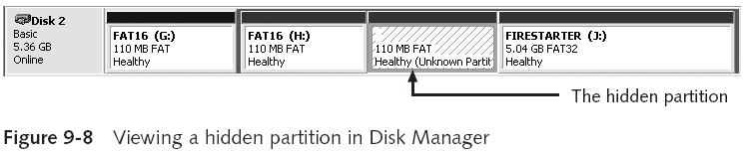

Hiding Partitions

Delete references to a partition using a disk editor

Re-create links for accessing it

Use disk-partitioning utilities

GDisk

PartitionMagic

System Commander

LILO

Account for all disk space when analyzing a disk

Marking Bad Clusters

Common with FAT systems

Place sensitive information on free space

Use a disk editor to mark space as a bad cluster

To mark a good cluster as bad using Norton Disk Edit

Type B in the FAT entry corresponding to that cluster

Bit-shifting

Old technique

Shift bit patterns to alter byte values of data

Make files look like binary executable code

Tool

Hex Workshop

Using Steganography to Hide Data

Greek for “hidden writing”

Steganography tools were created to protect copyrighted material

By inserting digital watermarks into a file

Suspect can hide information on image or text document files

Most steganography programs can insert only small amounts of data into a file

Very hard to spot without prior knowledge

Tools: S-Tools, DPEnvelope, jpgx, and tte

Examining Encrypted Files

Prevent unauthorized access

Employ a password or passphrase

Recovering data is difficult without password

Key escrow

Designed to recover encrypted data if users forget their passphrases or if the user key is corrupted after a system failure

Cracking password

Expert and powerful computers

Persuade suspect to reveal password

Recovering Passwords

Techniques

Dictionary attack

Brute-force attack

Password guessing based on suspect’s profile

Tools

AccessData PRTK

Advanced Password Recovery Software Toolkit

John the Ripper

Using AccessData tools with passworded and encrypted files

AccessData offers a tool called Password Recovery Toolkit (PRTK)

Can create possible password lists from many sources

FTK finds all stings in the data and makes a Word List from them

Can create your own custom dictionary based on facts in the case

Can create a suspect profile and use biographical information to generate likely passwords

FTK can identify known encrypted files and those that seem to be encrypted

And export them

You can then import these files into PRTK and attempt to crack them

Performing Remote Acquisitions

Performing Remote Acquisitions

Remote acquisitions are handy when you need to image the drive of a computer far away from your location

Or when you don’t want a suspect to be aware of an ongoing investigation

Remote Acquisitions with Runtime Software

Runtime Software offers the following shareware programs for remote acquisitions:

DiskExplorer for FAT

DiskExplorer for NTFS

HDHOST

Preparing DiskExplorer and HDHOST for remote acquisitions

Requires the Runtime Software, a portable media device (USB thumb drive or floppy disk), and two networked computers

Making a remote connection with DiskExplorer

Requires running HDHOST on a suspect’s computer

To establish a connection with HDHOST, the suspect’s computer must be:

Connected to the network

Powered on

Logged on to any user account with permission to run noninstalled applications

HDHOST can’t be run surreptitiously

See Figures 9-18 through 9-24

Making a remote acquisition with DiskExplorer

After you have established a connection with DiskExplorer from the acquisition workstation

You can navigate through the suspect computer’s files and folders or copy data

The Runtime tools don’t generate a hash for acquisitions

Last modified 10-25-10

