Objectives

Describe types of graphics file formats

Explain types of data compression

Explain how to locate and recover graphics files

Describe how to identify unknown file formats

Explain copyright issues with graphics
Recognizing a Graphics File

Contains digital photographs, line art, three-dimensional images, and scanned replicas of printed pictures

Bitmap images: collection of dots

Vector graphics: based on mathematical instructions

Metafile graphics: combination of bitmap and vector

Types of programs

Graphics editors

Image viewers

Understanding Bitmap and Raster Images

Bitmap images

Grids of individual pixels

Raster images

Pixels are stored in rows

Better for printing

Image quality

Screen resolution

Software

Number of color bits used per pixel

Understanding Vector Graphics

Characteristics

Lines and curves instead of dots

Store only the calculations for drawing lines and shapes

Smaller size

Preserve quality when image is enlarged

CorelDraw, Adobe Illustrator

Understanding Metafile Graphics

Combine raster and vector graphics

Example

Scanned photo (bitmap) with text (vector)

Share advantages and disadvantages of both types

When enlarged, bitmap part loses quality

Understanding Graphics File Formats

Standard bitmap file formats

Graphic Interchange Format (.gif)

Joint Photographic Experts Group (.jpeg, .jpg)

Tagged Image File Format (.tiff, .tif)

Window Bitmap (.bmp)

Standard vector file formats

Hewlett Packard Graphics Language (.hpgl)

Autocad (.dxf)

Nonstandard graphics file formats

Targa (.tga)

Raster Transfer Language (.rtl)

Adobe Photoshop (.psd) and Illustrator (.ai)

Freehand (.fh9)

Scalable Vector Graphics (.svg)

Paintbrush (.pcx)

Search the Web for software to manipulate unknown image formats

Understanding Digital Camera File Formats

Witnesses or suspects can create their own digital photos

Examining the raw file format

Raw file format

Referred to as a digital negative

Typically found on many higher-end digital cameras

Sensors in the digital camera simply record pixels on the camera’s memory card

Raw format maintains the best picture quality

The biggest disadvantage is that it’s proprietary

And not all image viewers can display these formats

The process of converting raw picture data to another format is referred to as demosaicing

Examining the Exchangeable Image File format

Exchangeable Image File (EXIF) format

Commonly used to store digital pictures

Developed by JEIDA as a standard for storing metadata in JPEG and TIFF files

EXIF format collects metadata

Investigators can learn more about the type of digital camera and the environment in which pictures were taken

EXIF file stores metadata at the beginning of the file

With tools such as ProDiscover and Exif Reader

You can extract metadata as evidence for your case

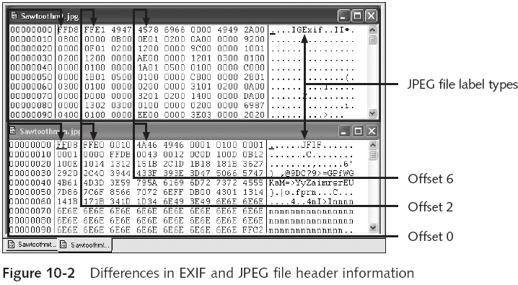

Online EXIF Viewer
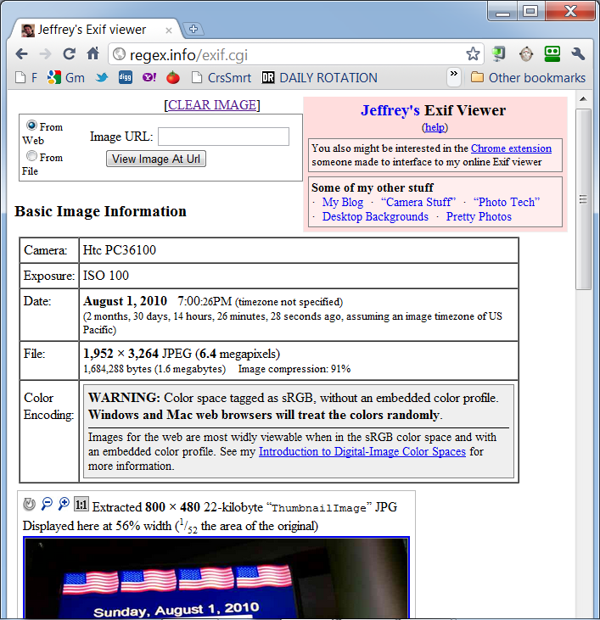
Link Ch 10a

Understanding Data Compression

Some image formats compress their data

GIF, JPEG, PNG

Others, like BMP, do not compress their data

Use data compression tools for those formats

Data compression

Coding of data from a larger to a smaller form

Types

Lossless compression and lossy compression

Lossless and Lossy Compression

Lossless compression

Reduces file size without removing data

Based on Huffman or Lempel-Ziv-Welch coding

For redundant bits of data

Utilities: WinZip, PKZip, StuffIt, and FreeZip

Permanently discards bits of information

Vector quantization (VQ)

Determines what data to discard based on vectors in the graphics file

Utility: Lzip
Locating and Recovering Graphics Files

Operating system tools

Time consuming

Results are difficult to verify

Computer forensics tools

Image headers

Compare them with good header samples

Use header information to create a baseline analysis

Reconstruct fragmented image files

Identify data patterns and modified headers

Identifying Graphics File Fragments

Carving or salvaging

Recovering all file fragments

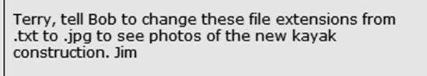
Computer forensics tools

Carve from slack and free space

Help identify image files fragments and put them together

Repairing Damaged Headers

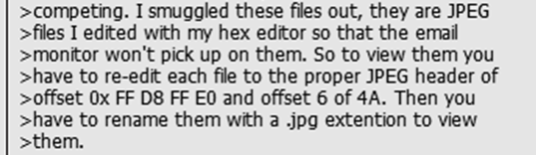
Use good header samples

Each image file has a unique file header

JPEG: FF D8 FF E0 00 10

Most JPEG files also include JFIF string

Exercise:

Investigate a possible intellectual property theft by a contract employee of Exotic Mountain Tour Service (EMTS)

Searching for and Carving Data from Unallocated Space

Steps

Planning your examination

Searching for and recovering digital photograph evidence

Use ProDiscover to search for and extract (recover) possible evidence of JPEG files

False hits are referred to as false positives

Rebuilding File Headers

Try to open the file first and follow steps if you can’t see its content

Steps

Recover more pieces of file if needed

Examine file header

Compare with a good header sample

Manually insert correct hexadecimal values

Test corrected file
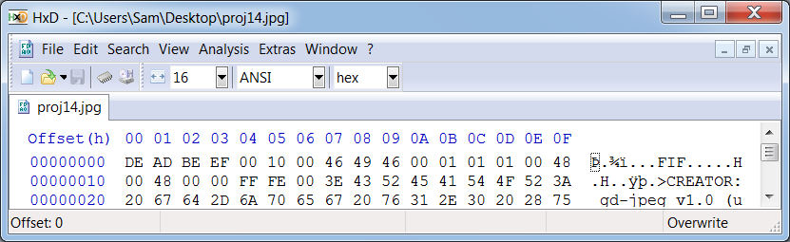

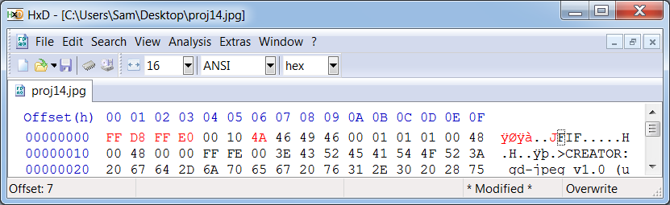

Reconstructing File Fragments

Locate the starting and ending clusters

For each fragmented group of clusters in the file

Steps

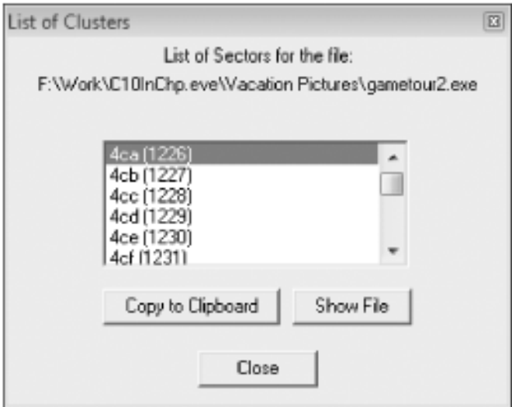
Locate and export all clusters of the fragmented file

Determine the starting and ending cluster numbers for each fragmented group of clusters

Copy each fragmented group of clusters in their proper sequence to a recovery file

Rebuild the corrupted file’s header to make it readable in a graphics viewer

Remember to save the updated recovered data with a .jpg extension

Sometimes suspects intentionally corrupt cluster links in a disk’s FAT

Bad clusters appear with a zero value on a disk editor
Identifying Unknown File Formats

The Internet is the best source

Search engines like Google

Find explanations and viewers

Popular Web sites

www.digitek-asi.com/file_formats.html

www.wotsit.org

http://whatis.techtarget.com

Analyzing Graphics File Headers

Necessary when you find files your tools do not recognize

Use hex editor such as Hex Workshop

Record hexadecimal values on header

Use good header samples

Tools for Viewing Images

Use several viewers

ThumbsPlus

ACDSee

QuickView

IrfanView

GUI forensics tools include image viewers

ProDiscover

EnCase

FTK

X-Ways Forensics

iLook

Understanding Steganography in Graphics Files

Steganography hides information inside image files

Ancient technique

Can hide only certain amount of information

Insertion

Hidden data is not displayed when viewing host file in its associated program

You need to analyze the data structure carefully

Example: Web page

Substitution

Replaces bits of the host file with bits of data

Usually change the last two LSBs

Detected with steganalysis tools

Usually used with image files

Audio and video options

Hard to detect

Using Steganalysis Tools

Detect variations of the graphic image

When applied correctly you cannot detect hidden data in most cases

Methods

Compare suspect file to good or bad image versions

Mathematical calculations verify size and palette color

Compare hash values

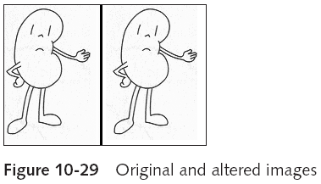

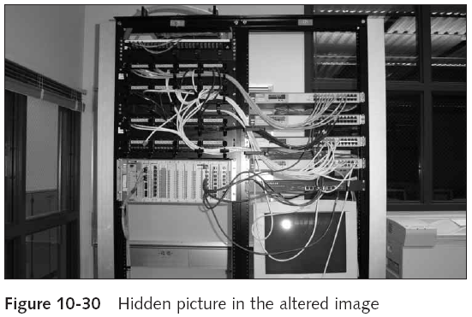

Identifying Copyright Issues with Graphics

Steganography originally incorporated watermarks

Copyright laws for Internet are not clear

There is no international copyright law

Check www.copyright.gov

Last modified 11-1-10

