Objectives

Describe primary concerns in conducting forensic examinations of virtual machines

Describe the importance of network forensics

Explain standard procedures for performing a live acquisition

Explain standard procedures for network forensics

Describe the use of network tools

Virtual Machines Overview

Virtual machines are important in today’s networks.

Investigators must know how to detect a virtual machine installed on a host, acquire an image of a virtual machine, and use virtual machines to examine malware.

Check whether virtual machines are loaded on a host computer.

Clues that virtual machines have been installed or uninstalled:

Folders named "Virtual Machines" or "My Virtual Machines"

Registry HKEY_CLASSES_ROOT shows file extensions .VMX or .VMC registered

VMware network adapter

VMware License Registry Key

Retained even if VMware is uninstalled

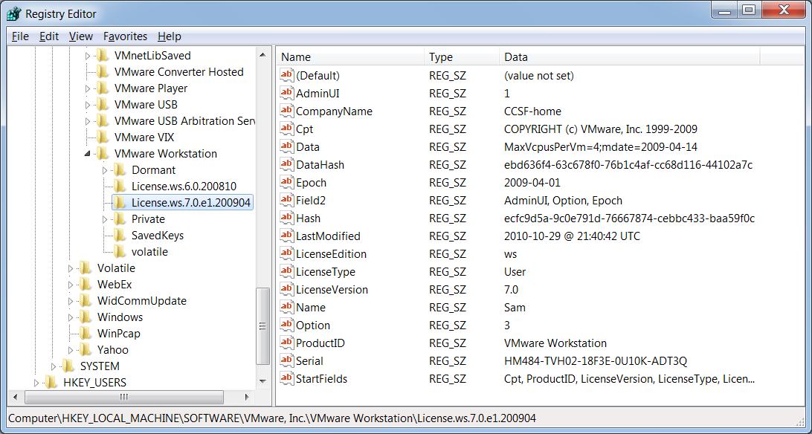

Imaging a Virtual Hard Disk

We have already covered that in the projects, including using a virtual write-blocker
Network Forensics Overview

Network Forensics Overview

Network forensics

Systematic tracking of incoming and outgoing traffic

To ascertain how an attack was carried out or how an event occurred on a network

Intruders leave trail behind

Determine the cause of the abnormal traffic

Internal bug

Attackers

Securing a Network

Layered network defense strategy

Sets up layers of protection to hide the most valuable data at the innermost part of the network

Defense in depth (DiD)

Similar approach developed by the NSA

Modes of protection

People (hiring and treatment)

Technology (firewalls, IDSs, etc.)

Operations (patches, updates)

Testing networks is as important as testing servers

You need to be up to date on the latest methods intruders use to infiltrate networks

As well as methods internal employees use to sabotage networks
Performing Live Acquisitions

Live acquisitions are especially useful when you’re dealing with active network intrusions or attacks

Live acquisitions done before taking a system offline are also becoming a necessity

Because attacks might leave footprints only in running processes or RAM

Live acquisitions don’t follow typical forensics procedures

Order of volatility (OOV)

How long a piece of information lasts on a system

Steps

Create or download a live-acquisition forensic CD

Make sure you keep a log of all your actions

A network drive is ideal as a place to send the information you collect; an alternative is a USB disk

Copy the physical memory (RAM)

The next step varies: search for rootkits, check firmware, image the drive over the network, or shut down for later static acquisition

Be sure to get a forensic hash value of all files you recover during the live acquisition

Performing a Live Acquisition in Windows

Several tools are available to capture the RAM.

Mantech Memory DD

Win32dd

winen.exe from Guidance Software

BackTrack
Developing Standard Procedures for Network Forensics

Developing Standard Procedures for Network Forensics

Long, tedious process

Standard procedure

Always use a standard installation image for systems on a network

Close any way in after an attack

Attempt to retrieve all volatile data

Acquire all compromised drives

Compare files on the forensic image to the original installation image

Computer forensics

Work from the image to find what has changed

Network forensics

Restore drives to understand attack

Work on an isolated system

Prevents malware from affecting other systems

Reviewing Network Logs

Record ingoing and outgoing traffic

Network servers

Routers

Firewalls

Tcpdump tool for examining network traffic

Can generate top 10 lists

Can identify patterns

Attacks might include other companies

Do not reveal information discovered about other companies
Using Network Tools

Using Network Tools

Sysinternals

A collection of free tools for examining Windows products

Examples of the Sysinternals tools:

RegMon shows Registry data in real time

Process Explorer shows what is loaded

Handle shows open files and processes using them

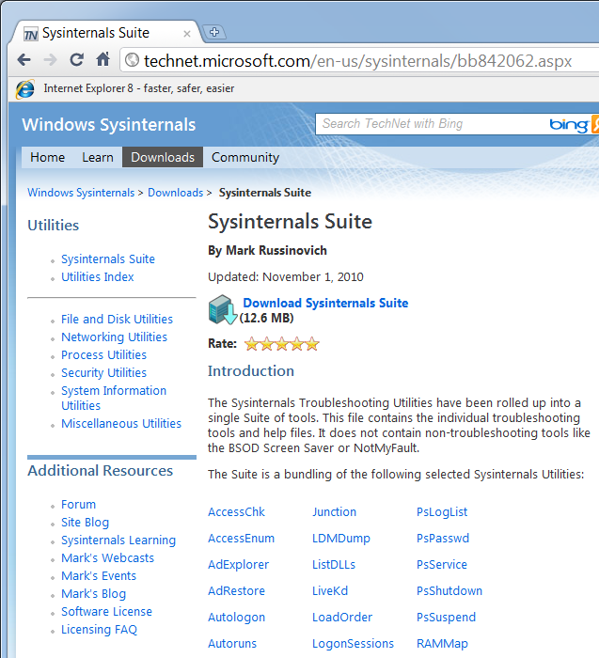
Filemon shows file system activity

SysInternals

Link Ch 11b

Tools from PsTools suite created by Sysinternals

PsExec runs processes remotely

PsGetSid displays security identifier (SID)

PsKill kills process by name or ID

PsList lists details about a process

PsLoggedOn shows who’s logged locally

PsPasswd changes account passwords

PsService controls and views services

PsShutdown shuts down and restarts PCs

PsSuspend suspends processes

Using UNIX/Linux Tools

Knoppix Security Tools Distribution (STD)

Bootable Linux CD intended for computer and network forensics

Knoppix-STD tools

Dcfldd, the U.S. DoD dd version

memfetch forces a memory dump

photorec grabs files from a digital camera

snort, an intrusion detection system

oinkmaster helps manage your snort rules

john

chntpw resets passwords on a Windows PC

tcpdump and ethereal are packet sniffers

With the Knoppix STD tools on a portable CD

You can examine almost any network system

BackTrack

Contains more than 300 tools for network scanning, brute-force attacks, Bluetooth and wireless networks, and more

Includes forensics tools, such as Autopsy and Sleuth Kit

Easy to use and frequently updated

Using Packet Sniffers

Packet sniffers

Devices or software that monitor network traffic

Most work at layer 2 or 3 of the OSI model

Most tools follow the PCAP format

Some packets can be identified by examining the flags in their TCP headers

TCP Header

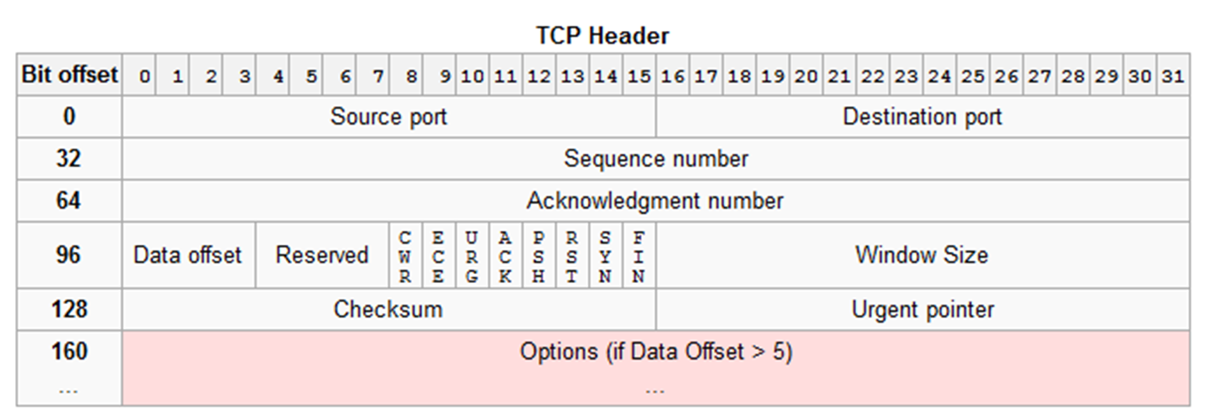
From Wikipedia

Tools

Tcpdump (command-line packet capture)

Tethereal (command-line version of Ethereal)

Wireshark (formerly Ethereal)

Graphical packet capture analysis

Snort (intrusion detection)

Tcpslice

Extracts information from one or more tcpdump files by time frame

Tcpreplay (replays packets)

Tcpdstat (near-realtime traffic statistics)

Ngrep (pattern-matching for pcap captures)

Etherape (views network traffic graphically)

Netdude (GUI tool to analyze pcap files)

Argus (analyzes packet flows)

Examining the Honeynet Project

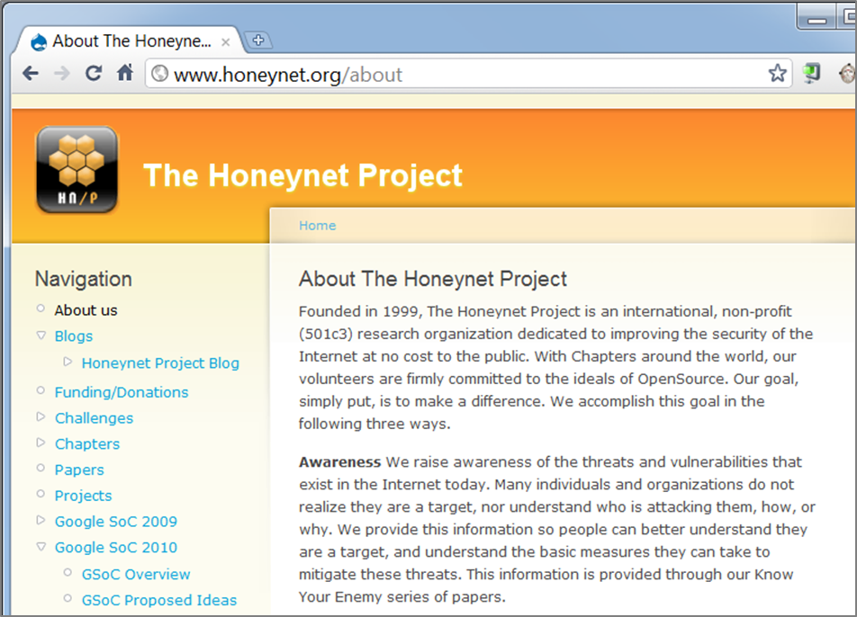
Attempt to thwart Internet and network hackers

Provides information about attacks methods

Objectives are awareness, information, and tools

Distributed denial-of-service (DDoS) attacks

A recent major threat

Hundreds or even thousands of machines (zombies) can be used

Zero day attacks

Another major threat

Attackers look for holes in networks and OSs and exploit these weaknesses before patches are available

Honeypot

Normal looking computer that lures attackers to it

Honeywalls

Monitor what’s happening to honeypots on your network and record what attackers are doing

Its legality has been questioned

Cannot be used in court

Can be used to learn about attacks

Manuka Project

Used the Honeynet Project’s principles

To create a usable database for students to examine compromised honeypots

Honeynet Challenges

You can try to ascertain what an attacker did and then post your results online

Last modified 11-8-10 4 pm

