Objectives

Explain the role of e-mail in investigations

Describe client and server roles in e-mail

Describe tasks in investigating e-mail crimes and violations

Explain the use of e-mail server logs

Describe some available e-mail computer forensics tools
Exploring the Role of E-mail in Investigations

With the increase in e-mail scams and fraud attempts with phishing or spoofing

Investigators need to know how to examine and interpret the unique content of e-mail messages

Phishing e-mails are in HTML format

Which allows creating links to text on a Web page

One of the most noteworthy e-mail scams was 419, or the Nigerian Scam

Spoofing e-mail can be used to commit fraud

Munshani v. Signal Lake Venture Fund

Munshani received an email and altered it

But he failed to alter the ESMTP numbers which uniquely identify each message an SMTP server transmits

Comparing ESMTP numbers from the server and the spoofed email revealed the fraud

Link Ch 12a
Exploring the Roles of the Client and Server in E-mail

Send and receive e-mail in two environments

Internet

Controlled LAN, MAN, or WAN

Client/server architecture

Server OS and e-mail software differs from those on the client side

Protected accounts

Require usernames and passwords

Name conventions

Corporate: john.smith@somecompany.com

Public: whatever@hotmail.com

Everything after @ belongs to the domain name

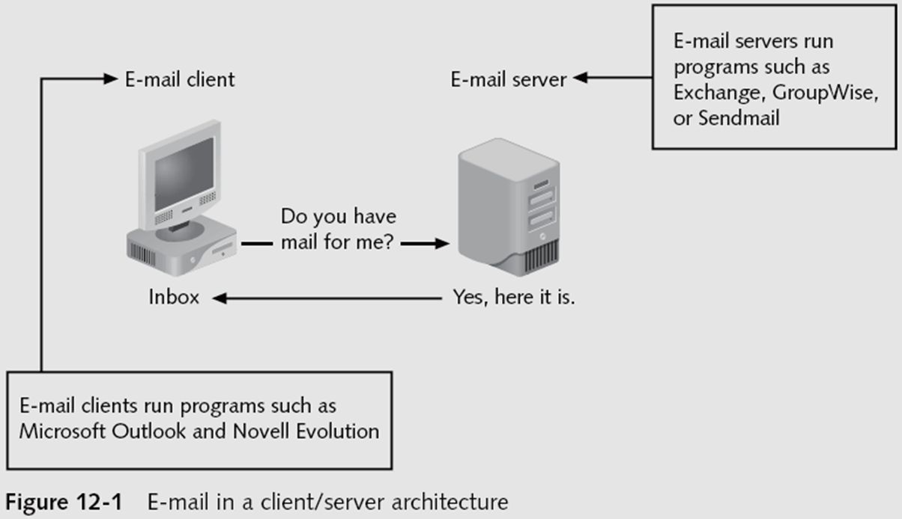
Tracing corporate e-mails is easier

Because accounts use standard names the administrator establishes

Investigating E-mail Crimes and Violations

Investigating E-mail Crimes and Violations

Similar to other types of investigations

Goals

Find who is behind the crime

Collect the evidence

Present your findings

Build a case

Depend on the city, state, or country

Example: spam

Always consult with an attorney

Becoming commonplace

Examples of crimes involving e-mails

Narcotics trafficking

Extortion

Sexual harassment

Child abductions and pornography

Examining E-mail Messages

Access victim’s computer to recover the evidence

Using the victim’s e-mail client

Find and copy evidence in the e-mail

Access protected or encrypted material

Print e-mails

Guide victim on the phone

Open and copy e-mail including headers

Sometimes you will deal with deleted e-mails

Copying an e-mail message

Before you start an e-mail investigation

You need to copy and print the e-mail involved in the crime or policy violation

You might also want to forward the message as an attachment to another e-mail address

With many GUI e-mail programs, you can copy an e-mail by dragging it to a storage medium

Or by saving it in a different location

Viewing E-mail Headers

Learn how to find e-mail headers

GUI clients

Command-line clients

Web-based clients

After you open e-mail headers, copy and paste them into a text document

So that you can read them with a text editor

Headers contain useful information

Unique identifying numbers, IP address of sending server, and sending time

Outlook

Open the Message Options dialog box

Copy headers

Paste them to any text editor

Outlook Express

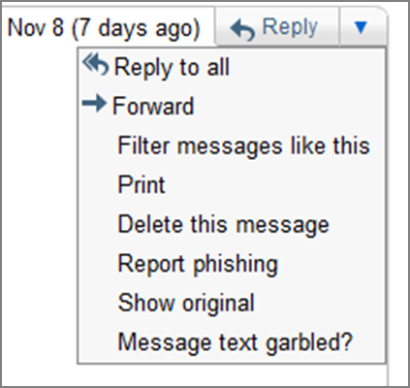
Open the message Properties dialog box

Select Message Source

Copy and paste the headers to any text editor

Email Headers in Gmail

Click “Reply” drop-down arrow, “Show original”

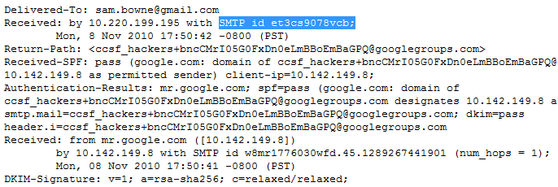

Examining E-mail Headers

Gather supporting evidence and track suspect

Return path

Recipient’s e-mail address

Type of sending e-mail service

IP address of sending server

Name of the e-mail server

Unique message number

Date and time e-mail was sent

Attachment files information

See link Ch 12b for an example—tracing the source of spam

Examining Additional E-mail Files

E-mail messages are saved on the client side or left at the server

Microsoft Outlook uses .pst and .ost files

Most e-mail programs also include an electronic address book

In Web-based e-mail

Messages are displayed and saved as Web pages in the browser’s cache folders

Many Web-based e-mail providers also offer instant messaging (IM) services

Tracing an E-mail Message

Contact the administrator responsible for the sending server

Finding domain name’s point of contact

www.arin.net

www.internic.com

www.freeality.com

www.google.com

Find suspect’s contact information

Verify your findings by checking network e-mail logs against e-mail addresses

Using Network E-mail Logs

Router logs

Record all incoming and outgoing traffic

Have rules to allow or disallow traffic

You can resolve the path a transmitted e-mail has taken

Firewall logs

Filter e-mail traffic

Verify whether the e-mail passed through

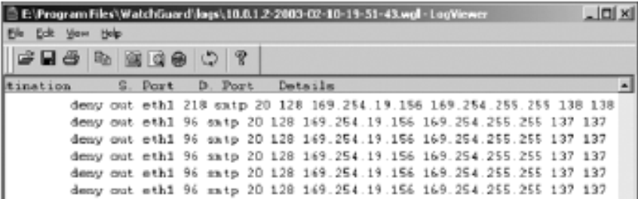
You can use any text editor or specialized tools

A Firewall Log

Understanding E-mail Servers

Computer loaded with software that uses e-mail protocols for its services

And maintains logs you can examine and use in your investigation

E-mail storage

Database

Flat file

Logs

Default or manual

Continuous and circular

Log information

E-mail content

Sending IP address

Receiving and reading date and time

System-specific information

Contact suspect’s network e-mail administrator as soon as possible

Servers can recover deleted e-mails

Similar to deletion of files on a hard drive

Examining UNIX E-mail Server Logs

/etc/sendmail.cf

Configuration information for Sendmail

/etc/syslog.conf

Specifies how and which events Sendmail logs

/var/log/maillog

SMTP and POP3 communications

IP address and time stamp

Check UNIX man pages for more information

Examining Microsoft E-mail Server Logs

Microsoft Exchange Server (Exchange)

Uses a database

Based on Microsoft Extensible Storage Engine

Messaging Application Programming Interface (MAPI)

A Microsoft system that enables different e- mail applications to work together

The “Information Store” is made of two files

Database files *.edb

Responsible for MAPI information

Database files *.stm

Responsible for non-MAPI information

Administrators can recover lost or deleted emails from these files:

Transaction log

Keep track of e-mail databases

Checkpoints

Marks the place in the transaction log where the last backup was made

Other useful files

Temporary files

E-mail communication logs

res#.log

Tracking.log

Tracks messages

Troubleshooting or diagnostic log

Logs events

Use Windows Event Viewer

Open the Event Properties dialog box for more details about an event

Examining Novell GroupWise E-mail Logs

Up to 25 databases for e-mail users

Stored on the Ofuser directory object

Referenced by a username, an unique identifier, and .db extension

Shares resources with e-mail server databases

Mailboxes organizations

Permanent index files

QuickFinder

Folder and file structure can be complex

It uses Novell directory structure

Guardian

Directory of every database

Tracks changes in the GroupWise environment

Considered a single point of failure

Log files

GroupWise generates log files (.log extension) maintained in a standard log format in GroupWise folders

Using Specialized E-mail Forensics Tools

Tools include:

AccessData’s Forensic Toolkit (FTK)

ProDiscover Basic

FINALeMAIL

Sawmill-GroupWise

DBXtract

Fookes Aid4Mail and MailBag Assistant

Paraben E-Mail Examiner

Ontrack Easy Recovery EmailRepair

R-Tools R-Mail

Tools allow you to find:

E-mail database files

Personal e-mail files

Offline storage files

Log files

Advantage

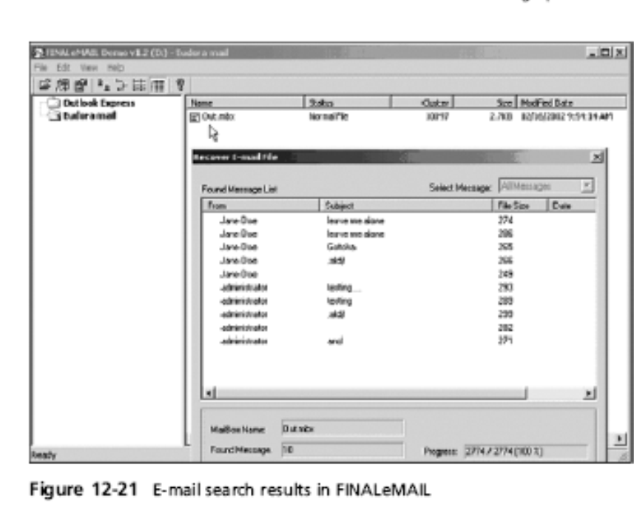
Do not need to know how e-mail servers and clients work

FINALeMAIL

Scans e-mail database files

Recovers deleted e-mails

Searches computer for other files associated with e-mail

Using AccessData FTK to Recover E-mail

FTK

Can index data on a disk image or an entire drive for faster data retrieval

Filters and finds files specific to e-mail clients and servers

To recover e-mail from Outlook and Outlook Express

AccessData integrated dtSearch

dtSearch builds a b-tree index of all text data in a drive, an image file, or a group of files

Using a Hexadecimal Editor to Carve E-mail Messages

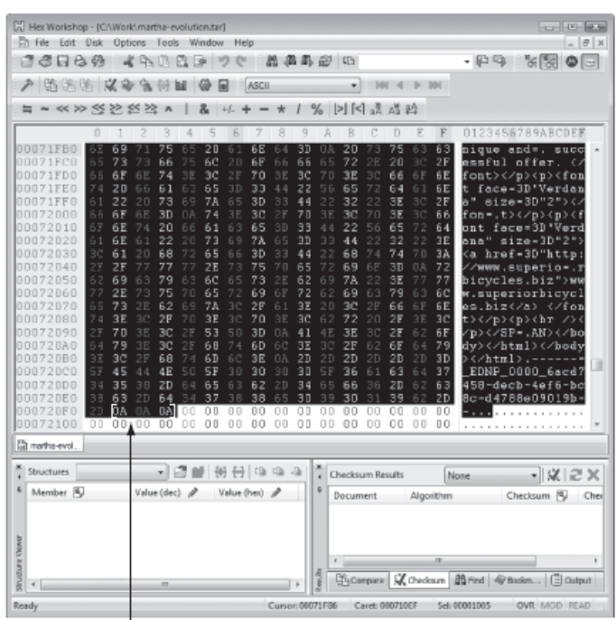
Very few vendors have products for analyzing e-mail in systems other than Microsoft

mbox format

Stores e-mails in flat plaintext files

Multipurpose Internet Mail Extensions (MIME) format

Used by vendor-unique e-mail file systems, such as Microsoft .pst or .ost

Example: carve e-mail messages from Evolution

Recovering Deleted Outlook Files

Microsoft's Inbox Repair Tool (scanpst)

Link Ch 12d

EnCase

Advanced Outlook Repair from DataNumen, Inc.

Link Ch 12e

Last modified 11-15-10 4 pm

