Objectives

Explain the basic concepts of mobile device forensics

Describe procedures for acquiring data from cell phones and mobile devices
Understanding Mobile Device Forensics

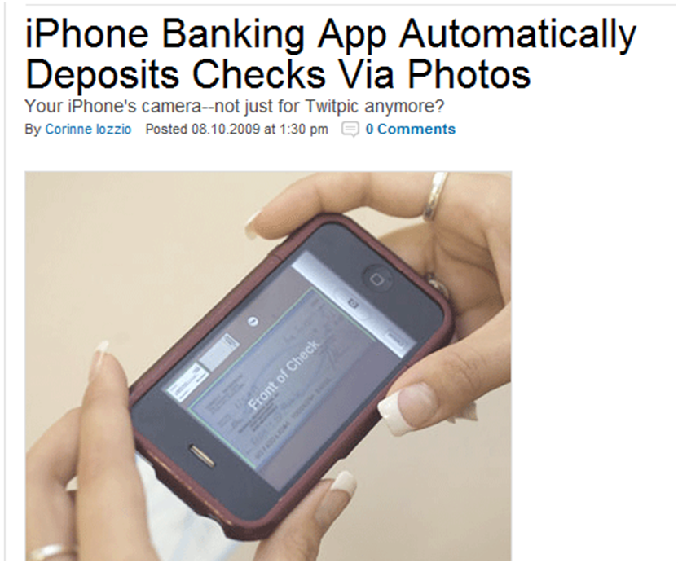
Data on iPhones

Screenshots of every map viewed

iPhone photos have GPS location data embedded

Apps store browsing history

iPhone stores everything you type, like a keylogger

Link Ch 13a

iPhone also stores screenshots after each action, in order to create an aesthetically pleasing shrinking effect (link Ch 13b)

Banking on iPhones

Link Ch 13c

Understanding Mobile Device Forensics

People store a wealth of information on cell phones

People don’t think about securing their cell phones

Items stored on cell phones:

Incoming, outgoing, and missed calls

Text and Short Message Service (SMS) messages

E-mail

Instant-messaging (IM) logs

Web pages

Pictures

Personal calendars

Address books

Music files

Voice recordings

Investigating cell phones and mobile devices is one of the most challenging tasks in digital forensics

Mobile Phone Basics

Mobile phone technology has advanced rapidly

Three generations of mobile phones:

Analog

Digital personal communications service (PCS)

Third-generation (3G)

3G offers increased bandwidth

Several digital networks are used in the mobile phone industry

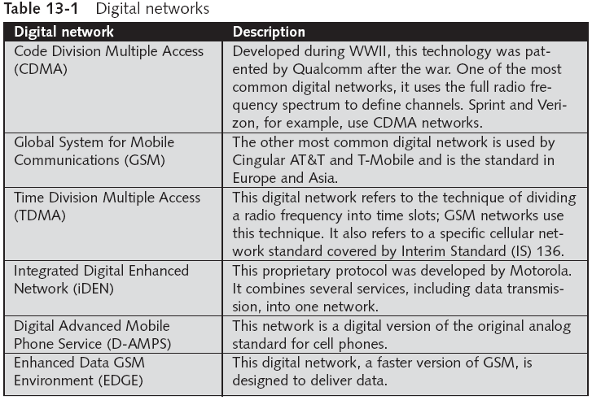

4G Networks

Orthogonal Frequency Division Multiplexing ( OFDM)

Uses power more efficiently, and is more immune to interference

Mobile WiMAX

Used by Sprint, will support speeds up to 12 Mbps

Ultra Mobile Broadband (UTMS)

Also known as CDMA2000 EV- DO

Will support speeds up to 100 Mbps

Multiple Input Multiple Output (MIMO)

Will support speeds up to 312 Mbps

Long Term Evolution (LTE)

Will support up to 144 Mbps

Main components used for communication:

Base transceiver station (BTS)

Cell phone tower and associated equipment

Base station controller (BSC)

Hardware & software that controls the BTS

Mobile switching center (MSC)

Routes calls

Has a database of subscribers with account and location data

Inside Mobile Devices

Mobile devices can range from simple phones to small computers

Also called smart phones

Hardware components

Microprocessor, ROM, RAM, a digital signal processor, a radio module, a microphone and speaker, hardware interfaces, and an LCD display

Most basic phones have a proprietary OS

Although smart phones use stripped-down versions of PC operating systems

Phones store system data in electronically erasable programmable read-only memory (EEPROM)

Enables service providers to reprogram phones without having to physically access memory chips

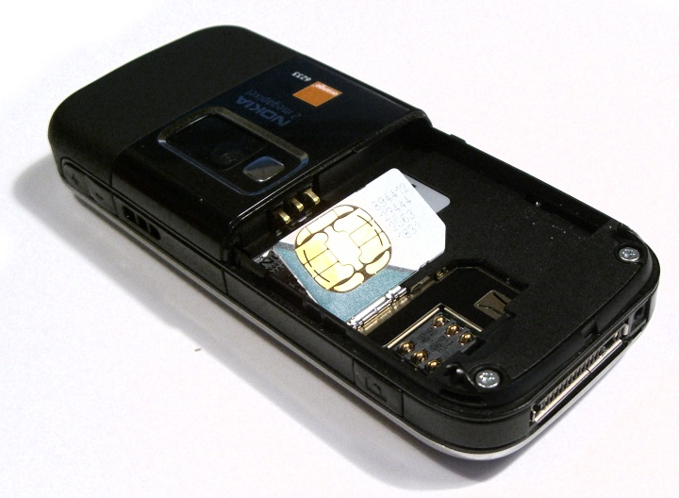
OS is stored in ROM
SIM Card
(from Wikipedia)

Nonvolatile memory

Subscriber identity module (SIM) cards

Found most commonly in GSM devices

Microprocessor and from 16 KB to 4 MB EEPROM

Sometimes even more, up go 1 GB EEPROM

GSM refers to mobile phones as “mobile stations” and divides a station into two parts:

The SIM card and the mobile equipment (ME)

SIM cards come in two sizes

Portability of information makes SIM cards versatile

Additional SIM card purposes:

Identifies the subscriber to the network

Stores personal information

Stores address books and messages

Stores service-related information

Inside PDAs

Personal digital assistants (PDAs)

Can be separate devices from mobile phones

Most users carry them instead of a laptop

PDAs house a microprocessor, flash ROM, RAM, and various hardware components

The amount of information on a PDA varies depending on the model

Usually, you can retrieve a user’s calendar, address book, Web access, and other items

Peripheral memory cards are used with PDAs

Compact Flash (CF)

MultiMedia Card (MMC)

Secure Digital (SD)

Most PDAs synchronize with a computer

Built-in slots for that purpose
Understanding Acquisition Procedures for Cell Phones and Mobile Devices

Understanding Acquisition Procedures for Cell Phones and Mobile Devices

The main concerns with mobile devices are loss of power and synchronization with PCs

All mobile devices have volatile memory

Making sure they don’t lose power before you can retrieve RAM data is critical

Mobile device attached to a PC via a cable or cradle/docking station should be disconnected from the PC immediately

Depending on the warrant or subpoena, the time of seizure might be relevant

Messages might be received on the mobile device after seizure

Isolate the device from incoming signals with one of the following options:

Place the device in a paint can

Use the Paraben Wireless StrongHold Bag

Use eight layers of antistatic bags to block the signal

The drawback to using these isolating options is that the mobile device is put into roaming mode

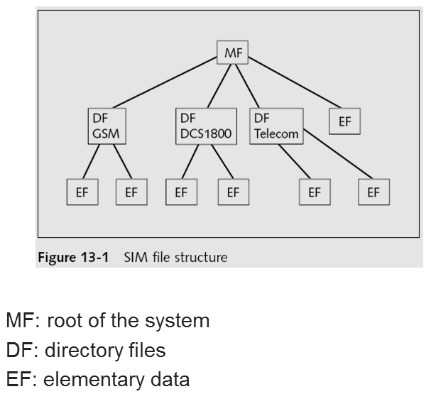
Which accelerates battery drainage

Check these areas in the forensics lab :

Internal memory

SIM card

Removable or external memory cards

System server

Checking system servers requires a search warrant or subpoena

SIM card file system is a hierarchical structure

Information that can be retrieved:

Service-related data, such as identifiers for the SIM card and the subscriber

Call data, such as numbers dialed

Message information

Location information

If power has been lost, PINs or other access codes might be required to view files

Mobile Forensics Equipment

Mobile forensics is a new science

Biggest challenge is dealing with constantly changing models of cell phones

When you’re acquiring evidence, generally you’re performing two tasks:

Acting as though you’re a PC synchronizing with the device (to download data)

Reading the SIM card

First step is to identify the mobile device

Make sure you have installed the mobile device software on your forensic workstation

Attach the phone to its power supply and connect the correct cables

After you’ve connected the device

Start the forensics program and begin downloading the available information

SIM card readers

A combination hardware/software device used to access the SIM card

You need to be in a forensics lab equipped with appropriate antistatic devices

General procedure is as follows:

Remove the back panel of the device

Remove the battery

Under the battery, remove the SIM card from holder

Insert the SIM card into the card reader

A variety of SIM card readers are on the market

Some are forensically sound and some are not

Documenting messages that haven’t been read yet is critical

Use a tool that takes pictures of each screen

Blackberries may require special hardware

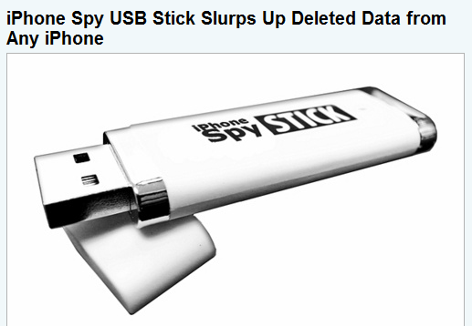
iPhone Forensics

MacLockPick II

Uses backup files

It can’t recover deleted files

MDBackUp Extract

Analyzes the iTunes mobile sync backup directory

Mobile Forensics Tools

Paraben Software Device Seizure Toolbox

Contains cables, SIM card readers, and more

Data Pilot

Similar to Paraben

BitPim

Can view data on many phones, but it's not intended for forensics

MOBILedit!

Has a write-blocker

SIMCon

Reads files on SIM cards

Recoveres deleted text messages

Archives files with MD5 and SHA-1 hashes

Software tools differ in the items they display and the level of detail

File structure of a SIM card viewed in SIMCon

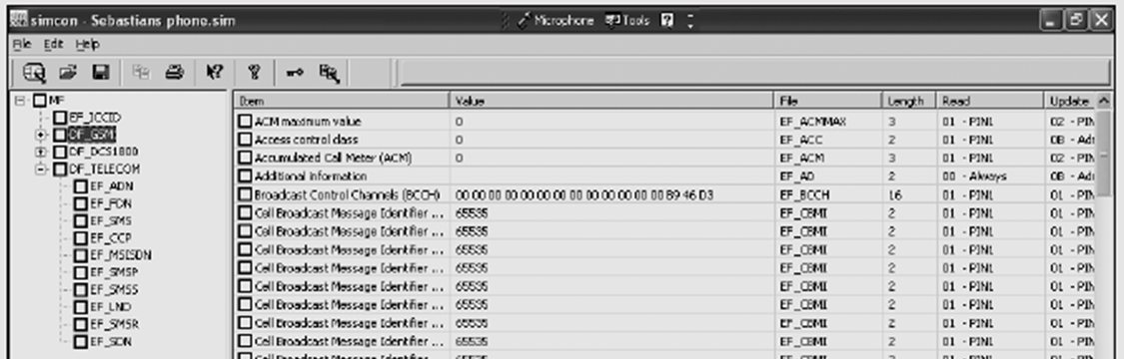

Last modified 11-15-10 4 pm

