Objectives

Explain the importance of reports

Describe guidelines for writing reports

Explain how to use forensics tools to generate reports
Understanding the Importance of Reports

Understanding the Importance of Reports

Communicate the results of your investigation

Including expert opinion

Courts require expert witness to submit written reports

Written report must specify fees paid for the expert’s services

And list all other civil or criminal cases in which the expert has testified for the preceding 4 years

Deposition banks

Examples of expert witness’ previous testimonies

Limiting a Report to Specifics

All reports to clients should start with the job mission or goal

Find information on a specific subject

Recover certain significant documents

Recover certain types of files

Before you begin writing, identify your audience and the purpose of the report

Types of Reports

Computer forensics examiners are required to create different types of reports

Examination plan

What questions to expect when testifying

Attorney uses the examination plan to guide you in your testimony

You can propose changes to clarify or define information

Helps your attorney learn the terms and functions used in computer forensics

Verbal report

Less structured

Attorneys cannot be forced to release verbal reports

Preliminary report

Addresses areas of investigation yet to be completed

Tests that have not been concluded

Interrogatories

Document production

Depositions

Written report

Affidavit or declaration

Limit what you write and pay attention to details

Include thorough documentation and support of what you write
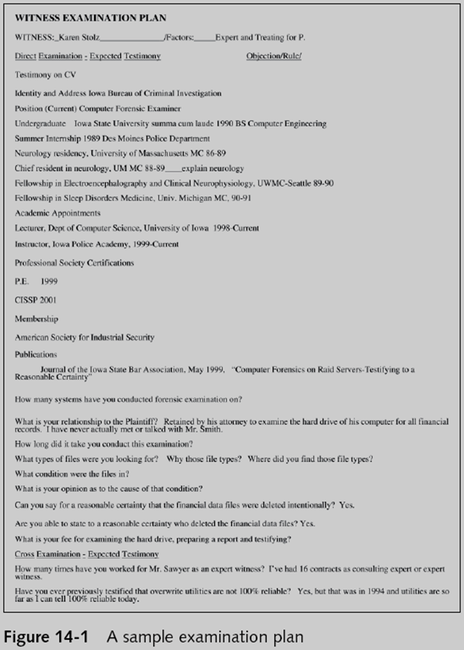

Guidelines for Writing Reports

Hypothetical questions based on factual evidence

Less favored today

Guide and support your opinion

Can be abused and overly complex

Opinions based on knowledge and experience

Exclude from hypothetical questions

Facts that can change, cannot be used, or are not relevant to your opinion

As an expert witness, you may testify to an opinion, or conclusion, if four basic conditions are met:

Opinion, inferences, or conclusions depend on special knowledge or skills

Expert should qualify as a true expert

Expert must testify to a certain degree of certainty

Experts must describe facts on which their opinions are based, or they must testify to a hypothetical question

What to Include in Written Preliminary Reports

Anything you write down as part of your examination for a report

Subject to discovery from the opposing attorney

Considered high-risk documents

Spoliation

Destroying the report could be considered destroying or concealing evidence

Include the same information as in verbal reports

Additional items to include in your report:

Summarize your billing to date and estimate costs to complete the effort

Identify the tentative conclusion (rather than the preliminary conclusion)

Identify areas for further investigation and obtain confirmation from the attorney on the scope of your examination

Report Structure

Structure

Abstract

Table of contents

Body of report

Conclusion

References

Glossary

Acknowledgements

Appendixes

Writing Reports Clearly

Consider

Communicative quality

Ideas and organization

Grammar and vocabulary

Punctuation and spelling

Lay out ideas in logical order

Build arguments piece by piece

Group related ideas and sentences into paragraphs

Group paragraphs into sections

Avoid jargon, slang, and colloquial terms

Define technical terms

Consider your audience

Consider writing style

Use a natural language style

Avoid repetition and vague language

Be precise and specific

Use active rather than passive voice

Avoid presenting too many details and personal observations

Include signposts

Draw reader’s attention to a point

Designing the Layout and Presentation of Reports

Decimal numbering structure

Divides material into sections

Readers can scan heading

Readers see how parts relate to each other

Legal-sequential numbering

Used in pleadings

Roman numerals represent major aspects

Arabic numbers are supporting information

Providing supporting material

Use material such as figures, tables, data, and equations to help tell the story as it unfolds

Formatting consistently

How you format text is less important than being consistent in applying formatting

Explaining examination and data collection methods

Explain how you studied the problem, which should follow logically from the purpose of the report

Including calculations

If you use any hashing algorithms, be sure to give the common name

Providing for uncertainty and error analysis

Protect your credibility

Explaining results and conclusions

Explain your findings, using subheadings to divide the discussion into logical parts

Save broader generalizations and summaries for the report’s conclusion

Providing references

Cite references by author’s last name and year of publication

Follow a standard format

Including appendixes

You can include appendixes containing material such as raw data, figures not used in the body of the report, and anticipated exhibits

Arrange them in the order referred to in the report

Generating Report Findings with Forensics Software Tools

Forensics tools generate reports when performing analysis

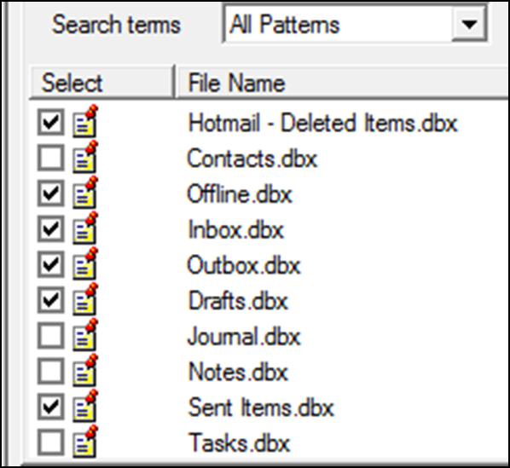
Report formats

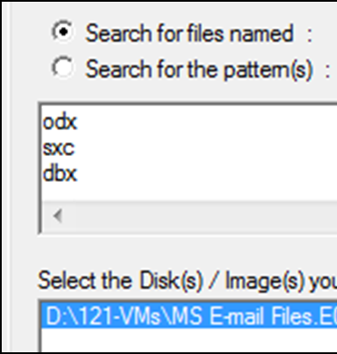
Plaintext

Word processor

HTML format

Using ProDiscover Basic to Generate Reports

Create a new project

Add an image file to the project

Search for file extensions

Using FTK Demo to Generate Reports

Create a new case

Add evidence to the case

Analyze evidence with FTK

Look for image files

Locate encrypted files

Search for specific keywords

Indexed search

Live search

Create bookmarks

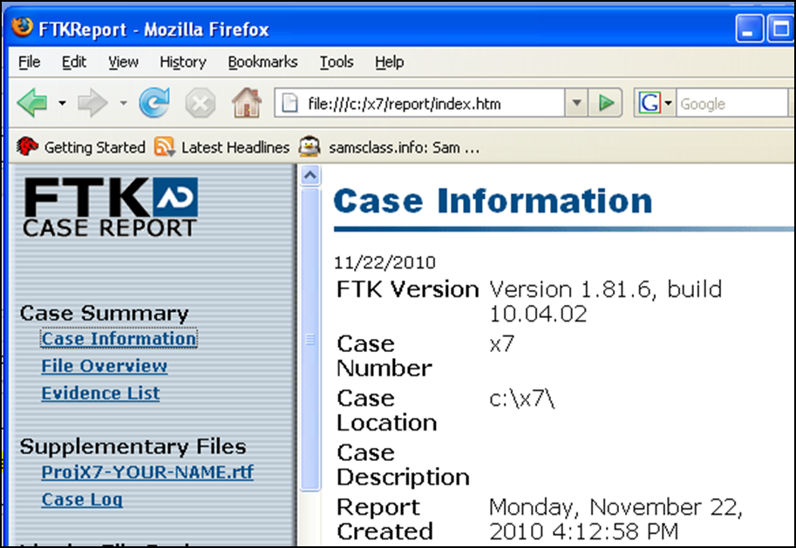
Generate a report from your bookmarks

Last modified
11-15-10 4 pm

