Topics

What is Forensic Science?

What is Digital Forensics?

Uses of Digital Forensics

Role in the Judicial System
What is Digital Forensics?

Digital Evidence

Computers record evidence of everything you do, and also

Cell phones

ATM machines

Web servers

Email servers

SMS systems

etc.

Slow to Change

Attorneys and judges often know little about digital evidence

Digital forensic scientists must therefore be teachers as well as technical experts

Forensic Science

Forensics

Application of science to solve a legal problem

Digital Forensics

Application of computer science and investigative procedures

Analysis of digital evidence

Search authority

Chain of custody

Validation with mathematics

Use of validated tools

Repeatability

Reporting

Expert presentation

Items to Examine

Laptop and desktop computers

Mobile devices

Networks

Cloud systems

Video, audio, and images

Authenticity, comparison, enhancement

Uses of Digital Forensics

Criminal investigations

Child pornography

Identity theft

Homocide, sexual assault, robbery, burglary…

Almost every criminal investigation

Civil litigation

Intelligence

Administrative matters

Forensics Backlog

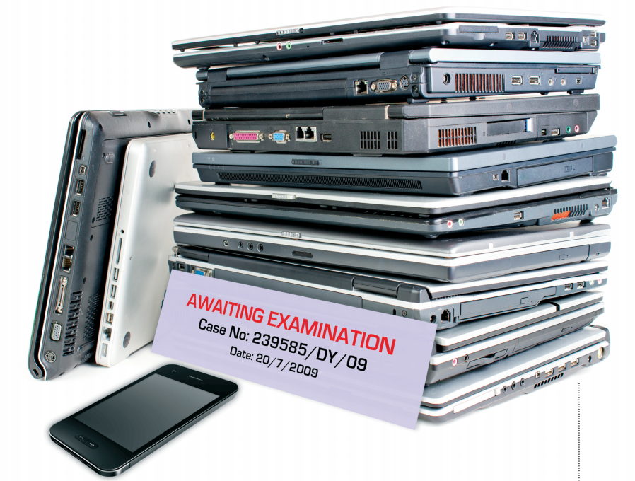
"…there were massive backlogs within all police forces, to the point where it was six months to two years before some computers could be examined"

Link Ch 1a on my Web page

samsclass.info

"CNIT 121"

Law Enforcement Paradigm

Police need to think of and seek out digital evidence

Seize

Cell phones

Gaming consoles

Cameras

Etc.

Bind. Torture. Kill.

Dennis Rader

Respected citizen

Also a serial killer

Murdered ten people in Kansas from 1974 to 1991

He confessed in an anonymous letter to a newspaper

He offered to send police a floppy disk

Police said it couldn't be traced

Metadata

Metadata on the RTF file he sent contained

Dates

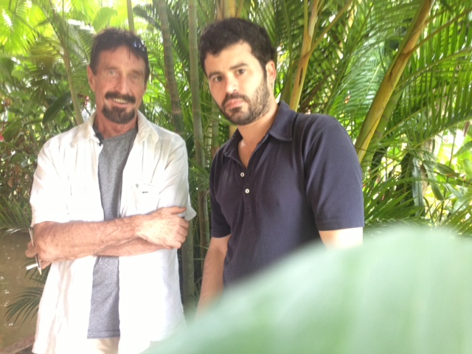
Title: "Christ Lutheran Church"

"Last Saved By:" Dennis

Christ Lutheran Church Wichita website showed Dennis Rader as President of Congregation Council

John Mcaffee

Fugitive from Belize police

Posed for a photo in Guatemala

Published on the Internet with GPS location metadata

Link Ch 1c

Civil Litigation

eDiscovery is a $780 million business

Hiring in San Francisco now

eDiscovery definition

"any process in which electronic data is sought, located, secured, and searched with the intent of using it as evidence in a civil or criminal legel case"

Both parties are entitled to examine evidence

This process is called "Discovery"

Google's Billion Dollar eDiscovery Error

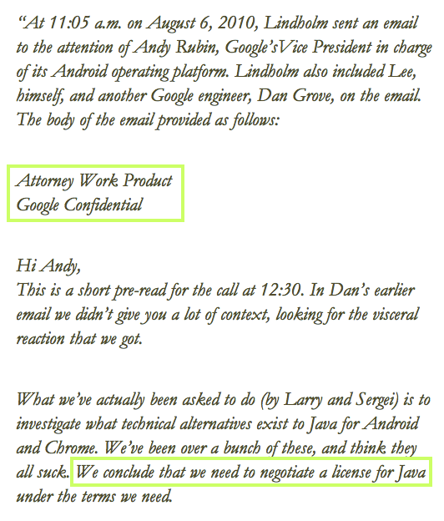
This email was marked "Confidential" on some copies but not on others

Accidentally revealed as evidence

Link Ch 1d

(Google didn't actually lose the $1 billion)

Intelligence

Terrorists and foreign governments use digital tools and the Internet

US Military uses documents and media in the DOCEX and DOMEX processes

DOMEX

DOCEX (Document Exploitation)

"Procedures used by the United States Armed Forces to discover, categorize, and use documents seized in combat operations"

"Documents" includes
digital media

DOMEX (Document and Media Exploitation)

Use of documents by
various agencies after
collection

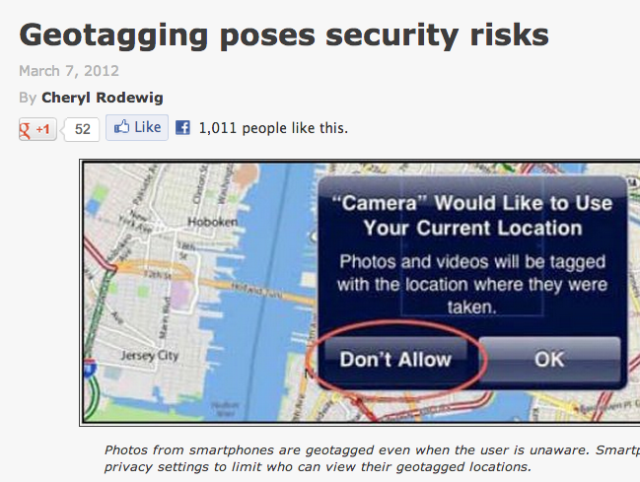
Link Ch 1f

Real Aid to the Enemy

"…a real-world example from 2007. When a new fleet of helicopters arrived … in Iraq, some Soldiers took pictures ... From the photos that were uploaded to the Internet, the enemy was able to determine the exact location of the helicopters inside the compound and conduct a mortar attack, destroying four of the AH-64 Apaches."

Link Ch 1d

Administrative Matters

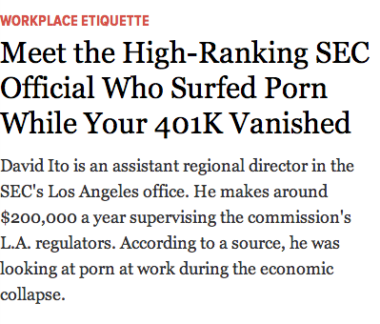
Digital evidence is used to detect policy violations

Accessing forbidden websites at work

SEC Office of the Inspector General

Firewall logs showed officials surfed porn at work

Link Ch 1f

Locard's Exchange Principle

When perps enter or leave a crime scene, they will leave something behind or take something with them

Such as DNA, fingerprints, hair, fibers, etc.

Also true of digital forensics

Registry keys, log files, etc.

Scientific Method

Forensic science is new and procedures are still being developed

A scientist is normally regarded as objective, neutral, dealing only with facts

BUT forensic experts are hired by both prosecution and defense, and state expert opinions as well as facts

Organizations of Note

Scientific Working Group on Digital Evidence

"brings together organizations actively engaged in the field of digital and multimedia evidence to foster communication and cooperation as well as to ensure quality and consistency within the forensic community"

Link Ch 1h

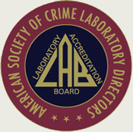
American Academy of Forensic Sciences

Premier forensic organization in the world

Develops standards of practice

6000 members, including directors of most federal crime labs

Link Ch 1i

American Society of Crime Laboratory Directors/
Laboratory Accreditation Board (ASCLD/LAB)

ASCD/LAB accredited labs are the "gold standard" in forensics

They set standards and requirements for accreditation

Link Ch 1j

NIST (National Institute of Standards and Technology)

National Software Reference Library

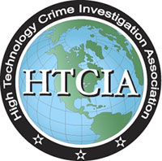
Known file signatures for operating system software and other items of no investigative value

Computer Forensic Tool Testing

Link Ch 1l

ASTM International

Also develops standards for forensics

Link Ch 1k

HTCIA (not in textbook)

High-Tech Crime Investigation Association

Organization of peace officers, investigators, prosecuting attorneys, and security professionals

But NOT criminal defense experts

Link Ch 1g

Defense Lawyers

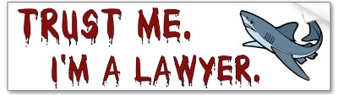
Understand their goals

Hurting the expert & freeing the client is a win for them

Image from http://www.zazzle.com/lawyer_shark_trust_me_bumper_sticker-128101885100809676

Role of the Forensic Examiner in the Judicial System

Expert witness

Qualified to render an opinion

Must be effective communicators

Must be teachers

Must be without bias

Follow the evidence wherever it leads

Last modified 1-12-13

