Topics

Basic Computer Operation

Bits & Bytes

File Extensions & File Signatures

How Computers Store Data

RAM: Random Access Memory

Volatility of Data

The Difference Between Computer Environments

Active, Latent, and Archival Data

Allocated and Unallocated Space

Computer File Systems
Bits & Bytes

A Bit is 0 or 1

8 bits is a byte

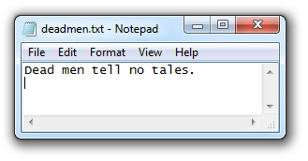
00000000 to 11111111

256 possible bytes

Can be written as a number 0 to 255

In Hexadecimal, 00 to FF

Binary Games

ASCII Text

One byte per character

7 bits encode character, one parity bit

94 printable characters

Originally used for English

Adapted to other languages

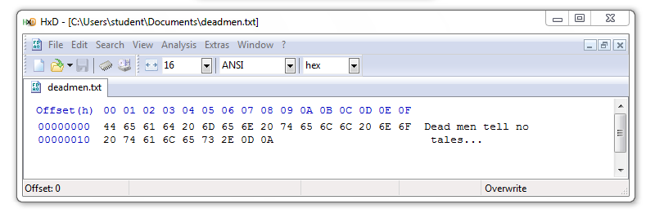
ASCII file in Hexadecimal

20 hex = 32 decimal = SPACE

0D 0A = 13 10 = CR LF

ASCII

From Wikipedia (Link Ch 2a)

Unicode

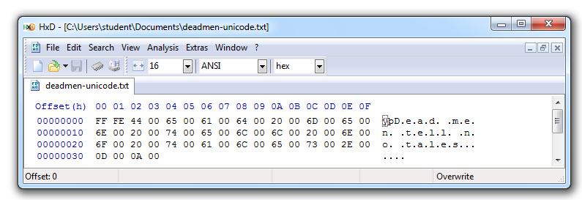
Encodes all "commercially significant" languages

Two bytes per character

FF FE at the start is a Byte Order Mark (Link Ch 2c)

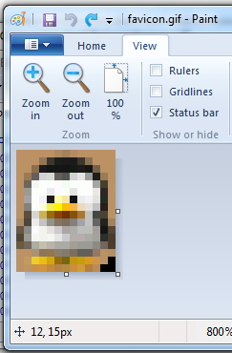
File Headers & File Carving

GIF Image (13x16 pixels)

GIF File Header

GIF89a – Version of GIF

0D 00 0A 00 – 13 pixels x 16 pixels
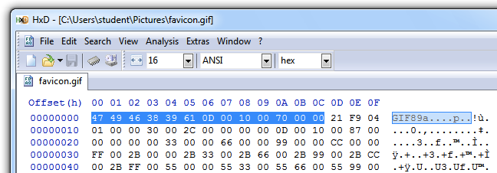

GIF Specification

Link Ch 2d

File Carving

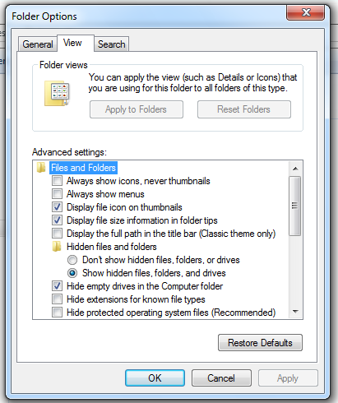
Rebuilding files by assembling blobs of data found on a disk

Relies on file headers and footers

Done automatically by all-purpose forensic suites like FTK and EnCase

Many other tools exist to carve files

Project X1: Identifying File Types
File Extensions & File Signatures

File Extensions

Usually three letters long

Appear at the end of a file name, after a dot

Hidden in Windows by default

Used to specify the file type, icon, and default application

Hide File Extensions

Incorrect File Extension
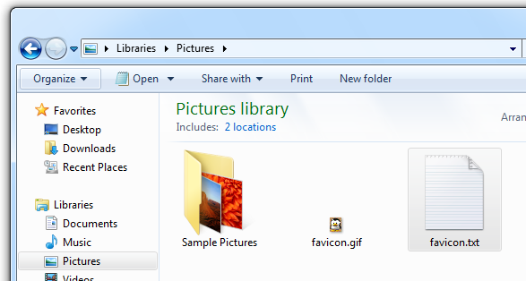

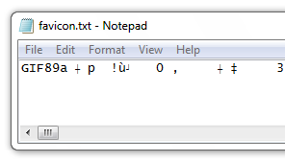
Wrong Default Application

Any stream of bytes can be interpreted as ASCII

Open With…
How Computers Store Data

Storage Methods

Electromagnetism

Hard disks and floppy disks

Microscopic Electrical Transistors

SSDs, USB flash drives, SD cards, etc.

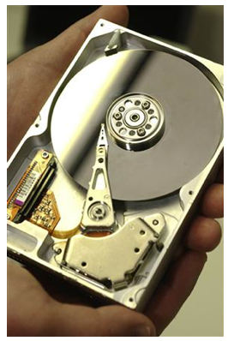
Reflecting Light

CDs, DVDs, Blu-ray

They are all nonvolatile – they retain data without power

Magnetic Disks

Platter spins at 7,000 rpm to 15,000 rpm

Spindle is the axis

Read/write head is an electromagnet mounted to an actuator arm

Image from textbook

Disk Controller Card

Stores and retrieves data from the platters

Controlled by firmware stored in the Host Protected Area

Flash Memory

Made of transistors

Solid State Devices (SSDs)

Faster than hard disks

Use less power

More expensive

Optical Storage

Microscopic pits encode bits

Area between pits are called lands

There is one long spiral track for the whole disk

Data is read with laser light

See Link Ch 2e

Image from http://www.backgroundsy.com/file/large/blu-ray-disc-isolated.jpg

Volatile v. Nonvolatile Memory

Memory is short-term storage

Storage devices (hard disks, SSDs, and optical disks) are nonvolatile—data is retained without power

RAM is main system memory

RAM is volatile—data is lost when power goes off

Volatility of RAM
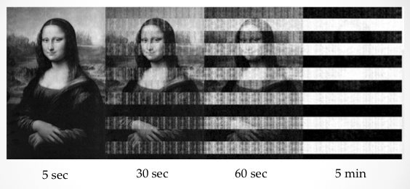

From Princeton (Link Ch 2f)

RAM Forensics

RAM contains important evidence that is not normally written to the hard disk

Instant messages

Network connections

Running processes

BUT there are no time-stamps on RAM contents

It can be misleading
Computing Environments

Four Categories

Stand-alone

Networked

Mainframe

Cloud

Stand-Alone

A computer not connected to any other computer

Such as a laptop not connected to Wi-Fi or cellular data

BUT networks are everywhere now, even in BART or on airplanes

Networked

A computer connected to at least one other computer

Evidence might be on servers and network devices as well as the local computer

Almost every computer is networked now

Mainframe

A powerful computer used at a business, or shared by many users

Located in a data center or colocation center

Image from http://danialsharifudin.blogspot.com/2012/08/classification-of-computer.html

Cloud Computing

Examples of Cloud Computing

Gmail

Facebook

Twitter

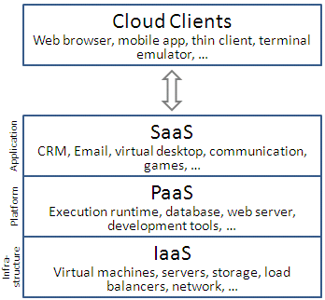
Amazon Web Services

CloudFlare

Cloud Services

Infrastructure as a Service (IaaS)

Platform as a Service (PaaS)

Software as a Service (SaaS)

Figure from Wikipedia (Link Ch 2m)

IaaS

The most basic cloud service

Outsources hardware needs

Servers, storage, routers, switches…

Examples

Amazon EC2

Windows Azure Virtual Machines

Google Compute Engine

Rackspace Cloud

Link Ch 2m

PaaS

Provides a computing platform

OS, programming language execution, database, and Web server

Examples

AWS Elastic Beanstalk

Heroku

Google App Engine

Windows Azure Compute

Link Ch 2m

SaaS

Providers install and operate application software in the cloud

Users access the software from cloud clients

Examples

Google Apps

Microsoft Office 365

Link Ch 2m

IaaS

Outsource hardware needs

Servers, storage, routers, switches…

Examples

Amazon EC2

Windows Azure

Google Compute Engine

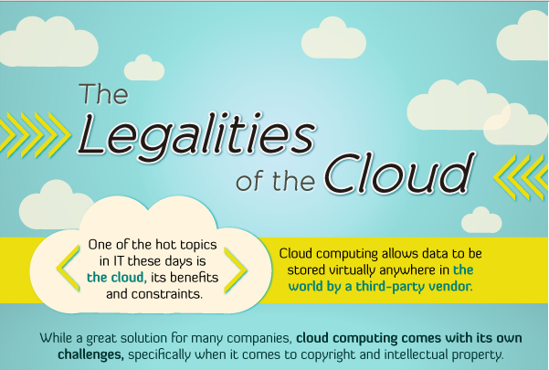
Link Ch 2m

Image from link Ch 2g

Instagram

Online photo-sharing site

In Dec. 2012, Instagram changed its terms of service

Perpetual rights to all photos

Right to sell photos to advertisers without payment or notice to the user

Instagram lost half its daily users in a month

Links Ch 2h, Ch 2i

AWS Outage

Dec. 24, 2012

Netflix was down, because they rely on AWS (Link Ch 2j)

Amazon has had several other major outages (Link Ch 2k)
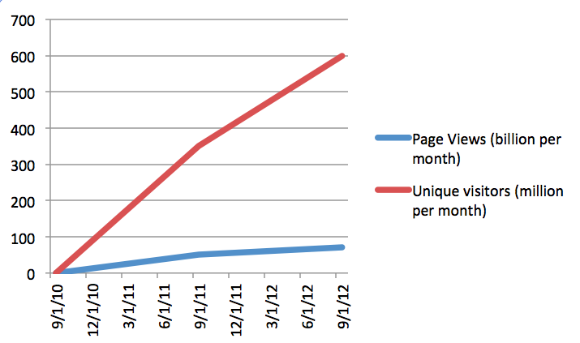

From 2011 (Link Ch 2l)

Cloudflare Growth

Last modified 1-24-13

