Active, Latent, and Archival Data

Active Data

Data the operating system can "see" and use

Files and folders that appear in Windows Explorer

Reside in allocated space

Can be acquired by copying files

Latent Data

Data that has been deleted or partially overwritten

Invisible to OS

Does not appear in Windows Explorer

A bitstream or forensic image is required to acquire this data

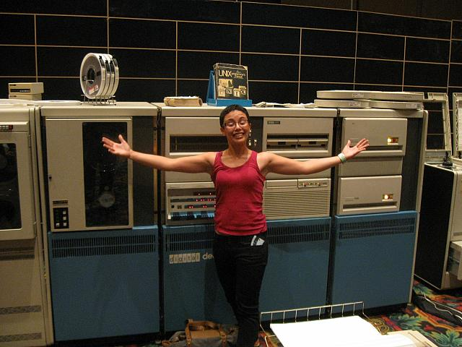
Archival Data

Also called Backups

Commonly stored on

External hard drives

DVDs

Magnetic tapes

Cloud backup services like Iron Mountain or Symform

Legacy Archival Data

Made with software or hardware that is no longer in production

To acquire the data, you need to get old devices

User's groups

eBay

Image: PDP-11 at Defcon 17

Link Ch 2n
Computer File Systems

File System

Keeps track of used and free sectors

Location of each file

Filename

Last modified date

Permissions

FAT (File Allocation Table)

Oldest and simplest file system

FAT12 (for floppy disks)

FAT16 (2 GB max. partition size)

4 GB on Win 2000 (link Ch 2p)

FAT32 (Common on USB drives)

Not used on Windows XP or later

FATX for the X-Box

exFAT used for Windows CE

Link Ch 2o

NTFS (New Technology File System)

Used by Win XP, 7, and Server

Advantages

Journaling (recovers from errors)

Encryption

Permissions

Uses B-Trees for fast searches

HFS+ (Hierarchical File System)

Used by Apple products

Also uses B-Trees

Related versions

HFS

HFSX

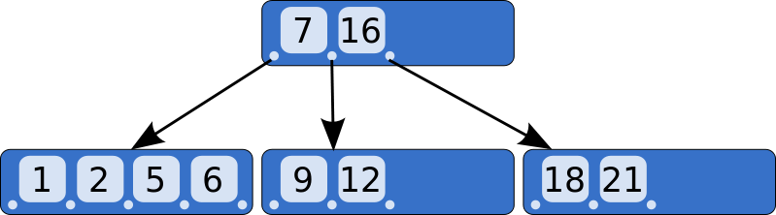
B-Tree

An way of storing objects so they can be searched quickly

Image From Wikipedia

Allocated and Unallocated Space

Space on a Hard Drive

Allocated

Active data

In use

Can be seen by OS

Unallocated

No longer in use

Slack space (Drive slack)

Invisible to OS

Space on a Hard Drive

Host Protected Area and Device Configuration Overlays

Hidden area on a hard drive

Difficult to detect

Not used by OS

Stores device firmware and data

Accessed by firmware update routines, which can be reverse engineered

Data Persistence

Old Data is Left in Slack Space

Unallocated clusters

Remains on drive until overwritten

Can be years

Even an Overwrite may not get it all

If the new file doesn't use all the sectors

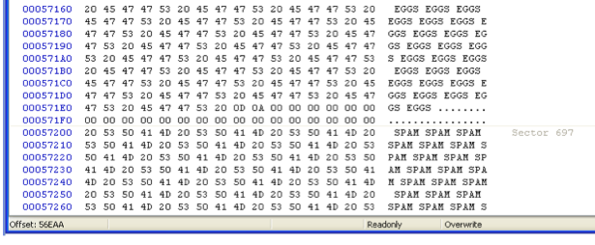
Project 2

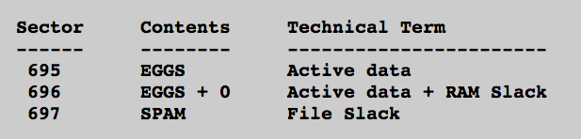

Magnetic Drive Storage

Sector = 512 bytes

All data is read and written a sector at a time

Cluster

Varies, often 4096 bytes = 8 sectors

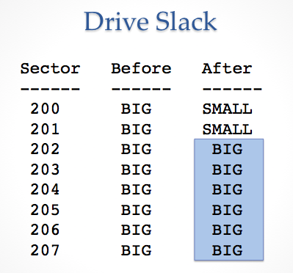
OS can only use space a cluster at a time

Example

BIG file: 4000 bytes

Written onto disk

Nearly fills 8 sectors = 1 cluster

Delete BIG file

Save SMALL file on same cluster

SMALL file: 1000 bytes

Only uses 2 clusters

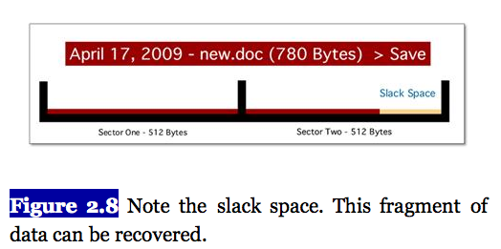
Error in Textbook

Discussion from Fig. 2.5 through 2.8 is wrong

Book says a 780 byte file only overwrites 780 bytes on disk, when it actually overwrites 1024 bytes

Page File (Swap Space)

Used for virtual memory

Temporary storage when your computer runs out of available RAM

Windows puts data here even when RAM is not full

It also loads old data from swap back into RAM

I once found something years old in my RAM

Potential Page File Contents

Passwords

Fragments of images or documents

Anything else from RAM

BUT there is no timestamp, so it will be hard to connect to a specific user or event

Hiberfil.sys

Contains entire RAM contents

Filled when a computer hibernates

Whole Disk Encryption

Because of the Page file and the Hiberfil

You can never be sure where your data is

Whole Disk Encryption

The only way to be sure all your data is protected

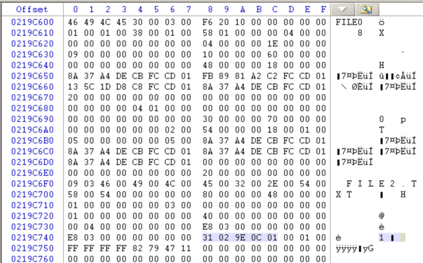
Microsoft BitLocker

Apple FileVault

TrueCrypt (Open Source)

Project 8: NTFS Data Runs

Last modified 1-24-13

