Topics

Forensic Laboratories

Policies and Procedures

Quality Assurance

Hardware and Software

Accreditation v. Certification
Forensic Laboratories

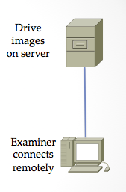
Most are run by law enforcement agencies

FBI's crime lab in Quantico, VA is largest in the world

Regional Computer Forensic Laboratory (RCFL)

FBI Program

16 facilities throughout US

They process smartphones, hard drives, GPS units, and flash drives

Virtual Labs

Evidence repository separate from the examiner

This is how the FBI does it

Saves money, increases access to resources

Role-based access

Examiners and management get full access

Investigators, prosecutors, and attorneys get restricted access

Concerns with Virtual Labs

Security

Must retain integrity or evidence will be inadmissible in court

Performance

High-speed connectivity required

Cost

Lab Security

Physical security

Keep unauthorized people out of critical areas

Examination stations

Evidence storage

Keys, swipe cards, access codes

Digital access control is better than keys

Keeps an audit trail to support chain of custody

Protection from fire, flood. etc.

Chain of Custody

Evidence must be signed in and out of storage

Evidence log must be complete

Work in Isolation

Forensic examination computer should not be connected to the Internet

This avoids arguments over contamination by malware

Evidence drives may contain malware

Scan them with antivirus software

Evidence Storage

Data safe

Protects evidence from tampering

Fireproof and waterproof

Evidence log

Must record who entered, when, and what they removed or returned

Data storage lockers must be kept locked
Policies and Procedures

Standard Operating Procedures (SOPs)

Documents that detail evidence collection, examinations, etc.

These ensure consistency and reliability

Very important to handle questions in court

Unusual situations will often require special handling

Best Practices for Evidence Collection

For proper evidence preservation, follow these procedures in order (Do not use the computer or search for evidence)

Photograph the computer and scene

If the computer is off do not turn it on

If the computer is on photograph the screen

Collect live data - start with RAM image (Live Response locally or remotely via F-Response) and then collect other live data "as required" such as network connection state, logged on users, currently executing processes etc.

If hard disk encryption detected (using a tool like Zero-View) such as full disk encryption i.e. PGP Disk — collect "logical image" of hard disk using dd.exe, Helix - locally or remotely via F-Response

Unplug the power cord from the back of the tower - If the computer is a laptop and does not shut down when the cord is removed then remove the battery

Diagram and label all cords

Document all device model numbers and serial numbers

Disconnect all cords and devices

Check for HPA then image hard drives using a write blocker, Helix or a hardware imager

Package all components (using anti-static evidence bags)

Seize all additional storage media (create respective images and place original devices in anti-static evidence bags)

Keep all media away from magnets, radio transmitters and other potentially damaging elements

Collect instruction manuals, documentation and notes

Document all steps used in the seizure

From link Ch 3a
Quality Assurance

A well-documented system of protocols used to assure accuracy and reliability

Peer reviews of reports

Evidence handling

Case documentation

Training of lab personnel

Reviews

Technical review

Focuses on results and conclusions

Are the results reported supported by the evidence?

Administrative review

Ensures all paperwork is present and completed correctly

Proficiency Testing

Examiner's competency must be confirmed and documented

Open test

Examiner is aware they are being tested

Blind test

Examiner is not aware they are being tested

Internal test

Conducted by agency itself

External test

Conducted by independent agency

Results must be documented
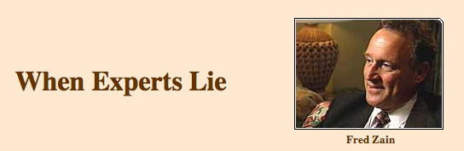

West Virginia State Police forensics expert who testified in hundreds of criminal cases

Very persuasive in court

…became something of a forensics "star," sought after by prosecutors who wanted to win convictions in difficult cases

Lies

Falsified his own credentials

Fabricated and altered evidence

Convicted an innocent man of sex crimes in 1997

He was freed when DNA evidence proved he was innocent

Sued State of West VA

That exposed Fred Zain

Real rapist was caught 24 years later

Link Ch 3b

Tool Validation

Each tool, software or hardware, must be tested before use on an actual case

Paper records are necessary to prove this

Documentation

Case File

Case submission forms

Requests for assistance

Chain of custody reports

Examiner's notes

Crime scene reports

Examiner's final reports

Copy of search authorizatity

All collected in a case file

Preprinted forms help maintain uniformity

Examiner Notes

Must be detailed enough to enable another examiner to duplicate the process

Discussions with key players including prosecutors and investigators

Irregularities found and actions taken

OS versions & patches

Passwords

Changes made to the system by lab personnel and law enforcement

It may be years before trial, and you will need to understand your notes

Examiner's Final Report

Formal document delivered to prosecutors. investigators, opposing counsel, etc.

Remember the audience is nontechnical

Avoid jargon, acronyms, and unnecessary details

Examiner's Final Report Contents

Identity of the reporting agency

Case ID #

Identity of the submitting person and case investigator

Dates of receipt and report

Detailed description of the evidence items submitted

Serial numbers, makes, models, etc.

Identity of the examiner

Description of the steps taken during the examination process

Results and conclusions

Examiner's Final Report Sections

Summary

Brief description of the results

Detailed findings

Files pertaining to the request

Files that support the findings

Email, Web cache, chat logs, etc.

Keyword searches

Evidence of ownership of the device

Glossary
Digital Forensic Tools

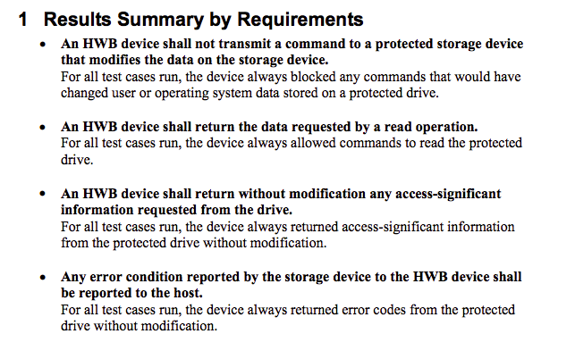
NIST's Forensic Tool Testing Project

Link Ch 3c

Hardware Tools

Cloning devices

Cell phone acquisition devices

Write blockers

Portable storage devices

Adapters

Cables

Much more

Computer Recommendations

Multiple multicore processors

As much RAM as possible

Large, fast hard drives

FTK 4 recommends:

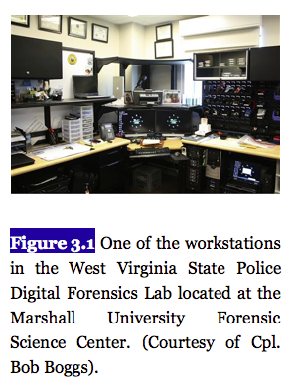
64-bit processor, Quad core

8 GB RAM

A dedicated 150 GB hard disk for the PostgreSQL database; SSD or RAID preferred

1 GB network

Link Ch 3d
Image from textbook

Non-PC Hardware

Cellebrite's UFED

Supports over 3,000 phones (Link Ch 3e)

Paraben

Competes with Cellebrite

Supports more than 4,000 phones, PDAs, and GPS units

Cloners and Kits

Hardware Cloners

Faster, can clone multiple drives at once

Provide write protection, hash authentication, drive wiping, audit trail…

Crime scene kits

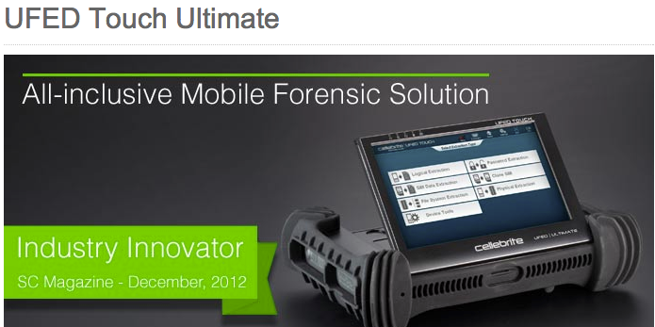
Preloaded with supplies to collect digital evidence

Pens, digital camera, forensically clean storage media, evidence bags, evidence tape, report forms, markers…

Software: Open-Source

SIFT: SANS Investigative Forensic Toolkit

SIFT Workstation is free, based on Ubuntu

Link Ch 3g

SIFT Capabilities

File carving

Analyzing file systems

Web history

Recycle bin

Memory

Timeline

Windows (MSDOS FAT, VFAT, NTFS)

Mac (HFS)

Solaris (USF)

Linux (ext2/3/4)

Evidence Image Support

Expert Witness (E01)

RAW (dd)

Advanced Forensic Format (AFF)

SIFT Capabilities

The Sleuth Kit (File system Analysis Tools)

log2timeline (Timeline Generation Tool)

ssdeep & md5deep (Hashing Tools)

Foremost/Scalpel (File Carving)

WireShark (Network Forensics)

Vinetto (thumbs.db examination)

Pasco (IE Web History examination)

Rifiuti (Recycle Bin examination)

Volatility Framework (Memory Analysis)

DFLabs PTK (GUI Front-End for Sleuthkit)

Autopsy (GUI Front-End for Sleuthkit)

PyFLAG (GUI Log/Disk Examination)

Commercial Tools

EnCase & FTK have similar capabilities

Searching

E-mail ananysis

Sorting

Reporting

Password cracking

EnCase & FTK

Search tools

E-mail addresses

Names

Phone numbers

Keywords

Web addresses

File types

Date ranges

Don't Trust Tools

Using a tool without understanding what it's doing is a trap

Verify all findings with a second tool, like a simple hex editor

You must figure out how the data got on the system and what it means

Other Multipurpose Tools

Acquisition, verification, searching, reporting, wiping, etc.)

SMART

ProDiscover

X-Ways Forensics

Helix (Linux-based)

Raptor (Linux-based)

Other Tools

Mac Tools

Softblock

Macquisition

Blacklight

BlackBag

Mac Marshall

Dossier from LogiCube

Hardware acquisition

Tableau

Write-blockers

Weibetech

Write-blockers
Accreditation v. Certification

Accreditation

Endorsement of a crime lab's policies and procedures

ASCLD/LAB does this

Very burdensome to achieve

Not possible for every lab

ASTM also accredits labs

Certification

Applies to examiners, not the lab

SWGDE Core Competencies for Forensic Practitioner Certification

Pre-examination procedures and legal issues

Media assessment and analysis

Data recovery

Specific analysis of recovered data

Documentation and reporting

Presentation of findings

Link Ch 1h

Last modified 2-1-13

