Topics

Crime scenes

Documenting

Chain of Custody

Forensic Cloning

Live and Dead Systems

Hashing

Final Report
Crime Scenes and Collecting Evidence

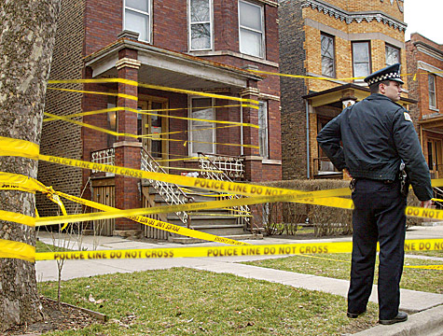
Securing the Scene

Unnecessary people must be kept out

Network connections place data at risk

Once it is assured that volatile data won't be lost, disconnect network cables

Isolate seized phoned from network

Image from crimescenecleanupdetroit.com

Removable Media

Memory cards can be tiny

Hidden in books, wallets, hat bands, etc.

Also DVDs, external hard drives, thumb drives, memory cards

Examine books and manuals to determine the skill level of the target

Are they using encryption?

Cell Phones

Valuable evidence

Text messages, email, call logs, contacts

Interacting with the phone can change data

Apple's "Find My iPhone" app can be used to remotely wipe the phone

Isolating Cell Phones

Turn the phone off

BUT it may require a password when turned back on

Shielded container

Paint can, Faraday bag

Power

Provide external battery pack to keep phone alive

Seize power cables if phone is off, so it can be charged for examination

Questions at the Scene

After scene is secured, ask these questions

What kinds of devices are present?

How many device?

Are the devices running?

What tools are needed?

Do we have the necessary expertise?

Order of Volatility

Gather most volatile evidence first

CPU, cache and registers

Routing table, ARP cache, processes

RAM

Temp files/swap space

Hard disk

Remotely logged data

Archival media
Documenting the Scene

If you don't write it down, it didn't happen

Types of Documentation

Photographs

Written notes

Video

Record precise details

Type, make, model, serial number

Whether a device is on or off

Network connections

Peripheral connections like printers

Document and label cables

Photography

Walk through the scene to find devices and see what will be needed

Then photograph entire scene before anything is disturbed

Broad perspective, then each item of evidence in its original position

Add a ruler in a second photo for perspective

Photos don't replace notes

Notes

No set standard

Chronological is common

Those notes will guide you in court later

Notes can be discoverable and may be seen by other side

Don't draw conclusions or speculate
Chain of Custody

Marking Evidence

Initials, dates, case numbers

Permanent markers

Sealed in evidence anti-static bag

Tamper-resistant evidence tape

Forensic cloning
Cloning

Exact copy of a hard drive, bit for bit

Gathers unallocated space and Master File Table

Time-consuming process

Usually done at the lab, not on the scene\

In civil cases, you may lack legal authorization to remove the computer

Must clone it on-scene

Purpose of Cloning

Examine a copy, not the original

Unless there are exigent circumstances, like a missing child

You can recover from mistakes

A properly authenticated forensic clone is as good as the original in court

The Cloning Process

Copy one hard drive to another, larger hard drive

Source drive normally removed from computer

Critical to use a write-blocker

Hardware or software

Forensically clean destination drive first

Proof of that goes in the case file

Forensically Clean Media

Can be proven devoid of data

"Sterile"

Overwrite entire drive with a pattern of data

Such as 00000000

Forensic Image Formats

Proprietary

EnCase (.E01) – Actually "Expert Witness"

AccessData Custom Content Image (.AD1)

Open

Advanced Forensics Format (AFF)

Open format, see link Ch 4a

Raw (.dd or .001)

Direct uncompressed disk image

Risks and Challenges

Biggest Risk: Writing to the evidence drive

Bad sectors

Damaged or malfunctioning drives

Corrupt boot sector

Antiforensics measures (theoretical, not practical risk)

eDiscovery

Gathering and presenting electronically stored information (ESI) for legal cases

Cloning preserves evidence best

Can be expensive and impractical

du Pont v. Kolon

Kolon lost and was hit with

$920 million judgement

20-year ban from competing with du Pont

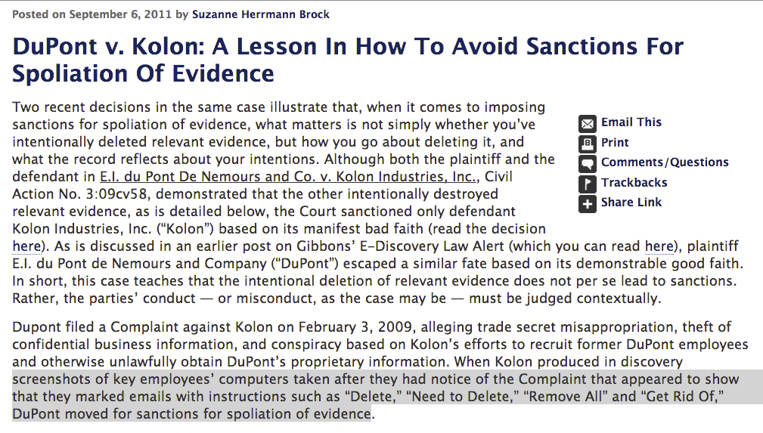
Links Ch 4b, 4c

Spoilation

Last modified 2-13-13

