Topics

Live and Dead Systems

Hashing

Final Report
Live and Dead Systems

Old School: Pull the Plug

Loses RAM data

May render encrypted files unavailable

May corrupt data on the disk when power goes off

May lose some evidence that doesn't get properly written to disk

Now: Live Acquisition

Modern tools being marketed to first responders

Non-technical people

Live acquisition is important if RAM is important

Malware -> RAM is important

Possession of child porn -> RAM unimportant

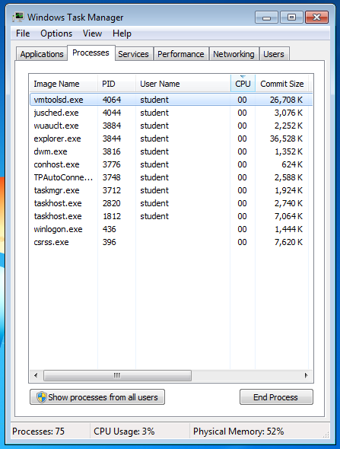
Examiner needs proper skills and tools

Principles of Live Collection

Least invasive procedure possible

RAM may contain

Running processes

Executed console commands

Passwords in cleartext

Unencrypted data

Instant messages

IP Addresses

Trojans

Conducting and Documenting a Live Collection

Work without interruptions

Every interaction with the computer must be noted

I did this…the computer did that

Make desktop visible by moving the mouse

Or press a key (and record which)

Note date and time

Note icons and taskbar buttons of running programs

Open Task Manager & record processes

Capture RAM with a forensic RAM imager

Perform proper shutdown

Task Manager

Show processes from all users

Record all processes

Perp will probably claim malware did it later

Hashing Algorithms

Even a single changed bit in the input file completely changes the hash

If the hash of two files match, the files can be regarded as identical

MD5 is most common

SHA-1 is better

In practice, either will do

Hash value must accompany all evidence images

So copies can be verified
Final Report

Consider the audience

Many reports are too technical & confusing

Avoid jargon and code

The report generated by FTK or EnCase should be included, but it's not readable enough alone

Add a detailed narrative of all actions taken by the examiner

Add a summary written in plain English

Last modified 2-18-13

