Topics

Deleted data

Hibernation Files

Registry

Deleted Data
Recovering Deleted Data

File Carving

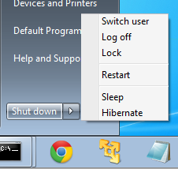
Allocated space contains active data

Deleted files are in unallocated space

Useful tools

ProDiscover

FTK or EnCase

Foremost

Recuva

Photorec
Hibernation File

Shutdown Options

Sleep – data kept in RAM

Power still on

Documents lost if power fails

Hibernate – RAM copied to Hiberfil.sys

Power off

Documents never lost

Hybrid Sleep

Default for Windows 7 desktops

Puts open documents and programs on disk

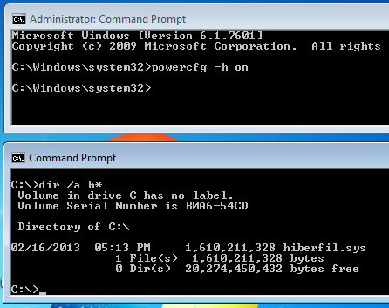
Keeps them in RAM as well for fast wakeup

Documents not lost if power fails

Enabling Hibernation

Link Ch 5i

Registry -- Not in book, but may be on quizzes and Final Exam

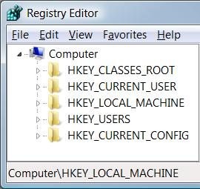
Understanding the Structure of the Registry

The registry consists of five root keys

HKey_Classes_Root

HKey_Current_User

HKey_Local_Machine

HKey_Users

HKey_Current_Config

Or HKCR, HKCU, HKLM, HKU, and HKCC

Subkeys

Root keys (sometimes called predefined keys), contain subkeys

Subkeys look like folders in Regedit

HKCU has these top-level subkeys: AppEvents, Console, Control Panel, …

A root key and its subkeys form a path

HKCU\Console

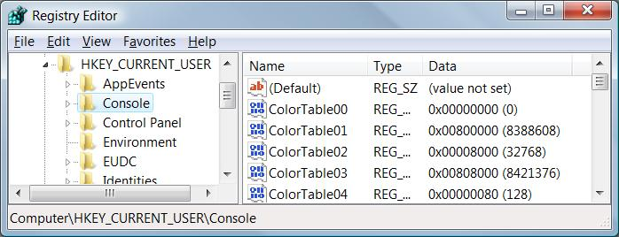
Values

Every Subkey contains at least one value

But it may show (value not set)

The default value (often undefined)

Values have name, data type, and data

Hives

A key with all its subkeys and values is called a hive

The registry is stored on disk as several separate hive files

Hive files are read into memory when the operating system starts (or when a new user logs on)

HiveList

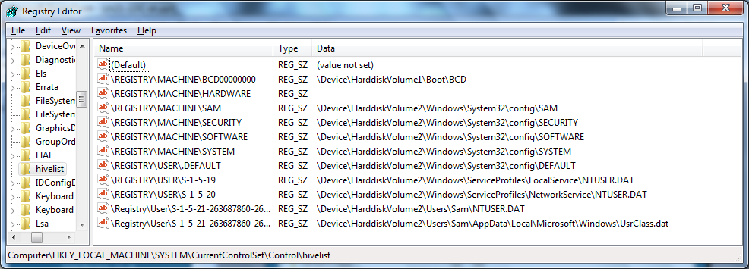
HKLM\System\CurrentControlSet\Control\HiveList

Hardware Hive

\Registry\Machine\Hardware has no associated disk file

Windows 7 creates it fresh each time you turn your system on

HKCR and HKCU

These keys are links to items contained in other root keys

HKey_Classes_Root (HKCR)

Merged from keys within HKLM\Software\Classes and HKU\sid_Classes

sid is the security identifier of the currently logged on user

HKey_Current_User (HKCU)

HKU\sid

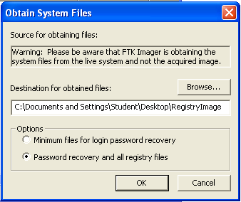
Purpose of Registry

Database for configuration files

Registry artifacts are very valuable for forensics

Search terms

Programs run or installed

Web addresses

Files recently opened

USB devices connected

Acquiring the Registry

FTK Imager

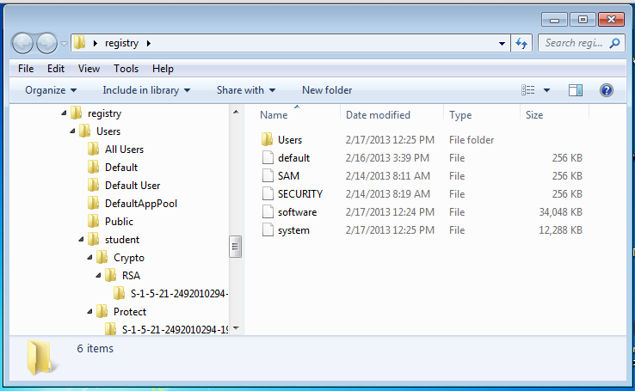

Acquired Files

Reference

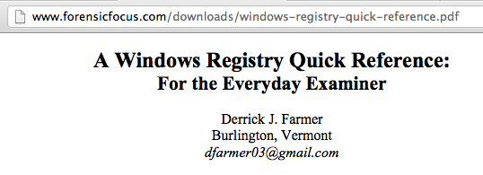
Link Ch 5c

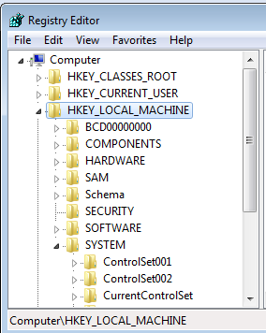

Important Registry Data

Control Set

Time Zone

User Assist

USB Store

Control Set

A live Registry has an important key named HKLM\System\CurrentControlSet

Contains Time Zone, USBSTOR, and other information

Control Set

Acquired image doesn't contain CurrentControlSet

It's ephemeral data—not stored in the hive files

To determine which ControlSet is current, look in

System\Select

In this case, ControlSet001 is Current

Link Ch 5a

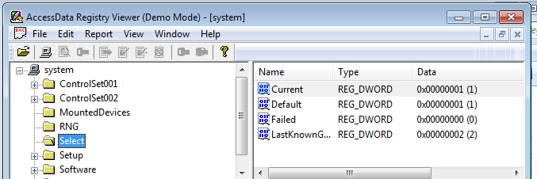

Time Zone

System\ControlSet001\Control\TimeZoneInformation

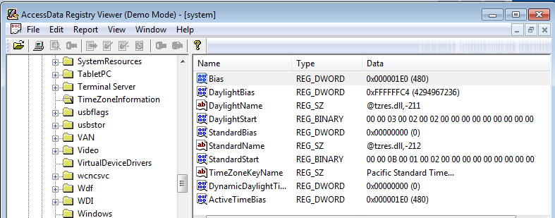
Assuming that ControlSet001 is Current

UserAssist

Shows objects the user has accessed

To see it, open Users\Username\NTUSER.DAT

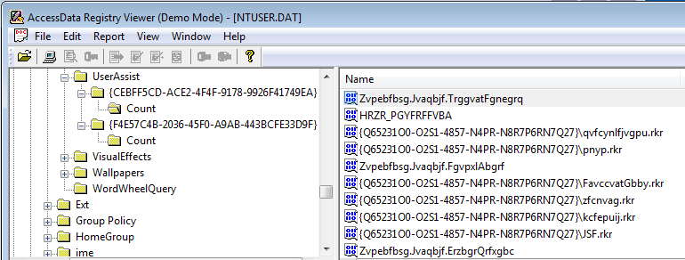
Navigate to Software\Microsoft\Windows\CurrentVersion\Explorer\UserAssist

UserAssist Decoded in Lower Left Pane
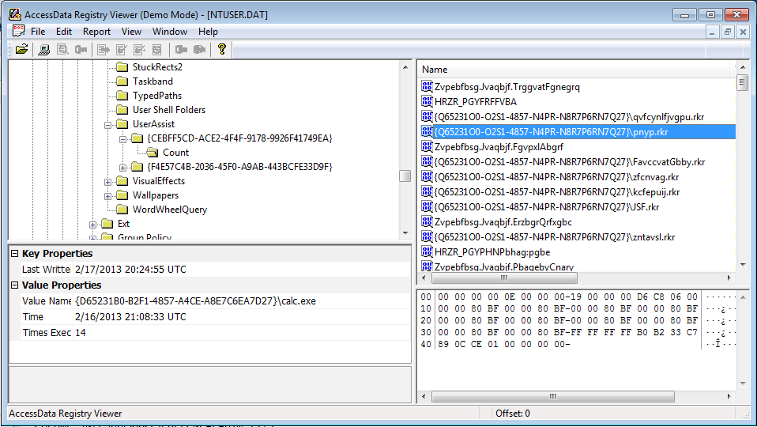
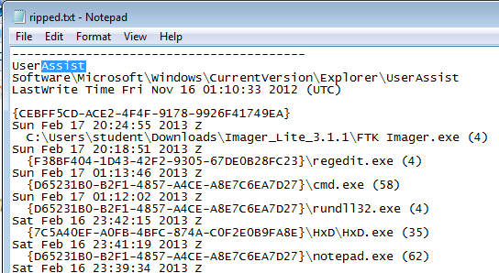

RegRipper

Link Ch 5k

Ripped Registry

USBSTOR

System\ControlSet001\Enum\USBSTOR

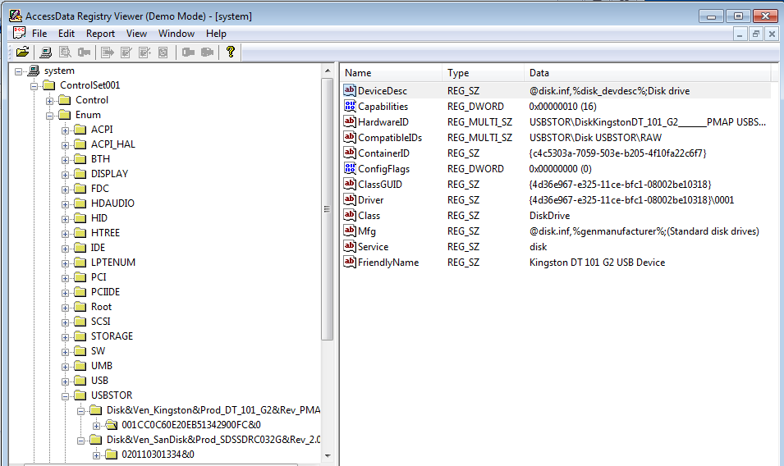
Assuming Current Control Set is 1

Last modified 2-18-13

