Topics

Attribution

Recycle Bin

Metadata

Thumbnail Images

Most Recently Used Lists

Restore Points and Shadow Copies

Prefetch and Link Files
Attribution

Evidence of an action is easy to find

Search terms

images

Web pages viewed

Attribution is more difficult

Who was using the computer when the action took place?

One machine may have multiple accounts

Win XP starts with Administrator and Guest

Both disabled by default in Windows 7

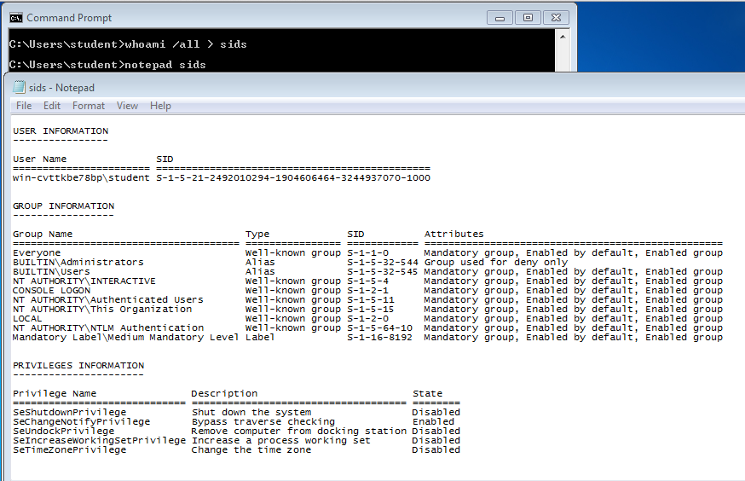
SID (Security Identifier)

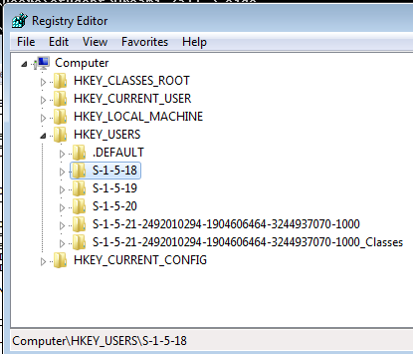

SIDs in the Registry

Well-Known SIDs

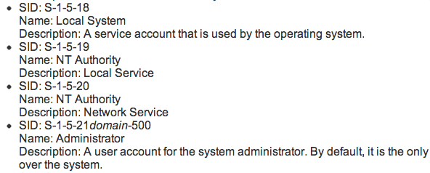
Link Ch 5o

External Drives

USBSTOR shows exactly which USB devices have been attached to a computer

Helpful in attributing evidence found on removable devices

Print Spooling

When a document is printed, two files are created

Enhanced Meta File (EMF) contains an image of the document to be printed

Spool File contains information about the print job

They are normally deleted after printing finishes, but may be retained on some systems
Recycle Bin

Recycle Bin Operation

Not everything deleted goes into the Recycle Bin

Shift+Delete will bypass the Recycle Bin, so will "Delete" from a command prompt

A user can disable the Recycle bin in Recycle Bin Properties

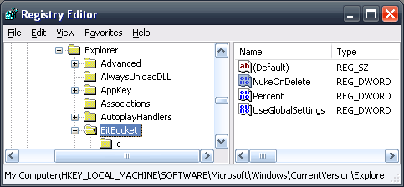
NukeOnDelete Registry Key

Win XP

(Link Ch 5p)

Win 7

(Link Ch 5q)

Metadata

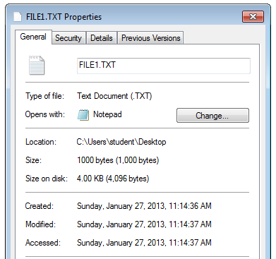
Metadata

Data about data

File system metadata

Timestamps (Created, Modified, Accessed)

Permissions, owner

Application metadata

Author's name

GPS coordinates

Software owner's name

Timestamps

WARNING: These all depend on the system clock, which can be reset

Created

Modified

Accessed

Even if the file was not opened, but just scanned by antivirus

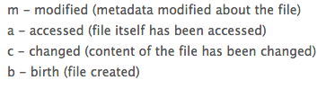

MACR Times

Sleuthkit will show these four timestamps

Link Ch 5r


Timestamp Principles

Be very careful

Perform experiments on similar systems to verify conclusions

Use multiple tools

Watch out for system clock changes

Demo: John McAfee's Photo

Exif Viewer

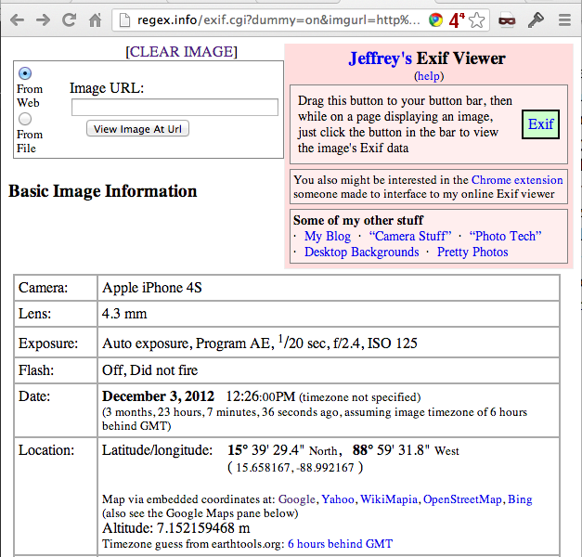
Link Ch 5t

Link Ch 5u

Removing Metadata

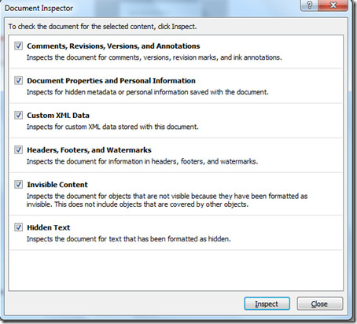
Microsoft Office Document Inspector

Link Ch 5v

Other tools

Link Ch 5w

Thumbnail Cache

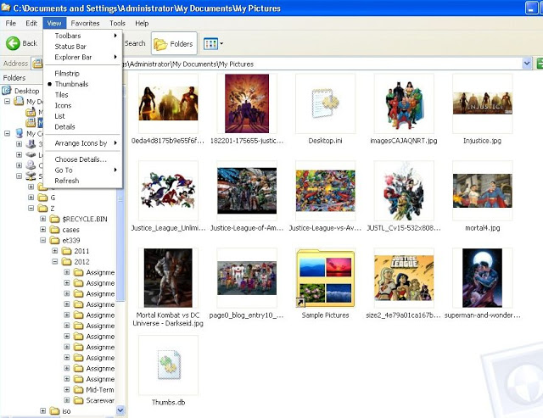
Windows XP Thumbnails

Thumbs.db

Hidden file in same folder as images

Image from link Ch 5x

Windows 7 Thumbnails

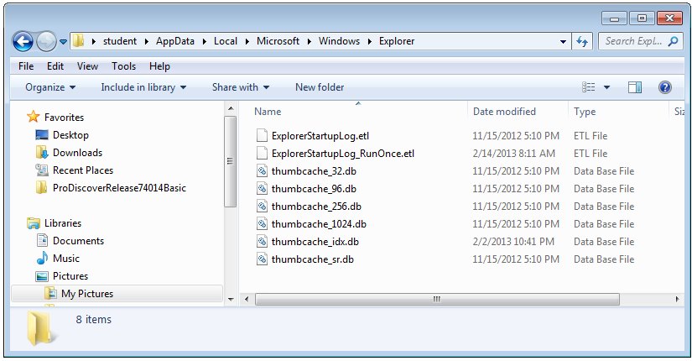
To view these, see tool at link Ch 5x

Most Recently Used

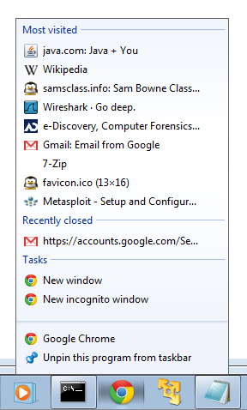
Right-click taskbar button in Windows 7

Click File icon In Paint

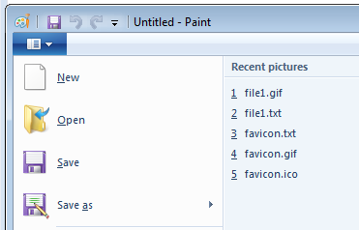
Many, many, other places

System Restore

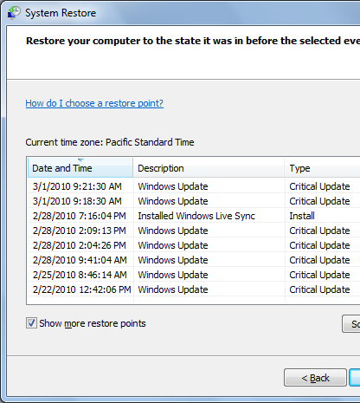
Restore Points

Win 7 creates a restore point every 7 days by default

XP and Vista did it every day

They are created by a Shadow Copy service, which can copy files even when they are in use

When Restore Points Are Created

An application is installed with a compatible Vista or Win 7 installer

Windows Updates

System Restore is performed

A Restore Point is made first so the System Restore can be reversed

Windows Backup

A Restore Point is created as part of the backup process

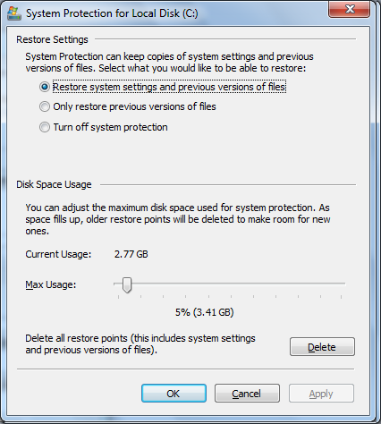

Restore Settings

Click Configure

Choose whether to monitor system settings or just files

"System Settings" includes the Registry and many other system file types

System Restore Files

In C:\System Volume Information

You can't open this folder, or even take ownership of it

It's only intended for System access

Previous Versions

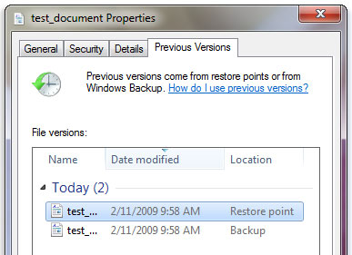
Image from microsoft.com

PreFetch

To make a Windows machine run faster

A shortcut to programs you commonly open is saved in the Prefetch folder

There are Prefetch Viewers to help read the files

The format is different in Win XP and Win 7/Vista

Links Ch 5y, 5z

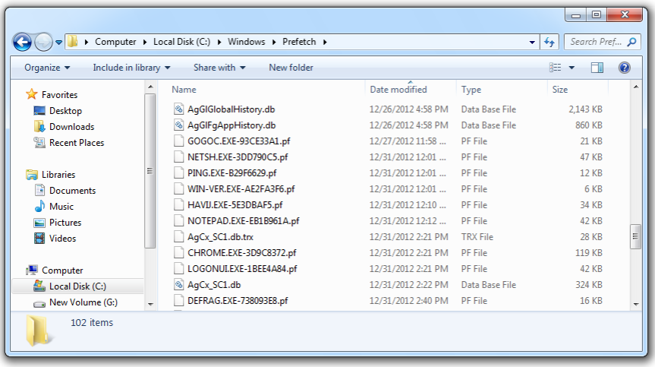

PreFetch in Win 7

Link Files

Shortcuts to programs and other files

They have time and date stamps

Links in the "Recent Files" folder to network shares even contain the MAC address of the server!

Recent Files

Recent Files Viewer

Works on Win XP & Win 7

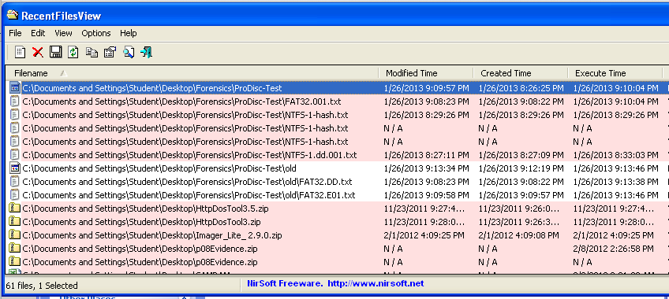
Link Ch 5z1

Installed Programs

Give information about the user's activities

Recently uninstalled programs may also be important evidence of guilt

Traces of uninstalled programs may be found in

Programs folder

Links

Prefetch files

Last modified 3-4-13

