Topics

Encryption

Breaking Encryption
Steganography

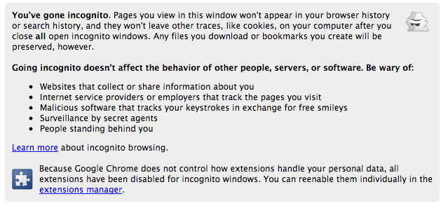
Hiding and Destroying Data

Antiforensics

Techniques to manipulate, erase, or obfuscate digital data to make its examination difficult, time-consuming, or virtually impossible

Private Browsing

Simple Privacy Methods

Weak, relatively ineffective

Delete cookies

Clear temporary internet files

Clear history

Changing filenames and extensions

Burying files in unrelated directories

Real obstacles to forensic examiners

Hiding files within other files (steganography)

Encryption
Encryption

Protecting Secrets

We all need encryption for

Credit card #s

Passwords

Medical data

Without encryption, the Web would be much less useful

Encryption Defined

Encryption converts data from plaintext (readable) to ciphertext (scrambled)

Algorithm is the mathematical process to encrypt and decrypt the message

Key is a value needed to encrypt and decrypt the data, usually a long random series of bits, sometimes derived from a password or passphrase

Caesar Cipher

Shift each letter forward one character

ABCDEFGHIJKLMNOPQRSTUVWXYZ

BCDEFGHIJKLMNOPQRSTUVWXYZA

CCSF --> DDTG

ROT13

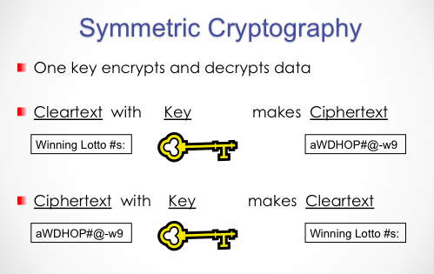
Shift each letter forward 13 characters

ABCDEFGHIJKLMNOPQRSTUVWXYZ

NOPQRSTUVWXYZABCDEFGHIJKLM

CCSF --> PPFS --> CCSF

Encrypting with ROT13 twice returns you to plaintext

Decryption algorithm = Encryption algorithm

Very weak—obfuscation, not encryption

Used in TypedURLS registry key, and for passwords in an early version of Netscape (Link Ch 6a)

Asymmetric Cryptography Algorithms

Use two keys that are mathematically related

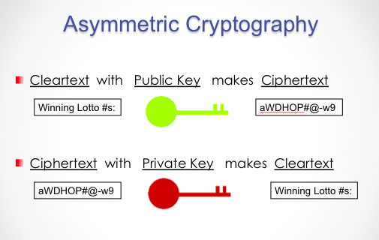
Data encrypted with one key can be decrypted only with the other key

Another name for asymmetric key cryptography is public key cryptography

Public key: known by the public

Private key: known only by owner

Popular Algorithms

Symmetric Encryption

DES, 3DES, AES, Blowfish

Asymmetric Encryption

RSA, ECC, ElGamal

The most secure algorithms are open-source

Proprietary, secret algorithms are almost always insecure

Keys

A sequence of random bits

The range of allowable values is called a keyspace

The larger the keyspace, the more secure the key

8-bit key has 2⁸ = 256 values in keyspace

24-bit key has 2²⁴ = 16 million values

56-bit key has 2⁵⁶ = 7 x 10¹⁶ values

128-bit key has 2¹²⁸ = 3 x 10³⁸ values

Brute Force Attack

In 1997 a 56-bit key was broken by brute force

Testing all possible 56-bit keys

Used 14,000 machines organized via the Internet

It took 3 months

See link Ch 12d

How Many Bits Do You Need?

How many keys could all the computers on Earth test in a year?

Pentium 4 processor: 10⁹ cycles per second

One year = 3 x 10⁷ seconds

There are less than 10¹⁰ computers on Earth

One per person

10⁹ x 3 x 10⁷ x 10¹⁰ ⁼ 3 x 10²⁶ calculations

128 bits should be enough (3 x 10³⁸ values)

Unless computers get much faster, or someone breaks the algorithm

Practical Key Lengths

Private keys of 128 bits or longer are practically unbreakable at the moment

Public keys must be much longer

2048 bits is the minimum recommended key size for RSA (length Ch 6b)

Common Encryption Products

Windows 7: BitLocker and EFS

Apple: FileVault

Linux: TrueCrypt

Full Disk Encryption

Much safer

Does not encrypt a "boot partition"

File and Folder encryption

Encrypting File System (EFS)

In File Properties in Windows

Easy to use

Uses password to make a key

Part of the NTFS file system

BitLocker

Encrypts entire system partition

BitLocker To Go encrypts USB sticks

Requires Windows 7 Ultimate

But it's available in all versions of Windows 8

Uses Trusted Platform Module chip

Best forensic method: seize the running, logged-in machine

BitLocker is decrypted at that point

Apple FileVault

128 bit AES

Can encrypt whole drive

Keys can be backed up with Apple

TrueCrypt

Free open-source software

Runs on Linux, Mac, or Windows

Can encrypt part or all of a disk

Can use AES, Serpent,or Twofish

256-bit keys

Breaking Encryption

Breaking Passwords

Ask the user for it

Brute force attack

Use every possible combination of characters

Dictionary attack

Use passwords from a dictionary of common passwords

Reset Passwords

Possible with administrator privileges or a hacking tool like UBCD

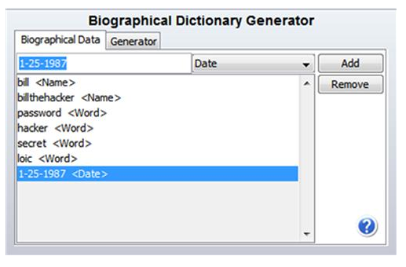
Won't get you into EFS-encrypted files

Custom Dictionary

Acquire the hard disk (and RAM, if possible) of the evidence machine

Extract all strings

Use that as the password dictionary

Password Cracking Tools

Password Recovery Toolkit (PRTK) from AccessData

John the Ripper

Cain

Ophcrack

Hashcat (in Backtrack)

PRTK's Biographical Dictionary Generator

Breaking BitLocker

Cold Boot Attack

Freeze the RAM and recover the key

Dissolve the TPM chip and recover the key with a microelectrode

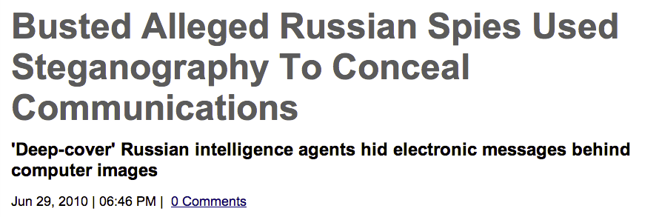
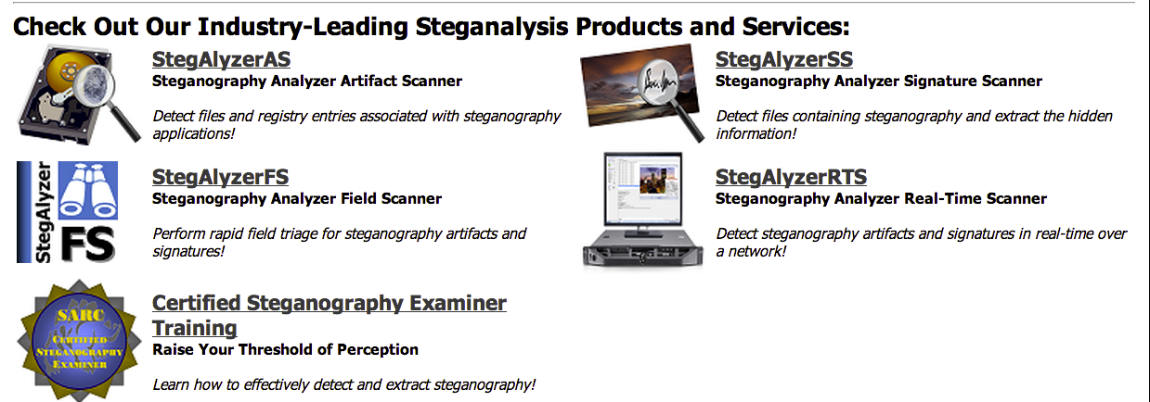
Both are exotic, impractical attacks

User may have backed up the key in a Microsoft account (Ch 7c)
Steganography

Steganography

Hiding a payload file inside another carrier file

Used by Osama Bin Laden and Russian spies (link Ch 6d)

Steganography Detection Tools

Link Ch 6e

Hiding and Destroying Data

Data Destruction

Drive Wiping

Darik's Boot and Nuke (DBAN)

Window Washer

Evidence Eliminator

Mac OS X Secure Erase

Many others

Some erase whole disk, some only erase files or unused blocks, others erase only header & footer

Presence of these tools may be treated as evidence of guilt in court

Especially if they were used just before evidence seizure

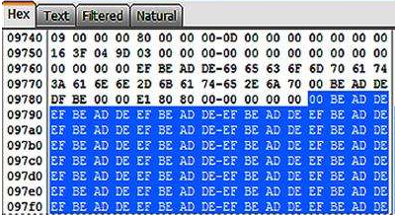
Some Wipers use Repeating Patterns

This is a sign of disk erasure

Defragmentation

Moves clusters to tidy up disk

Makes files open faster

Causes some sectors to be overwritten

Automatically performed weekly in Windows 7

Last modified 3-12-13

