7. Legal

Topics

Fourth Amendment

E-Discovery

Duty to Preserve

Private Searches

ECPA

Searching With & Without a Warrant
Fourth Amendment

The right of the people to be secure in their persons, houses, papers, and effects, against unreasonable searches and seizures, shall not be violated, and no Warrants shall issue, but upon probable cause, supported by Oath or affirmation, and particularly describing the place to be searched, and the persons or things to be seized.

Criminal Law—Searches Without a Warrant

1. Did the government act?

2. Did that action violate a person's reasonable expectation of privacy?

Only if both answers are "YES" does the Fourth Amendment apply

A person acting at the request of law enforcement becomes an agent of the government, and Q1=YES

Reasonable Expectation of Privacy

No simple answer

A computer can be treated as a closed container

If an officer lacks authority to open a desk drawer or box, there isn't authority to examine a computer either

If a reasonable expectation of privacy exists, the government must get a search warrant, or meet one of the documented exceptions

Are individual files closed containers?

Case law is unclear

Data a individual places on shared computers or drives is not protected by the fourth amendment

Private Searches

Fourth amendment does not apply if the examiner is not acting at the request of government

If a Geek Squad worker finds illegal files on a computer, that evidence is admissible

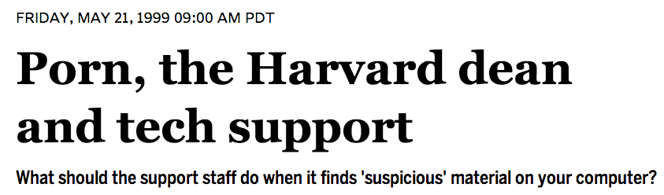
Link Ch 7a

Email

Treated like regular postal mail

Email has fourth amendment protection while it is being transmitted, but the protection stops when it is delivered to its destination.

Legal interception is regulated by the Wiretap Act of 1968

Prohibits unauthorized monitoring

Lists procedures needed to obtain a warrant for wiretapping

The Electronic Communications Privacy Act (ECPA)

Bans third parties from intercepting and/or disclosing electronic communications

An amendment to the the Wiretap Act, passed in 1968

Changed in 1994 by CALEA (Communications Assistance to Law Enforcement Act)

Changed again by the PATRIOT Act

Re-authorized in 2006

CALEA (Communications Assistance to Law Enforcement Act)

Requires telecommunications providers to assist law enforcement with wiretaps

In practice, this forces them to use special equipment

Expanded in 2006 to cover broadband Internet providers

From the FCC (Link Ch 7b)

CALEA and the Internet

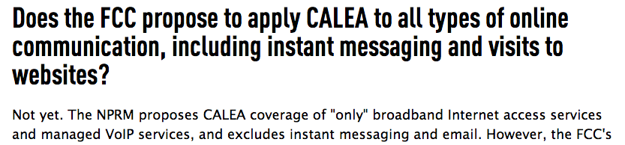
CALEA doesn't yet apply to instant messages and Email

From the EFF (Link Ch 7c)

The USA PATRIOT Act


Uniting and Strengthening America by Providing Appropriate Tools Required to Intercept and Obstruct Terrorism

Here's what the DoJ says about it (Link Ch 8d)

EFF on PATRIOT Act

Link Ch 7e
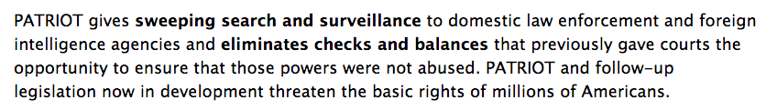

National Security Letters

National Security Letters are allowed by the PATRIOT Act, forcing Internet service providers to tap users and not tell them

A recent verdict below may stop them, but it may be appealed (Link Ch 7g)

Exceptions to the Search Warrant Requirement

An authorized person gives voluntary consent for the search

"Voluntary" will be judged on the totality of the circumstances

Consent can be revoked at any time

Search must stop at that time

BUT if you have already made a forensic clone, you only need to return the original and may continue to examine the clone

So make the clone promptly

Scope of consent

Consenting to search a house may not apply to closed containers and computers

Party may set forth restrictions on the search

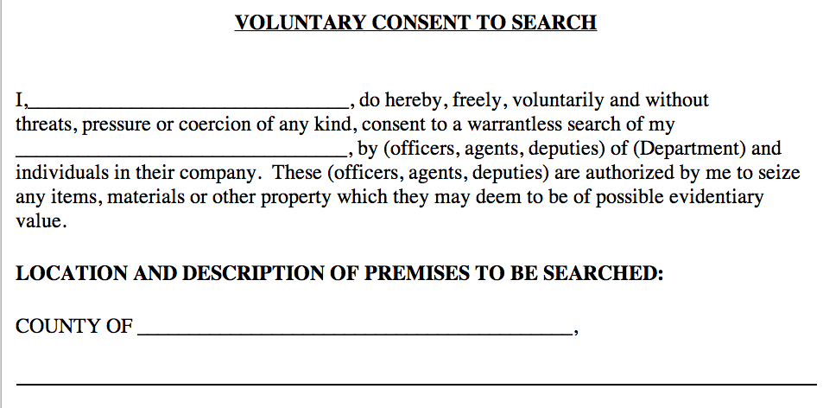
Consent Forms

Link Ch 7h

Consent Searches

Third parties can sometimes consent

Roommates, spouses, parents…

If a device is shared, all parties can consent to search its common areas

None of the users have a reasonable expectation of privacy in the common areas

Password-protected areas are not common areas

Unless the suspect shared the password with the third party

Consent Searches

Spouses can consent to the search of common areas

Parents can consent to a search of a minor child's property (age under 18)

Technicians often uncover evidence during their work

It's unclear whether technicians have the right to consent to a search

Exigent Circumstances

An immediate seizure and search of a digital device is required under one of three conditions:

Evidence is under imminent threat of destruction

A threat puts law enforcement or the public in danger

Suspect is expected to escape before a search warrant can be acquired

This may justify seizure only, not search

Plain View

If officers are legally allowed to be where they are and can see something immediately incriminating

They can use that evidence

A forensic examiner investigating one crime may find evidence of another

Stop the search until a separate search warrant is obtained

Border Searches

These searches are allowed more latitude

Border searches

Searches by probation or parole officers

Employees

Employees in the workplace may not have a reasonable expectation of privacy

Officers can search a computer if an employer or co-worker with shared authority gives permission

Government employees can only be searched if the search is "work-related, justified at their inception, and permissible in scope"
Searching with a Warrant

Search warrant is granted by a judge, based on probable cause that a crime was committed and evidence will be found at that location

Computer may have different roles

A computer containing child porn is contraband

Computer may contain incriminating documents

Computer may be the instrument of a crime such as hacking

Seize Hardware or Information?

Hardware must be seized if computer is:

Contraband

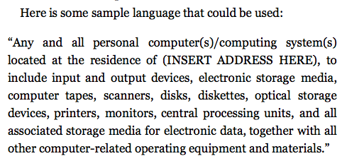
Evidence

Fruits

Instrumentality

Otherwise, all you need is the data

Particularity

You need to state clearly what can be seized and what cannot

Establishing Need for Off-Site Analysis

Examination is time-consuming and best performed in a forensics lab

This should be explained in the affidavit justifying removing and holding the devices

Stored Communications Act

Lays out process law enforcement must use to force disclosure of data from Internet Service Providers (ISPs)

Email

Subscriber and billing information

Enacted in 1986

Two types of service providers

Electronic Communication Service (ECS)

Including telephone and email services, like AOL

Remote Computing Service (RCS)

Provides storage or processing services

Electronic Discovery (eDiscovery)

The process of collecting, preparing, reviewing, and producing electronically stored information (ESI) in the context of the legal process

ESI is

Easily modified

Volatile

Easily duplicated or dispersed

Large volume of data

Duty to Preserve

Rules of Civil Procedure were changed in 2006 to address digital evidence

Opposing attorneys must deal with ESI early in the process

Duty to preserve potentially relevant data begins with there is "reasonable expectation of litigation"

Failure to preserve is spoilation of evidence

Can lead to severe sanctions

Duty to preserve often starts long before a subpoena is served

eDiscovery

Data sampling is a way to test large volumes of ESI for the "existence or frequency of relevant information"

Costs of eDiscovery can be massive

Typically costs are borne by the producing party

Costs can be shifted to the requesting party if certain conditions are met

Private Searches in the Workplace

Employers have a lot of latitude to search an individual's company computer

Best practice: computer use policy stating that work computers, email, etc. are for work purposes only and may be searched at any time

Fourth amendment (if law enforcement is doing the search)

A work computer can be searched with consent of a supervisor or another employee who has common authority over the area to be searched

Consult with attorney for guidance

Expert Testimony

Expert witnesses can state opinions

Expert doesn't need a PhD or other credentials

An expert has "special knowledge, skill, training, or experience" which makes him or her qualified to "aid the factfinder in matters that exceed the common knowledge of ordinary people"

Several images are from the textbook, I didn't cite sources for them

Last modified 3-20-13

