Topics

Internet

Web browsers and evidence they create

E-mail function and forensics

Chat and social networking evidence
Internet Overview

Internet Concepts

URL (Uniform Resource Locator)

http://www.ccsf.edu/NEW/en/myccsf.html

Protocol: http

Host: www

Domain name: ccsf.edu

Top-level domain: .edu

Fully qualified domain name: www.ccsf.edu

Path to file: NEW/en/myccsf.html

Browser

IE, Chrome, Firefox, Safari, etc.

HTTP Process

HTTP (Hypertext Transfer Protocol)

Designed to deliver Web pages

First the domain name must be converted to an IP address with a query to a DNS Server (Domain Name Service)

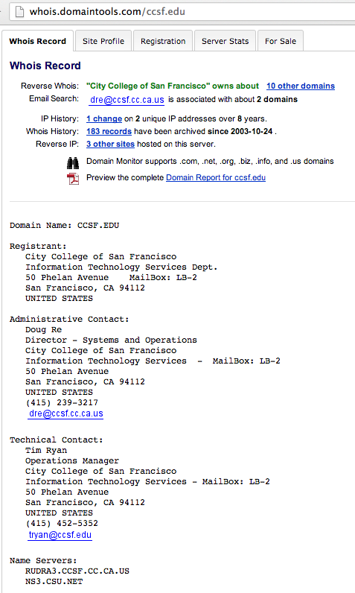
Then the page is fetched by sending an HTTP GET request to the Web server

Pages are written in HTML (HyperText Markup Language)

May also contain images, video, sounds, etc.

Static and Dynamic Web Pages

Static pages are the same for every visitor

Dynamic pages are constructed to customize them for each viewer (Web 2.0)

Ex: Facebook, Gmail

Fetch items from databases

A Content Management System builds the page for each viewer

Viewers are identified by cookies

Some code runs on the server, (like SQL and CGI scripts), and other code runs on the client (like JavaScript)

Whois

Identifies the registered owner of a domain name or IP address

Who Wrote the FlashBack OS X Worm?

“mavook” took credit on the “BlackSEO” forum (in Russian)

His home page was mavook.com in 2005

Link Ch 8a

Whois History

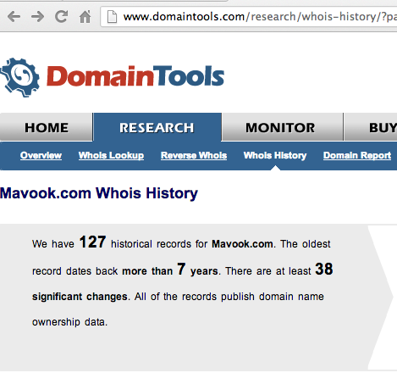
Who is Mavook?

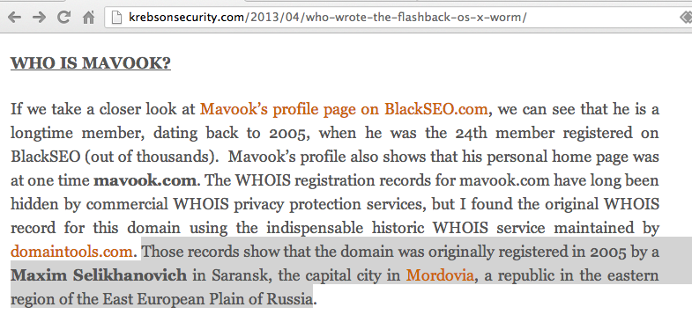

Peer-to-Peer (P2P)

File-sharing

Uses Bittorrent protocol

Vast majority of P2P traffic is stolen music, videos, and software and other illegal content

Consumes vast amounts of bandwidth and ports

Examples: Gnutella, Limewire, uTorrent, Vuze, The Pirate Bay (Link Ch 8b)

Index.dat Files

Binary file used by Internet Explorer

Tracks URLs visited, number of visits, etc.

Link Ch 8c leads to “Index Dat Spy”

Best to find the files and list them

Link Ch 8d leads to “Index Dat Reader”

Shows all the results together

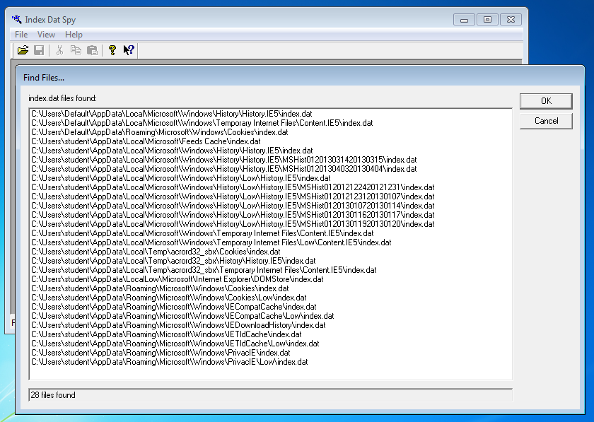

Files back to 2012!

Index.dat Reader Shows All Entries

Back to 1899!

(Remember not to trust your tools!)
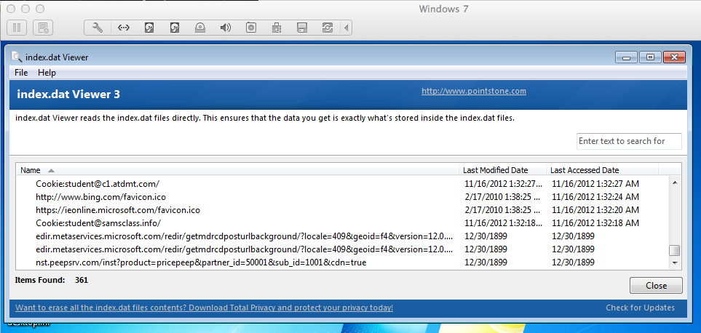

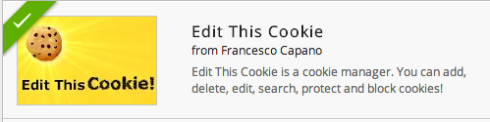
Web Browsers

Cookies

“Edit This Cookie” Chrome Extension (Link Ch 8e)

Cookies

Plain text files

Often dropped by third parties

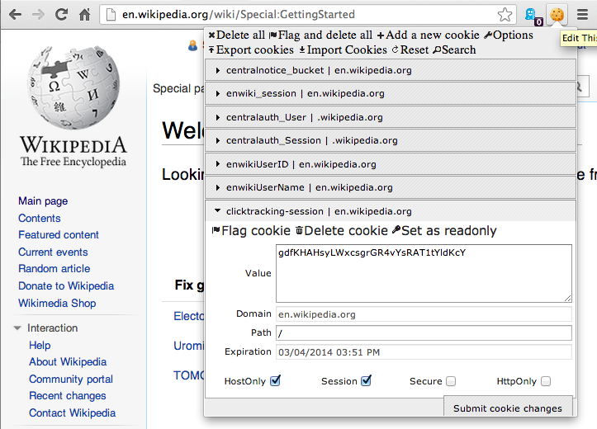
A cookie from a site does NOT prove the user visited that site
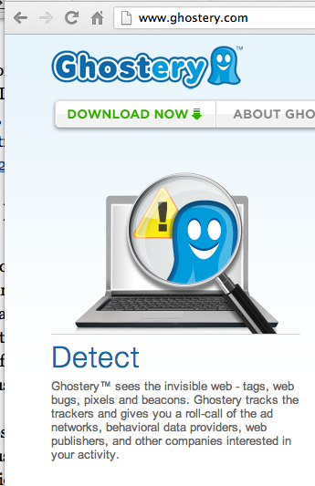

Temporary Internet Files

aka Web Cache

Makes pages reload faster

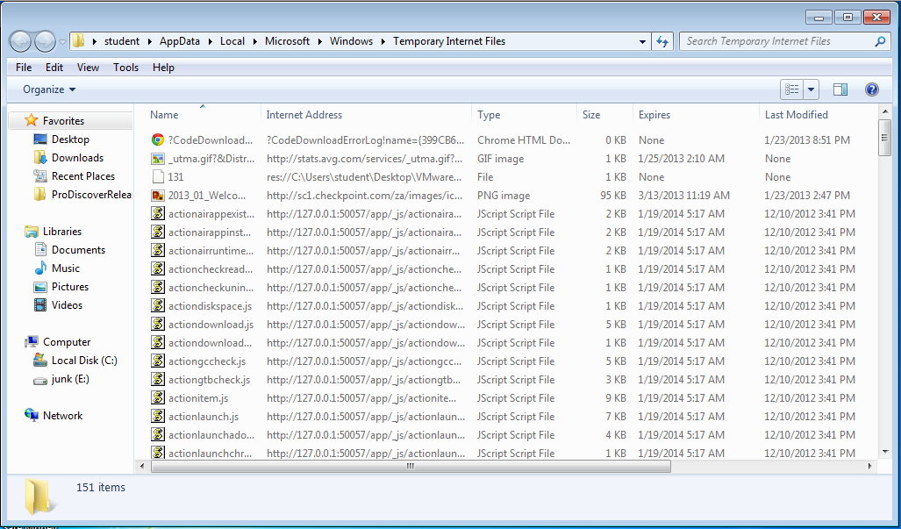
Internet Options, General tab, under Browsing history, click Settings. In the Settings dialog box, click View files.
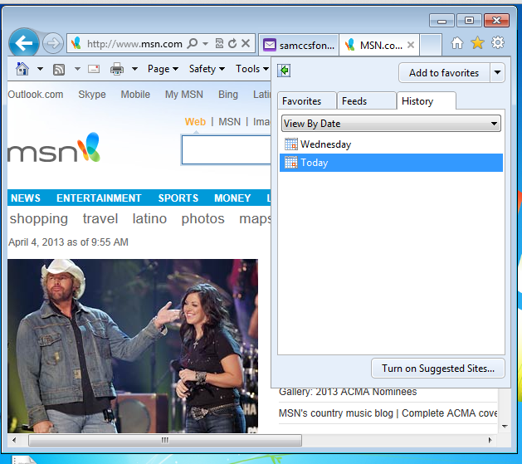

Error in Textbook

HTTPS resources are cached by Internet Explorer the same as HTTP resources

Internet History
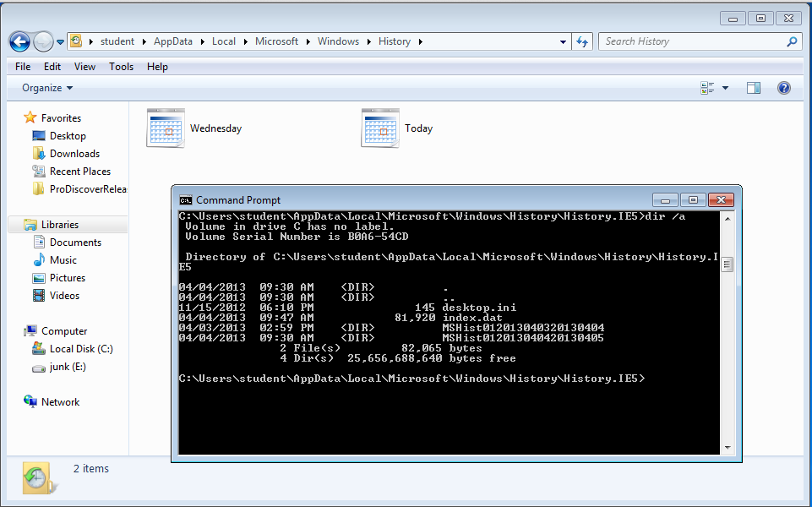

TypedURLs
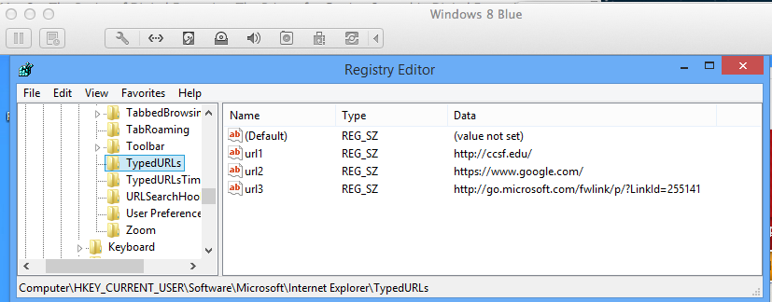

Chat Clients

Popular Chat Clients

AOL Instant Messenger

Yahoo! Messenger

Windows Live Messenger

Trillian

ICQ

Many more

Popular among pedophiles


Link Ch 8h

Data from Chat Clients

Contact or “Buddy” list

Block list

List of recent chats

Logging of chats

Manually saved chat logs

Acceptance list for video chat, file transfers, personal messages

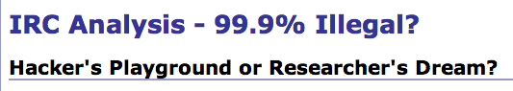
Cell phone associated with account

IRC (Internet Relay Chat)

No central authority

IRC Networks
Undernet, IRCNet, Efnet, etc.

Link Ch 8i

ICQ

42 million active users

Average user connected more than 5 hours per day

47% female

80% of users between 13 and 29

High level of privacy—only invited users can chat with you
Email

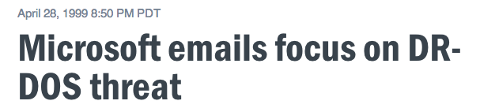
Value of Email

One of the best sources of evidence

People forget that emails are not private

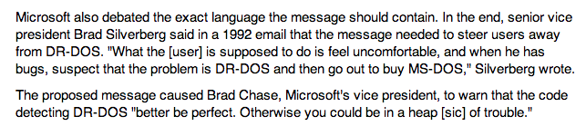

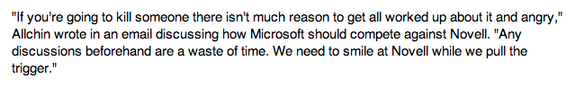
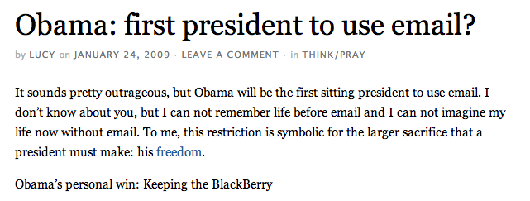

Link Ch 8l

How Email is Accessed

Web-based mail

Gmail or Hotmail

Accessed through a browser

Email client

Outlook

Stores data in .pst or .ost file

Proprietary database format (Link Ch 8m)

Windows Live Mail (formerly Outlook Express)

Outlook Express used .DBX files (databases)

Windows Live Mail uses .EML files (plain text files, one per message)

Email Protocols

SMTP (Simple Mail Transfer Protocol)

Used to send emails from one server to another

Post Office Protocol (POP)

Used by email clients to receive email messages

Internet Message Access Protocol (IMAP)

Used by email clients to receive email messages, more features than POP

Email as Evidence

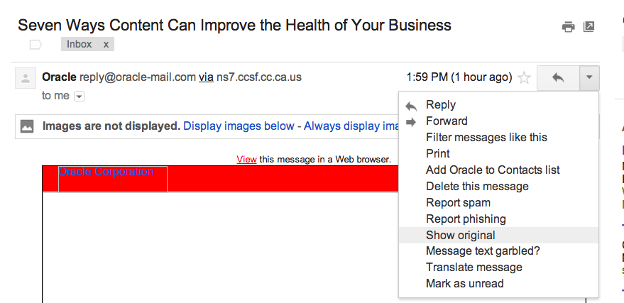
Communications relevant to the case

Email addresses

IP addresses

Dates and times

Where Email can be Found

Suspect’s computer

Any recipient’s computer

Company SMTP server

Backup media

Smartphone

Service provider

Any server the email passed through

Components of an Email

Header

Shows the servers the email passed through

Body

Readable message

Attachments

Gmail: “Show Original”

Header
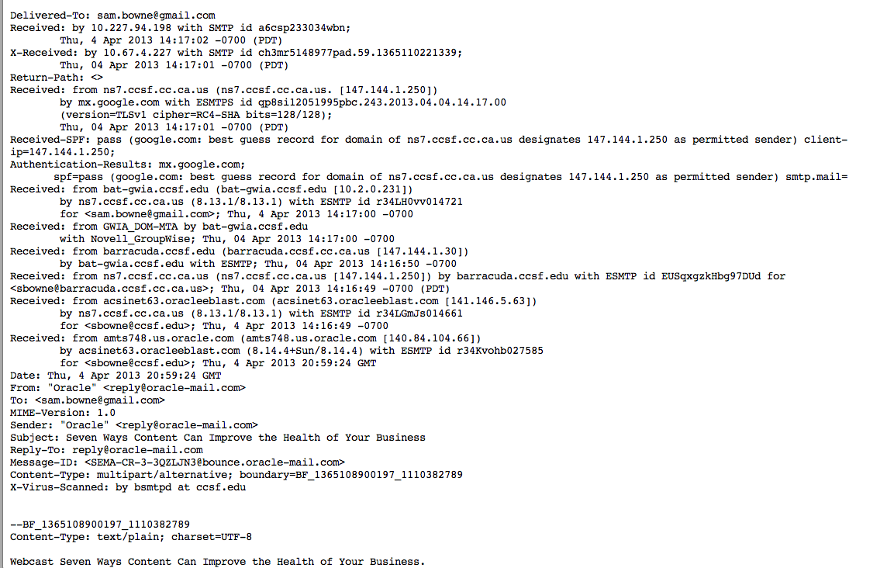

Email--Covering the Trail

Spoofing

Falsifying the origin of an email

Anonymous Remailer

Strips the headers

Forwards email without them

Typically doesn’t keep logs

Protects the privacy of users

Shared Email Accounts

Create an account on a free Web service like Yahoo!

Share the username and password with recipients

Write an email and don’t send it

Save it in the “Drafts” folder

Recipient can log in and see it

Used by terrorists

Can be “One-Time Account”

Mailinator

Cannot send, only receive

No passwords or privacy

Tracing Email

Message ID is unique

Proves that the email has passed through that server

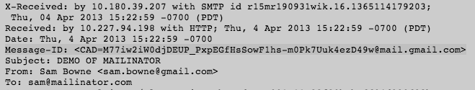
Detects falsified emails

Social Networking

Over-Sharing


People talk constantly and share everything

Facebook

Twitter

FourSquare

People check-in with their current location

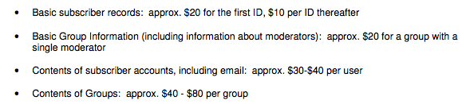
Evidence may be on suspect’s computer, smartphone or provider’s network

Link Ch 8n

Last modified 4-4-13

